Computer Science Programming Project – PoolGame
Contents
Analysis of the problem 5
Problem identification 5
Stakeholders 5
Casual gamers (STK.1) 5
Casual competitive gamers (STK.2) 5
Individuals with accessibility needs (STK.3) 5
Remarks 6
Testers 6
Research the problem 6
Existing solutions 6
Gang Beasts 6
Jackbox Party Pack Series 8
Golf With Your Friends 9
Mario Kart 8 Deluxe 10
Minecraft: Bedrock Edition 12
Pool (both video game and analogue versions) 13
Accessibility Guidelines 14
Features of my proposed solution 14
Limitations 14
Applicable computational methods 15
Specify the proposed solution 15
Features 16
Essential (i.e. success criteria) 16
Desirable 17
Optional 18
Out-of-scope/Excluded 18
Minimum system requirements 18
Software 18
Hardware 19
Design of the solution 19
The rules of pool 19
Definitions 20
Objects and locations 20
Terms 21
Rules 21
Decompose the problem 22
Match 22
Turn order 23
Objects 25
Menus 25
Main Menu 26
Settings 27
Pause 28
Match End 28
Describe the solution 29
Screen 29
Justification 30
Match 30
Justification 31
Menu 31
Justification 32
Sprite 32
Justification 33
CollideObject 33
Justification 34
Pocket 35
Justification 35
Cushion 35
Justification 36
PoolBall 36
Justification 37
ObjectBall 37
Justification 37
CueBall 37
Justification 38
Notes 38
Table 38
Widgets 38
Describe the approach to testing 38
During development 38
During evaluation 39
Survey prototype 39
Developing the solution 40
MonoGame 40
Gameplay loop 40
Update and Draw 40
Iterative development process/testing 41
1st iteration – setting up 42
Familiarising myself with MonoGame 42
Sprite, CollideObject, and PoolBall 45
CueBall 50
Friction 52
Review 54
2nd iteration – completing the environment 54
PoolBall-PoolBall collisions 54
Graphing the table’s dimensions 61
Sidenote 70
Pool ball textures 70
All pool balls 78
Pockets 81
Cushion textures 87
Cushion collisions 101
Reworks 111
Review 117
3rd iteration – adding menus and a graphical user interface 117
UI framework 117
Barebones main menu 118
Screen switching 120
Settings 122
Evaluation 122
Testing to inform evaluation 122
Gameplay loop tests 122
Survey 125
Responses 125
Review 127
Unused tests 128
New player settings test 128
Keyboard and mouse verses controller 128
Success of the solution and description of the final product 129
Evaluating against success criteria 129
Conclusions 130
Maintenance and development 131
Maintenance 131
Further development 131
Credits 132
Source code 133
Program.cs 133
Game1.cs 133
Classes/ 135
Screen.cs 135
Screen Inheritors/ 136
MainMenu.cs 136
Match.cs 137
Sprite Inheritors/ 146
CircleSprite.cs 146
CircleSprite Inheritors/ 147
Cushion.cs 152

Analysis of the problem

Problem identification
I’ve found that there aren’t group activities that are available to most people; most are either too expensive, slow to pick up on, too repetitive, or lack proper accessibility considerations. A solution to this problem could bring people together more (where other methods of connection may be out of their reach) or just provide an easier and simpler way for groups to be entertained.
A computational approach is perfect for this problem as many parts can be easily customised to accommodate whoever’s using it. Whereas analogue entertainment methods often can’t meet everyone’s needs (e.g. someone with a mobility disability might have a hard time with sports, someone with very little money might not be able to afford going out with friends).
A program-based solution could also be taken almost anywhere if it can run on a laptop. There’s less risk of losing parts when, for example, bringing it to a friend’s house because it wouldn’t need to be physically brought and instead could already be installed on the friend’s computer. It’s also cheaper for end-users since they just need to install it rather than buying parts or paying extra fees, making it accessible to a wider range of people in difficult financial situations. In addition, my solution has the potential to be more scalable than any analogue game because no more equipment or space is needed for extra players (except small amounts of memory and secondary storage), especially if only one keyboard and mouse/controller is needed.
Note that more specific applications of computational methods are described at the end of the analysis section because, up until then, I didn’t fully know the form my program would take. This meant I could add more contextual information, rather than vague definition-like ideas.

Stakeholders

Casual gamers (STK.1)
These will likely be the largest portion of my solution’s demographic, so they should be accommodated for as well; they range in age from children to adults. They play games to socialise and have fun (rather than to compete with others or challenge themselves) so my solution needs to be intuitive, relaxed, and have the capability for some form of multiplayer. Within this demographic are some pre-teen children, so my solution will also need to be kid friendly.

Casual competitive gamers (STK.2)
These are still a reasonable portion of the demographic, so suitable mechanics should be introduced so that they can be entertained as well. They will need some sort of score-keeping system and a leader board to be implemented. I should also reduce reliance on random events because that would be an unfair way to win/lose a game, potentially making other players annoyed when this could’ve been avoided.

Individuals with accessibility needs (STK.3)
A key part of the problem my solution is trying to solve is the lack of availability of group entertainment to some people, so my solution should be able to accommodate most their needs. They may need my solution to be able to run on low-end machines, colour-blind modes, mobility accommodations, etc.. I will need to do more research into exactly how I can help them the most.

Remarks
Due to the range of conflicting requirements (e.g. relaxed vs competitive), toggles may need to be available to alter how a few mechanics work to provide the best experience for different audiences.
I will be using (STK.1), (STK.2), and (STK.3) to refer to my stakeholders. If something is applicable to a particular stakeholder, I will write (STK.x) after it.

Testers
My solution will be tested by people within the demographics of the stakeholders where possible to reveal how suitable it is for them and for any other feedback they may have. Where this is not possible, I will be sure to research the sorts of things each demographic needs and try to accommodate those results. This will help me improve my solution by adding, tweaking, or removing features.
Some testers may have computer science experience and as such will be able to provide direct feedback on the source code. The benefit to this is that they may be able to evaluate my solution with a more technical lens, increasing the chance of finding bugs and/or exploits.

Research the problem

Existing solutions
I will be looking at existing solutions to parts of my problem (or similar problems) and noting features to apply to my solution and ones to be mindful of (i.e. features that could be added but might not be suitable or features that could easily be added accidentally (e.g. confusing controls)). If a similar feature is present multiple existing solutions, I’ll only write it down in the first game it appears in to remain concise.
Note that the number of features I write about for each game is not necessarily representative of how effective that game and its features are at solving my problem, just the quantity of features.

Gang Beasts
Gang Beasts is a multiplayer physics-based indie fighting game developed by Boneloaf. Its gameplay focuses on ‘knocking out’ other players with various environmental hazards with the goal of being the last one standing.
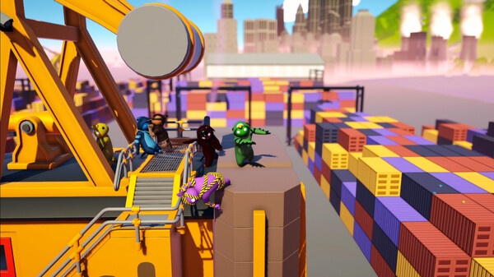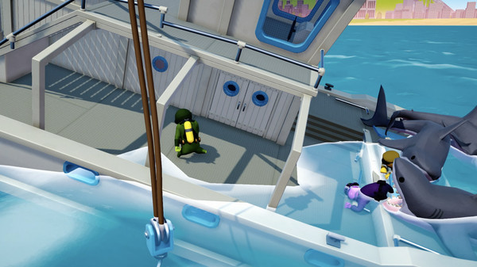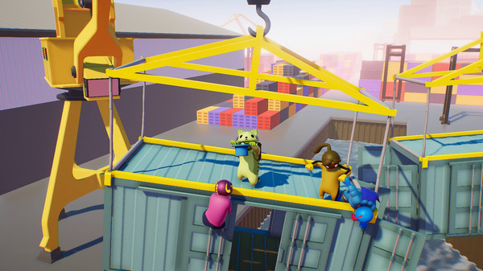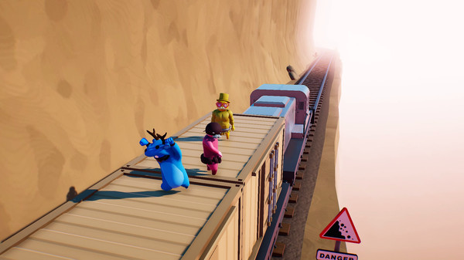
Image credit: https://store.steampowered.com/app/285900/Gang_Beasts/
Feature which could be applied to my solution | Justification
Simple menus and a “ready up” system | These ensure that players can start games quickly and when everyone is ready. The simple menus also make it easier for players to change settings and exit games, reducing the need for online guides and streamlining player’s experiences. (STK.3)
Simplistic environments and a minimalistic graphical user interface | These make it clearer for players to identify what they should be focusing on during a game, without being distracted by anything meaningless. (STK.3)
Environmental hazards | These create a more interesting and chaotic environment for players to engage with, reducing the boredom that comes from replaying the same thing over and over again. (STK.1)  They also provide different chances for players to combat each other in simple, unique ways without requiring new controls that may be hard to input and/or learn. (STK.2)
No inappropriate imagery | This makes the game suitable for all ages, allowing younger children to play. (STK.1)
Each player is assigned a colour and name and are allowed to pick an outfit for their character | This helps players avoid confusing who’s who mid-game even if they have some vision difficulties. (STK.3)
Using a keyboard, players can slow down or speed up the game with + or – respectively. | This make it more manageable for players with slower response times to be on an equal footing with faster players. (STK.3)
Both controller and keyboard/mouse support, with intuitive controls (e.g. space bar/A as jump and WASD/joysticks for movement) and an option to remap them in the settings. | This makes it easier for players to learn to play the game without needing time to remember specific controls. (STK.1)  While it may give less freedom to extreme competitive gamers (not casual competitive gamers), they aren’t a part of my stakeholders so I shouldn’t compromise the overall playability of my game for them.
Up to 4 players able to play at any one, with heavy interactivity between players and a score system. | This encourages players to be more competitive and obstruct each other, while keeping the playing field fair. (STK.2)

Features to be mindful of in my solution | Notes
Hidden techniques and combos | They are not explained to player, so most people either don’t know they exist or stumble into them accidentally. This can increase the skill ceiling for the game, making competition more intense (STK.2). Although, the game doesn’t rely on these moves for gameplay to be enjoyable, so less experienced players can still easily play (STK.1).
It revolves around fighting | This could be seen as unsuitable for some younger audiences. It skirts around this by using cartoon violence (i.e. no blood or gore) and it is presented in a light-hearted way. But players can still be ‘knocked out’ in more gory ways like by being pushed into a meat grinder or eaten by a shark.

Jackbox Party Pack Series
The Jackbox Party Pack Series is a series of collections of multiplayer indie minigames developed by Jackbox Games. Its gameplay focuses on gaining points across rounds to win by competing in minigames with various theme, often involving player-submitted answers.
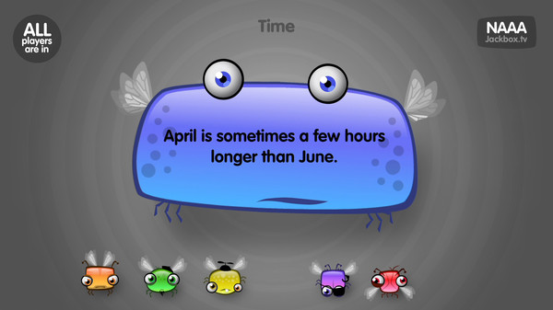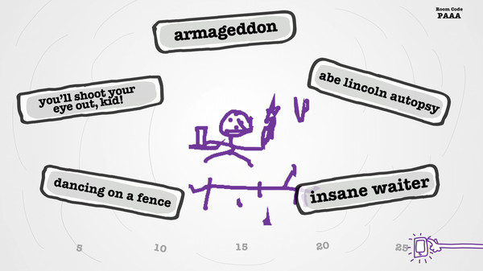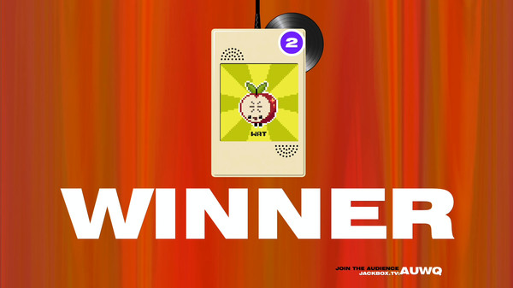
Image credits: https://store.steampowered.com/app/331670/The_Jackbox_Party_Pack/ https://store.steampowered.com/app/397460/The_Jackbox_Party_Pack_2/

Feature which could be applied to my solution | Justification
No reliance on reaction time, only having a timer to make sure players submit their answers relatively quickly | This solves the problem of game speed having a greater impact on those who have lower reaction times. (STK.3)  It also bypasses the need for a game-speed modifier option, saving on development time and effort.
Each ‘Party Pack’ has different games to choose from when playing | This ensures a fresh experience for returning players, keeping them entertained even if they’ve played it before.  (STK.1, STK.2)
Simple controls (via a mobile device) to submit answers with an on-screen mobile keyboard or the touch screen (e.g. for drawing) | This makes it easier for players to play the game even if they have limited gaming experience (since they only need to use their fingers to tap or draw). (STK.1)  It also reduces the need for players to remap controls because they are so simple (although it could be troubling for players with impaired motor skills). (STK.3)
Option to suppress potentially inappropriate content | This allows much younger groups to avoid seeing any inappropriate content while still allowing older groups the freedom to have as much fun as they want. (STK.1)
Up to 8 players can play most of the games within each pack | This means that large groups don’t need to rotate out players. Less people are on the side-lines waiting for their turn, so more people can have fun together. (STK.1)

Features to be mindful of in my solution | Notes
A connection to the internet is required for players to submit their answers | With no in-person group input methods due to the nature of the game, it makes playing it in-person require every player to have a mobile device. If players are in a place with no internet or some don’t have phones, it can’t be played (also if some players can’t afford mobile data). (STK.3)

Golf With Your Friends
Golf With Your Friends is a multiplayer indie extreme variant on minigolf developed by Blacklight Interactive. Levels often require players to bounce their golf balls off moving objects, swim across water, avoid explosives, and much more.
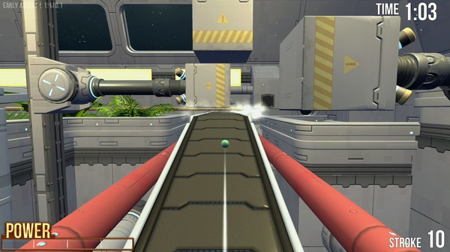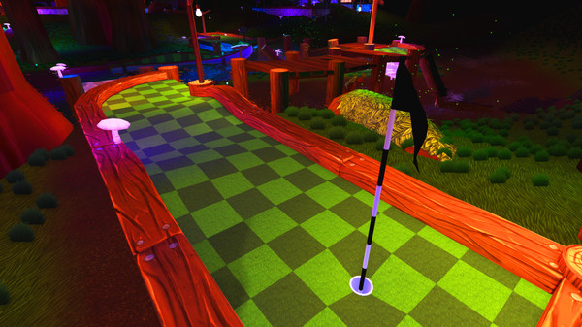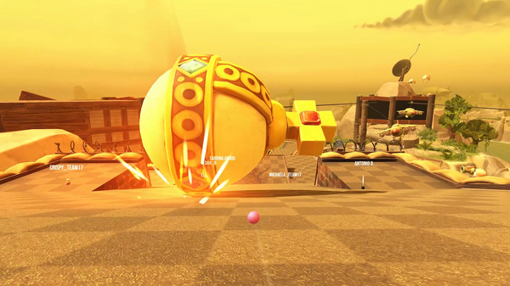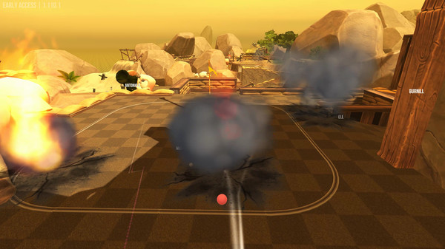
Image credit: https://store.steampowered.com/app/431240/Golf_With_Your_Friends/
Feature which could be applied to my solution | Justification
Builds off an existing and well-known game (crazy golf) | This means most new players are already familiar with the rules, so the time to learn how to play is reduced. (STK.1)
Players can interact with each other (by knocking into other player’s golf balls to send them off course). | This allows players to compete with each other and lets them actively disadvantage each other as well. (STK.2)
A player’s golf ball is always in view of them and is customisable, with colours, a name, and a trail. | This helps players avoid confusing who’s who mid-game even if they have some vision difficulties. (STK.3)
The game is scored in terms of how many shots it takes for a player to sink their golf ball | This gives players with slower reaction times an equal chance of winning since the time taken to finish isn’t taken in to account. (STK.3)
The settings menu has options to modify gameplay (e.g. toggle ball collisions, alter gravity) | This allows players to customize their experience to how they’d prefer for the most fun. It also keeps games fresh even after a few replays. (STK.1)

Features to be mindful of in my solution | Notes
Some courses can be quite challenging to complete (e.g. precise balancing or aiming) | Easier courses are available, so newer players or those with accessibility needs can still have fun while playing.  Adding a handicap/assistance mode could level the playing field if I chose to add hard parts to my game, but it may be hard to tweak it to make it fair enough.

Mario Kart 8 Deluxe
Mario Kart 8 Deluxe is a multiplayer racing game developed by Nintendo, featuring characters from many of their franchises. The goal is to be the first to complete all the laps of a race, collecting and using various items to disadvantage other players such as banana peels to trip players behind up or red shells to home onto players in front.
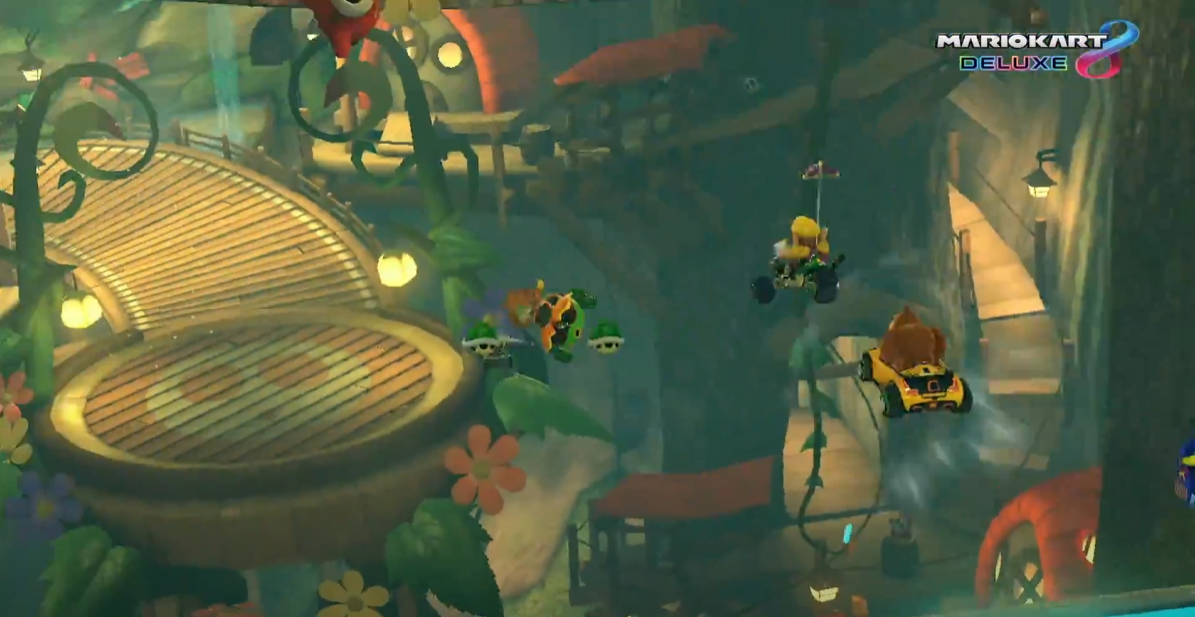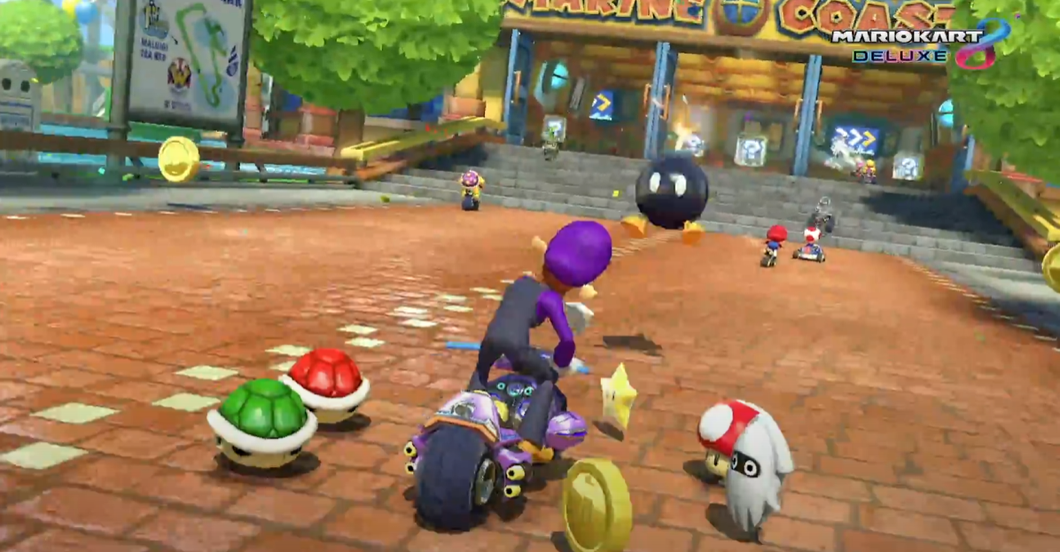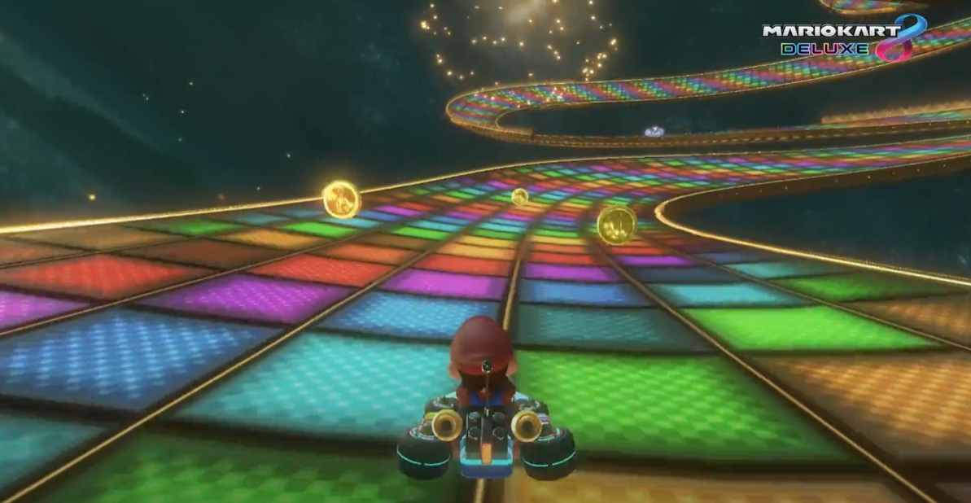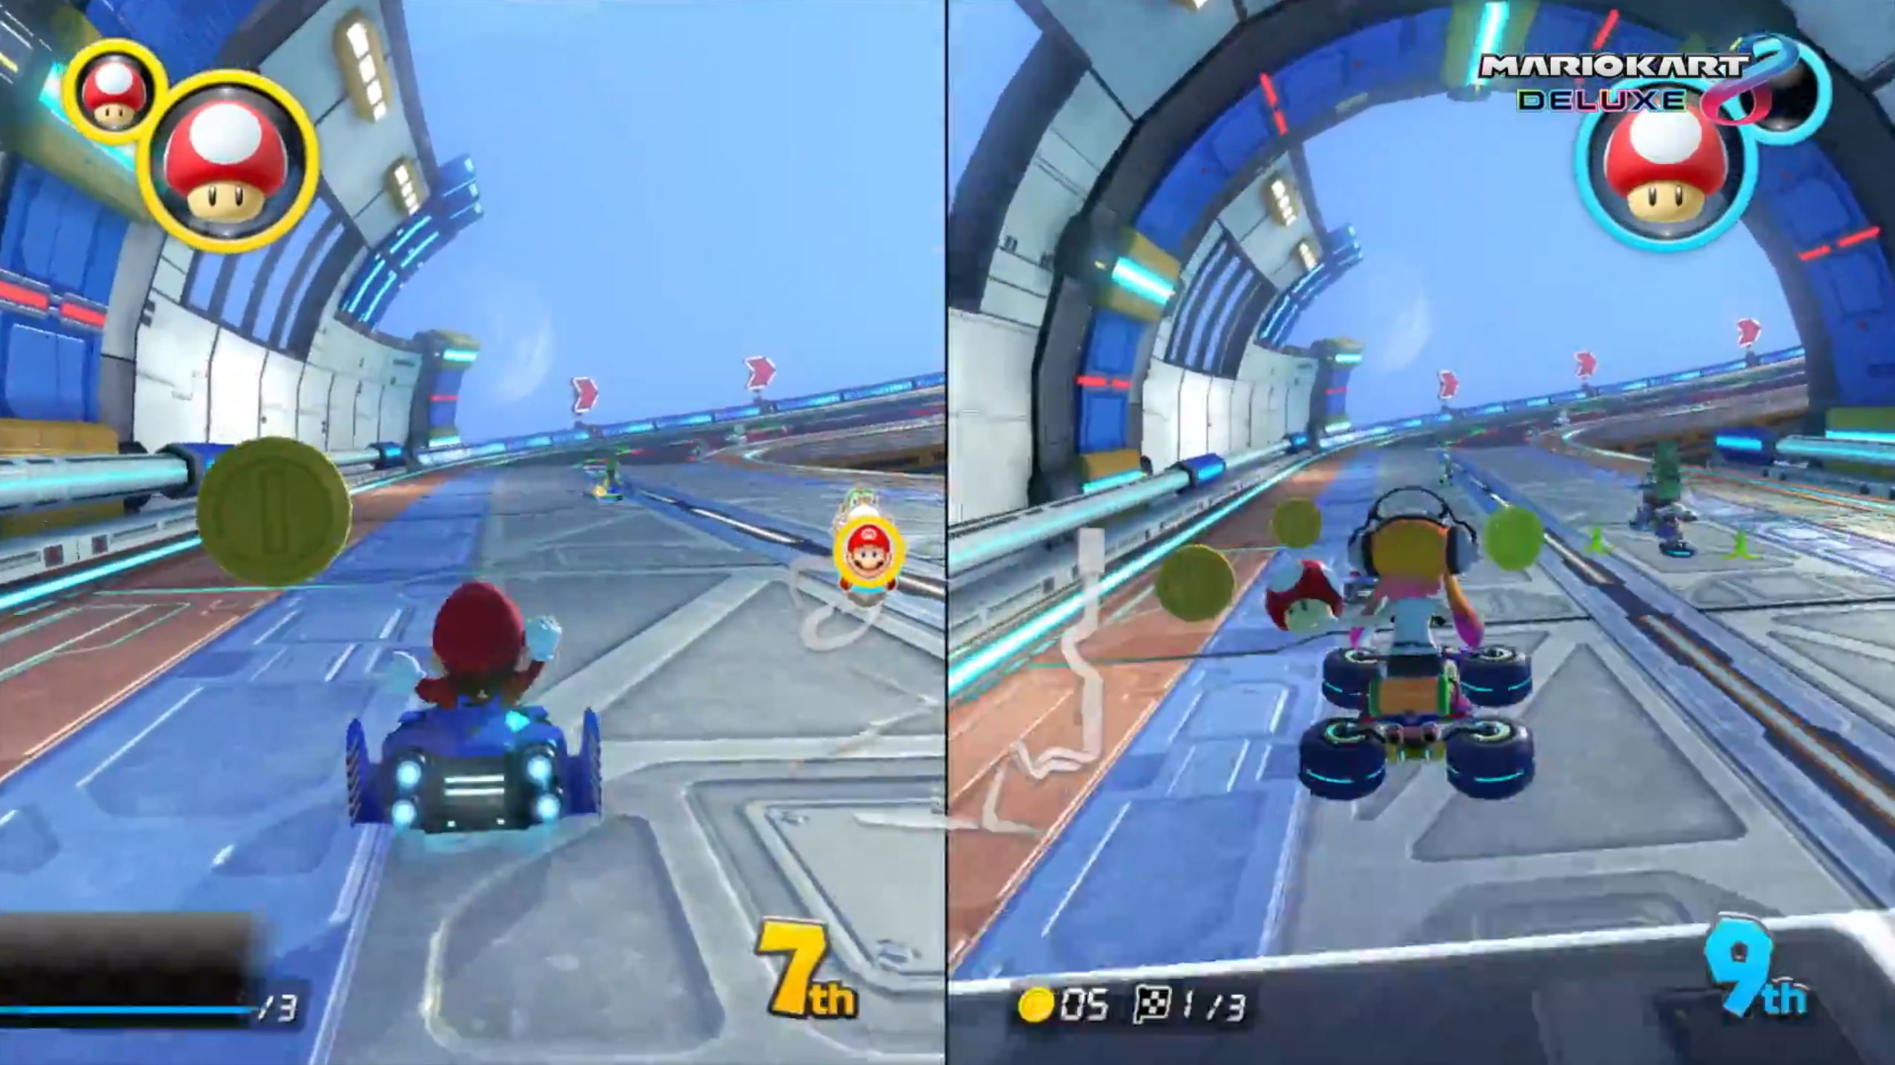
Image credit: https://www.nintendo.com/en-gb/Games/Nintendo-Switch-games/Mario-Kart-8-Deluxe-1173281.html?red_source=mariokart8.nintendo.co.uk#Overview
(Screenshots from the trailer)
Feature which could be applied to my solution | Justification
Assistance modes (e.g. auto-accelerate and smart steering) | This might help players who have accessibility needs keep up with other players. (STK.3)  It also levels the playing field for less-skilled players or those who are newer to the game, allowing them to play with more experienced players. (STK.1)
Item boxes | These add an element of randomness to the game and enable players who are behind to still have a chance to catch up (especially with items like the blue shell, which temporarily stuns the player in first place). Similar to Assistance modes, this shortens the gap in skill between players. (STK.1)
Difficulty options (e.g. item balancing and bot difficulty levels) | These allow for a more customisable experience and more fun for groups of players who aren’t looking for too hard of a challenge. (STK.1)

Features to be mindful of in my solution | Notes
Requires specific hardware (a Nintendo Switch) to play | Most people don’t own a Nintendo Switch, so it limits the number of people who can play the game. If it was available on multiple devices, it would be more accessible to more people.
Reliance on reaction time | It may be challenging for those with certain physical disabilities or coordination difficulties to play on an even footing to those without.
The randomness of item boxes may be seen as unfair | This is particularly evident if a player is hit multiple times with detrimental items. It fixes this by varying the chance of certain items occurring.

Minecraft: Bedrock Edition
Minecraft: Bedrock Edition is a version of Minecraft, a multiplayer open-world voxel-based survival game developed by Mojang Studios. Its gameplay is open ended; players can build houses, farm crops, slay monsters, travel to other dimensions, obtain artifacts through archaeology, and much more.
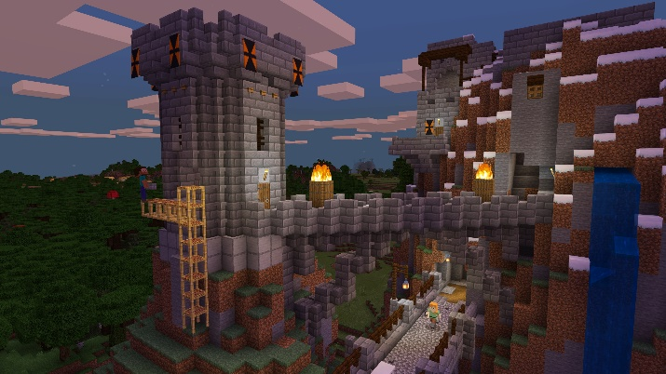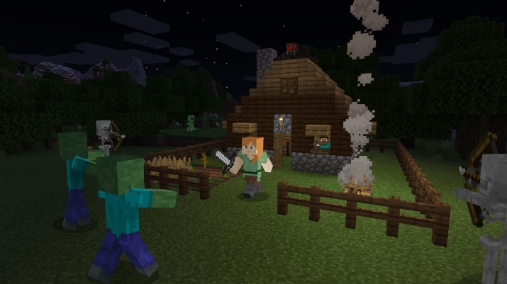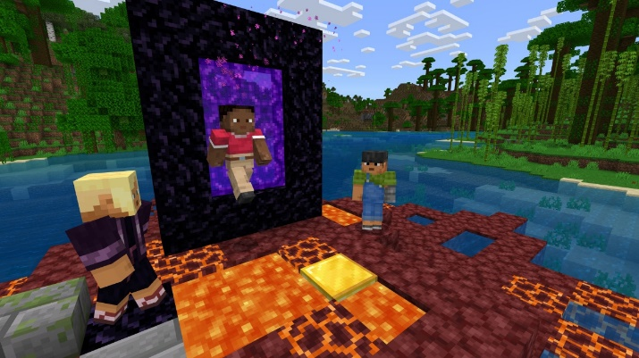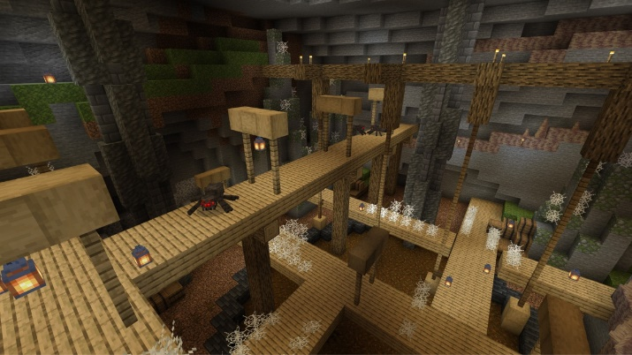
Feature which could be applied to my solution | Justification
Cross-platform multiplayer | This allows for more people to play together even if they don’t all have the same devices. They don’t need to buy expensive new hardware to play together, so the financial situation of prospective players matters less. (STK.3)
Variable graphics settings | These allow both for players with lower-end machines to play without issue and for those with higher-end machines to fully utilise theirs for improved graphics. (STK.1, STK.3)
The menus are large and well-spaced with an easy-to-read default font | This makes them easy to navigate and understand without even needing to enable any specialised settings. (STK.3)

Features to be mindful of in my solution | Notes
It has a steep knowledge curve and is open-ended | This means that newer players miss a lot of content because they don’t know it’s there. And with its continued updates, even old players sometimes can’t keep up.  Also, many of the mechanics aren’t explained in-game (e.g. potion brewing, travelling to the End dimension). Players often have to resort to using search engines to look for answers to mechanics-based questions, rather than being guided through them by the game.

Pool (both video game and analogue versions)
Pool is a tabletop sport played with a pool cue and several pool balls. The aim depends on the exact variant of pool, but in general it is to pocket (i.e. hit a ball into one of the table’s holes with a cue) the eight ball before your opponent. It has been around long enough to be adapted into many video games; these games can provide a viewable trajectory for a player’s shots while aiming.
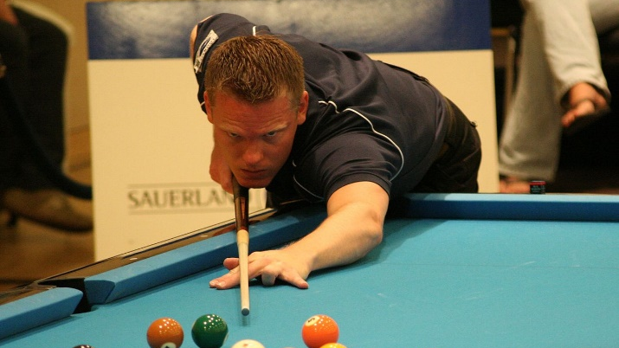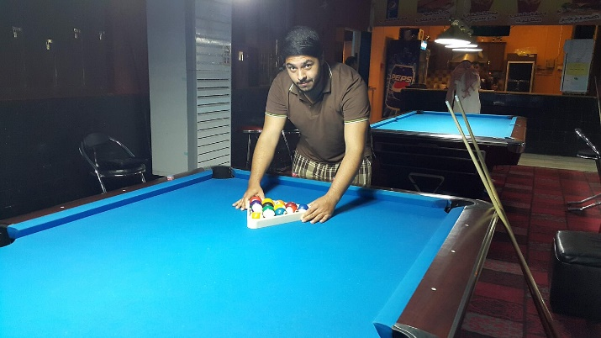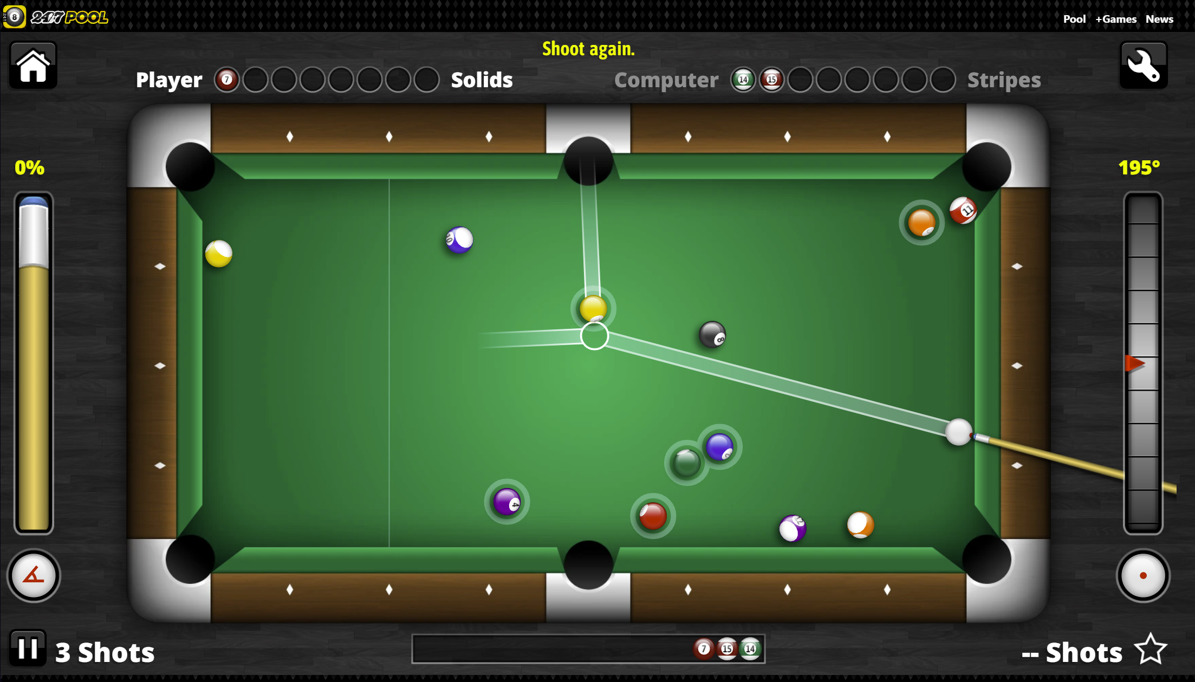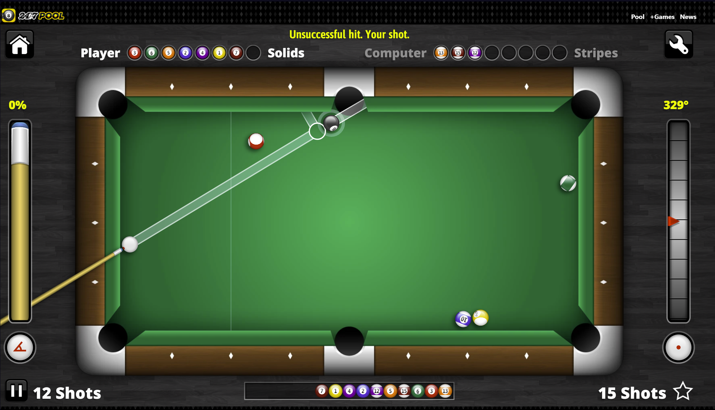
Image credits: https://en.wikipedia.org/wiki/Pool_(cue_sports)
https://www.247pool.com (screenshots of gameplay)
Feature which could be applied to my solution | Justification
Simple objective, mostly simple rules (depending on the specific rules players use) and well-known, also relying on real-world physics | This means that newer players are more likely to be able to pick up the game quickly, as I mentioned before. It also makes how objects move in-game more intuitive to learn. (STK.1)
Turn-based play | This allows players to take their time when planning their moves and removes any reliance on reaction time, meaning those with lower reaction times aren’t disadvantaged. (STK.3)
Players can disrupt each other’s strategies (e.g. by leaving the cue ball in hard-to-shoot-from locations at the end of their turn) | This adds to the strategy of the game and increases interactivity (and therefore compactivity) between players without direct player-verses-player combat. (STK.2)

Features to be mindful of in my solution | Notes
Its gameplay loop can feel repetitive, with little variation. | Variations of the classic eight-ball pool like one-pocket or nine-ball pool are meaningfully different, but they can still have the same premise and can feel repetitive if played enough.
Relies on player’s precision for some difficult shots | This may make it harder for less experienced players to hold their own against experts, reducing the availability for certain groups to play together.

Accessibility Guidelines
While these aren’t solutions outright, they’re help along the path to creating one (specifically for disabilities and other impairments). I’ll try to keep it in mind when designing my game, so that it is built with accessibility in mind rather than having it patched on later (which could be difficult and/or time-consuming). For this I will mostly be using gameaccessibilityguidelines.com because it seems to have a good reputation and lists a lot of features that I might not have thought of while designing. It separated features into categories (e.g. motor, cognitive, hearing) and by how easy they are to implement.
On top of using that website, I’ll try to avoid needing to provide alternatives for accessibility by not causing them in the first place. For example, instead of implementing a colour-blind mode, my game shouldn’t rely on sounds for players to receive necessary information (e.g. gunshots in a first-person shooter).

Features of my proposed solution
My solution will be a simulated game of pool. I have chosen pool because its premise is simple (i.e. hit more balls into pockets than your opponent to win) so it is easy to understand for newer players. Furthermore, pool is quite widespread, so a lot of newer players might be able to play without having to learn a whole new game. Due to its simplicity, its premise can be expanded upon to suit certain group’s preferences (e.g. adding obstacles, adding an equivalent to Mario Kart’s items, having more than one cue ball, etc.). Also, it’s a turn-based game, meaning that people with slow reaction times or other similar difficulties won’t be at a meaningful disadvantage while playing.
Ideally, it will be able to be played by 2 or more players at a time so that larger groups have less people watching on the side-lines being bored, and smaller groups can play too. A single player mode isn’t relevant to the stakeholders, so it isn’t likely to be added.
It will have simple menus to help players start games smoothly and find any relevant settings quickly. Where possible, there should be multiple ways for players to receive information and differentiate objects in the game’s environment (e.g. colours and patterns to differentiate between different object balls). There should also be controller support (on top of keyboard and mouse) because it helps people with mobility disabilities remap the controls to suit their specialised hardware (while that might not work perfectly for everyone, it should at least help a lot of players).

Limitations
Since it’s a turn-based game, for larger groups, people might have to spend a while waiting for their turn. It should be fine with 3 or 4 players, but when groups larger than 10 play they might get bored. This can be prevented if more than one game is being played at a time, but that requires more than one computer, which may not be available. To deal with this, I could look into split screen with multiple input devices to potentially allow for two or more games to be played simultaneously on the same device.
The lack of pool-like input methods (i.e. mouse rather than cue) and possibility for small quirks in the game’s physics might make it less (rather than more, as it aims to) intuitive for some players (especially those already very experienced in analogue pool). Also, humans typically have fine motor control when handling a cue, allowing for small adjustments. Whereas a keyboard and mouse or a controller input might not give as much freedom, leading to frustrating or less satisfying shots. To help players cope with these potential issues, I’ll consider adding multiple different ways of shooting the cue ball, allowing players to choose the way that best suits them. I’ll also aim to make the physics as realistic as possible while making sure to avoid risk of performance issues by going overboard.

Applicable computational methods
While each of these methods is useful for developing and running my game, abstraction and computational calculations are likely the most essential, otherwise the game wouldn’t even be able to run.
Method | Justification
Decomposition | My game has the potential to have lots of different features, so decomposing it into smaller parts to focus on each before building it back up to a full solution will be extremely useful. For example, the menu system is entirely different from pool ball collisions, so tackling each on its own should make things much easier.
Computational calculations | The ability to perform many calculations correctly and quickly is vital for my game’s success. Some of the key features of my game will rely on the capability for this. For example, each frame, a large number of collisions need to be calculated for the pool balls to move accurately and at their expected speeds.  For some games, a pen-and-paper or board-game approach could work, but (for a simulated game of pool) that simply isn’t possible without an actual pool equipment.
Abstraction | Reducing the number of non-essential parts of my game should help it run smoother on lower-end hardware. Using 2 dimensions instead of 3, for example, will drastically reduce both the time to develop it and the strain on some users’ computers. Simplifying some of the collision physics (e.g. treating all collisions as perfectly elastic) should also reduce the computational load.  In addition, much of the calculating and deriving I will have to do to develop algorithms will be models rather than real-world scenarios because, otherwise, I would spend too much time accounting for things that make almost no difference.
Logic | Computational logic like if statements and switch cases can help algorithms decide which exact course of action to take when specific requirements are met. For example, if I choose to split an object’s collisions into separate parts (e.g. middle and ends), an if and else if block will help.  Also, logic helps with much of a player’s input. I wouldn’t be able to respond to, for example, button presses without something like “if (buttonPressed)”.
Scalability and object-oriented programming | With the game’s variable player count, features should ideally be indefinitely scalable (obviously with some numerical limit) to allow many players to play at once. Add object-oriented programming into the mix, and instances of any object can be constructed as many times as needed.  Object-oriented programming lets me create objects to represent repeated things and subclasses of these objects can represent specific versions of them. This allows for, for example, all pool balls to function the exact same way without repeating lines of code. Specialised pool balls like the cue ball can then be made through inheritance with a subclass. Also, if I needed to, for example, iterate through an array of all the table’s pool balls but all the pool balls were either CueBall or ObjectBall objects, I could utilise polymorphism because of their shared superclass (PoolBall) to do it anyway.

Specify the proposed solution
With the above idea of how to approach the problem in mind, I have outlined the requirements and features of my game. I have categorised them to help keep within the scope of the project.

Features

Essential (i.e. success criteria)
Feature | Description | Justification
Simulated physics (EF.1) | The game’s physics must make sense for players, being as realistic as possible while abstracting where necessary to avoid performance issues. Where it becomes more complex, the physics used must be derived mathematically with proof shown.  (Note that, due to the potential; vague nature of this requirement, a survey will have to be used to make sure that a high proportion of stakeholders agree or disagree if this requirement has been met.) | If the game isn’t a realistic enough adaptation of analogue pool, it may feel uncomfortable or unintuitive to play (potentially putting off some players). If it’s overly realistic it will be slower to run on low-end machines, so it will be less accessible to people whose computers don’t meet the requirements.  This would exclude some of my game’s stakeholders (part of (STK.3)), so I will need to thread the line between overly realistic and not realistic enough.
Local multiplayer (EF.2) | There must be capability for more than two players to play in one match. | This allows gatherings to be fully entertained while playing my game, without people waiting on the side lines for matches to finish.  It should be noted that with a larger number of players (e.g. 10), players may have to wait their turn anyway because of how long a round could get (but that’s arguably better than them not being able to play at all).
A Score system (EF.3) | There must be a clear way for players to keep track of their scores mid-match. | If the game is scored in-game, it allows (STK.2) players to compete without needing pen-and-paper scorekeeping. It can also make for exciting moments when someone clearly behind makes a comeback (which is only knowable if both players’ scores are visible).
Performance on lower-end devices (EF.4) | The game must be able to run on my low-end laptop with at least 30 frames per second. | If it can’t run on my laptop, it likely won’t be able to run on many others’ even lower-end laptops. I chose mine because it’s the only one I have available and fits within the bracket of “lower-end” laptops. (STK.3)  30 frames per second was chosen because below it can be too jittery to play smoothly and enjoyably.
Controller support (on top of keyboard and mouse support) (EF.5) | Controller inputs to be able to do everything that a keyboard and mouse can as easily as they can. This includes menu navigation, settings alteration, and cue aiming/firing. | Controllers are preferred by a lot of (STK.1) likely because they can be used while not up close to the computer (e.g. on a sofa while the game is on a console and television). They are also easy to pass around when players are cycling who’s currently playing.  Also, some people have specialised controllers to help with accessibility needs (STK.3). Adding controller support provides an easier way for these people to remap the controls to their controller so they can have an easier time playing that they would otherwise.
Desirable features (EF.6) | At least two desirable features (listed below) should be implemented. | The features above are all required, but if it was just those the game might feel empty. It isn’t two specific features because each of the desirable features is different and might end up fitting or might not (hence why they aren’t all just marked as essential). However, having the requirement that at least two must be included combats this by ensuring that they don’t just get forgotten during development.

Desirable
Feature | Description | Justification
An assist mode (DF.1) | An option should exist (enabled within settings or if chosen on startup) to help players aim the cue for shooting. This could be an algorithm to adjust aim to increase the chance to pot a ball, or it could be guidelines to show the cue ball’s (and potentially others’) paths after a number of bounces. | These will help those with specific needs have an easier and more fun time playing my game. (STK.3). It could also level the playing field between more and less experienced players, letting new players have more fun with their friends. (STK.1)
Control remapping (DF.2) | An option in the settings menu that allows all possible in-game player actions to be remapped to any button on keyboard and mouse or standard gamepad controllers. | This enables the above feature (controller support) to be used more effectively by people with specialised hardware. It also allows anyone else who feels uncomfortable with the controls the ability to customise them to suit their needs. (STK.3). Furthermore, if there are more optimal control schemes, competitive players might use them to gain an advantage while playing. (STK.2).
Minimalistic/simplistic graphics (DF.3) | Any visuals in all parts of the program (including menus) need to be clear, concise, and easy for players (especially younger or (STK.3)) to interpret. The colour scheme will be simple and won’t include excessive detail like reflections or shading.  (Note that, due to the vague nature of this requirement, a survey will have to be used to make sure that a high proportion of (STK.3) agree or disagree if this requirement has been met.) | Simple menus would help players change settings easier and start game sessions quicker, streamlining their experience. (STK.1) (STK.3). Simple graphics would make it easier for players to keep track of what’s important mid-game. The lack of reliance on high-resolution assets will also increase performance because less needs to be loaded. (STK.3).
Variable resolution (not aspect ratio) (DF.4) | The aspect ratio of the screen should be able to switched between at least the following resolutions: 1280x720, 1920x1080, and 2048x1080 (i.e. 720p, 1080p, and 2K). | For users with less low-end laptops or computers, if their game was stuck in 1280x720 they wouldn’t be able to make full use of their hardware to improve the game’s visuals. Furthermore, the lack of this feature could produce much more obvious individual pixels on larger monitors
Clear ways for players to receive information and differentiate objects in the game (DF.5) | Every element on the screen should aim to have multiple ways for players to observe it (e.g. both colours and patterns on object balls to distinguish them from each other). Where this is not feasible, things like high contrast and large text should be used instead.  (As above, a survey will also be used to evaluate this requirement’s success.) | This would reduce potential confusion for players, lessening the chance of non-skill-based mistakes made by players like potting opponent’s object balls. This issue would be exemplified in players with vision/reading difficulties (younger ones and (STK.3)), but alternatives could reduce this (e.g. a visually impaired person could rely on sounds)

Optional
Feature | Description | Justification
Bot “players” (OF.1) | Non-human players that have the capability of aiming and shooting the cue ball with reasonable accuracy. Different skill levels should have different chances to hit any given ball. | While this feature isn’t a specific requirement from stakeholders, it could still make it nicer for smaller/one-person groups so that they can play with more “players”. (STK.1)
Different game modes or toggleable features (OF.2) | At least one game within the program other than regular pool. However, it should still rely on the basic controls and logic of pool (e.g. shoot cue ball, pot object balls to win).  Possible game modes include: environmental hazards, allowing for more ways for players to make use of and be challenged by their environment without requiring any new controls to learn; item boxes (or equivalent) so that players who are losing have a chance to catch up; multiple cue balls, enabling interactivity between players (e.g. by knocking into other player’s cue balls to send them off course). | This is a way of adding some variety to my game. If players either don’t find pool fun or have played my game too much they could still hopefully find some enjoyment in it. This could also reduce the issue with players having to wait there turn in larger groups if, for example, one game mode isn’t turn based. (STK.1)

Out-of-scope/Excluded
Feature | Justification
Online multiplayer (OEF.1) | The focus of the game is for local multiplayer, so it wouldn’t meaningfully benefit the majority of the stakeholders. Also, online multiplayer can be difficult and time-consuming to implement. It would take up development time, delaying release considerably for a feature that a lot of players wouldn’t need to use.
Multiple platforms (OEF.2) | This amount of development would take a lot more time to implement than I have available for this project. My game will be limited to an application that can be installed on PCs and other similar hardware.
Inappropriate imagery, or wording (OEF.3) | My game must be suitable for as wide of an age range as possible, so anything that isn’t suitable for younger children shouldn’t be included.

Minimum system requirements

Software
Requirement | Justification
.NET 6.0 Runtime (SR.1) | .NET 6.0 is one of the frameworks I’m planning on using to develop my game. It (or later versions) is necessary for running a game written in C# (the language I’m planning on using).
Windows 10 or later (SR.2) | .NET 6.0 doesn’t support any earlier versions of Windows. I’ve chosen only Windows (rather than macOS or Linux) because it is by far the most common operating system and the only one I have access to (without virtual machines). I have no way to verify if my game works on other operating systems, so it must require Windows.

Hardware
One of the goals of my project is to have it work well on low-end hardware, so there are minimal specific hardware requirements. Ideally, if it can run something like a search engine (which almost all low-end laptops can), it can run my game.
Requirement | Justification
1280x720 or higher-resolution display, 16x9 resolution (HR.1) | 1280x720 is the resolution that many low-end laptop screens use. For this reason, it is also the resolution that most of the game will be developed in (scaling up for testing purposes). Also, it should be easier to upscale graphics for higher resolutions than to downscale them for lower ones (since, at a certain point, things get too small to be viewed clearly), meaning that starting at the lower end of resolutions maximises the number of resolutions the game should be able to work with.

Design of the solution
In this section, I will decompose the structure of my proposed solution to the problem presented in the Analysis section (my game). I will outline the structure of the solution (the menu layout, gameplay loop, etc.) and go into detail on specific sections, relating more to the implementation through programming than just vague ideas.
I’ll use C# to develop my game because I it’s a language I would like to get better at, and it has a good reputation for game development. I will also be using the MonoGame framework; I’ve heard it’s intuitive to learn and doesn’t have as many built-in features as Unity. This is ideal since my goal for this project is to gain more experience with development, and this approach leaves room for me to build more features myself. The integrated development environment I’ll be working in is Visual Studio 2022 because it allows me to initialise C# programs easier than VSCode and was built with .NET in mind, so development should be a more streamlined process than it would be using VSCode or any other IDE.

The rules of pool
There are many different varieties of analogue pool (see Wikipedia – Pool (cue sports) for some examples https://en.wikipedia.org/wiki/Pool_(cue_sports)). To standardise which variant I’m using, I will be basing the rules of my game on the World Pool Association’s rules (https://www.wepf.org/docs/rules_2014.pdf). I will create simplified rules to make them easier to understand, so they may differ from the WPA’s exact rules. Note that some things (e.g. playing out of turn or jump shots) will be impossible in a simulated turn-based environment, so they don’t need to be explicitly included in my rules.

Definitions
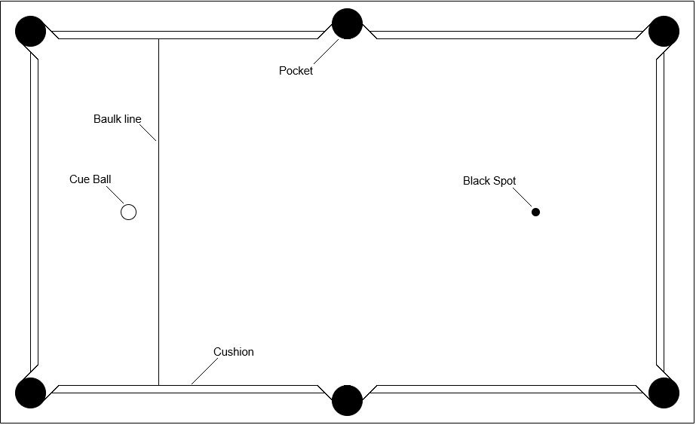
Black and white image of what the game screen layout will be during a match (except for the labels).

Objects and locations
Note that the dimensions I’m using here are within the ranges of what they would typically be in analogue pool. Also note that all pool balls are the same size here, despite not always being that way in analogue pool. They are all in centimetres for consistency.
Table – the plane that pool is played on, dimensions 160cm by 90cm (aspect ratio 16:9).
Pool ball – the ball that players either shoot with or at (encompassing all other ball types), diameter 5cm.
Cue ball – the pool ball that the players shoot with.
Object ball – a pool ball that is hit by other balls (encompassing coloured and eight balls).
Coloured ball – an object ball that isn’t the eight-ball (encompassing striped and solid balls).
Striped/solid – the striped and solid coloured balls respectively.
Eight ball – the object ball that isn’t a coloured ball.
Baulk line – the line where the cue ball starts in the middle of, it defined the left-most 1/5th of the table.
Kitchen – the area enclosed by the baulk line and the edges of the table, to the left of the baulk line.
Cushion – lining around the table that pool balls bounce off, sometimes called “rails” by others.
Pocket – holes that consume any pool balls that fall in them, diameter 9 cm.
Black spot – a mark that shows where the eight-ball is placed before a break, it lies half way up the baulk line.

Terms
Potted– when a pool ball goes into a pocket, the player that causes it is said to have “potted” it (or “pocketed” it).
Scratch – when the cue ball is potted.
Triangle – the arrangement of object balls at the start of the match, forming a triangle.
Break – the first shot of the match, before the triangle is disturbed.
Standard foul – an illegal move that doesn’t result in a loss for the player who committed it.
Loss of match foul – an illegal move that results in a loss for the player who committed it.

Rules
- The match is split into turns. Each player’s turn begins when the previous player’s turn is over and no balls are moving on the table. Each player’s turn ends when they have shot their final shot on their turn.
- If a player pots one of their coloured balls on their turn, they gain another shot. A player can only gain one shot per shot they make (meaning they can’t get two extra shots for potting two balls in one shot).
- A player wins the match by potting all of their object balls and then the eight-ball.
- If a player has committed a standard foul, the next player can choose to place the cue ball anywhere within the kitchen (except on top of other pool balls or in pockets). Committing a foul grants a player’s opponent an extra shot on their turn (to a maximum of 2). Committing a foul also negates any extra turns gained by potting object balls. A player has committed a foul if, on their turn:
  - The cue ball is potted
  - An opponent’s object ball is potted
  - The first object ball hit is an opponent’s object ball
  - The first object ball hit is the eight-ball (while at least one of their coloured balls is still in play)
  - No object balls are hit
- If a player has committed a loss of match foul, they lose and their opponent wins. A player has committed a loss of match foul if, on their turn they:
  - Commit a foul during the same shot that the eight-ball is potted (e.g. pot the eight ball and then pot the cue ball)
  - Pot the eight-ball while at least one of their coloured balls is still in play
  - Pot the eight-ball and their last coloured ball in the same shot
- At the start of each match, 7 coloured balls of each colour are arranged in a triangle with the eight-ball in between them (placed on the black spot). They are arranged as such, with the top of the triangle pointing towards the baulk line:
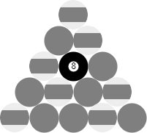
- It is randomly decided who plays first each match. But if matches are played one after the other, the player who played first last match cannot play first. If there are more than two players (as there can be in my proposed solution), a player cannot play twice before another player has played once.
- The type of a player’s coloured balls is decided by the first player to pot an object ball; the colour of object ball they pot is their colour for the rest of the match.

Decompose the problem
I’ve broken down my game into different components that can be brought together to form the game. Each component is associated with a screen in the game and can handle the underlying logic itself. Each screen should be structured so that they are all connected (directly or indirectly). This ensures that each of them is quick and easy to get to for a streamlined experience. Splitting up the game into different screens also ensures that processes (e.g. collision detection) aren’t run and objects aren’t rendered pointlessly while in another screen, which will improve overall performance.
The aspect ratio of all screens will be 16x9 because that is what the vast majority of device screens are. (HR.1). While a variable aspect ratio would be ideal, the pool table needs a fixed aspect ratio so that no errors occur with object positioning (e.g. if the height of the screen is less than the diameter of a pool ball, no pool balls could fit on the table). To streamline this, users will be able to pick one of a few different resolutions (e.g. 1280x720, 1920x1080). (DF.4).
Overall, the connections between screens should look something like this:
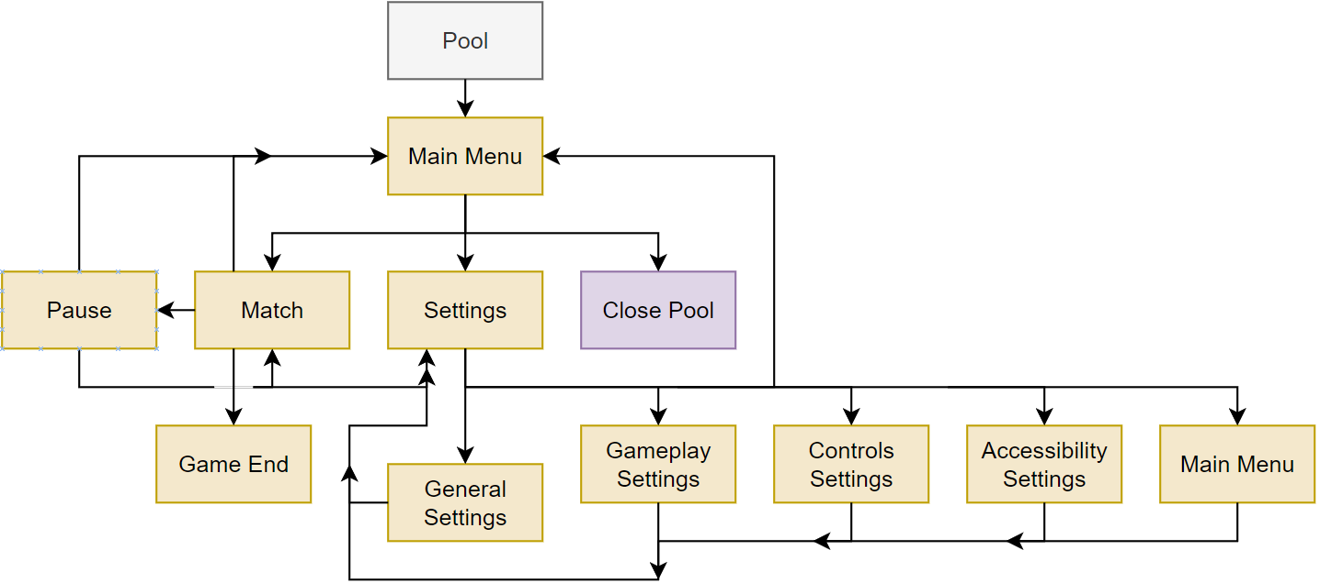
Orange rectangles represent screens, arrows represent the screens that can be accessed from another screen. The diagrams for individual screens will only have the screens they lead to, not the ones that lead to them, because otherwise it would look too cluttered.
Note that more time has been spent here designing the menu system because a lot of things in the match system might change during development. So, I reasoned that there’s not much point defining things in detail if they will surely change and redefinitions are needed.

Match
Here’s how Match should link to other screens:
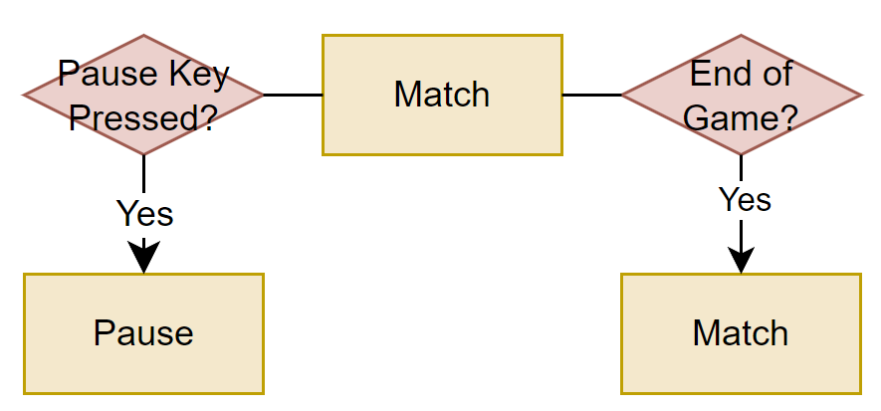
Red diamonds represent decisions, with their outcomes leading off as arrows.
Note that Main Menu is accessible through Pause. Also, it loops back to itself because another match can be loaded at the end of a match.
The Match screen holds most of the substance of my game, it displays and runs matches of pool. Scores are reset to zero when a match is restarted or ended, not when the Match screen is loaded, to not reset scores every time the pause button is pressed.
Here’s an example of what the screen might look like at the start of a match:
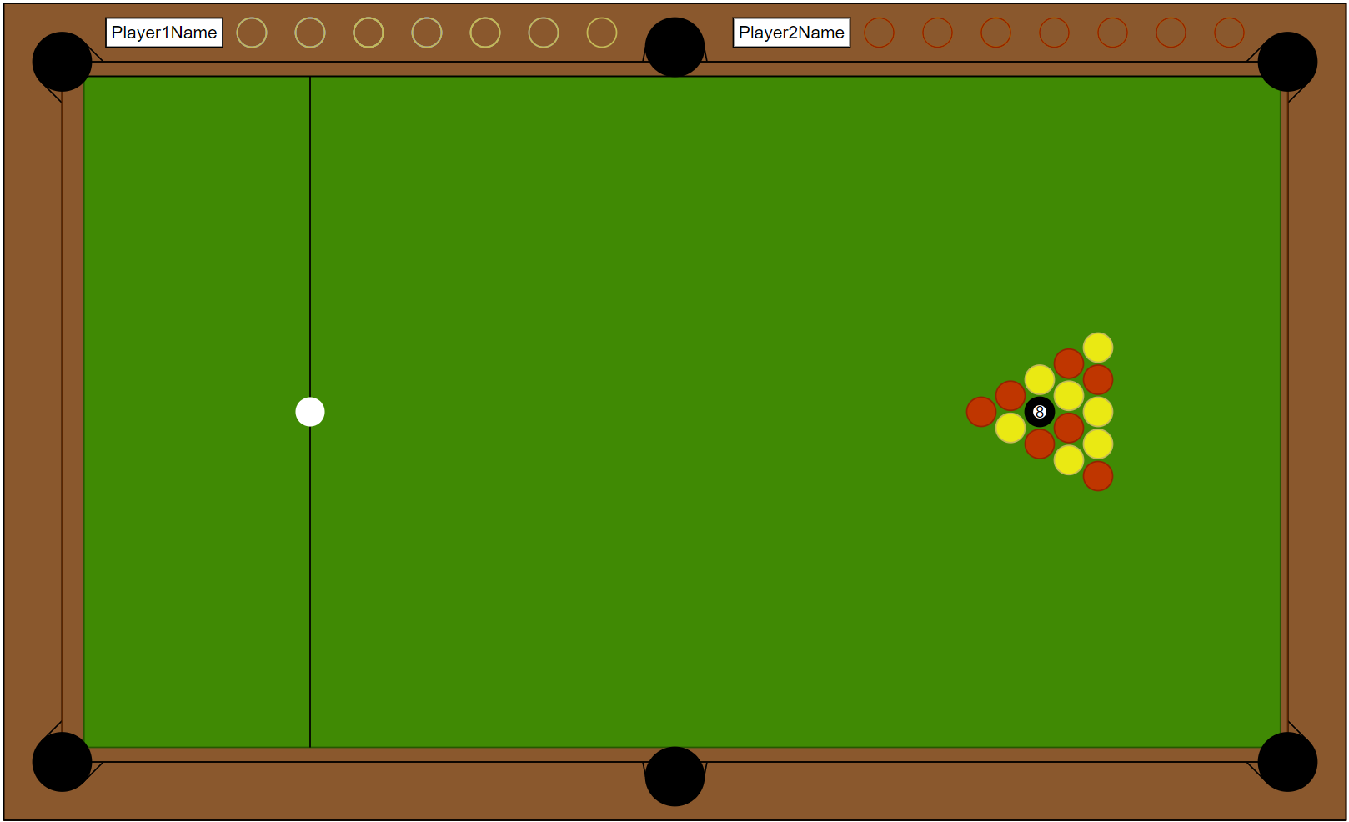
Note that player scores could go around the rest of the board as well, but this is just for two players. Also note that the scores will be shown by filling in the empty circles after each player’s name to represent how many balls they have potted.

Turn order
To clear up some confusion, I defined clear terminology for each section of a match. Each match encompasses ‘n’ rounds (where ‘n’ rounds are played before the match ends), each round encompasses ‘m’ turns (where ‘m’ is the number of players), each turn encompasses two phases (the Aim and Move phases). This is illustrated below (where it follows from 1 to ‘m’ turns in 1 to ‘n’ rounds):
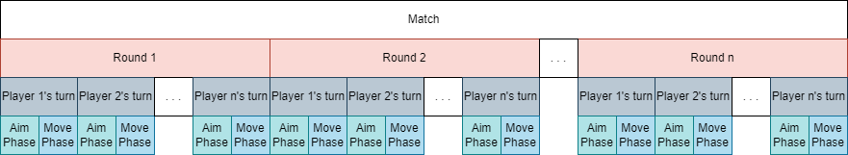

Aim
When any round starts, player 1’s turn begins with them entering the Aim phase of round 1. In this phase, they aim and fire their cue ball. Aiming the ball should feel as close to analogue pool as possible (i.e. pick a direction and an intensity for each shot). There are different methods that can be used to achieve this.
- One method is to let them click a point on the table and the ball should move towards that point on the Move phase. Its initial speed would increase the further that point was from the cue ball. (i.e. if they click far away from their cue ball, they move with more initial speed and therefore will likely move further.).
- Another method is to have a click represent a direction (as above) but then pull back a rendered pool cue to aim (maybe with a bar on the side to represent the intensity). This would give players an indication of how intense their strike will be before finalising it.
- An oscillating force bar could also work. In this instance, you would click in the direction you want to go in when the force of the shot is where you want it to be.
I decided to go with the first option. This was because it felt like the most intuitive and easiest to control of the three. The second one is trying too hard to be like analogue pool, when the freedom of programmed pool can have many better alternatives. Also, the velocity bar is only helpful if players know what scale it’s using (i.e. how fast does maximum velocity go and how fast does minimum velocity go?), which could be challenging to implement intuitively. The third relies too much on timing, meaning players with either slow reaction speeds or motor difficulties could have a hard time. It also suffers from the ambiguity of the second option.
To implement it, I could use an algorithm to, when shooting, subtract the cue ball’s position vector from the mouse’s position vector to gain a vector in that direction with a magnitude equal to the distance between the two. It would then set the cue ball’s velocity to this (or possibly a multiple of it, depending on how strong it is).
Note that I can add the other two (and more if I think of them) as options in settings later if they work better for some players.

Move
After player 1 aims and sets the initial velocity, the Move phase begins. In this phase, the cue ball moves according to the velocity set during the Aim phase. A simple algorithm to add a pool ball’s velocity to its position each frame is all that’s needed for this to be achieved.
During this phase, any collisions between balls or between a ball and the cushions will be calculated and the balls’ velocities will be altered accordingly (i.e. they will bounce if they hit something). However, the exact details of the collision detection and response will be decided during development. This is because I might change how a certain object is rendered (e.g. the cushions might be rectangles, or they might be trapeziums). With changes like this, I would have to completely rethink collision detection as well as collision response.
However, I will still formalise a couple of basic collision detection algorithms for objects I think are less likely to change shape.
- Circle-circle collisions (i.e. a pool ball colliding with another pool ball or a pocket) can be detected by checking if the square of the distance between the two circles is less than the square of the sum of their radii. The collision condition can be given by $r_{a}+r_{b}>\sqrt{{\left(a_{x}-b_{x}\right)}^{2}+{\left(a_{y}+b_{y}\right)}^{2}}$ for two objects centred at $\left(a_{x},a_{y}\right)$ and $\left(b_{x},b_{y}\right)$ with radii $r_{a}$ and $r_{b}$. We can do away with having to find the square root (which can cost time that we don’t want to waste while checking all collisions) by squaring both sides of the equation, getting ${\left(r_{a}+r_{b}\right)}^{2}>{\left(a_{x}-b_{x}\right)}^{2}+{\left(a_{y}+b_{y}\right)}^{2}$.
- Circle-line collisions can be detected by checking if the distance between the line and the circle’s centre is less than its radius.

Justification
Each turn is split into two phases to avoid it checking for collisions or handling similar logic when in the aim phase to save memory. The aim and move phases are both part of the same screen because the display doesn’t radically change between the two; also, it’s simpler to initialise all of the objects at the start of a match (rather than re-initialising them every move phase).

Objects
There are a few notable objects in the Match screen. Each is an existing part of analogue pool, adapted as a class in my game.
Pool balls represent any pool balls in play, including cue balls, eight balls, and coloured balls (its subclasses). They are basic circle objects that move and react as described in my turn order explanation above.
Pockets are stationary, placed in six positions as shown in diagrams earlier. Each will erase any pool balls that collide with them (determined by the circle-circle collision algorithm shown earlier). Note that cue balls won’t fully disappear because they respawn on the next aim phase.
Cushions are also stationary (shown in earlier diagrams), keeping the pool balls within bounds. Each cushion will cause colliding pool balls to bounce off perfectly elastically (i.e. no kinetic energy loss).
The table holds all of the other objects, enabling it to update them, render them, and do pretty much anything else with them. This should give me absolute control when developing and testing objects in my game.

Justification
Splitting up the match environment in this way ensures that each object can be developed independently. When an object is made, it will be tested with all other already-implemented objects to check it implements well. This should reduce potential conflicts that could result from simultaneous development. Also, it helps others (and me) understand the code because each object is in its own place. This also makes navigating when I need to change objects simple, reducing unnecessary time wasted during development.

Menus
Most of the screens will be menus, mainly featuring buttons, dropdown menus, and/or sliders. Buttons will be used to move between screens (e.g. buttons labelled “Settings” go to the Settings screen); they are intuitive to use and, when labelled, make it clear what they do. Dropdown menus will be used for changing discrete settings (e.g. controls or toggles); they let players view all of the options rather than cycling through them one at a time, making it easier to find specific setting options. Sliders will be used to change continuous settings (e.g. sound-effect volume) from 0% to 100% (with a 1% step to ensure it always shows an integer); they allow for precise customisation over specific settings without having vague labels (e.g. 10% and 50% instead of “low” or “medium”) while also not needing a separate button for mute (since players can just set the slider to 0%).
The layout of menu screens will be quite plain, with only the above features (except the Match End screen, which displays more information like scores). This makes it clear what the players should be focusing on in each menu, making it easier to find the settings they’re looking for. (DF.3).

Main Menu
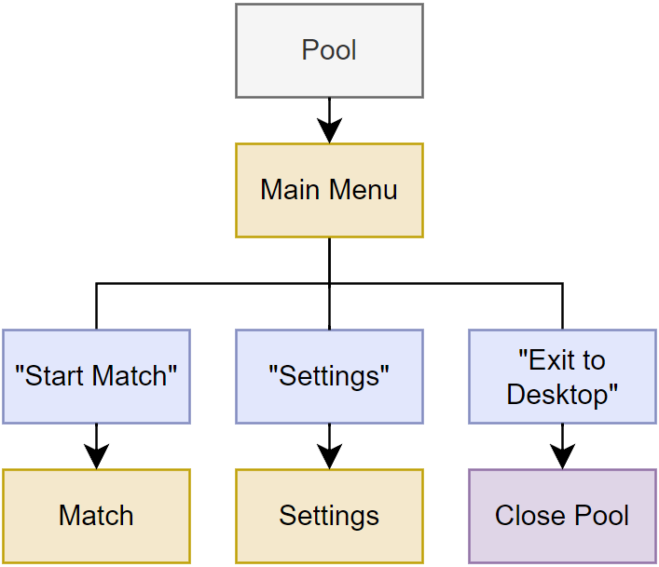
Blue rectangles represent buttons, with their display text in quotes.
The Main Menu screen is the screen that will initially be shown when my game is opened, it is linked to by any button labelled “Exit to Main Menu”. Its main function is to be a hub for most of the other screens, while allowing users to exit the program. There will be 3 buttons on the screen. Each button’s destination screen is given in brackets (if applicable):
- “Start Match” (Match) with default (or previously saved) gameplay settings.
- “Settings” (Settings)
- “Exit to Desktop” – closes the program, requires a confirmation to prevent accidental exits.

Justification
The Main Menu should be displayed when a match starts so that players can access settings before they start a match. This should allow players to modify settings to enhance their experience as soon as they boot up the game if they need. It also allows players to easily exit the game if they accidentally opened it.
Because of the Main Menu’s utility, it is linked to by every screen (except Settings’ sub-screens) so that it can be accessed easily.
Note that closing the program and exiting a match in my game could both come under the term “Exit Game” (despite being different). So, “Exit to Desktop” will always be used to refer to closing the program and “Exit to Main Menu” will always be used to refer to exiting a match and going back to Main Menu.

Settings
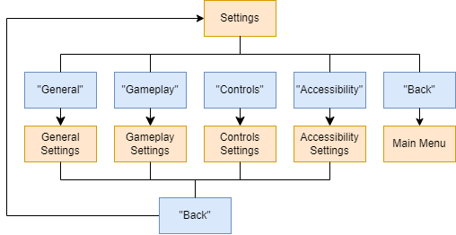
The Settings screen is linked to by any button labelled “Settings” and is much like the Main Menu screen in that both are hubs to reach other screens. This screen will have 5 buttons, each leading to their own sub-menu or back to main menu. Each sub-menu’s button’s type will be given in square brackets. Note that each sub-menu’s specific settings may change as more features are added or features are removed:
- “General” (General Settings)
  - Volume [slider] – since there are no music or voices, only one slider is needed
  - Resolution [dropdown] – only certain values for resolution will be supported for reasons noted above
  - Full screen/Windowed Mode [button] – toggles between full screen mode and windowed mode, useful for some specific devices or situations.
- “Gameplay” (Gameplay Settings) – if the Settings screen is opened during a match, this menu’s settings (or at least some of them) will not be changeable.
  - (none yet, if it stays empty this menu will be removed)
- “Controls” (Controls Settings) – this menu will have a list of each action associated with an input (e.g. shooting) for keyboard and mouse and controller. with the default key
  - Example input [custom] – Each input has a box next to it that displays its currently-bound key and prompts players to change that when clicked on. Next to that, it also has a button that resets the input to its default key bind. Note that it will warn players if they are assigning two inputs to the same key.
- “Accessibility” (Accessibility Settings)
  - Assist mode [button] – toggles the assist mode
  - Change colours [custom] – gives the player the ability to change the colour of all things in the game to help with vision difficulties.
- “Back” (Main Menu) – in all of Settings’ sub-menus, it will be used to go back to Settings

Justification
This screen gives users the ability to customise their experience. It’s separated into different menus so that users can quickly find the settings they are looking for, instead of having to search through a big list.
Also, Gameplay Settings’ settings will not be fully changeable mid-match because it could lead to some game-breaking effects (such as the number of players changing mid-match).

Pause
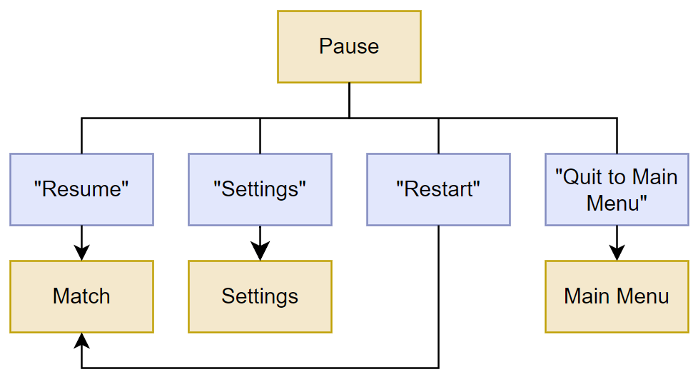
The Pause screen will popup when a certain key is pressed during a match. It will have the following buttons:
- “Resume” (Match) – Resumes the current match
- “Settings” (Settings)
- “Restart” (Match) – Initialises a new match, requires a confirmation to prevent accidental restarts
- “Exit to Main Menu” (Main Menu) – requires a confirmation to prevent accidental exits

Justification
The pause screen will allow players to pause the match if they need to take a break or do something else. It will also let players change some settings mid-match. This should allow them to test specific settings or correct them without restarting a match (losing their progress). It also allows players to exit or restart matches smoothly for any reason.

Match End
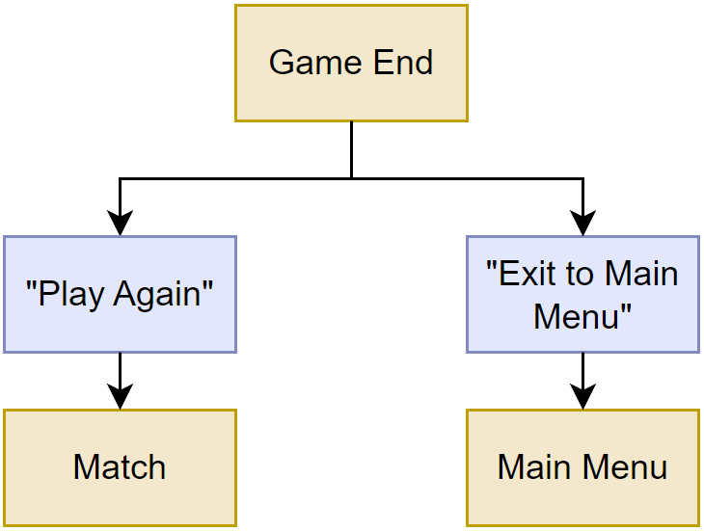
The Match End screen will only appear when a match is over (therefore, it can only be reached through the Match screen). It will display the scores of the players and announce a winner. It will have the following buttons:
- “Play Again” (Match) – Re-loads the Match screen with the same setup as before.
- “Exit to Main Menu” (Main Menu) – does not require a confirmation because no data can be lost when a match is already over.

Justification
The Match End screen serves as a transition screen between Match and Main Menu (or Match and Match again if players choose to play again). It allows players to instantly play again if they want, rather than having to go back to Main Menu, minimising repetitive button presses if a few matches have been played.

Describe the solution
Continuing from the layout of my game outlined above, here is a simple initial class diagram (leaving out methods and attributes, which will be explained later, to keep it readable):
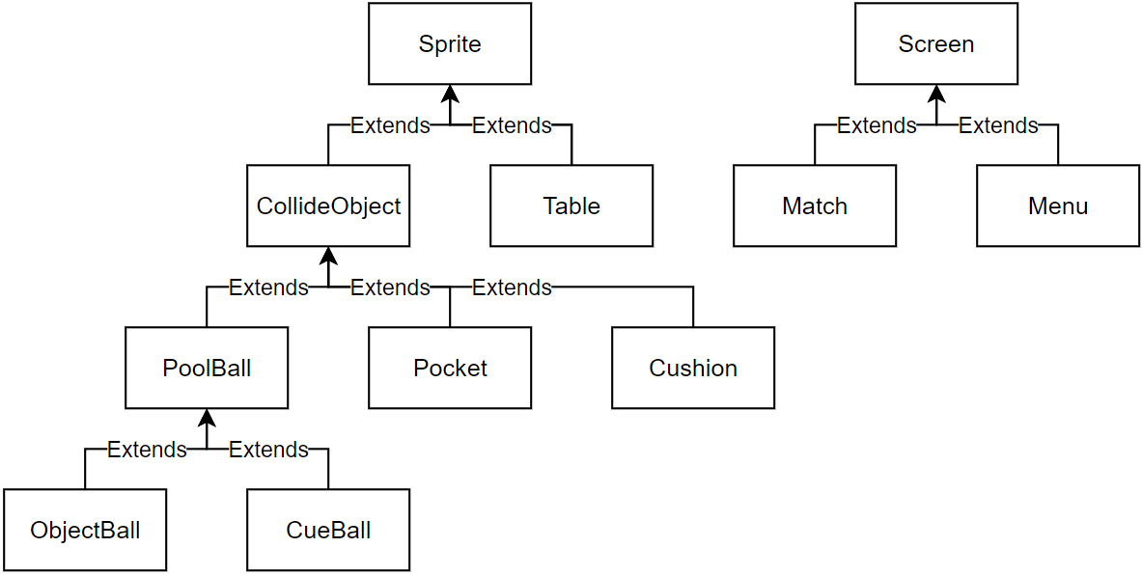
Note that Menu doesn’t have any subclasses because each menu will be an instance of Menu class. Also note that I will be using Subclass : Superclass to indicate when certain classes inherit from a superclass because that is how C# does it.
Each different object and screen are encapsulated within its own class to not only make the code easier for developers to read and understand, but also for them to know where exactly any new objects should fit into all of it. This should make it overall more cohesive and polished with minimal backtracking to understand old code.
Most of the classes are sub-classes of Sprite because Match (the main portion of the game) revolves around PoolBall, Pocket, and Cushion, and Table. The former three come under CollideObject, a subclass of Sprite which handles collisions. Table isn’t a CollideObject because it only handles the logic of the game (Cushions and Pockets stop PoolBalls leaving the screen instead).
Note that I will be using pre-existing code for most of the graphical user interface elements because the focus of this project is pool, not menu design. I will decide on the specific framework I plan on using during development to make sure that it meshes well with what I end up making.
MonoGame uses Update and Draw methods inside of a Game1 class to handle updating and rendering logic. Some of my classes will have their own versions of those methods that can be called within Game1.Update and Game1.Draw. This should make Game1’s file clearer and therefore easier to read and understand. (For example, PoolBall.Update might get called within Game1.Update, rather than PoolBall’s update logic being defined within Game1.Update.)

Screen
Screen
- backgroundColour : Color
+ LoadContent()
+ Update()
+ Draw()
Note: - signifies a private attribute/method, + signifies a public one.
Screen is a superclass for Match and Menu, it will display the background for each screen. Each instance of Screen will have a collection of relevant Sprites (and Sprite’s subclasses) and a collection of widgets (e.g. buttons, sliders), both of which will only be initialised/active when their associated screen is displayed.
Attribute | Explanation | Justification
- backgroundColour : Color | Holds the background colour of the screen. | This lets users easily change background colours within settings if I make a widget that alters backgroundColour.  because many of MonoGame’s Uses MonoGame’s Color type because many of MonoGame’s built-in methods rely on Color objects

Method | Explanation | Justification
+ LoadContent() | The same as MonoGame’s Game1.LoadContent, described later when I look at MonoGame’s code. Called when the Screen is constructed. | This should set up the screen with everything it needs to start updating and drawing.
+ Update() | The same as MonoGame’s Game1.LoadContent, described later when I look at MonoGame’s code. Called when Game1.Update is called to update the currently active things on Screen. | This should separate each Screen’s logic from each other to avoid conflicts and improve readability.
+ Draw() | The same as MonoGame’s Game1.Draw, described later when I look at MonoGame’s code. Called when Game1.Draw is called to draw the currently active things on Screen. | Same reasons as above.

Justification
Screen provides a stable baseline for Match and Menu, handling the things they have in common to prevent those classes from repeating too much code and making them easier to setup.
Using the same methods as Game1 (i.e. LoadContent, Update, and Draw) should also make it easier for other developers to understand my code even if they just have a small amount of prior knowledge on MonoGame. (Note that this usability feature also applies to Sprite and its subclasses).

Match
Match : Screen
- sprites : Sprite[]
- players : String[]
- scores : Dictionary<int,int>
Match is the Screen that displays a match of pool. It holds all of the PoolBalls, Pockets, Cushions, and the Table for each match. It also keeps track of score and turn order, switching to the Match End screen (an instance of Menu) when a match is over. It has no methods (except inherited ones) because most of the logic is handled by its collections of objects and widgets.
Attribute | Explanation | Justification
- sprites : Sprite[] | Holds all the Sprite objects on screen. | It’s an array because the number of sprites shouldn’t change once the Match is initialised. This also lets me iterate through it when I need to call Update or Draw methods.
- players : String[] | Stores an array of player names. Each player’s position in players represents their place in turn order. | This helps me keep turn order consistent. It also means that I can also refer to each player with an index, which could be helpful.
- scores : Dictionary<int,int> | A dictionary (i.e. collection of key-value pairs) assigns the current scores to each player. | Uses int for both parameters because each player has a numerical index (as described above) which should be more general than a name. This allows me to, for example, access player 1’s score by writing scores[0], rather than needing to write scores[“playerName”] (which isn’t possible to do ahead of time for all player names).

Justification
Match is unique in that it is the only Screen that has CollideObjects and doesn’t have any widgets. This means I don’t need to maintain a widgets array, only a sprites one.
Each Menu has a collection of relevant Sprites so that it can always initialise in the same way and save data when, for example, a match is paused and resumed (going from Match to a Menu and back to Match).
Also, Match needs to keep track of different information than Menu, only being saved for the duration of a match instead of the entire time the game is open.

Menu
Menu : Screen
- widgets : Placeholder[]
- settings : Dictionary<string,object>
Menus are all of the Screens that aren’t Match. They will only feature widgets, no CollideObjects. They will also be able to store changed settings (if applicable) to ensure that settings are saved throughout the game.
Attribute | Explanation | Justification
- widgets : Placeholder[] | Holds all the widgets on screen. | It’s an array because the number of sprites shouldn’t change once the Menu is initialised. This also lets me iterate through it when I need to call Update or Draw methods. Note that I can’t clearly define its type yet because I haven’t chosen a UI framework yet.
- settings : Dictionary<string,object> | Holds key value pairs of every setting relevant to the Menu. | Its key is a string so that I can call, for example, settings[“Volume”] to get an exact volume value, improving readability over an index approach (like an array of settings would use). Its value is an object because it could really be anything, depending on the setting (e.g. Color, int, string) so it needs flexibility.

Justification
Since most of the Screens in my game are similar (e.g. just have widgets), having a Menu class prevents the need to setup lots of instances of Screen with repeated code. Instead, widgets will be built-in and therefore easy to add, configure, and position for different instances of Menu.
Each Menu has a collection of relevant Sprites so that it can always initialise in the same way and save data when, for example, a match is paused and resumed (going from Match to a Menu and back to Match).
Having a clear collection of which settings have which values reduces the chance that mix-ups happen if, for example, someone thought setting 8 was volume but it was actually screen brightness. This should help keep the settings screens more user-friendly. This approach also means that new settings can be added if any user feedback post-launch suggests more settings.

Sprite
Sprite
- texture : Texture2D
- position : Vector2
+ LoadContent()
+ Update()
+ Draw()
Sprite is the superclass for most of the objects the players interact with and see during a match. It handles textures and positions. Also, the (0,0) point (or origin point) will be in the middle of for all sprites.
Attribute | Explanation | Justification
- texture : Texture2D | Represents the texture of the sprite, to be rendered by Sprite.Draw. | Texture2Ds seem to be the convention for texture attributes in MonoGame because its built-in methods use them, so I would have to convert to Texture2D anyway if I chose a different type.
- position : Vector2 | Represents the position of the Sprite on screen, with (0,0) being the top left. Vector2s can store two ints which represent the Sprite’s x and y coordinates. | Again, Vector2s seem to be the convention in MonoGame. The Vector2 type also has some useful methods like Vector2.Distance and Vector2.Dot to make some calculations more readable in code (since I would have to calculate those manually if not).  It will also need some validation to ensure that each component is greater than zero (throwing an exception if not), otherwise it could lead to undiscovered bugs or just not run.
Sprite’s methods all have the same reasons as Screen’s, to be called by another class’s LoadContent, Update, and Draw methods. So, there’s no point repeating the table here. (I could create a GameObject class to be the superclass of Sprite and Screen, but they act differently enough to the point where I think that would confuse things.)

Justification
Since all of Sprite’s subclasses have both a position and a texture, Sprite handles that simple aspect for all of them. Rather than each of them needing to implement their own methods, Sprite keeps it all consistent and allows each to be overrode if necessary.
The (0,0) point of all Sprite objects will be the centre because it makes dealing with circles easier. To check if a point is within a circle, you just need to find the difference between their positions and see if it’s less than the radius. Whereas, with something like a top left centre, I would have to add the radius to the position’s coordinates to find the centre (an extra step that would be repeated many times per frame when it could’ve been avoided). While screen coordinates have the origin at the top left, that’s only one object so I don’t think I need to sacrifice this convenience for it.

CollideObject
CollideObject : Sprite
- radius : int
- boundingBox : Rectangle
- length : int
- orientation : int
- Type : ObjectType
+ DetectCollisions()
CollideObject encompasses all circles, rectangles, and lines that can collide with each other (switching between types with an enum ObjectType). ObjectType’s implementation will look something like this:
enum ObjectType
{
Circle,
Rectangle,
Line
}
ObjectType Type { get; set; }
CollideObject will have its own methods for the different combinations of collisions. The reason there are only 1 method (instead of 9, one for each combination) is that I can use a switch case within each method along with ObjectType to identify what types the two CollideObjects are. This means I just need to call DetectCollisions for them all, rather than one of 9 separately named methods.
Lines can be vertical, horizontal, 45 degrees left of the horizontal, or 45 degrees right of the horizontal. This is because if they were at any angle then collisions would be much harder to calculate. Also, these are really the only lines I need.
The three types of CollideObjects will be used in the Match screen in the following ways: Circles will be used for all pool balls and pockets, rectangles will be used for some boundaries, and lines will be used for parts of Cushions around the edges of the table.
Attribute | Explanation | Justification
- radius : int | Radius of Circle ObjectType. Used in one of CollideObject’s constructor overloads to assign the appropriate ObjectType when a radius is given. | It will also need some validation to ensure that it is greater than zero (throwing an exception if not), otherwise it could lead to undiscovered bugs or just not run.
- boundingBox : Rectangle | Bounding box of Rectangle ObjectType. Used in one of CollideObject’s constructor overloads to assign the appropriate ObjectType when a boundingBox is given. | MonoGame’s Rectangle objects could be useful when developing collision detection in the development section later. Simplifying the process compared to treating rectangles as just 4 lines.
- length : int | Length of Line ObjectType. Used in one of CollideObject’s constructor overloads to assign the appropriate ObjectType when a length and orientation is given. | It will also need some validation to ensure that it is greater than zero (throwing an exception if not), otherwise it could lead to undiscovered bugs or just not run.
- orientation : int | Orientation of Line ObjectType. Used in one of CollideObject’s constructor overloads to assign the appropriate ObjectType when a length and orientation is given.  It will specify the orientation of the line (e.g. vertical, horizontal). | It will also need some validation to ensure that it is within the range of orientations (throwing an exception if not), otherwise it could lead to undiscovered bugs or just not run. This range will be 1-4 inclusive (a number for each orientation), so if it’s less than 1 or more than 4 it should throw an error.
- Type : ObjectType | A way of specifying what shape each CollideObject instance is. | This will help differentiate the different CollideObjects apart from each other. Also, I can easily add new object types later if needed.

Method | Explanation | Justification
+ DetectCollisions() | The general method to detect when two CollideObjects are colliding. | As justified above, having one method keeps things simple when having to call methods. DetectCollisions doesn’t respond to collisions (e.g. change velocity) because each pair of object collisions is different and will be dealt with within their classes.

Justification
ObjectType is used rather than splitting the types into subclasses so that the collision method only have to be written in one class. This prevents, for example, the need for both rectangle-circle and circle-rectangle collision to exist (despite doing the same thing), since both have the same logic and can be handled with one method.
Each collision method will only change attributes of the instance of CollideObject that it is in to prevent attributes being changed twice when two objects collide. (e.g. for a PoolBall-PoolBall collision, each PoolBall with alter their own velocity, not each other’s as well.)
Only those specific line types are needed since that is what the cushions are made up of. Adding a general line, θ degrees from the horizontal, would be more complicated and ultimately unneeded.
I’m using a variable for the Type of object so that objects can be compared efficiently without needing separate classes. If they were in separate classes, some code may be redundant (i.e. a circle-rectangle collision in the circle class and a rectangle-circle collision in the rectangle class would both do the same thing but still must be repeated).

Pocket
Pocket : CollideObject
+ PotPoolBall()
Pockets are circle-type CollideObjects that initialise at the start of a match and are unmovable. They will remove any PoolBalls that come into contact with them. This will then be detected by Match, which will update scores and replace pool balls as needed.
Method | Explanation | Justification
+ PotPoolBall() | This will remove a PoolBall from Match’s array of Sprites when Pocket.DoCollision detects the one colliding with a Pocket. | Ensures that potted PoolBalls aren’t updated or drawn, preventing any more interactions they could have with non-potted PoolBalls.

Justification
Pockets are a core part of pool, with a unique function compared to other objects (i.e. potting PoolBalls). As such, they need their own logic and therefore their own class.
They remove any PoolBalls that hit them so that Match (which holds a list off all pool balls) can know and update the scores. It also removes the need to simulate the now-irrelevant PoolBalls.

Cushion
Cushion : CollideObject
- length : int
- width : int
- isHorizontal : bool
Cushions are a collection of Rectangle CollideObjects that initialise at the start of a match and are unmovable. They keep all the PoolBalls in bounds like they would in analogue pool.
Attribute | Explanation | Justification
- length : int | The length of the longer sides of the Cushion. | Rectangles need both a length and a width to be defined.
- width : int | The length of the shorter sides of the Cushion. | Rectangles need both a length and a width to be defined.
- isHorizontal : bool | Specifies whether length is referring to the vertical or horizontal side (and same for width). (i.e. whether it looks like ‘|’ or ‘–’). | All of the top and bottom cushions on an analogue pool table have the same dimensions and both of the end cushions have the same dimensions, so there can be two generalised  Cushion types (i.e. isHorizontal = true and isHorizontal = false). This will make it clearer to set up the table at the start of a match because I know for sure which type I need with a bool, rather than having to re-define dimensions each time.

Justification
Having Cushion as its own class (instead of just different instances of Rectangle CollideObjects) makes it simpler to set up the table each time. I can just write a Cushion constructor with pre-defined lengths and widths to fit on the table, rather than using a load of specific parameters for Rectangle CollideObject constructors.

PoolBall
Cushion : CollideObject
- velocity : Vector2
- acceleration : Vector2
+ ChangePosition()
+ ChangeVelocity()
+ DoFriction()
PoolBall will encompass both ObjectBall and CueBall. It’s a Circle CollideObject that initialises at the start of a match and moves around in response to players’ actions.
Attribute | Explanation | Justification
- velocity : Vector2 | Describes the current velocity of PoolBall in the form of a 2D vector. | Since position is also a Vector2, this consistency should make some of the maths derivations likely needed later a bit easier.  Also, without this, position would have no way of organically changing (having to be changed manually instead).
- acceleration : Vector2 | Describes the current acceleration of PoolBall in the form of a 2D vector. | Same as above.  Also, without this, velocity would have no way of organically changing (having to be changed manually instead).

Method | Explanation | Justification
+ ChangePosition() | Adds velocity to position to move the PoolBall. | This will be called every frame because, if velocity isn’t zero, position should always be changing.
+ ChangeVelocity() | Adds acceleration to velocity to alter the PoolBall’s speed. | This will be called every frame because, if acceleration isn’t zero, velocity should always be changing.
+ DoFriction() | Decreases acceleration (likely causing it to act in the opposite direction to motion). | This ensures that PoolBalls will eventually stop. Since collisions don’t slow them down in my game, this is the only way they can stop.  This also brings my game closer to an accurate simulation, which should make it more intuitive for players.

Justification
Since cue balls and object balls are so similar (despite serving different purposes), PoolBall covers their similarities. This reduces repeated code, reducing the chance for mistakes causing inconsistencies when copying the definitions of things like velocity and potential bug-causing differences.

ObjectBall
ObjectBall : PoolBall
- type : ballType
ObjectBalls are PoolBalls that cannot be directly controlled by players. They function almost the same as PoolBalls, but they are also assigned a type. The type variable uses an enum I will define called ballType
Attribute | Explanation | Justification
- type : ballType | This can be Solid, Striped, or Eight. This will be assigned by using a switch case in the constructor depending on the parameter passed in. | This separates the three object ball types, allowing other methods the chance to check what type a given ObjectBall is when necessary (e.g. if a potted ObjectBall’s type == Eight, then the current match will end).

Justification
Each ObjectBall is assigned a type so that players can tell them apart and scores can be kept track of by counting the number of potted ObjectBalls. An enum is used instead of subclasses because it would only one change.

CueBall
CueBall : PoolBall
+ Shoot()
+ DebugMove()
CueBall’s only difference from PoolBall is that it can be directly interacted with by players. I explained the specifics of its Shoot method when I was decomposing Match earlier on.
Method | Explanation | Justification
+ Shoot() | This changes the CueBall’s velocity according to the position of the mouse when the shoot key is pressed. Its magnitude will increase the further the mouse position is from the CueBall. | There needs to be a way for players to move the CueBall since that’s one of the core aspects of pool. I chose this method in particular because, of those I thought of, it felt the most natural. This should make it more intuitive for new players.
+ DebugMove() | This sets the CueBall’s position to the mouse position. It should be toggleable in settings. | This should help a lot with development and testing because I can teleport the CueBall to any position it needs to be in.  It shouldn’t always be enabled in the final version of the game because it makes it very easy to cheat, ruining the integrity of the game for those involved.

Justification
CueBall is unique enough both in its utility for testing and its function within the game (including its methods) that it wouldn’t make sense to just make it an instance of PoolBall (especially considering ObjectBall got its own class).

Notes
While decomposing and describing these classes, I realised that there were two that I didn’t need to define. Each has their own reasons and their replacement.

Table
With Screen subclasses (specifically Match), I realised that it fully encompassed what Table set out to do (i.e. oversee the current match, keep track of relevant information, and update and draw objects when needed). So, its only real purpose would be to render the pool table texture.
But the texture of the table could just as easily be either a background colour (since the rest of the table’s appearance is already handled by other objects) or an instance of Sprite. It doesn’t really matter which but making an entire subclass for just that is pointless.

Widgets
I realised that the entire point of using someone else’s UI framework is to provide an alternative to making my own Widget class. However, I still need to keep track of my requirements for such a framework to not use one that I would still need to do work on. The framework will need some sort of Widget class so that I can utilise polymorphism to iterate through an array of its various subclasses (e.g. button, slider). Since the vast majority of Widget’s details will be covered by that framework, I can’t really specify them here because I haven’t decided on a framework yet. Also, I require that it at least has the capability for buttons, sliders, and dropdowns that players can interact with. Players should be able to interact with them with their mouse, keyboard, or controller.

Describe the approach to testing

During development
To test each component of my solution during development, I will ensure that every subroutine and notable block of code passes a series of tests after it is implemented. If it fails any of these, it will be updated to make sure that it passes all of the tests. Note that each individual test will be repeated with the same parameters to ensure the first time wasn’t a fluke and increase the overall validity of all tests. The testing process will include:
- Simple tests – these just aim to make sure that the code works as intended for basic cases. When constructing a PoolBall, for example, the parameters will be simple (similar to what the actual values might be). The starting position could be in the middle of the screen and the radius could be 40 pixels. This ensures that it works for its intended purpose in the average case.
- Edge-case tests – these aim to catch any oddities that would otherwise slip through. With the PoolBall example, I might set the radius to zero or -40. I then might set the starting position to a vector with negative components (testing each approach separately to ensure that one doesn’t cover for the other). This ensures that, if I add new features that my simple tests didn’t account for, they are less likely to cause issues with existing code.
- User tests – in these tests my goal is to act like a user, playing the game how they might. For example, when I have a functioning full match environment, I might play through a game of pool. I would pot all of the balls of one colour and then pot the eight ball. This will not only test a few features simultaneously (in this scenario this includes all types of collisions, cue ball respawning, friction, etc.), but also give me an indication on a user’s experience with the game.
- Stress tests – in these tests, my aim is to go way bigger than any parameters should go. In the above example, I might test out a match with 100 object balls. During these tests, I will monitor my memory usage and frame rate to make sure they don’t stray away from my requirements. This safety factor of one half will ensure that my game will be easily runnable on its target computers. These tests will give me a rough idea of how unoptimized my code is and if I need to optimise it further to avoid issues.
I will also be using input validation (some of which I mentioned before) to make it easier for some bugs to be instantly isolated and found by them throwing an error straight away, rather than hiding and causing minor things in the background.

During evaluation
When I move on to evaluating my program, I will be testing different aspects of it. If I just re-tested the same things there would be no point because it would’ve already passed those tests. Instead, I will test broader things that I couldn’t’ve tested during development, like mimicking a new player’s interaction with all elements of the game (navigating menus, playing a match, etc.). If a test is failed, I will make a plan which should outline how I will attempt to fix the feature/s involved to pass the test. I will:
- run through a gameplay loop a few times and record the maximum memory my game takes up for the duration. This should give me a good idea of if it meets the hardware requirements.
- instruct someone who hasn’t seen my game before to adjust a certain setting to see if they can manage it. This should let me know if my menu system is intuitive or not.
- give a survey to members of my stakeholder groups for them to fill out with relevant questions about their experience with my game. This should provide me with accurate feedback on the game’s features and give me suggestions for any tweaks or new features I could add to improve it for them.
- let some testers play with keyboard and mouse for a bit, before switching to controller to see if there’s any notable difference in usability and general ability to navigate and play the game comfortably.
These should give me a broad overview to see if my game has met its success criteria or not, while also soliciting player feedback to help me improve my game to meet any unmet criteria and add more useful features.
Here’s a prototype of the survey (it may be modified to fit the actual features my game has). Each question should give me some insight on if a certain feature I outlined in analysis is met or not. I used multiple choice answers for rating-based questions so that I could find the average rating of each part rather than having to make judgements on what exactly “good” and “great” mean compared to “bad”.

Survey prototype
On a scale of 1-5, 1 being “strongly disagree” and 5 being "strongly agree”, how much do you agree with the following statements:
- I enjoyed [placeholder feature, will be finalised in the evaluation stage when I know if any extra features were added or not; possible multiple questions like this]
- The physics of the game was like you expect it to be in real life pool. (If you haven’t played real life pool, just rate the physics according to how you think they should be.)
- The wait between turns in local multiplayer wasn’t too long.
- If you played with a keyboard and mouse, it was intuitive and simple. (Skip this question if you didn’t.)
- If you played with a controller, it was intuitive and simple. (Skip this question if you didn’t.)
- The assist mode provided helpful guidance when you were aiming and shooting.
- Navigating the game’s menus was easy.
- Remapping controls was easy.
- The graphics of the game were clear, simplistic, and easy to interpret.
- There were multiple different ways for you to receive all important information on screen (e.g. which pool balls were yours and which were your opponents).
- The game is suitable for all ages in terms of how much inappropriate imagery or wording there was.
- I enjoyed the game.
Did you experience any bugs/issues while playing? If so, describe them.
What was the worst feature of the game? Why?
What was the best feature of the game? Why?
What feature/s would you recommend adding or changing in the game?

Developing the solution

MonoGame
By default, MonoGame sets up a Game1.cs file, defining a Game1 class (which itself is a subclass of Game, a class that handles some behind-the-scenes logic) where most of the boilerplate logic of the game should be. A Program.cs file is also there to create an instance of Game1 and run it. The game loop is separated into different methods of Game1: Game1 (the constructor), Initialize, LoadContent, Update, and Draw.

Gameplay loop
When the program is run, an instance of Game and an instance of Game1 are created and Run is called on the instance of Game1 which calls Initialize. Initialize handles some of the initialisation logic and calls LoadContent. Then Update is called once and the game loop starts.
The loop starts by Update being called which handles most of the logic for objects in-game such as updating variables, calculating hitboxes, etc. After that Draw is called which renders any sprites. Then the loop repeats.

Update and Draw
(Since both of these methods are for various different objects, I will try to refer to each with [object].method to clear up potential confusion.)
Some rendered Sprites need their own Sprite.Update method so that Game1.Update can call them each game loop so that all objects are successfully updated. Sprite.Update in turn houses the update logic for its Sprite for ease of use. A Game1.Update method might look something like this:
public override void Update(GameTime gameTime)
{
Base.Update(gameTime); // calling Game’s Update method

int exampleNumber = 1;
int exampleWord = “Hello, world”;

ExampleMethod1(exampleNumber);
ExampleMethod2(exampleWord);
}
All rendered Sprites also need their own Sprite.Draw method so that Game1.Draw can call them when rendering a SpriteBatch (a collection of sprites to be rendered). Sprite.Draw takes a SpriteBatch as a parameter and, in turn, that SpriteBatch has a SpriteBatch.Draw method that takes in various parameters (e.g. texture, position, origin, scale) and renders the sprite. A Game1.Draw method might look something like this:
public override void Draw(GameTime gameTime)
{
Base.Draw(gameTime); // calling Game’s Draw method

_spriteBatch.Begin();

exampleSprite1.Draw(_spriteBatch);
exampleSprite2.Draw(_spriteBatch);
exampleSprite3.Draw(_spriteBatch);

_spriteBatch.End();
}

Iterative development process/testing
I’ve split the development into 5 iterations, implemented via code. The specifics of each iteration will try to stick to its initial purpose, but might stray when necessary. That is to be expected, because some things I didn’t account for may happen or I may have new ideas mid-way through coding. With that being said, the iterations are split as follows:
- Setting up – This iteration encompasses creating both an environment and a pool ball which moves around in that environment with reasonably accurate physics. The pool ball should be able to be shot by the player (who can input a direction and a magnitude of the initial velocity), move around the screen, bounce off the edges of the table, and slow down due to friction. This iteration will provide a lot of the groundwork on which the later iterations are built on, making it important for it to be both as simple and as developed as possible.
- Completing the environment – This iteration primarily focuses on adding the rest of analogue pool’s parts to fill out the match environment. Each part will be developed independently of the others to hopefully reduce potential conflicts (which could occur if they were created simultaneously) and to ensure that the game is fully functioning after each new addition. At the end of this iteration, I will review all of the code and update/change anything that I think needs updating/changing and didn’t spot while developing it.
Note that this iteration won’t produce a fully-functioning game of pool, only the environment, objects, and object interactions of it. (Technically the game at this stage can be used to play pool, but it would be more like analogue pool in that no rules are enforced by the code.)
- Adding menus and a GUI – This iteration will fill out the menu system as described in the Design stage, allowing for easy access to settings and other menus.
- Developing the gameplay loop – This iteration will build upon the second iteration to add capability for multiple players, turns, and win conditions to make the game fully playable. Before this iteration, the game will be technically playable because it’s a simulation of a pool table. But this iteration will add structure and make sure that players can’t cheat.
- Finalising – The size of this iteration will entirely depend on how many features I’ve already added in the previous three iterations and how complete the game is. The aim for this iteration is to ensure that the game fully resembles the solution described throughout the Design section, adhering to all of the requirements laid out there. It will also potentially include things I didn’t think of during that stage that would bring it closer to solving my initial problem or emulating analogue pool.

1st iteration – setting up

Familiarising myself with MonoGame
When you make a new project with MonoGame, it has some boilerplate code inside of two files: Game1.cs and Program.cs. Game1.cs contains the methods I described earlier. They are pretty much empty, so I can fill in with whatever I need.
using Microsoft.Xna.Framework;
using Microsoft.Xna.Framework.Graphics;
using Microsoft.Xna.Framework.Input;
using System;
namespace PoolGame
{
public class Game1 : Game
{
private GraphicsDeviceManager _graphics;
private SpriteBatch _spriteBatch;
public Game1()
{
_graphics = new GraphicsDeviceManager(this);
Content.RootDirectory = "Content";
}
protected override void Initialize()
{
// TODO: Add your initialization logic here

base.Initialize();
}

protected override void LoadContent()
{
// Create a new SpriteBatch, which can be used to draw textures.
_spriteBatch = new SpriteBatch(GraphicsDevice);

// TODO: use this.Content to load your game content here
}

protected override void Update(GameTime gameTime)
{
if (GamePad.GetState(PlayerIndex.One).Buttons.Back == ButtonState.Pressed || Keyboard.GetState().IsKeyDown(Keys.Escape))
Exit();

// TODO: Add your update logic here

base.Update(gameTime);
}

protected override void Draw(GameTime gameTime)
{
_graphics.GraphicsDevice.Clear(Color.CornflowerBlue);

// TODO: Add your drawing code here

base.Draw(gameTime);
}
}
}
Program.cs essentially creates an instance of Game and runs it.
using var game = new PoolGame.Game1();
game.Run();
I was new to C# as a whole, so this code didn’t make much sense to me. Aiming to understand it more, I tried to separate out the first line into two. This ran the program the exact same way as the original version, but now it was more readable for me.
using PoolGame;

Game1 game = new Game1();
game.Run();
Running the program at this stage gives a blank window in cornflower blue (the default background colour). I changed it to just white after to make basic objects a bit more visible for development.
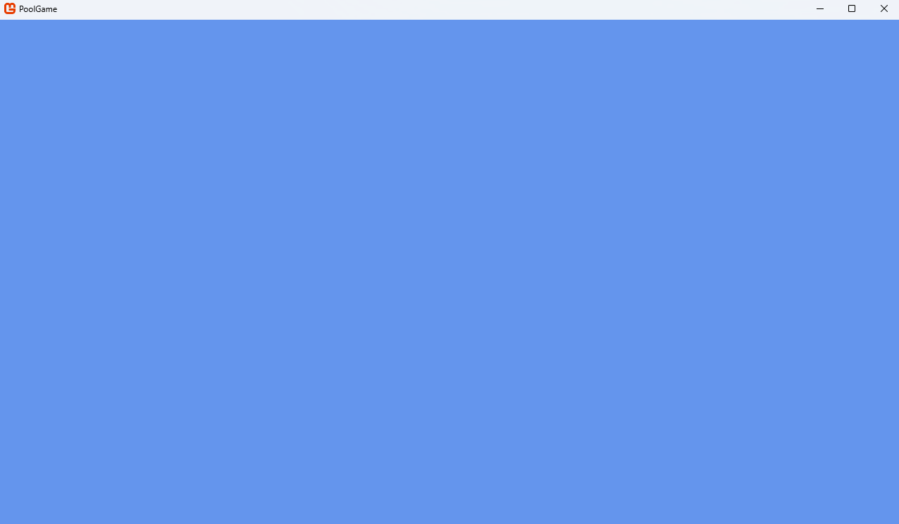
To begin, I need to setup a basic environment to place the objects I plan on adding later on in. I started by implementing a simple pool table rim to get the hang of the framework. I made it a 2x1 rectangle despite my screen’s 16x9 aspect ratio so that I could more easily judge if any proportions would break if the screen resolution was irregular (since 2x1 is more recognisable than 16x9).
I experimented with using a scale so that the image could be enlarged/reduced to fit the window, but eventually got rid of it because enlarging PNG files proved to be awkward (even with the scale parameter in Sprite.Draw). This was mainly because when a low-resolution sprite is scaled up, its individual pixels become more noticeable. Also, if multiple different sprites are scaled up different amounts, the size difference of individual pixels can be jarring.
Using MonoGame’s built in MGCB Editor, I could easily add PNG files to my game to convert them into Texture objects for use in any Draw method. The editor makes sure a copy of the actual file is saved within the program. If it was just a local file path instead, if I ran the program on another device the file wouldn’t be available. This would cause an error because the code would be trying to access something that doesn’t exist, so it’s much simpler just to store an asset in the program.
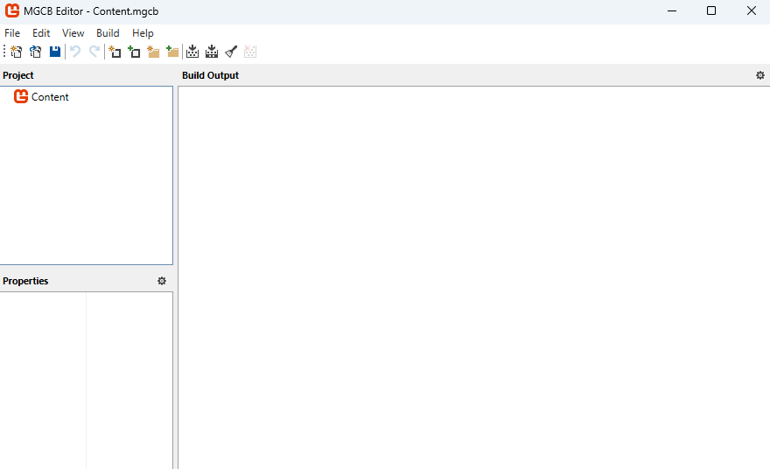
I initialised a texture with tableRimTexture = Content.Load<Texture2D>("2-1 rectangle (transparent)"); with a 2x1 rectangle image I’d made to represent the rim and rendered it in the window.
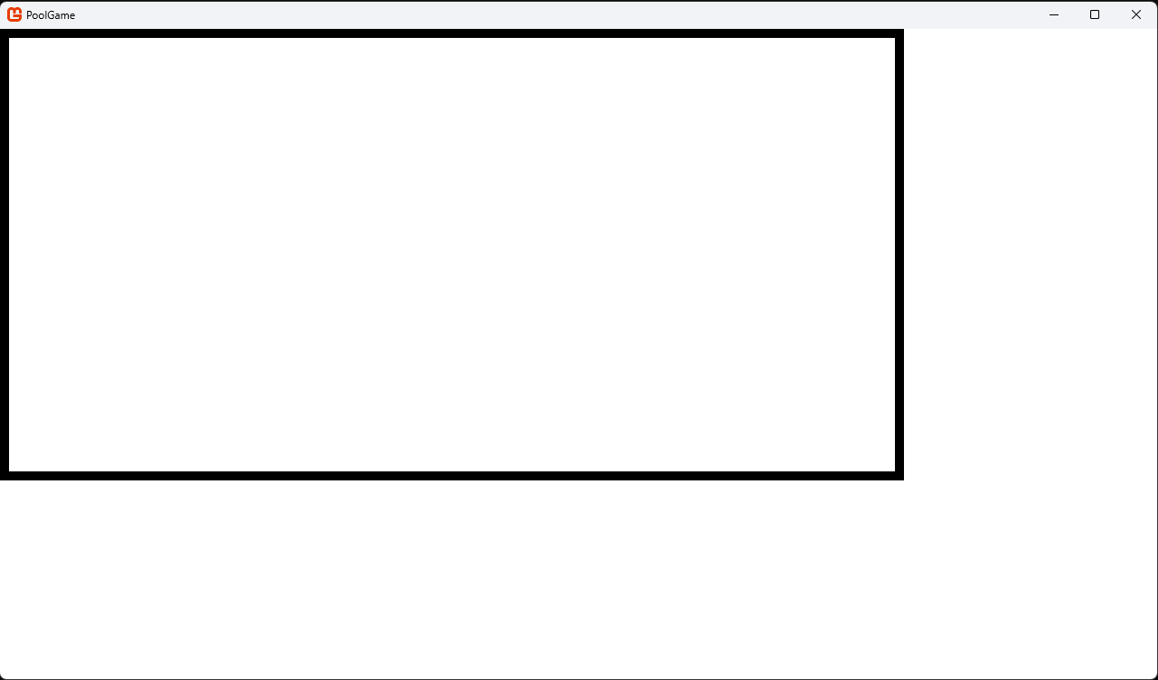However, I decided to scrap the visual rectangle. Instead, I chose to treat the edges of the screen as the edges of the table. This works well enough because the aspect ratio of pool tables in real life varies enough that 16x9 isn’t unusual for one. The lack of a texture for the edge shouldn’t be an issue for now, since the functioning cushions and pockets will be developed later and function as visual playing-surface-edge markers. Note that I can’t add any edge collisions yet because there is nothing for them to collide with.
Also at this stage, I realised I needed to make sure my files were organised well so that files could be added and found easier. I started by creating a folder titled ‘Classes’ that would house the .cs files containing individual classes in them. Each class is in its own file so they can be viewed and edited easier (otherwise, I’d potentially have to scroll down hundreds of lines of code just to access the class I want). The subclasses of a class would then be stored in a folder titled ‘[ClassName] Inheritors’ so that I would essentially have a class diagram in my solution’s file directory. For example, one branch of the folder tree might look like this:
PoolGame/
└── Classes/
├── Sprite.cs
└── Sprite Inheritors/
├── CollideObject.cs
└── CollideObject Inheritors/
└── PoolBall.cs

Sprite, CollideObject, and PoolBall
Following my class diagram from the Design phase, I made a basic Sprite class in Sprite.cs that stored a sprite’s texture as a Texture2D and position as a Vector2 (with position representing the coordinates of the centre of the object).
namespace PoolGame.Classes
{
public class Sprite
{
public Texture2D texture { get; set; }
public Vector2 position { get; set; } // a sprite's position is at its centre unless otherwise specified

public Sprite(Texture2D _texture, Vector2 _initialPosition)
{
texture = _texture;
position = _initialPosition;
}
}
}
Apart from a constructor and some parameters, it only needed a Draw method (plus an empty Update method):
public virtual void Draw(SpriteBatch spriteBatch)
{
spriteBatch.Draw(
texture,
position,
null,
Color.White,
0f,
new Vector2(texture.Width / 2, texture.Height / 2),
Vector2.One,
SpriteEffects.None,
0f
);
}
Most of the parameters in the spriteBatch.Draw method are their default (apart from ‘texture’, ‘position’, and ‘new Vector2(…)’). But to specify where the centre of the Sprite is, this particular override of the Draw method was needed. (In this case, the centre is represented by new Vector2(texture.Width / 2, texture.Height / 2)).
The textures for the Sprites could then be loaded with MonoGame’s Content.Load<Texture2D>() method. Here’s an example of what a cue ball might look like using a basic circle PNG as the texture for a Sprite object:
Texture2D poolBallTexture = Content.Load<Texture2D>("circle 99x99");
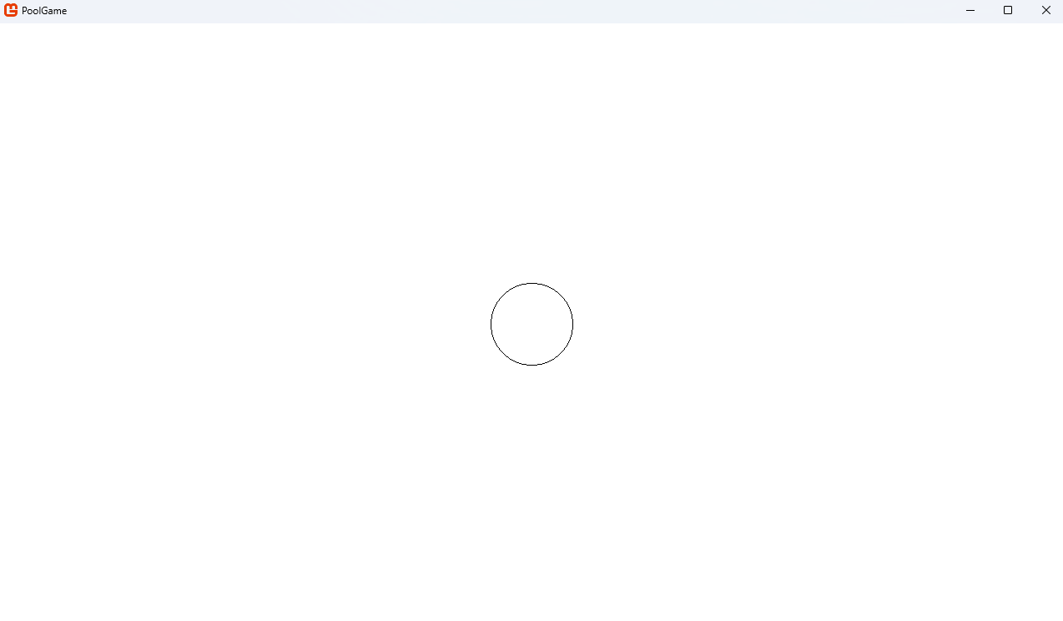
I then made a CollideObject class.
internal class CollideObject : Sprite
{
public float radius { get; set; }
public Rectangle boundingBox { get; set; }
public enum ObjectType
{
Rectangle,
Circle,
}
public ObjectType Type { get; set; }

// constructor for rectangles:
public CollideObject(Texture2D _texture, Vector2 initialPosition, Rectangle _boundingBox)
{
texture = _texture;
position = initialPosition;
boundingBox = _boundingBox;
Type = ObjectType.Rectangle;
}

// constructor for circles:
public CollideObject(Texture2D _texture, Vector2 initialPosition, float _radius)
{
texture = _texture;
position = initialPosition;
radius = _radius;
Type = ObjectType.Circle;
}

public override void Update(GameTime gameTime)
{
base.Update(gameTime);
}
}
It featured an enum called ObjectType (either being Rectangle or Circle) which would let collision detectors know which type it was when calculating collisions. There were two constructors, using a parameter of type Rect (the rectangle bounding box) or int (the circle radius) to determine which of the two the CollideObject was. Then I used Type = ObjectType.Rectangle or Type = ObjectType.Circle to set the attribute during construction. However, I realised that there weren’t any rectangles that could be collided with in my game (since the cushions were better modelled as individual trapeziums), so I removed the ObjectType altogether.
I left the Update method empty for now because there were no specific collisions to be coded yet. Creating the CollideObject class was still necessary so that PoolBall could inherit it later without me having to define a class after its own subclass (which could get unnecessarily messy).
Here’s the bones of the PoolBall class:
public class PoolBall : CollideObject
{
public PoolBall(Texture2D texture, Vector2 initialPosition, float radius) : base(texture, initialPosition, radius)
{
position = initialPosition;
radius = Match.poolBallRadius;
}

public override void Update(GameTime gameTime)
{
base.Update(gameTime);
}
}
I defined velocity and acceleration attributes as Vector2s. All PoolBalls have been abstracted to have a mass of 1. This is because their masses are all the same in analogue pool and having a mass of 1 makes velocity equal to momentum and acceleration equal to force, reducing the number of attributes each PoolBall needs and simplifying calculations and derivations. However, I then realised that the only force acting on a PoolBall in my game would be friction (ignoring air resistance, which has been abstracted because it is so minor). This is because velocity is only changed when its shot, a collision occurs (in which cases velocity is changed instantly in my game, so acceleration isn’t needed there) or by the friction between it and the table. So, I re-named acceleration to decelerationDueToFriction to plainly layout what it is.
After defining velocity and decelerationDueToFriction (the latter of which isn’t needed yet), I created a simple ChangePosition method to be called inside of PoolBall.Update (which, as mentioned in my MonoGame introduction, is called by Game1.Update each frame).
public void ChangePosition()
{
position += velocity;
}
I also defined a DoBoundsCollision method to be called inside of PoolBall.Update. It reflects a PoolBall’s component of velocity that is perpendicular to the edge of the screen it hits to keep it in bounds and make sure its reflection looks like a regular pool ball’s should. At the same time, I changed the PoolBall’s position appropriately to place it back inside the bounds of the screen. This prevents repeated velocity changes (since velocity is changed every frame the PoolBall is out of bounds) and prevents PoolBalls from escaping if one manages to get fully outside of the frame (which would be possible if velocity was large enough for the PoolBall to never need to touch the exact edge of the screen).
public void DoBoundsCollision()
{
// with top:
if (position.Y - radius < 0)
{
position = new Vector2(position.X, radius); // keeping in bounds if it clips out
velocity = new Vector2(velocity.X, -velocity.Y); // reversing part of it to give the effect of an elastic collision
}

// with bottom:
if (position.Y + radius > Game1.windowHeight)
{
position = position = new Vector2(position.X, Game1.windowHeight - radius); // keeping in bounds if it clips out
velocity = new Vector2(velocity.X, -velocity.Y); // reversing part of it to give the effect of an elastic collision
}

// with left:
if (position.X - radius < 0)
{
position = new Vector2(radius, position.Y); // keeping in bounds if it clips out
velocity = new Vector2(-velocity.X, velocity.Y); // reversing part of it to give the effect of an elastic collision
}

// with right:
if (position.X + radius > Game1.windowWidth)
{
position = new Vector2(Game1.windowWidth - radius, position.Y); // keeping in bounds if it clips out
velocity = new Vector2(-velocity.X, velocity.Y); // reversing part of it to give the effect of an elastic collision
}
}

Tests
ChangePosition()
To test ChangePosition, I created an instance of PoolBall in the centre of the screen called testBall and set its velocity to new Vector2(0, 10) by using C#’s Console.ReadLine to set the values while the program was running. After the input, it started moving directly East as expected. In a new launch of the program, I set it to new Vector2(-10, -10) and it moved directly Northwest. Trying other various Vector2 values worked as expected as well. Also, it never slowed down because decelerationDueToFriction is still zero.
Initial position | After movement
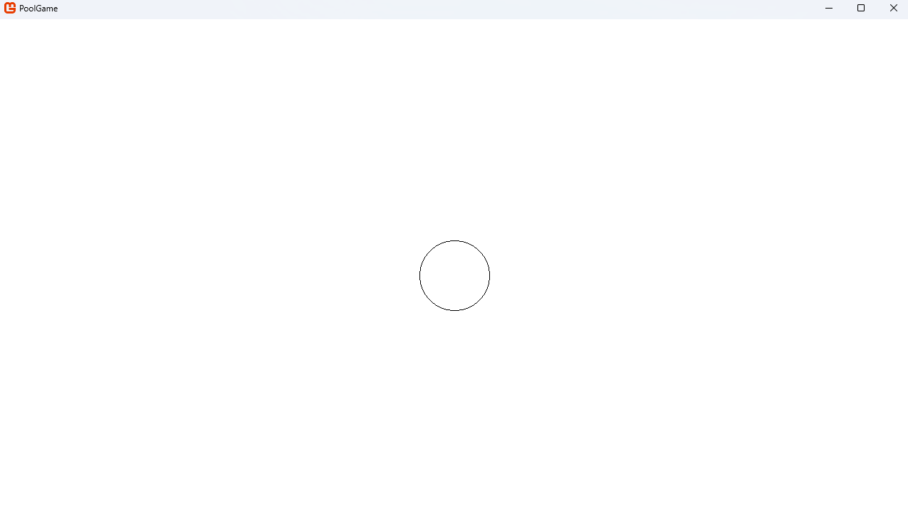 | 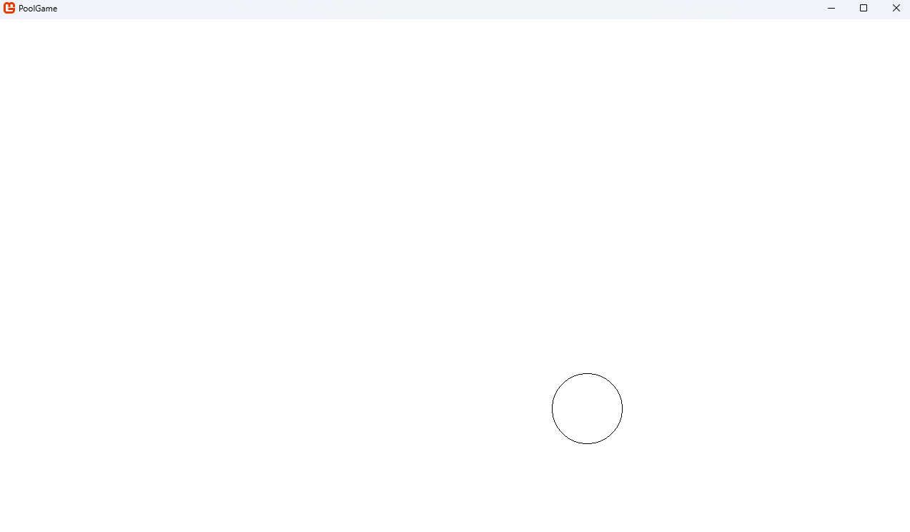
Overall, this shows that the function is working as expected. In response, no actions need to be taken.
DoBoundsCollision()
To test DoBoundsCollision, I added Console.WriteLine(testBall.Velocity) to Game1.Update so that it’s velocity would be outputted each frame. Changing the initial value of velocity to 10,10 caused it to bounce off the bottom of the screen when it reached it. Further, the output of its velocity changed from 10, 10 to 10, -10 as expected. I repeated this for the other three edges using various velocities and got similar results.
Position before collision
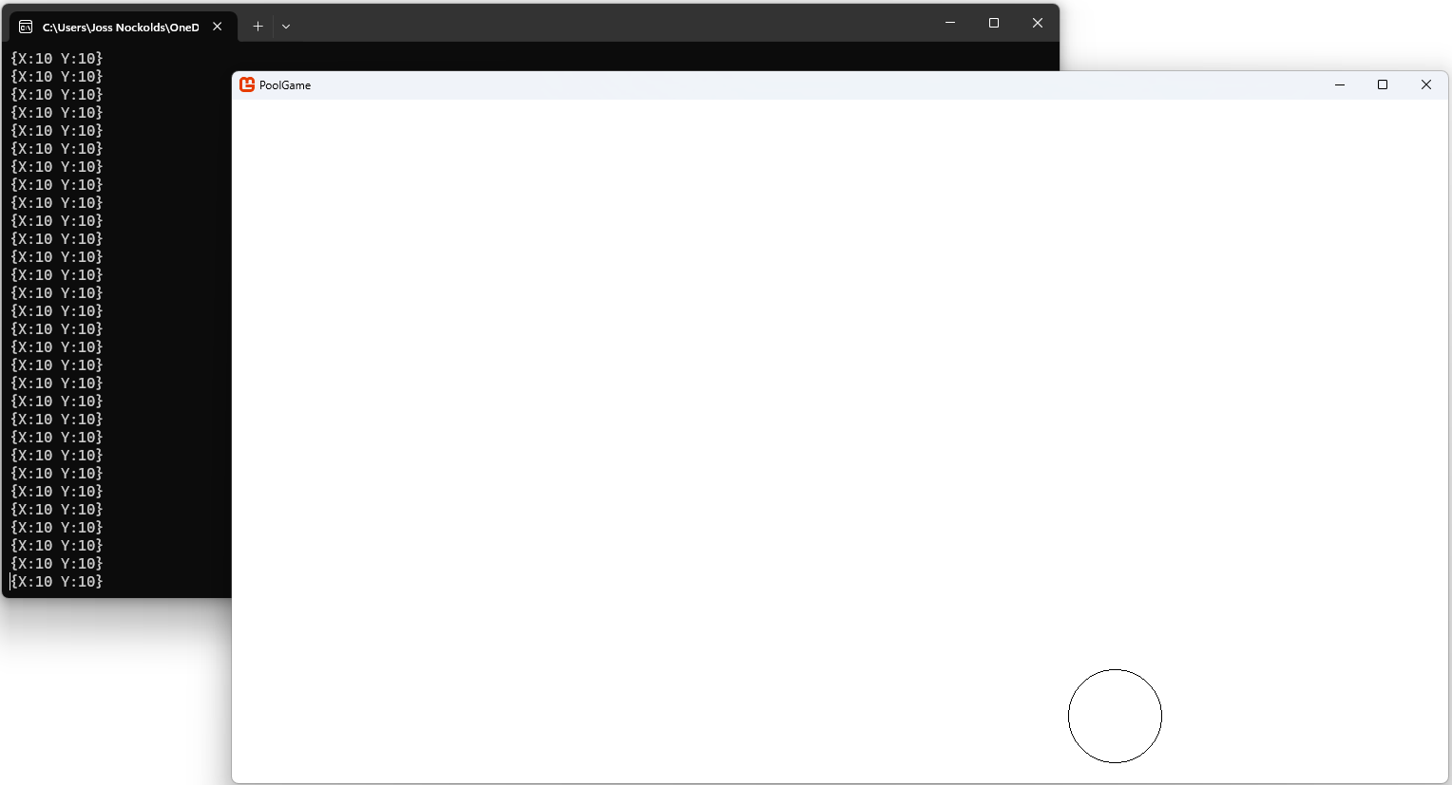

Position after collision
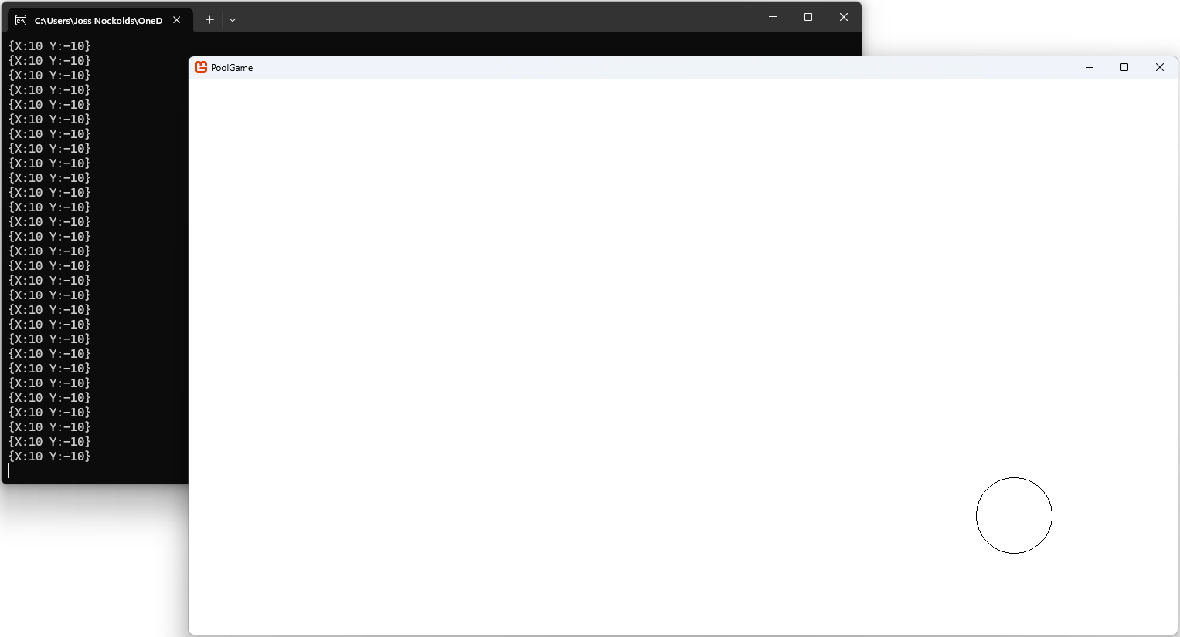
Overall, this shows that the function is working as expected. In response, no actions need to be taken.

CueBall
The CueBall class inherits from PoolBall.
public class CueBall : PoolBall
{
public CueBall(Texture2D texture, float _radius, Vector2 _position) : base(texture, radius)
{
radius = _radius;
position = _position;
}

public override void Update(GameTime gameTime)
{
base.Update(gameTime);
}

}

But CueBall also has a Shoot method. This takes in a mouse position (given by new Vector2(Mouse.GetState().X, Mouse.GetState().Y)). It then finds the relative position vector between the centre of the CueBall and the mouse position to give a direction and magnitude of initial velocity when shooting. This means that the CueBall will always move in the direction you click (provided it’s stationary beforehand), making aiming intuitive. It also means that the further you click away from it, the faster it moves.
public void Shoot(Vector2 mousePosition)
{
Vector2 movementVector = mousePosition - position;
velocity = movementVector;
}
However, since this approach causes the CueBall to move the distance between the click every frame, it moves way too fast. To fix this, I added a constant float VelocityMultiplier. After some experimentation, I set it equal to 1/25. That value seems to move the CueBall at a reasonable speed when the mouse is still within the window. movementVector is then multiplied by this before velocity is changed. (Note that it is still possible to achieve unrealistic velocities by clicking to shoot whilst the mouse is far away from the window with either a large monitor or second monitor. But people actually playing the game likely won’t encounter this issue since they should be playing in their monitor’s native resolution.)
public void Shoot(Vector2 mousePosition)
{
Vector2 movementVector = mousePosition – position;
velocity = movementVector * VelocityMultiplier;
}
Note that is should only be able to be triggered when the CueBall is stationary (as per the rules of pool). To do this, I added a requirement to the if statement in CueBall.Update to only shoot when the CueBall’s velocity is 0.
if ((currentMouseState.LeftButton == ButtonState.Pressed) & (velocity == Vector2.Zero))
{
Shoot(currentMousePosition);
}

I also added a DebugMove method that just sets the position of the CueBall to the mouse position (and velocity to 0 to stop it moving).
public void DebugMove(Vector2 _position)
{
velocity = Vector2.Zero;
position = _position;
}
In Game1.Update, it is triggered with the right mouse button and teleports the CueBall to the mouse position.
if (Mouse.GetState().RightButton == ButtonState.Pressed)
{
DebugMove(currentMousePosition);
}

Tests
Shoot(Vector2 mousePosition)
To test Shoot, I just needed to aim in a direction and press my left mouse button. I aimed towards the bottom left corner of the screen. Just under under 1 second (timed manually) after shooting, the CueBall was in the position shown below.
Before pressing LMB | After pressing LMB (note that WIN+SHIFT+S doesn’t show the mouse when screenshotting)
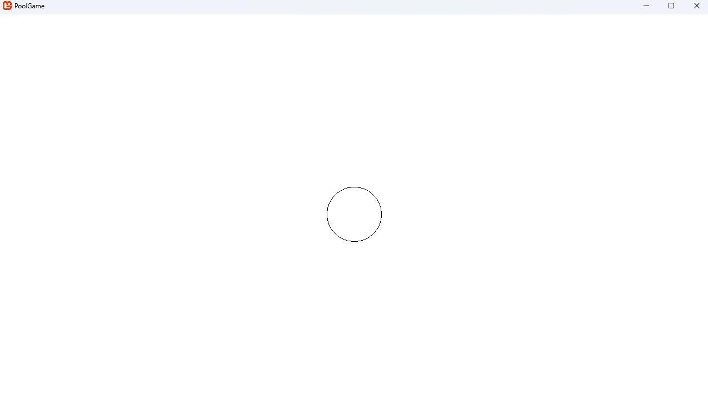 | 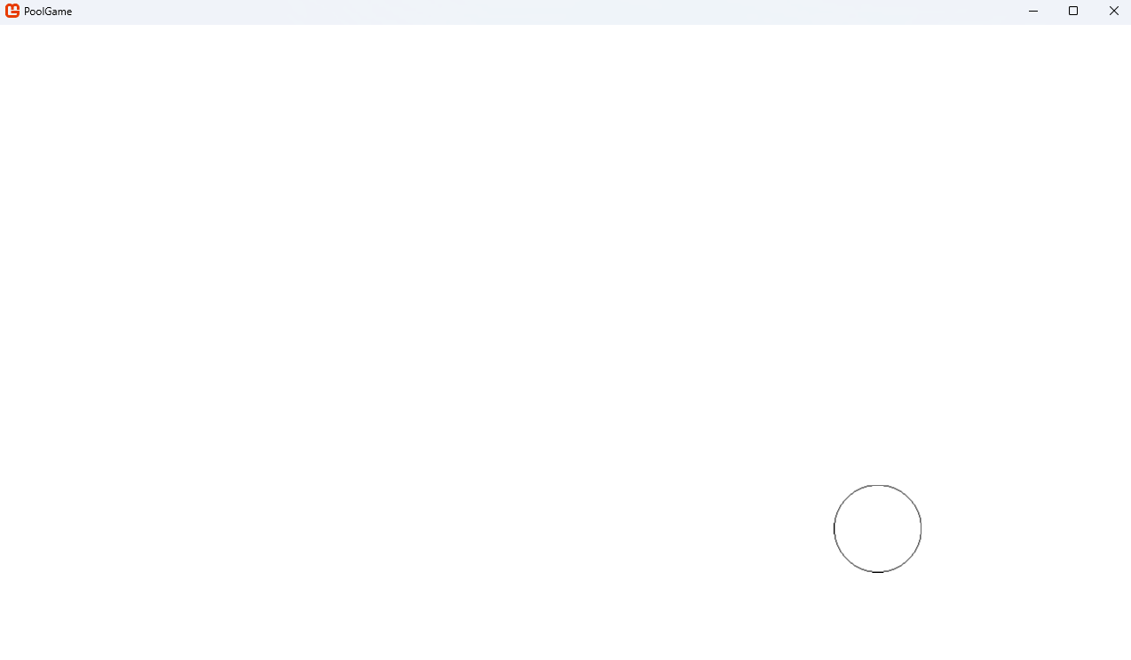
(Ideally I would use video evidence to show this, but I don’t think that would work with Microsoft Word (the program I’m using to write this in).)
In addition, when I attempted to shoot repeatedly after the CueBall was already moving, its velocity didn’t change.
Overall, this shows that the function is working as expected. In response, no actions need to be taken.
DebugMove(Vector2 _position)
To test DebugMove, I also needed to just pick a spot and click. I chose the top right corner of the screen, aiming to click a point where the CueBall would be teleported partially out of bounds to also re-test the bounds collisions with DebugMove involved. I also opted to do this while the it was moving (having been shot just before).
Before pressing RMB | After pressing RMB
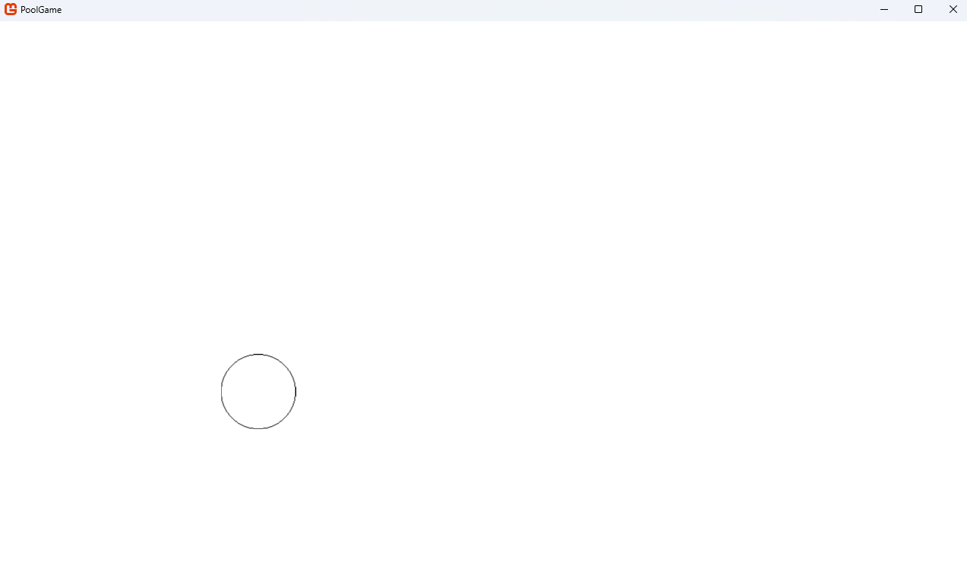 | 
It stayed within the bounds of the screen as expected, and it stopped moving.
Overall, this shows that the function is working as expected. In response, no actions need to be taken.

Friction
Note that for most of the maths I do in this writeup, I’m using LaTeX. It’s a typesetting system built on TeX, both of which are designed specifically for mathematical notation. For example, \frac{1}{2} produces $\frac{1}{2}$ when rendered.
For simplicity, we will always consider stationary PoolBalls to be on the point of moving, meaning that, for all situations, we can use the formula $F=μN$. Where $F$ is the frictional force acting on the PoolBall, $μ$ is the coefficient of friction between the PoolBall and the table surface, and $N$ is the normal rection force acting on the PoolBall due to the surface. Here’s a free body diagram for the PoolBall (with $W$ being the weight of the PoolBall):
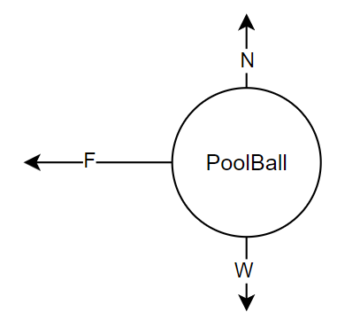
Since the resultant force in the vertical direction is zero, we can resolve forces vertically as follows:
$$R\left(↑\right): N-W=0$$
$$⟹N=W$$
Since $W$ is equal to the mass of the PoolBall multiplied by the gravitational field strength it is experiencing (given by the formula $W=mg$). $m$ and $μ$ don’t change and, using abstraction, we can view $g$ as a constant as well. This means $F$ has a constant magnitude (since $F=μmg$, where $μmg$ is constant) and acts opposite to the motion of the PoolBall (part of friction’s definition). Now I can decide the exact value of $F$ myself through experimenting with only changing one variable (i.e. $μ$, since $m$ already equals 1 and I’m letting $g$ equal 1 too for simplicity). After some experimentation, I landed on a value of 0.01. This value causes the CueBall to stop after moving 3 widths of the screen when the cursor is aimed at the far edge of the screen. This should hopefully give players both enough precision for smaller shots and enough power for longer shots.
Now, in ChangePosition, I added this before the position is changed to make sure decelerationDueToFriction is direction is kept the same as velocity’s. (The same not the opposite because it is subtracted from velocity, not added.)
if (velocity.Length() > 0) // prevents division by zero because Normalize() divides by Length()
{
decelerationDueToFriction = Vector2.Normalize(velocity) * coefficientOfFriction;
}
Creating a DoFriction method, we get:
public void DoFriction()
{
if (velocity = Vector2.Zero)
{
velocity = Vector2.Zero;
decelerationDueToFriction = Vector2.Zero;
}
else
{
velocity -= decelerationDueToFriction;
}
}
However, the PoolBall wasn’t fully stopping when it got to a slow enough speed (in fact it sped up forever right after it stopped). This was likely because subtracting decelerationDueToFriction repeatedly was unlikely to ever reach exactly zero velocity (and often blew past it). To fix this, I changed the velocity = Vector2.Zero in the if statements to Math.Abs(velocity.X) < 0.1 | Math.Abs(velocity.Y) < 0.1. This instead checks if either component of velocity is close to zero.
But this unearthed another problem; now the PoolBall was stopping too abruptly sometimes. If either the PoolBall’s velocity’s X or Y was very small and the other was larger, it would stop the PoolBall when it should still be moving with the other component. To fix this, I separated DoFriction into horizontal and vertical sections so that it could deal with each individually. I also replaced the 0.1 in the if statements with the constant ThresholdVelocity for better readability. (Note that I can’t alter the X and Y components of a Vector2 directly, so to update velocity I instead had to create a new Vector2 using the previous velocity’s components as a base).
public void DoFriction()
{
// horizontal:
if (Math.Abs(velocity.X) < ThresholdVelocity)

velocity = new Vector2(0, velocity.Y);
decelerationDueToFriction = new Vector2(0, decelerationDueToFriction.Y);
}
else
{
velocity = new Vector2(velocity.X - decelerationDueToFriction.X, velocity.Y);
}

// vertical:
if (Math.Abs(velocity.Y) < ThresholdVelocity)
{
velocity = new Vector2(velocity.X, 0);
decelerationDueToFriction = new Vector2(decelerationDueToFriction.X, 0);
}
else
{
velocity = new Vector2(velocity.X, velocity.Y - decelerationDueToFriction.Y);
}
}

Tests
DoFriction()
To test DoFriction, I shot the CueBall a few times and off the edges of the screen. Each time it successfully slowed down almost exactly at the position of the cursor. I would show images as proof, but they look pretty much identical to the previous images I’ve shown, so they wouldn’t add anything meaningful.
Overall, this shows that the function is working as expected. In response, no actions need to be taken.

Review
This iteration achieves what it set out to do. It set up my C# project It successfully created an area for testing, defined by the edges of the screen, which acts how cushions on a pool table would act (i.e. the pool ball bounces off them elastically). It also created a functioning pool ball that can be intuitively controlled (in my and some people I’ve asked to test’s opinions) to let players aim where they need to with the desired magnitude of velocity. Finally, the pool ball does slow down due to friction, meaning that it won’t just keep moving forever (which would be unlike analogue pool). All the physics thus-far is sound, except the abstractions but, as mentioned at the times of abstracting, they shouldn’t be noticeable.
Because of my style of development (i.e. testing informally pretty much constantly before a method is even complete), when I got to the official test portion of each part my code passed them all. However, I don’t yet know how rigorous my testing was, so I might still have made some mistakes. But there’s plenty of time to discover and fix mistakes along the way. I plan on using GitHub’s built in Issues section of my repository to report issues as they come up (and issues I discover right at the end of a day, so can’t fix at the time). This should help me not forget about issues I discover while developing other parts of the code, make sure I don’t forget about issues I’ve just caused before stopping coding, and keep track of how many pre-existing parts of the code had hidden issues so I can decide if I need to be more rigorous with my testing.
Overall, this iteration has laid a bunch of solid groundwork that should be scalable with more pool balls and other objects added in the next iteration.

2nd iteration – completing the environment

PoolBall-PoolBall collisions
First, I added an instance of PoolBall (acting as a placeholder ColouredBall until that class is implemented) in the centre of the screen to test PoolBall-PoolBall collisions. I then added this PoolBall and the CueBall to a PoolBall[] array called poolBalls (utilising polymorphism because both CueBall and later ColouredBall inherit from PoolBall) which would eventually hold all pool balls. I did this so that I could iterate through the array whenever I needed to handle the collisions for all pool balls (extending to handling them colliding with other objects, such as Pockets).
I started by defining the procedure DoCircleCircleCollision to check if the two PoolBalls collide. I added it as one of CueBall’s methods just to avoid it triggering twice as it would if it was one of PoolBalls’ (since now there’s two instances of PoolBall). This does mean that, for the moment, this only works for PoolBalls colliding with the CueBall, but that will be changed later once the collision logic is all worked out.) It checks if the centres of the poolBalls are withing two radii of each other, if they are then they are overlapping and therefore colliding. If they are colliding, it then sets both of their velocities to zero just so that I can clearly see if the function is working or not.
public void DoCircleCircleCollision()
{
foreach (PoolBall poolBall in Game1.poolBalls)
{
if (poolBall == this) // no need to check if it collides with itself
{ continue; }
else
{
if (Vector2.Distance(poolBall.position, position) < radius * 2)
{
// [placeholder, for testing]:
poolBall.velocity = Vector2.Zero;
velocity = Vector2.Zero;
}
}
}
}
This works for detecting the collision, but something needs to be done after that to each PoolBall’s velocity to make them ‘bounce’ off each other. To achieve this, I need the collisions to be elastic (or nearly elastic), meaning that the system’s (i.e. the two PoolBalls’) kinetic energy is conserved through the collision. To calculate kinetic energy, we can use the formula $E_{K}=\frac{1}{2}mv^{2}$, where $E_{K}$ is the total kinetic energy of the system (i.e. both PoolBalls), $m$ is the total mass of the system, and $v$ is the total velocity of the system. Since $\frac{1}{2}$ and $m$ are constant, $v^{2}$ must be constant before and after the collision for the collision to be elastic.
To simplify the problem, I started by looking at a moving ball colliding with a stationary ball. I used the PhET Collision Lab to look at different scenarios to try and gain an understanding on how these collisions work
If the two balls collide like below (with the arrows with a ‘v’ at the end representing their velocity vectors), ball 2’s velocity after the collision is always parallel to the position vector between the two balls on collision. I could calculate the direction of ball 2’s velocity (i.e. not a magnitude as well) by calculating the distance between the two centres.
Ball 1’s velocity after the collision is perpendicular to ball 2’s. In the scenario below it’s 90 degrees anticlockwise from ball 2’s, but sometimes it’s 90 degrees clockwise (e.g. if ball 1 had started lower than ball 2 and was aimed upwards).
Before collision:  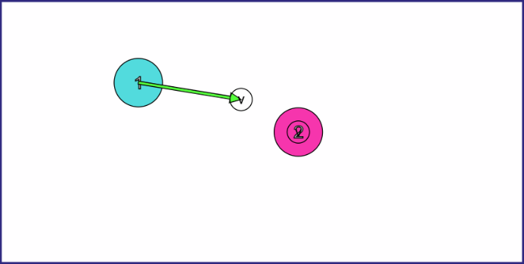 | Frame before collision:  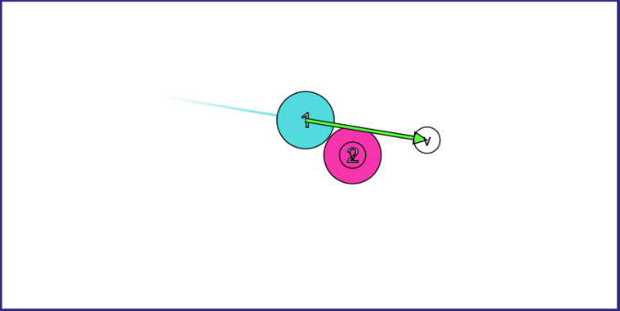
Frame after collision:  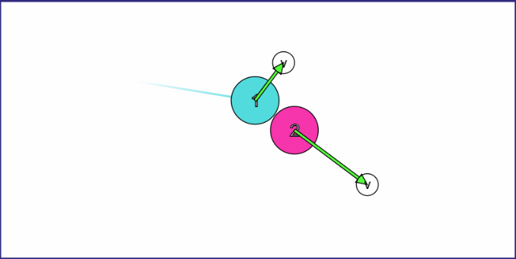 | After collision:  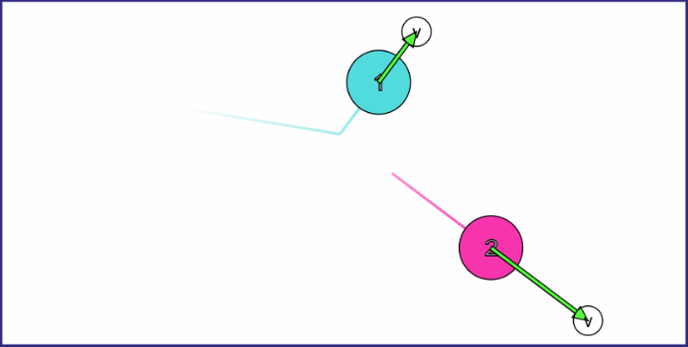
To find the relative position vector of the two balls, I just had to take ball 2’s position (a Vector2 representing the position of its centre) and subtract it from ball 1’s (that way the vector is pointing in the same direction that ball 2 moves in, rather than pointing the other way). Then to find ball 1’s, I started by using a 2D rotation matrix to rotate ball 2’s direction vector $θ^{∘}$.
$$b=\left(\begin{matrix}\cos\left(θ\right) & -\sin\left(θ\right) \\ \sin\left(θ\right) & \cos\left(θ\right)\end{matrix}\right)a$$
If $a=\left(\begin{matrix}a_{1} \\ a_{2}\end{matrix}\right):$
$$b=\left(\begin{matrix}\cos\left(θ\right) & -\sin\left(θ\right) \\ \sin\left(θ\right) & \cos\left(θ\right)\end{matrix}\right)\left(\begin{matrix}a_{1} \\ a_{2}\end{matrix}\right)=\left(\begin{matrix}a_{1}\cos\left(θ\right)-a_{2}\sin\left(θ\right) \\ a_{1}\sin\left(θ\right)+a_{2}\cos\left(θ\right)\end{matrix}\right)$$
If $θ=90:$
$$b=\left(\begin{matrix}a_{1}\cos\left(θ\right)-a_{2}\sin\left(θ\right) \\ a_{1}\sin\left(θ\right)+a_{2}\cos\left(θ\right)\end{matrix}\right)=\left(\begin{matrix}-a_{2} \\ a_{1}\end{matrix}\right)$$
However, when I started to write the code to achieve this perpendicular movement (planning on using some placeholder velocities, since I hadn’t calculated those yet), it was quickly becoming clear by my third ‘else’ statement that this code wasn’t generalised enough. This was because, depending on the quadrant of the screen ball 1 was in and the position on ball 2 it collided with, the velocity calculations changed). If this was going to eventually work with two moving balls, it would need to be much less situational and more formulaic.
I started to think more about vectors and realised that the dot product might be more useful here.
The dot product is an operation that acts on two vectors and returns a scalar value. One of its uses (because there’s more than 1, as you’ll see later) is to find the acute angle (i.e. the angle less than 90 degrees since two intersecting lines will usually have 2 different angles involved) between two vectors. The dot product can be written in three different ways, as follows (where the dot product operator is $⋅$):
$$v_{a}⋅v_{b}=\left|v_{a}\right|\left|v_{b}\right|\cos\left(θ\right)=v_{a1}v_{b1}+v_{a2}v_{b2}$$
Where $v_{a}=\left(\begin{matrix}v_{a1} \\ v_{a2}\end{matrix}\right)$ and $v_{b}=\left(\begin{matrix}v_{b1} \\ v_{b2}\end{matrix}\right)$ are the two final velocities of the balls and $θ$ is the acute angle between them.
Since the two vectors need to be perpendicular, $θ$ must be 90 degrees. It follows that:
$$v_{a}⋅v_{b}=\left|v_{a}\right|\left|v_{b}\right|\cos\left({90}^{∘}\right)=v_{a1}v_{b1}+v_{a2}v_{b2}$$
$$⟹\left|v_{a}\right|\left|v_{b}\right|×0=v_{a1}v_{b1}+v_{a2}v_{b2}$$
$$⟹v_{a1}v_{b1}+v_{a2}v_{b2}=0$$
Also, we can use the law of conservation of momentum which allows us to state that that the total momentum in a system before a collision is equal to the total momentum after. ($p=mv$, where $p$ is the momentum). With this, I could sum both the ball’s initial velocities and set it equal to the sum of their final velocities (disregarding mass since it had been abstracted to 1 earlier) to create 2 more equations.
$$u_{a}+u_{b}=v_{a}+v_{b}$$
$$⟹\left(\begin{matrix}u_{a1} \\ u_{a2}\end{matrix}\right)+\left(\begin{matrix}u_{b1} \\ u_{b2}\end{matrix}\right)=\left(\begin{matrix}v_{a1} \\ v_{a2}\end{matrix}\right)+\left(\begin{matrix}v_{b1} \\ v_{b2}\end{matrix}\right)$$
$$⟹u_{a1}+u_{b1}=v_{a1}+v_{b1}$$
$$u_{a2}+u_{b2}=v_{a2}+v_{b2}$$
Where $u_{a}=\left(\begin{matrix}u_{a1} \\ u_{a2}\end{matrix}\right)$ and $u_{b}=\left(\begin{matrix}u_{b1} \\ u_{b2}\end{matrix}\right)$ are the initial velocities of the balls (which we know already since we can get the balls’ velocity attributes before the collision).
With this, I had three equations with the components of both balls’ velocities after the collision. However, since there were four unknowns ($v_{a1}, v_{a2}$, $v_{b1}$, and $v_{b2}$), mathematically it would be impossible to solve this system of equations without knowing more of the context.
At this point, I took a step back from the vector maths and looked at the mechanics of this situation. Since our situation obeys the conservation of momentum and the conservation of kinetic energy and the masses of the two balls are equal, it turns out that the objects swap components of their velocities along the line of impact (the line formed by the relative position vector). In a sense, if:
The vector components of the initial velocities of the two balls parallel to the line of impact are $u_{a∥}$ and $u_{b∥}$ and the components perpendicular are $u_{a⊥}$ and $u_{b⊥}$.
And the vector components of the final velocities of the two balls parallel to the line of impact are $v_{a∥}$and $v_{b∥}$.
Then:
$$v_{a∥}=u_{b∥}$$
$$v_{b∥}=u_{a∥}$$
Re-combining the velocities:
$$v_{a}=u_{b∥}+u_{a⊥}$$
$$v_{b}=u_{a∥}+u_{b⊥}$$
To get these components, I needed to make use of the second property of the dot product: if you find the dot product of a vector $a$ and a unit vector $n$ (i.e. a vector with a magnitude of 1), $a⋅n$, you get the scalar component $a$ has in the direction of $n$. For example, if the direction of $n$ was only in the y direction, $a⋅n$ would return the y component of $a$, $a_{y}$.) If you then multiply this scalar value by $n$, you get a vector representing only the component of $a$ in the direction of $n.$Using this method, I was able to find the component of velocities parallel to the line of impact. Then if you subtract this from the full velocity, you get the remaining perpendicular component.
So, our vectors $v_{a}$ and $v_{b}$ can be found as below, where $p$ is the relative position vector between the two ball’s centres and $\hat{p}$ is $p$ normalised to have a magnitude of 1:
$$\hat{p}=\frac{p}{\left|p\right|}$$
$$u_{a∥}=\hat{p}\left(u_{a}⋅p\right), u_{b∥}=\hat{p}\left(u_{b}⋅p\right)$$
$$⟹u_{a⊥}=u_{a}-\hat{p}\left(u_{a}⋅p\right),u_{b⊥}=u_{b}-\hat{p}\left(u_{b}⋅p\right)$$
$$⟹v_{a}=\hat{p}\left(u_{b}⋅p\right)+u_{a}-\hat{p}\left(u_{a}⋅p\right)$$
$$\text{and} v_{b}=\hat{p}\left(u_{a}⋅p\right)+u_{b}-\hat{p}\left(u_{b}⋅p\right)$$
Simplifying further, since the dot product has the distributive property:
$$v_{a}=u_{a}+\hat{p}\left(\left({u_{b}-u}_{a}\right)⋅p\right)$$
$$v_{b}=u_{b}+\hat{p}\left({(u_{a}-u}_{b})⋅p\right)$$
Now I had the final velocities of the two balls only in terms of known pre-collision attributes. Also, I didn’t need to do any extra work to generalise further or work out any magnitudes since so few conditions were assumed at the start of calculations. I didn’t even assume that one ball was stationary, so this should work for any two balls of any positions and velocities colliding.
To implement this, I created a DoAllPoolBallPoolBallCollisions method in PoolBall to cycle through all PoolBalls in the poolBalls array, calculate if they were colliding with the PoolBall, and alter velocity values of both to what they would be post-collision. I used MonoGame’s built-in Vector2.Dot() function to find the dot products. Otherwise, I would have to sum the components manually in the code which would cause the readability to suffer even more than it has from an already long line.
I could’ve used the += operator since, as proven above, this essentially just adds another vector to the balls’ initial velocities. However, I decided against it because I think it’s easier to think of this calculation as a complete change in velocity, rather than an addition, and I didn’t want it to be misleading for others reading it.
public static void DoAllPoolBallPoolBallCollisions()
{
for (int i = 0; i < poolBalls.Count() - 1; i++)
{

if (poolBalls[i] == this) // no need to check if it collides with itself
{ continue; }
else
{
if (Vector2.Distance(poolBalls[i].position, position) < radius * 2)
{
Vector2 relativePositionVector = poolBalls[i].position - position; // the vector that is normal to the collision surface (i.e. other ball), pointing towards poolBalls[i]
Vector2 unitNormalVector = relativePositionVector / relativePositionVector.Length(); // normalised to have a magnitude of 1

// adjusting velocity:
velocity = velocity + (Vector2.Dot(poolBalls[i].velocity - velocity, unitNormalVector) * unitNormalVector);
}
}

}
}
However, when I tried this by shooting the CueBall directly at another PoolBall, the CueBall just keeps going forwards with the other PoolBall and they get stuck inside of each other. This also seems to keep the both of them going far longer than they would otherwise, reducing the effect of friction.
Initial position   | After collision  
After first edge bounce  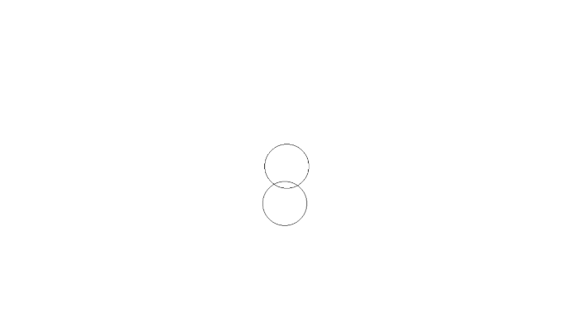 | After second edge bounce  
It turned out that this was caused since each PoolBall is updated in an order, not simultaneously (since the entirety of poolBalls is iterated through, item-by-item, every time PoolBall.Update is called to update each PoolBall). This meant that, in the event of a collision, one PoolBall would change its own velocity using the pre-collision velocity values of both PoolBalls. But then the second PoolBall (the one of the two that is updated later due to the order of poolBalls) would think that the first PoolBall’s calculated post-collision velocity was its pre-collision velocity, meaning the second PoolBall’s velocity change didn’t work.
To fix this, I moved DoAllPoolBallPoolBallCollisions to Game1, being called inside of its own Game1.Update method. I had to change how it iterated through poolBalls now to cover all collisions with all PoolBalls, making sure to use incrementing start indexes to prevent a pair being checked twice. I also had to assign temporary variable the values of each new velocity when it was calculated so that I could use pre-collision velocity values for both PoolBalls to prevent the same error as before. Once both were calculated, they were then assigned to the relevant PoolBalls.
(Apologies for MS Word’s text wrapping reducing readability, but I didn’t want to make the text too small.)
public static void DoAllPoolBallPoolBallCollisions() // in Game1.cs rather than PoolBall.cs so that all velocities can be changed on the same frame
{
for (int i = 0; i < poolBalls.Count - 1; i++)
{
for (int j = i + 1; j < poolBalls.Count; j++) // j = i + 1 prevents repeatedly checking the same pairs
{
if (poolBalls[i] == poolBalls[j]) // no need to check if it collides with itself
{ continue; }
else
{
if (Vector2.Distance(poolBalls[i].position, poolBalls[j].position) < poolBalls[i].radius * 2)
{
Vector2 relativePositionVector = poolBalls[i].position - poolBalls[j].position; // the vector that is normal to the collision surface (aka other ball), pointing towards poolBalls[i]
Vector2 unitNormalVector = relativePositionVector / relativePositionVector.Length(); // normalised to have a magnitude of 1

// adjusting velocities with temporary variables:
Vector2 newVelocity = poolBalls[i].velocity + (Vector2.Dot(poolBalls[j].velocity - poolBalls[i].velocity, unitNormalVector) * unitNormalVector);
Vector2 newOtherVelocity = poolBalls[j].velocity + (Vector2.Dot(poolBalls[i].velocity - poolBalls[j].velocity, unitNormalVector) * unitNormalVector);
poolBalls[j].velocity = newOtherVelocity;
poolBalls[i].velocity = newVelocity;
}
}
}
}
}
While this algorithm does have a time complexity of about O(n^2), since n is the size of poolBalls which is fixed in the low tens when fully displaying all PoolBalls, it shouldn’t impact performance notably.
With this, I finally had a working collision handler that should work with as many PoolBalls as needed. I could then test both if it works on a larger scale and if it works fast with the next step in this iteration, as shown below, making adjustments if it caused too much load on my test computer.

Tests
DoAllPoolBallPoolBallCollisions()
To test DoAllPoolBallPoolBallCollisions, I added another instance of PoolBall and offset the heights of each by 100 pixels to prevent them instantly colliding. I ran my game, aimed my cursor at the lower of the two PoolBalls, and shot. Almost all the CueBall’s momentum was transferred to the PoolBall and it was sent flying across the screen. After bouncing a few times, it came to rest due to friction.
Initial positions (CueBall on left)  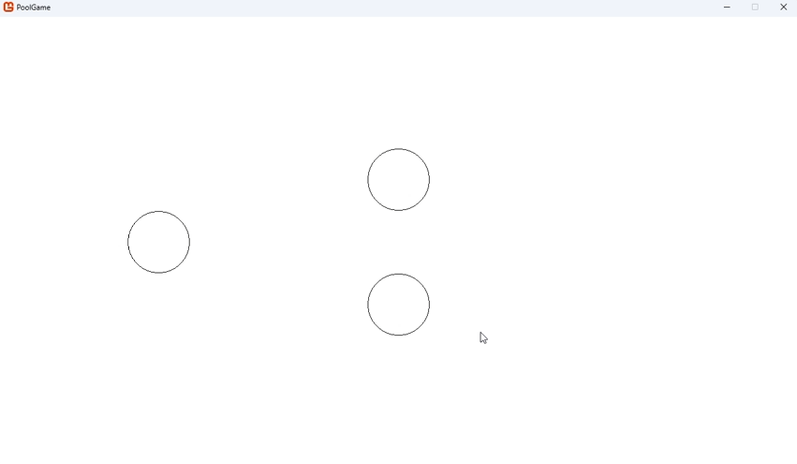 | Pre-collision  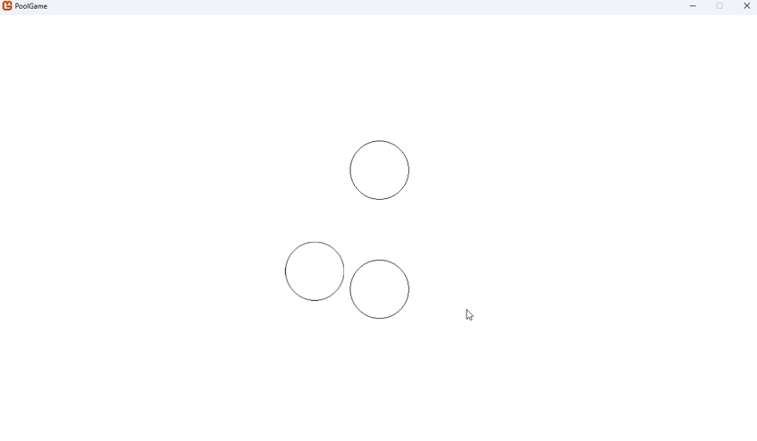
Post-collision  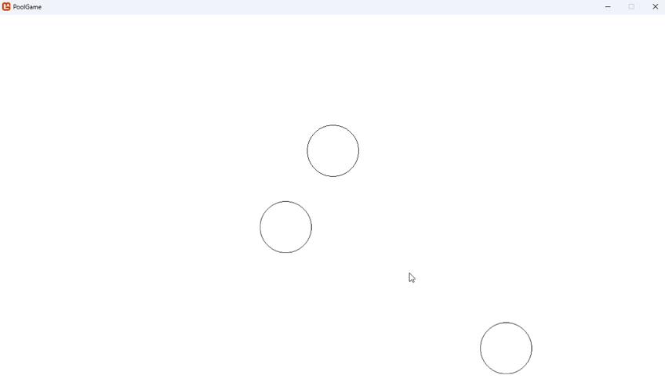 | Resting positions  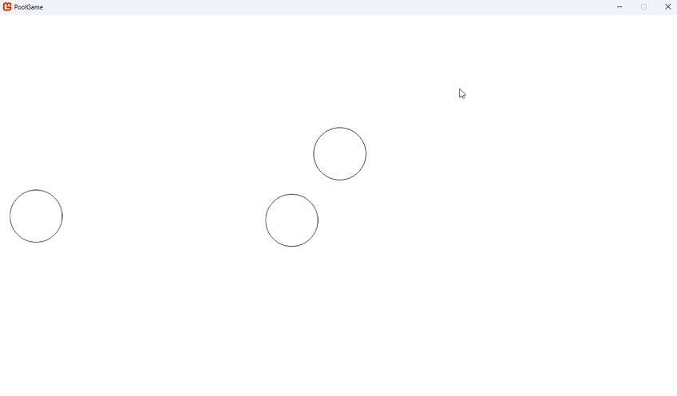
(Note that my cursor position is now visible because I switched to taking screenshots of screen recordings instead of manual screenshots. I didn’t think to do this sooner, because I thought it would also remove the cursor, but when I had to resort to using it here to keep track of all the fast-moving objects, I realised it would’ve also let me show the cursor position the whole time)
Now I tried aiming at the other PoolBall and shooting. This time, because I didn’t hit it head-on, both the CueBall and PoolBall bounced off with approximately even magnitudes of velocity. They both bounced off the upper edge and the CueBall made its way back to the other PoolBall from earlier. When they collided they promptly both stopped because friction had already made the CueBall slow down so much.
Initial positions (CueBall in middle)  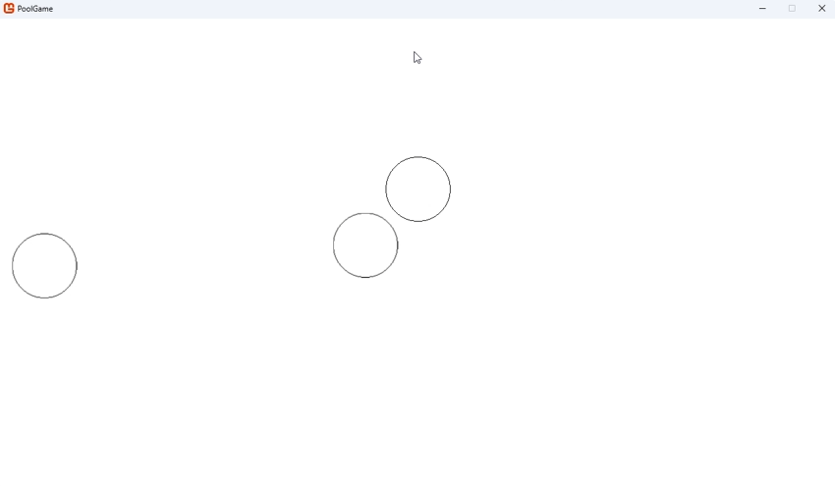 | Post-collision (no frames captured pre-collision)  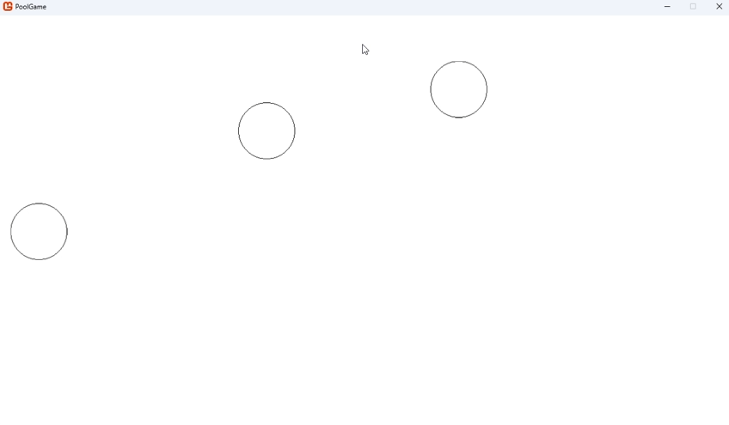
Pre-second-collision  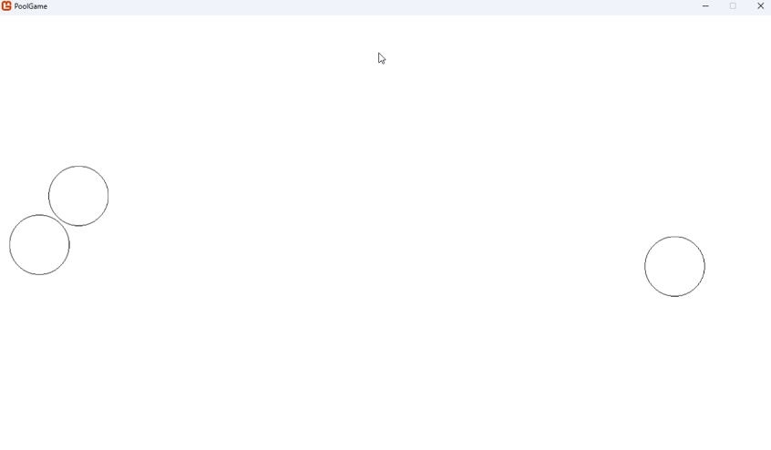 | Resting positions  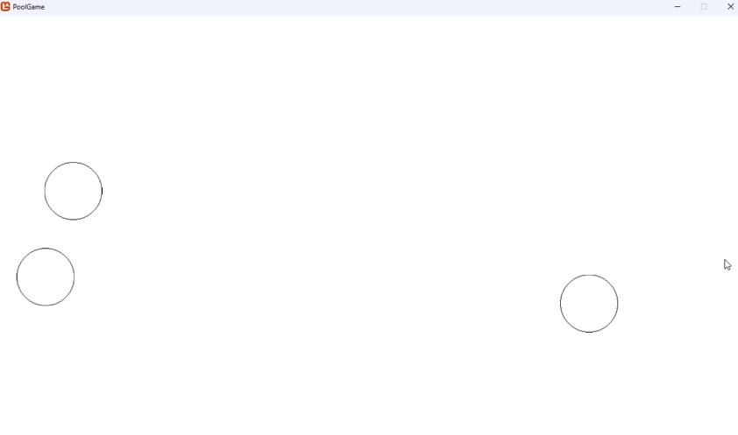
To end, I aimed the CueBall at the right-most PoolBall and shot. This time it barely clipped the top edge of the PoollBall but still sent it downwards. The CueBall then bounced off the left edge. Both then bounced off edges and came to rest.
Initial positions (CueBall in upper left) | Pre-collision  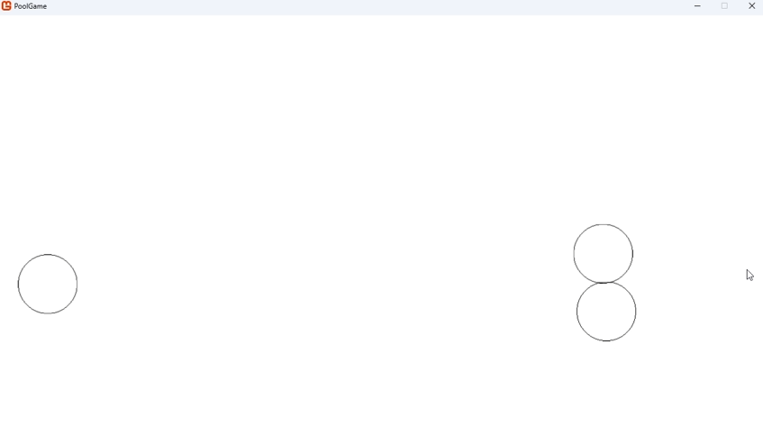
Post-collision (after CueBall’s right edge bounce)  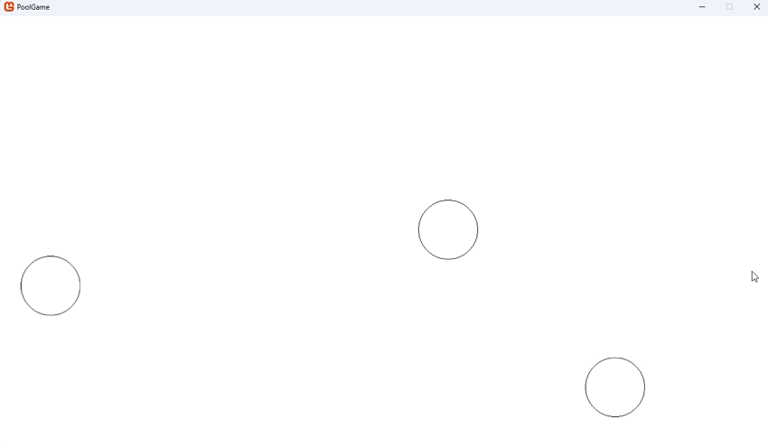 | Resting positions  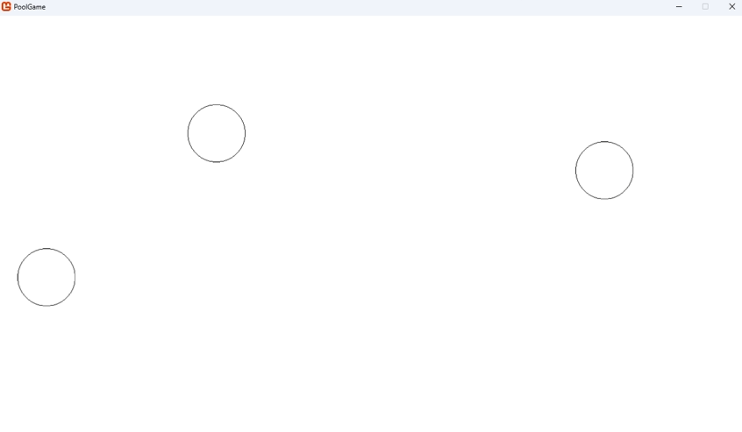
I restarted the game and repeated this a few times with various positioning and found no evidence of errors.
Overall, this shows that the function is working as expected. In response, no actions need to be taken.

Graphing the table’s dimensions
Before continuing, I decided to make a graph of the pool table on Desmos so that I could have consistent dimensions for the table and everything on it. Desmos is a web-based graphing calculator that has a lot of nice features that work well for this use. Here’s the link to my graph: https://www.desmos.com/calculator/snnrtihent.
One thing to note is that computers often consider the top left the origin (i.e. the point (0,0)) and move downwards when increasing the y-coordinate. But Desmos (since it uses a Cartesian coordinate grid) consider the bottom left (if we’re only considering positive numbers) the origin and moves upwards when increasing the y-coordinate. This means that effectively my graph is a flipped version of how it will render on screen (specifically flipped along the x-axis). But this shouldn’t matter much since the table has a horizontal line of symmetry along its middle so flipping it like that won’t change its layout. For example, here’s how the graph of $y=\sqrt{x}$ would look in both systems:
Rendered in Desmos | Rendered in my game*
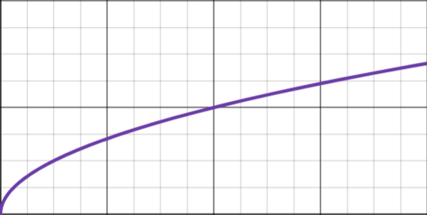
*Note that my game doesn’t have the capability to actually render this, so I just flipped the Desmos screenshot for illustrative purposes.
An advantage of using Desmos (as opposed to pen and paper or a computer-aided design program like draw.io) is that I can set up variables for all the equations to keep values consistent and able to be changed easily (like I can in C#). I used this to add a spacing variable $s$ that keeps the pockets one $s$ away from the edges of the table at all times (to make the table feel a bit more spacious). This also means that I know exactly which variables I need to use in my program to calculate positioning.
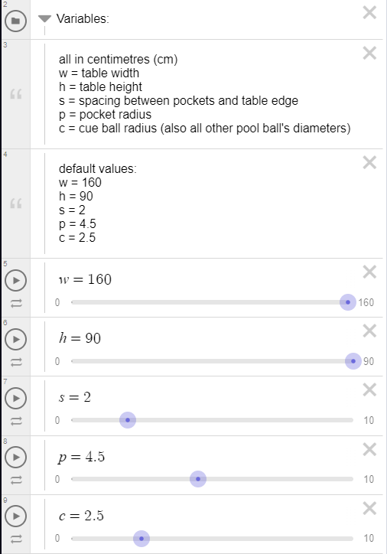
I can also separate parts of the table into folders so that I can display them individually. This helps remove clutter when only dealing with certain parts of the table.
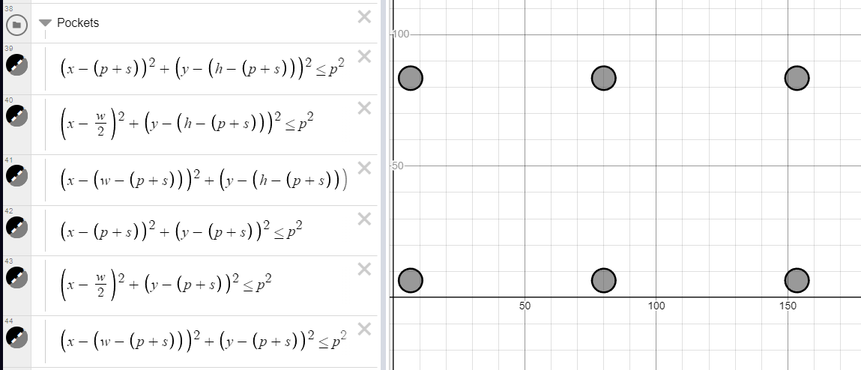
(I used inequalities so that Desmos would render them as filled-in circles rather than just outlines.)
I standardised the aspect ratio of the table to be 16:9 since the actual dimensions of pool tables can vary somewhat and 16:9 fits within that range. Also, the majority of monitors use that aspect ratio, so it should maximise the space the game can take up on such monitors. However, using Desmos, I can vary that by changing the table’s width and height variables (default 160x90, trying to keep as close as possible to the real-world size in centimetres with a scale of 1:8 centimetres to pixels for a 1280x720 resolution). Here are some examples of different height/width combinations:
Width | Height | Image
160 | 90 | 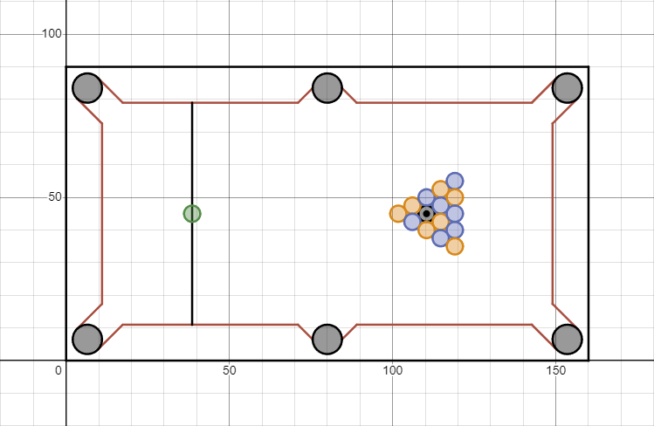
90 | 90 | 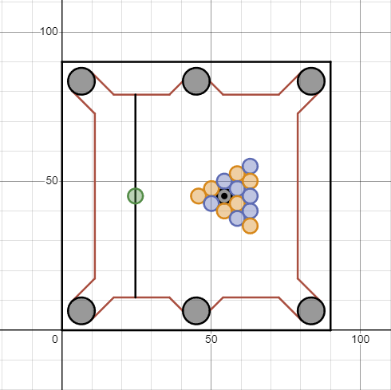
160 | 50 | 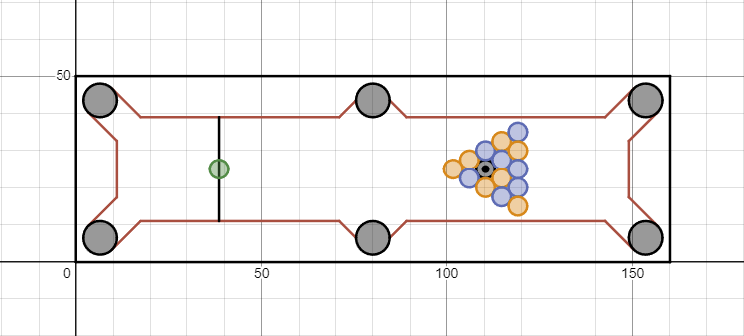
20 | 90 | 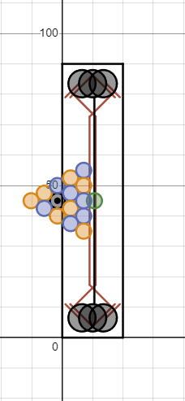
Note that, with some values (e.g. w=20, h=90), the table breaks as shown. But this shouldn’t effect the graph’s overall utility because the pool table will never have such extreme dimensions.
Putting this all together, I fully constructed a to-scale pool table in Desmos which would allow me to easily get most (if not all) of the positional information needed for my game.
Here’s a part of my process, showing how I derived the equations for some of the coloured balls’ positions. (Remember that the eight ball’s centre sits on the “black spot”, a point one fifth from the left side of the playing surface (as viewed from my graph) and vertically centred.):

Step 1 – finding the black spot
Since it lies one fifth across the playing surface, I just needed to find the horizontal length of the playing surface and subtract one fifth of it from the left side of the surface (the vertical position is trivial, just being half the variable $h$ or table height).
The total width of the table is $w$, the spacing between the pockets and the edge of the table is $s$, and the radius of each pocket is $p$. Since the gap between the table edge and cushion edge is the diameter of a pocket plus the space it is away from the edge, the distance between the pairs of points shown below (blue and black; purple and green) is equal to $s+2p$.
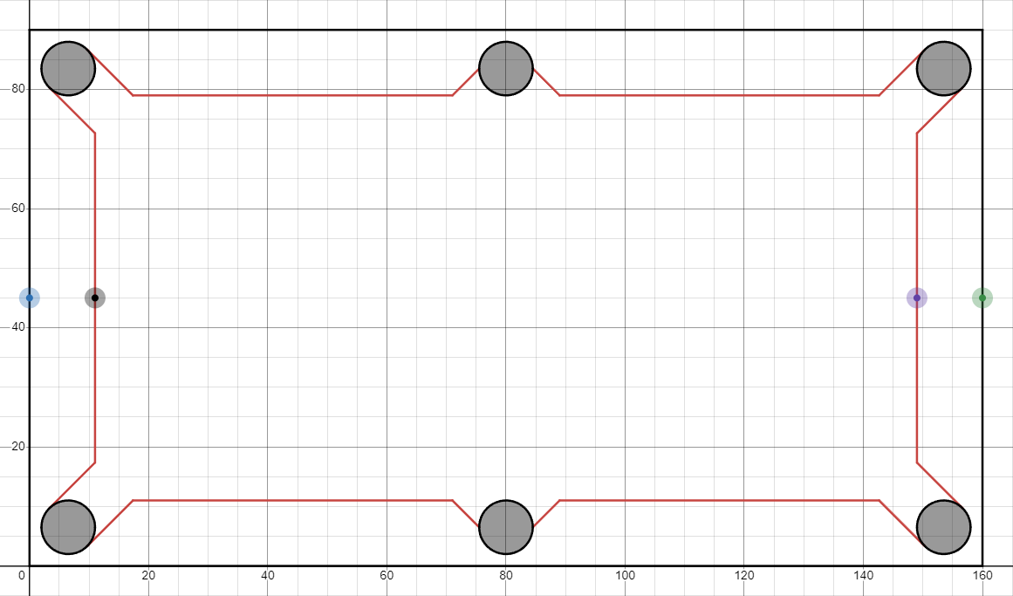
So, the coordinates of the inner points, black and purple, are $\left(s+2p,\frac{h}{2}\right)$ and $\left(w-\left(s+2p\right),\frac{h}{2}\right)$ respectively. From this, we can calculate the distance between those points (i.e. the length of the playing surface) as $\left|w-\left(s+2p\right)-\left(s+2p\right)\right|$ (the x-coordinate of one subtracted from the other, with the absolute value to ensure it’s a positive distance). Therefore, the x-coordinate of the black spot is $s+2p+\frac{4}{5}\left|w-\left(s+2p\right)-\left(s+2p\right)\right|$, simplifying we find the coordinates of the black spot (and therefore the centre of the eight ball) to be $\left(\frac{1}{5}\left(4w-3\left(s+2p\right)\right),\frac{h}{2}\right)$. Note that the absolute value can be removed because the expression won’t go below zero with $s$ and $p$ being much smaller than $w$.

Step 2 – creating the eight ball and some of its neighbours
The equation of a circle, centre $\left(x_{1},y_{1}\right)$ radius $r$ is as follows:
$${\left(x-x_{1}\right)}^{2}+{\left(y-y_{1}\right)}^{2}=r^{2}$$
This can be derived using the Pythagorean theorem to set up an equation in which the distance between $\left(x_{1},y_{1}\right)$ and all valid points $\left(x,y\right)$ (written as $\sqrt{{\left(x-x_{1}\right)}^{2}+{\left(y-y_{1}\right)}^{2}}$) is equal to the radius of the circle $r$. So the all the points $\left(x,y\right)$ on the circle satisfy the equation $\sqrt{{\left(x-x_{1}\right)}^{2}+{\left(y-y_{1}\right)}^{2}}=r$ which (by squaring both sides) gives ${\left(x-x_{1}\right)}^{2}+{\left(y-y_{1}\right)}^{2}=r^{2}$ (the well-known circle equation).
This means that the equation for the eight ball is ${\left(x-\frac{1}{5}\left(4w-3\left(s+2p\right)\right)\right)}^{2}+{\left(y-\frac{h}{2}\right)}^{2}=c^{2}$. (Remember that $c$ is the cue ball radius and therefore the radius of all other balls in this model).
From here the positions of the ball above and the ball below the eight ball can be found by just adding or subtracting twice the radius of the cue ball from the y-coordinate of the eight ball (keeping the x-coordinate the same). Giving: ${\left(x-\frac{1}{5}\left(4w-3\left(s+2p\right)\right)\right)}^{2}+{\left(y-\left(\frac{h}{2}+2c\right)\right)}^{2}=c^{2}$ and ${\left(x-\frac{1}{5}\left(4w-3\left(s+2p\right)\right)\right)}^{2}+{\left(y-\left(\frac{h}{2}-2c\right)\right)}^{2}=c^{2}$. (Centres are kept in brackets rather than distributing the negative operation to maintain clarity that whatever expression comes after the $-$ in brackets is the centre coordinate.) This produces:
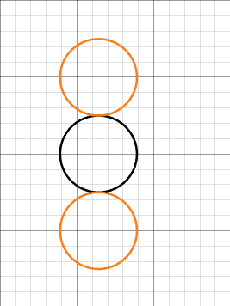
The next step is to give a general equation for the two balls to the left of those three (remember all the object balls together should form a triangle). The table must also have a line of symmetry at $y=\frac{h}{2}$, so the two circle’s centres’ y-coordinates are $\frac{h}{2}+c$ and $\frac{h}{2}-c$. The x-coordinates are an unknown variable I’ve called $x_{1}$. Using Desmos’ sliders, I adjusted $x_{1}$until it was near the correct position.
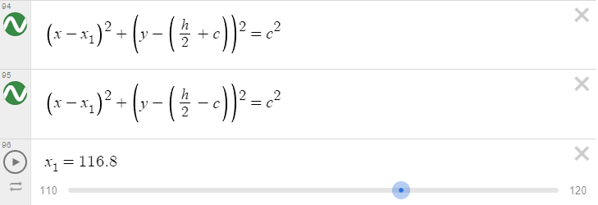
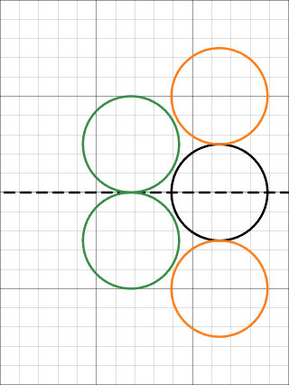

Step 3 – finding exact positions
From here, we can take two approaches to find $x_{1}$ (more exist, but I only tried two). We can either treat the equations of the eight ball and one of the balls as a system of equations and solve simultaneously for one solution. Or we find the distance between the centres of the two circles and set it equal to twice their radius because that would be the distance if the two were adjacent. I will show both approaches below.

Approach 1 – using a system of equations
For this, I’m going to use the following two equations, the first being the eight ball’s and the second being the upper pool ball’s (it wouldn’t have mattered if I used the lower one instead, the same value of $x_{1}$ should be found, the choice was arbitrary):
$${\left(x-\frac{1}{5}\left(4w-3\left(s+2p\right)\right)\right)}^{2}+{\left(y-\frac{h}{2}\right)}^{2}=c^{2}$$
$${\left(x-x_{1}\right)}^{2}+{\left(y-\left(\frac{h}{2}+c\right)\right)}^{2}=c^{2}$$
Expressing the second equation in the form $y=f\left(x\right)$, we get:
$$y=\frac{h}{2}+c±\sqrt{c^{2}-{\left(x-x_{1}\right)}^{2}}$$
Using Desmos, we can see that only $y=\frac{h}{2}+c-\sqrt{c^{2}-{\left(x-x_{1}\right)}^{2}}$ intersects the eight ball, so we will just use that equation to simplify the problem.
From here we substitute this value of $y$ into the first equation:
$${\left(x-\frac{1}{5}\left(4w-3\left(s+2p\right)\right)\right)}^{2}+{\left(\frac{h}{2}+c-\sqrt{c^{2}-{\left(x-x_{1}\right)}^{2}}-\frac{h}{2}\right)}^{2}=c^{2}$$
$$⟹{\left(x-\frac{1}{5}\left(4w-3\left(s+2p\right)\right)\right)}^{2}+{\left(c-\sqrt{c^{2}-{\left(x-x_{1}\right)}^{2}}\right)}^{2}=c^{2}$$
Plotting this on Desmos, it shows the x-coordinates of the two points at which the circle’s intersect as orange lines.
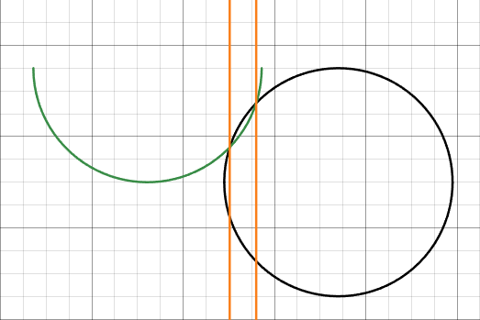
Then we could simplify the equation, expressing it as a function of $x$ in terms of $x^{2}$, $x$, and a constant term (i.e. a quadratic equation). Generalising, if we look at the equation $ax^{2}+bx+c=0$ where $a,b,c$ are all constant, we can derive an equation to give all of the possible $x$ values that satisfy this equation. Here I used a method called “completing the square”.
$$ax^{2}+bx+c=0$$
$$⟹x^{2}+\frac{b}{a}x=-\frac{c}{a}$$
$$⟹{\left(x+\frac{b}{2a}\right)}^{2}-\frac{b^{2}}{4a^{2}}=-\frac{c}{a}$$
$$⟹{\left(x+\frac{b}{2a}\right)}^{2}=\frac{b^{2}}{4a^{2}}-\frac{c}{a}$$
$$⟹x+\frac{b}{2a}=±\sqrt{\frac{b^{2}}{4a^{2}}-\frac{c}{a}}$$
$$⟹x=-\frac{b}{2a}±\sqrt{\frac{b^{2}}{4a^{2}}-\frac{4ac}{4a^{2}}}$$
$$⟹x=-\frac{b}{2a}±\frac{\sqrt{b^{2}-4ac}}{2a}$$
$$⟹x=\frac{-b±\sqrt{b^{2}-4ac}}{2a}$$
This formula is often referred to as the “quadratic formula” because of its ability to simplify the process of solving quadratic equations.
As you can see, the $±$ causes a lot of quadratic equations to have two solutions (i.e. one where it’s a $+$ and one where it’s a $-$). However, if the inside of the square root is equal to zero, there will only be one solution because the $±$ doesn’t change the expression. Because we only want 1 solution (i.e. one point at which the circles intersect), we can state that $\sqrt{b^{2}-4ac}=0⟹b^{2}-4ac=0$. Then all we’d need to do is substitute in the coefficients of our quadratic equation and solve for $x_{1}$. This gives us a value for $x_{1}$ in terms of the variables we already know (i.e. $c, p, s, w)$.
However, when I was working through this method, it required some truly awful brute-force algebra (you can try it if you want). So instead, I swapped to using another approach.

Approach 2 – equating distances
The centres of the two circles are $\left(\frac{1}{5}\left(4w-3\left(s+2p\right)\right),\frac{h}{2}\right)$ and $\left(x_{1},\frac{h}{2}+c\right)$, so the shortest distance between their centres is given by the Pythagorean theorem:
$${\left(\frac{1}{5}\left(4w-3\left(s+2p\right)\right)-x_{1}\right)}^{2}+{\left(\frac{h}{2}-\frac{h}{2}-c\right)}^{2}=D^{2}$$

Equating to $2c$:
$$4c^{2}={\left(\frac{1}{5}\left(4w-3\left(s+2p\right)\right)-x_{1}\right)}^{2}+{\left(\frac{h}{2}-\frac{h}{2}-c\right)}^{2}$$
$$⟹4c^{2}={\left(\frac{1}{5}\left(4w-3\left(s+2p\right)\right)-x_{1}\right)}^{2}+c^{2}$$
$$⟹c\sqrt{3}=\frac{1}{5}\left(4w-3\left(s+2p\right)\right)-x_{1}$$
$$⟹x_{1}=\frac{1}{5}\left(4w-3\left(s+2p\right)\right)-c\sqrt{3}$$
Therefore, we now have the coordinates of the centres of the circles (a much simpler method than the first one), meaning we can graph them perfectly.
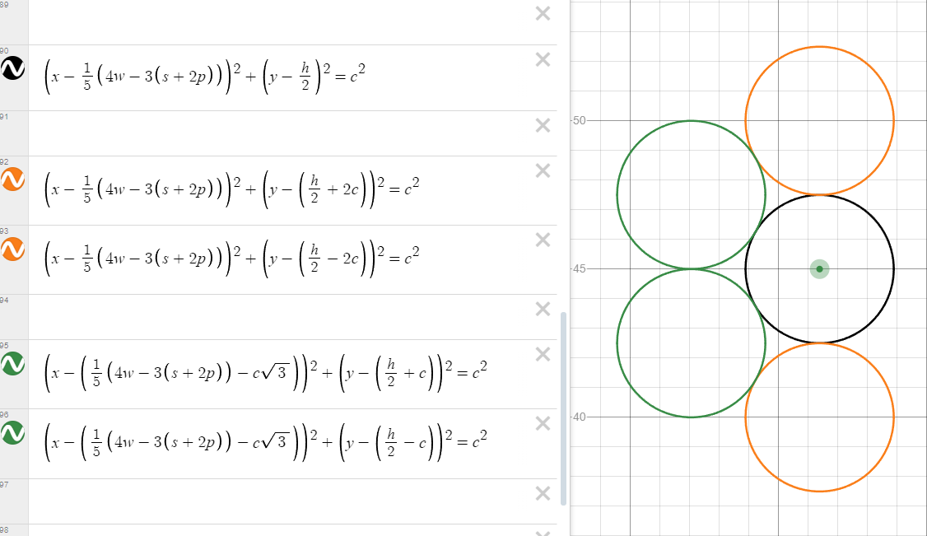
Also, notice that the differences between the x-coordinates of the centres is $c\sqrt{3}$. Using this fact, I didn’t need to do the derivation again and could instead just add or subtract multiples of $c\sqrt{3}$ when moving rows. For example, the next coloured ball on the left is just $-2c\sqrt{3}$ centimetres away from the eight ball.
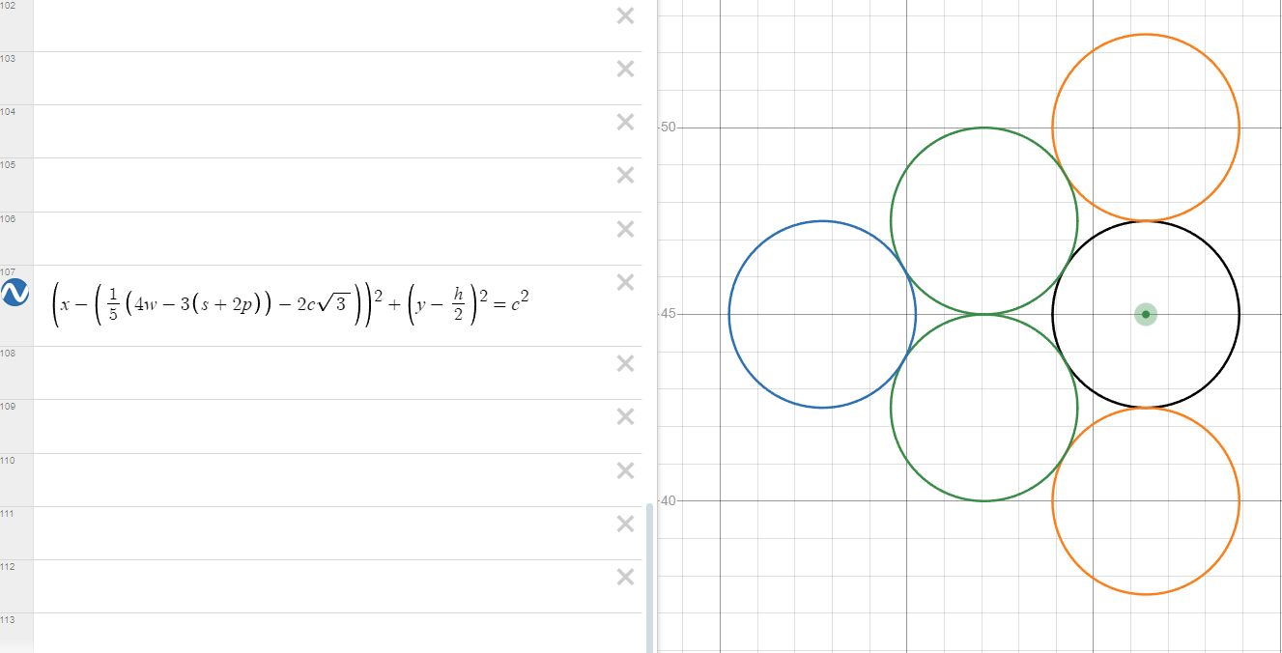
One consequence of using exact mathematical values for positions is that it can produce some quite messy equations. For example, due to the coloured balls forming a tight-knit triangle and the starting position of the eight ball being very specific, the equations for the coloured balls turned out much longer than they would have if a less exact approach (i.e. playing around with numerical approximations until they lined up nicely) was used instead.

Sidenote
Another neat thing with graphing calculators like Desmos is that is has effectively unlimited resolution (not actually infinite, since at some point the numbers get too precise/large for it to handle). This means you can zoom in as much as you want to really see precise detail. Here’s an example (if you look at the axis on the edges of the images, you can see the change numerically too):
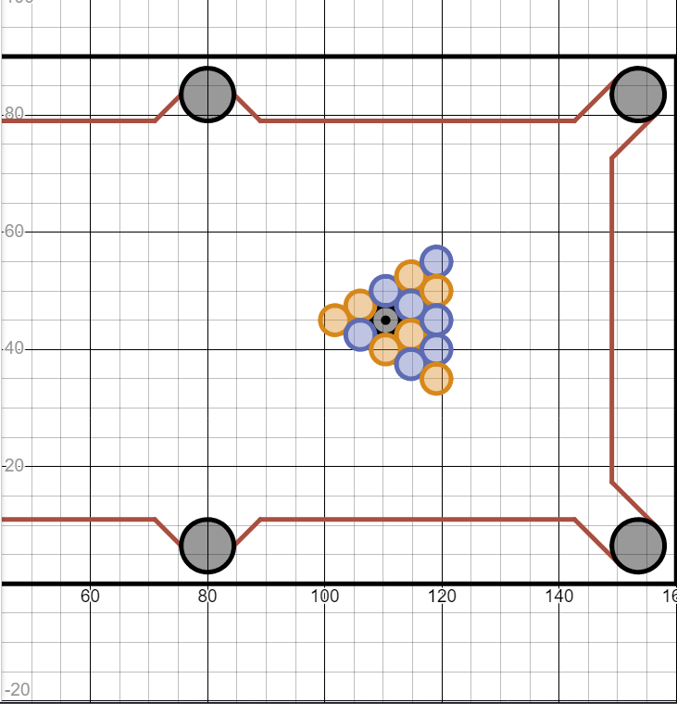 | 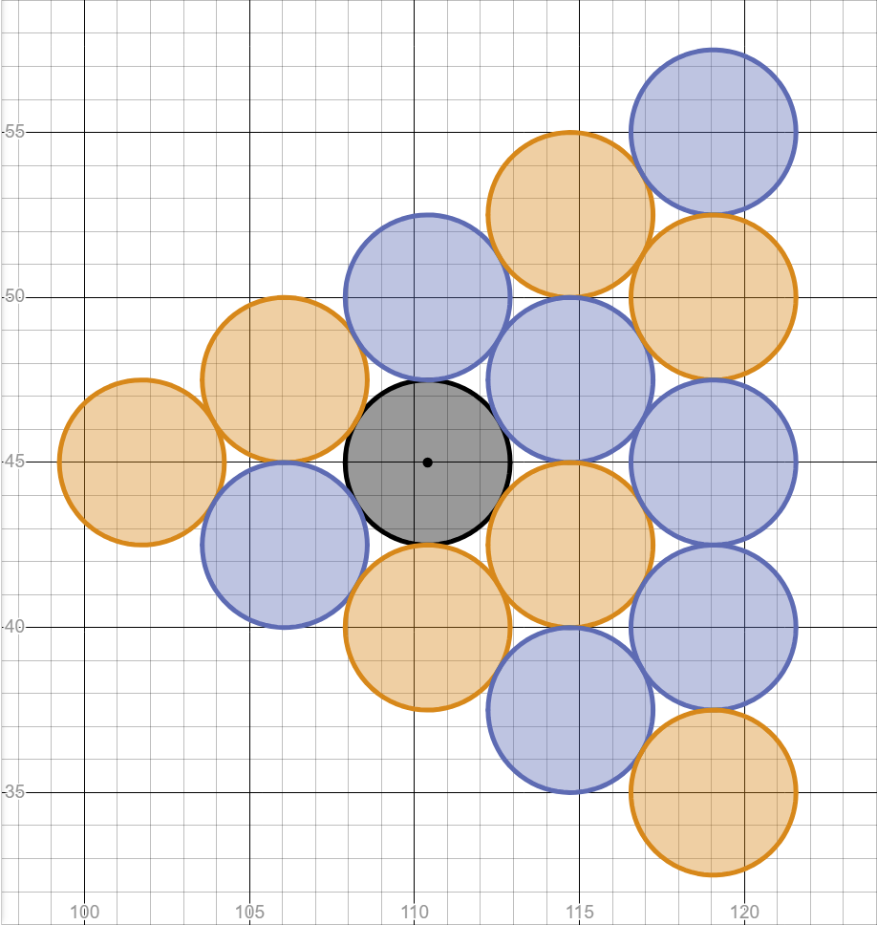
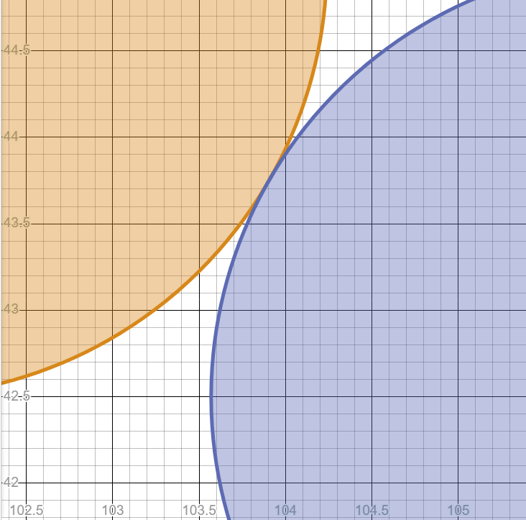 | 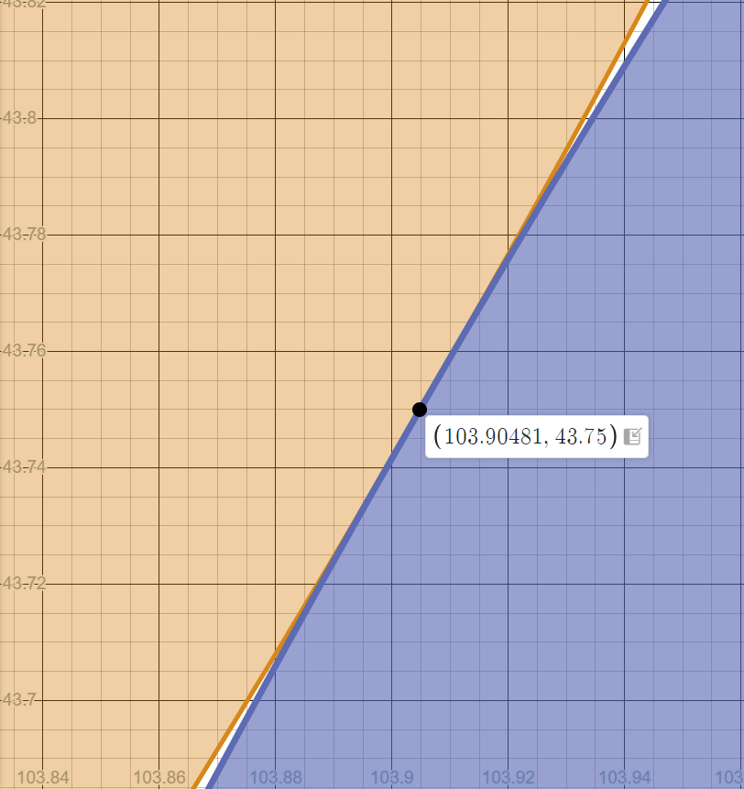
(Also, if you select a plotted equation, you can see the point/s at which it intersects other plotted equations as shown. This could’ve been helpful if I’d chosen to use a numerical approximation for the positions).

Pool ball textures
Before I rendered the object balls, I needed to give them a texture so that they could be distinct from the cue ball. Up until now, I had been using a very basic circle outline as the texture for both pool balls used in collision testing, but this was going to make it very confusing when lots of them move at the same time.
Since I used a PNG image for the basic circle. I used draw.io (a web-based technical drawing program) to create some simple sprites for the cue ball, the solid coloured pool balls, and the striped coloured pool balls.

I used off white and dark grey to make them visible against the white background while also being distinct from one another while also making it clear that these were prototypes (hence the absence of more vibrant ball colours).
While these images did render (thanks to MonoGame’s MGCB editor), they were way too large. To handle this, I used my Desmos graph’s pixel ratio to work out that the images needed to be 40x40 pixels for a 1280x720 resolution.
However, even with this change, since the balls didn’t spin when moving the striped ones looked odd (as if they were sliding, rather than rolling). To prevent this odd appearance, I changed the coloured ball images to bright red and yellow, changing the background to dark green. These colours are more in line with a pool variant like blackball pool and the darker background helps to make every object more distinct and visible. (Note that I can’t really show how strange it looked, because that relies on a video not an image.)
This worked perfectly for a 1280x720 resolution. But if that changed, the hitboxes no longer matched the sprites, making the game pretty much unplayable. To combat this, I had to resort to generating textures with a function, rather than loading a pre-existing one. I could’ve used the scale parameter in MonoGame’s Draw function, but I was worried that at higher resolutions the image would be too pixelated due to the resolution difference.
I created a function called CreateBlockColouredCircleTexture. It has the circle’s radius and colour as parameters (as well as Game1’s GraphicsDevice which is needed as a parameter in Texture2D’s constructor). I defined int diameter = radius * 2 because the generated texture needs to form a square whose side lengths are the circle’s diameter, and having a diameter variable makes this (as well as the positioning in the loops later on) look cleaner. pixelColours is an array whose size is equal to the square of the circle’s diameter (in pixels) which I looped through to assign each pixel its own colour. In hindsight, I might’ve been able to use a 2D array (if the SetData function has an overload for those) to make the code slightly more understandable, but it works perfectly fine so I don’t see a need to change it now. circleTexture is just an empty Texture2D texture that I map pixelColours onto at the end before returning it.
Now, for the loops, I treat it as moving down rows and across columns of an image’s pixels by adding the current y-coordinate multiplied by the diameter to the current x-coordinate. This converts Cartesian coordinates into indexes (with the origin in the top left). Essentially, for each pair of indexes it has in each loop:
It starts with this:
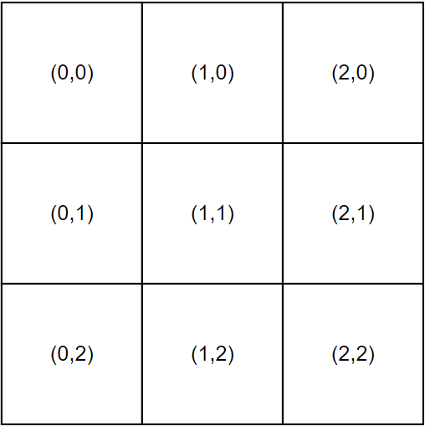
Converts it to this:
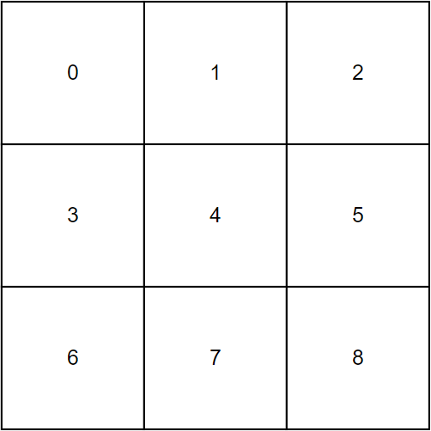
And iterates through it like this:
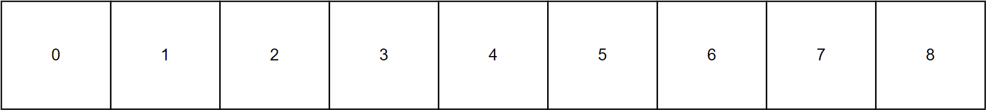
Now that it’s essentially just iterating through a coordinate grid, I can use inequalities to specify which points should be coloured and which shouldn’t. For each point, I used an if statement to see if that point is within the bounds of the circle. If it is, the colour of that pixel is set to the input colour. If it isn’t, it’s set to transparent instead.
int distanceSquared = ((radius - xCoordinate) * (radius - xCoordinate)) + ((radius - yCoordinate) * (radius - yCoordinate));
The equivalent mathematical inequality (rendered using Desmos) includes all the points inside the circle and is contained within a cube whose side length is the circle’s diameter (for all $r>0$):
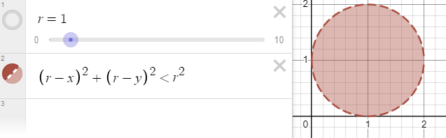
After iterating all the way through pixelColours, it then maps pixelColours onto circleTexture which converts the array of colours into a Texture2D.
Putting it all together, I produced this function:
public static Texture2D CreateBlockColouredCircleTexture(GraphicsDevice graphicsDevice, int radius, Color textureColour)
{
int diameter = radius * 2;
Texture2D circleTexture = new(graphicsDevice, diameter, diameter); // empty texture the size of the circle
Color[] pixelColours = new Color[diameter * diameter];

// iterating through array as if it were a coordinate grid to find points easier:
for (int xCoordinate = 0; xCoordinate < diameter; xCoordinate++)
{
for (int yCoordinate = 0; yCoordinate < diameter; yCoordinate++)
{
// centre is at the point: (radius, radius)
int distanceSquared = ((radius - xCoordinate) * (radius - xCoordinate)) + ((radius - yCoordinate) * (radius - yCoordinate)); // square root isn't necessary because it can be compared to radius^2 faster

if (distanceSquared < radius * radius) // note: <= produces some spikey edges whereas < doesn't
{
pixelColours[xCoordinate + (yCoordinate * diameter)] = textureColour;
}
else
{
pixelColours[xCoordinate + (yCoordinate * diameter)] = Color.Transparent;
}
}
}
circleTexture.SetData(pixelColours); // maps the array of colours onto the texture
return circleTexture;
}
Here’s an example for a green circle, rendered as a Sprite:
testTexture = CreateBlockColouredCircleTexture(graphicsDevice, 50, Color.Green);
testSprite = new(testTexture, new Vector2(Game1.windowWidth / 2, Game1.windowHeight / 2));

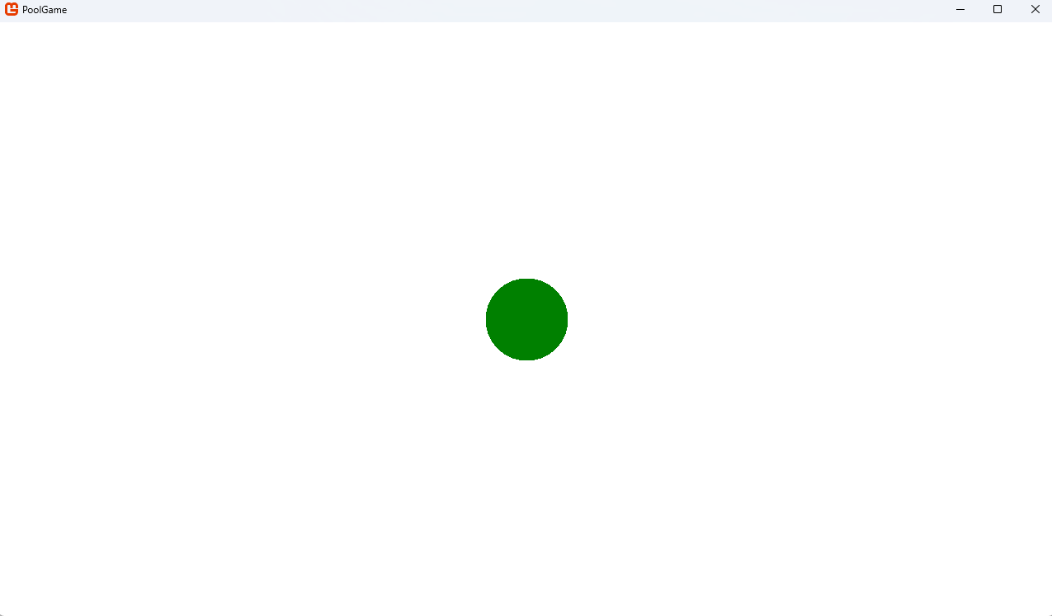
While this can look pixelated at lower resolutions, fixing that would require something like anti-aliasing which is out of the scope for this project.
Overall, this function now not only makes changing the resolution not cause any rendering errors, but it also opens the option to add customisable pool ball colours down the road.
Also, note that this function doesn’t have the capability to render more detailed circle sprites, only block-coloured ones. For sprites like the eight ball’s, I’ve kept them as one block colour for now (black for the eight ball). I will consider changing this later, but it isn’t really necessary for the game to function.

Tests
CreateBlockColouredCircleTexture(GraphicsDevice graphicsDevice, int radius, Color textureColour)
To test CreateBlockColouredCircleTexture, I will attempt to render Sprite objects with a variety of different colours and radii. Every time that I change one variable, I will keep the other constant as a control variable to make sure it wouldn’t somehow impact the size.
Colour | Radius | Image | Test passed?
Color.Pink | 50 | 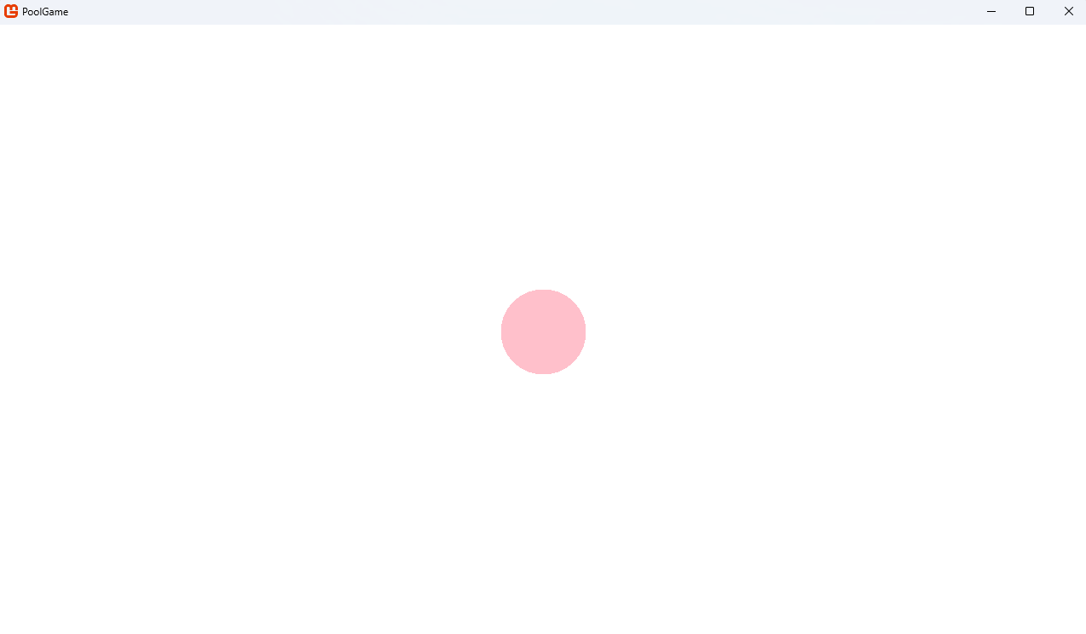 | Yes
Color.Pink | 100 | 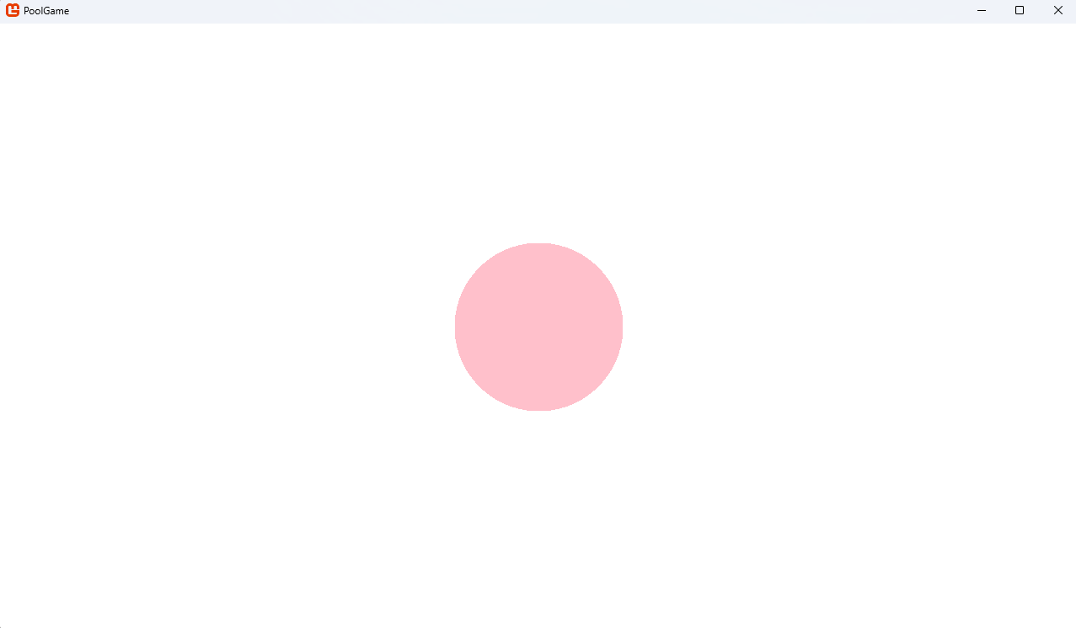 | Yes*
Color.Pink | 5 | 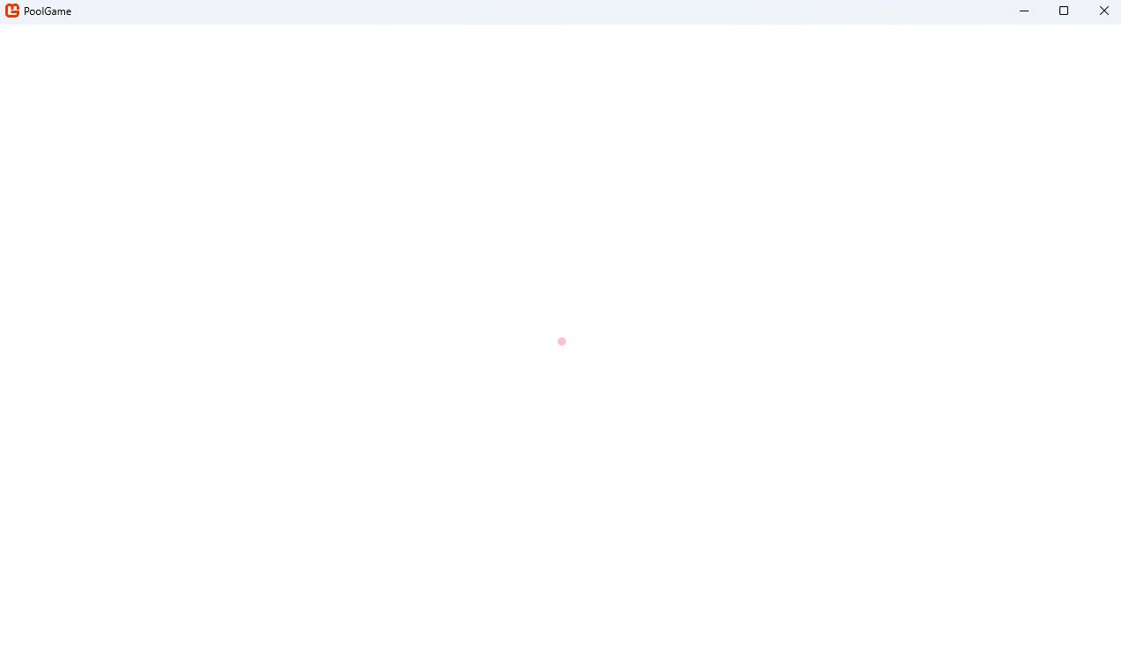 | Yes
Color.Pink | 1 |  | Yes**
Color.Pink | 640*** | 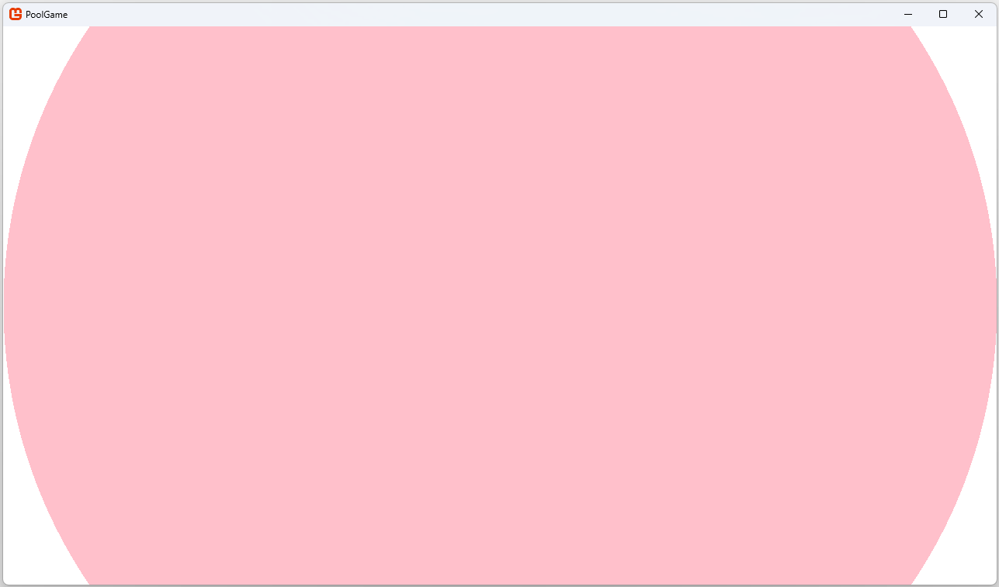 | Yes****
 | 1280 | 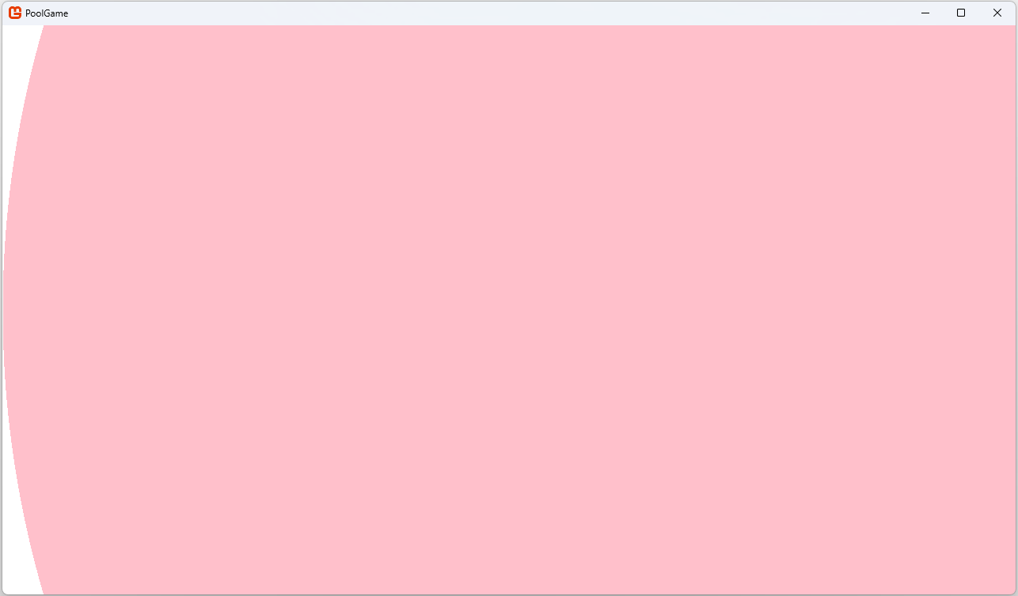 | Yes****
Color.Pink | -100 | 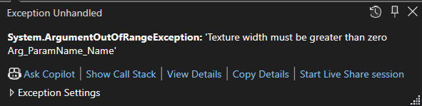 | Yes******
Color.Pink | 0 |  | Yes******
Color.Pink | 100.5 | Invalid input, C# mandates that all inputs must be integers | Yes******
Color.Pink | 300 | 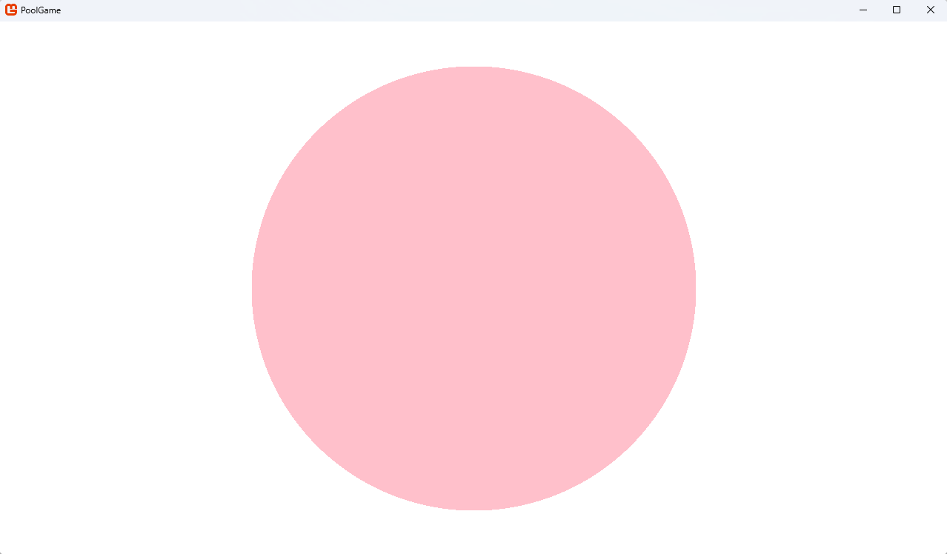 | Yes
Color.Goldenrod | 300 | 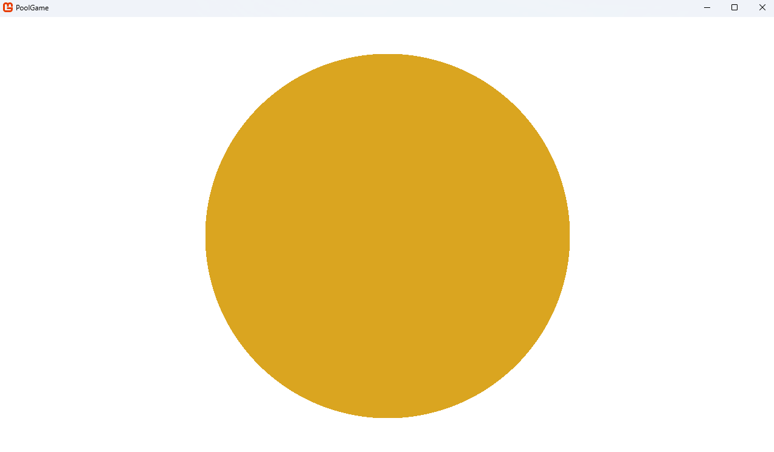 | Yes
Color.LimeGreen | 300 | 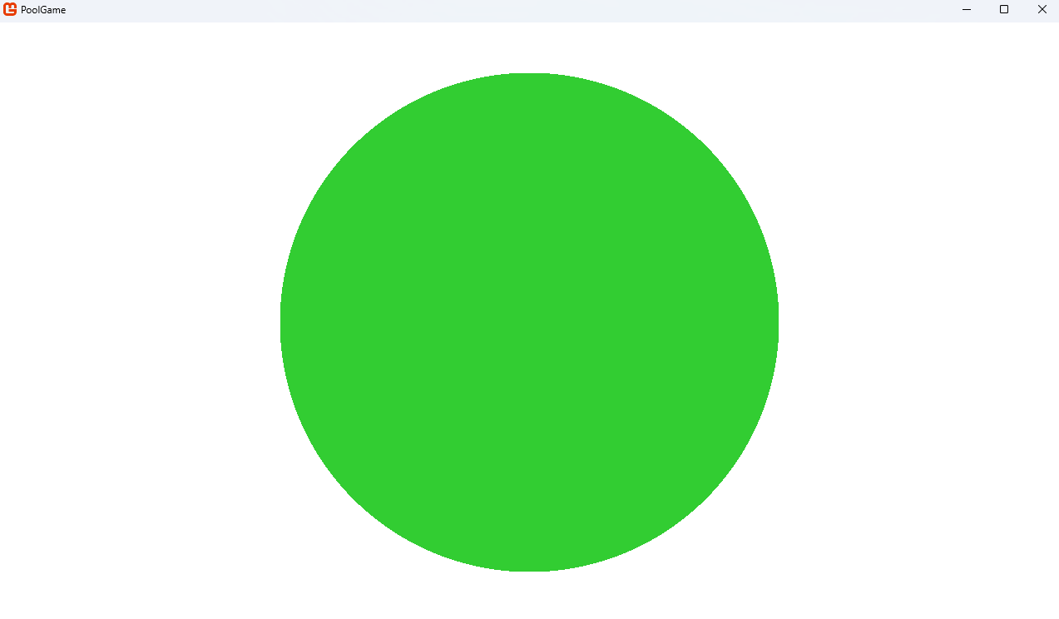 | Yes
Color.Red | 300 | 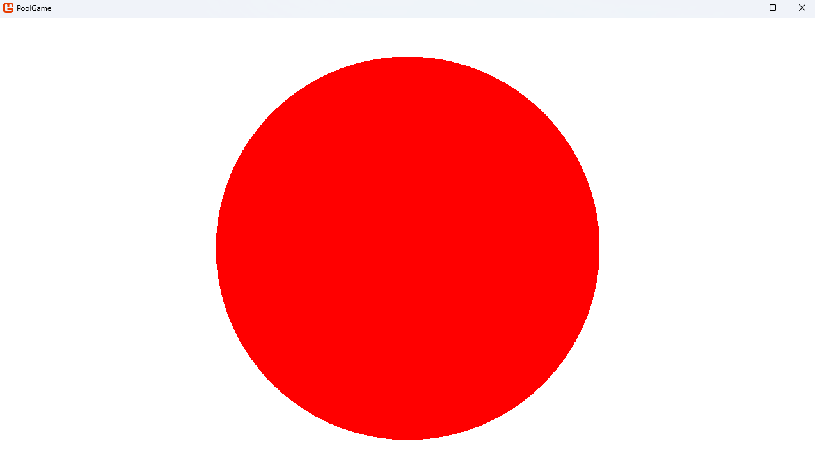 | Yes
new Color(21, 88, 67) | 300 | 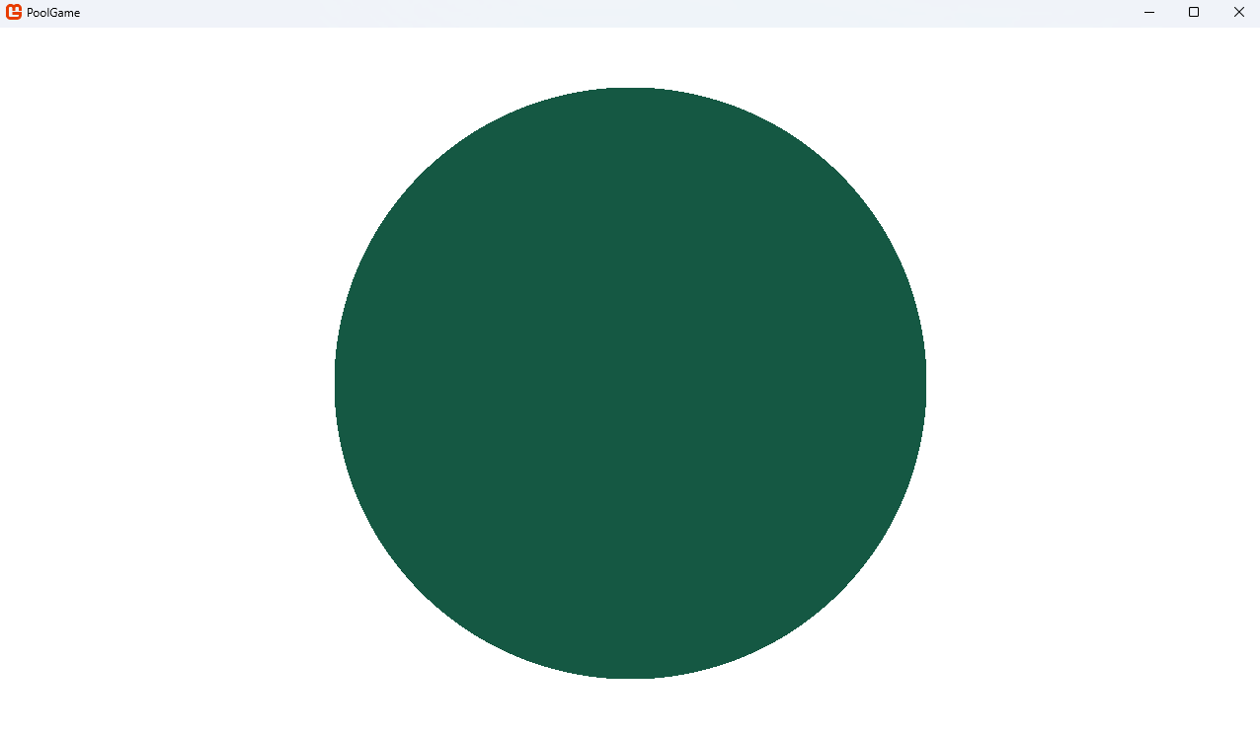 | Yes*******
*For this one and the one above, I measured the circle’s diameters (easier to measure than radii) with a ruler on my monitor to confirm that this one was exactly twice as wide.
**The “circle” isn’t visible because it only takes up one pixel which was destroyed when I shrunk the image in MS Word, but in the game window it did render.
***640 is half the screen width, so we can easily see that it’s the correct size.
****Note that a snippet of a window behind the game window is visible because I wanted to make sure I didn’t accidentally crop the very edges of the screen when I screenshotted to show that it does form a circle exactly up to the edges.
*****1280 is the screen width, so we can easily see that it’s the correct size. Note also that I had to change the centre to make sure the curvature wasn’t all outside of the field of view.
******When radius is negative, zero, or not an integer, the code correctly throws an error, eliminating the chance for undetected errors to go unnoticed down the road if, for example, radius was calculated by a function that could return non-positive numbers or floats.
*******Colour accuracy verified by using W3Schools’ “HTML Color Picker” at https://www.w3schools.com/colors/colors_picker.asp
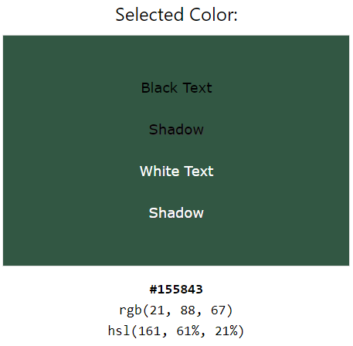
Overall, this shows that the function is working as expected. In response, no actions need to be taken.

All pool balls
I can use the “Coloured balls” folder in my Desmos graph and the textures to now create instances of PoolBalls in the correct positions on the table. I added all the new variables from my Desmos graph that were relevant to the placement, replacing their single-character variable names with fully written descriptors to improve clarity. Otherwise, people would have to refer back to a legend every time they need to find out what each variable represents.
Since each coloured ball is relative to the eight ball’s position, I created a local variable just for that position so that I don’t need to rewrite it in full for each PoolBall’s constructor. I’ll only show some to prevent this section getting too bloated and repetitive since all the object balls’ positions are almost identical and very long.
eightBallPosition = new Vector2((4f / 5) * ((Game1.windowWidth - (4 * pocketRadius) - (2 * tablePocketSpacing))), Game1.windowHeight / 2);
// positioned 1/5th the width of the playing surface
// first column:
_yellowObjectBall1 = new(yellowObjectBallTexture, new Vector2(eightBallPosition.X - (2 * poolBallRadius * Math.Sqrt(3)) - (2 * spacing), eightBallPosition.Y), poolBallRadius, false);

// second column:
_yellowObjectBall2 = new(yellowObjectBallTexture, new Vector2(eightBallPosition.X - (poolBallRadius * Math.Sqrt(3)) - spacing, eightBallPosition.Y + poolBallRadius + spacing), poolBallRadius, false);

_redObjectBall1 = new(redObjectBallTexture, new Vector2(eightBallPosition.X - (poolBallRadius * Math.Sqrt(3)) - spacing, eightBallPosition.Y - poolBallRadius - spacing), poolBallRadius, false);
I can then add all these new balls into the poolBalls array so that they are updated correctly.
poolBalls = new List<PoolBall> { _cueBall, _eightBall, yellowObjectBall1, _yellowObjectBall2, _yellowObjectBall3, _yellowObjectBall4, _yellowObjectBall5, _yellowObjectBall6, _yellowObjectBall7, _redObjectBall1, _redObjectBall2, _redObjectBall3, _redObjectBall4, _redObjectBall5, _redObjectBall6, _redObjectBall7};
However, when I started the game, some of the balls immediately move. I reasoned that this was likely because the balls are immediately touching/overlapping, therefore their collisions would trigger immediately. One possible contributor to this is the fact that that since their centres were derived on the basis that they intersect each other at one point, they ended up intersecting each other at one point/pixel as designed. Another contributor could be the Math.Sqrt(3) function giving a value that caused them to overlap (since $\sqrt{3}$ is irrational, the function must give an approximate value because numbers stored on a computer can only have so much precision).
Using my Desmos graph again, I replaced $\sqrt{3}$ with the variable $S$. I then defined $S$ as $\sqrt{3}+a$ (with another new variable, $a$) so that I could change the value $a$ to see if any pool balls overlap.
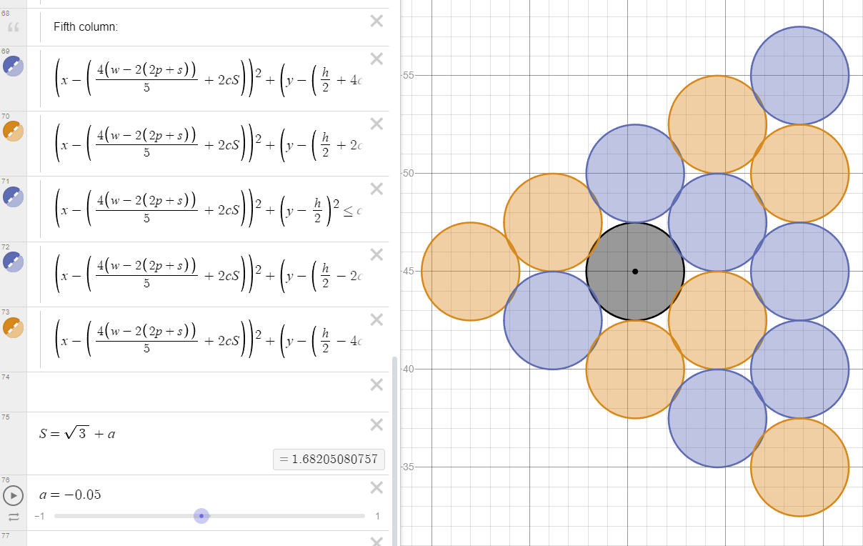
As you can see, when $a=-0.05$ they overlap. This means that, if Math.Sqrt(3) is underestimating $\sqrt{3}$, they can overlap (even if it’s by a much smaller amount than this, the collision detection should still detect them as colliding).
I decided to fix both issues at once. I added spacing between each ball (both vertically and horizontally), making sure to add more spacing as they got further away (i.e. 1$×$ for 1 ball away from the eight ball, 2$×$ for 2 balls away, 3 $×$ for 3, etc.). I also replaced Math.Sqrt(3) with sqrt_3 = 1.7320508076f (an overestimate since $\sqrt{3}=1.732050807568…$ truncates to 1.7320508075 not 1.7320508076) which I could then refer to instead. An overestimate ensures that they are moved further away from each other, rather than closer.
// first column:
_yellowObjectBall1 = new(yellowObjectBallTexture, new Vector2(eightBallPosition.X - (2 * poolBallRadius * sqrt_3) - (2 * spacing), eightBallPosition.Y), poolBallRadius, false);

// second column:
_yellowObjectBall2 = new(yellowObjectBallTexture, new Vector2(eightBallPosition.X - (poolBallRadius * sqrt_3) - spacing, eightBallPosition.Y + poolBallRadius + spacing), poolBallRadius, false);

_redObjectBall1 = new(redObjectBallTexture, new Vector2(eightBallPosition.X - (poolBallRadius * sqrt_3) - spacing, eightBallPosition.Y - poolBallRadius - spacing), poolBallRadius, false);
(Looking back, given that all balls start at zero velocity, this shouldn’t’ve caused the issue (only causing problems when the CueBall causes them to move, not from the start). But those approaches did fix it somehow (and made it look nicer since the balls were more spaced apart), so it must’ve been something to do with it.)
Overall, the table now looks like this:
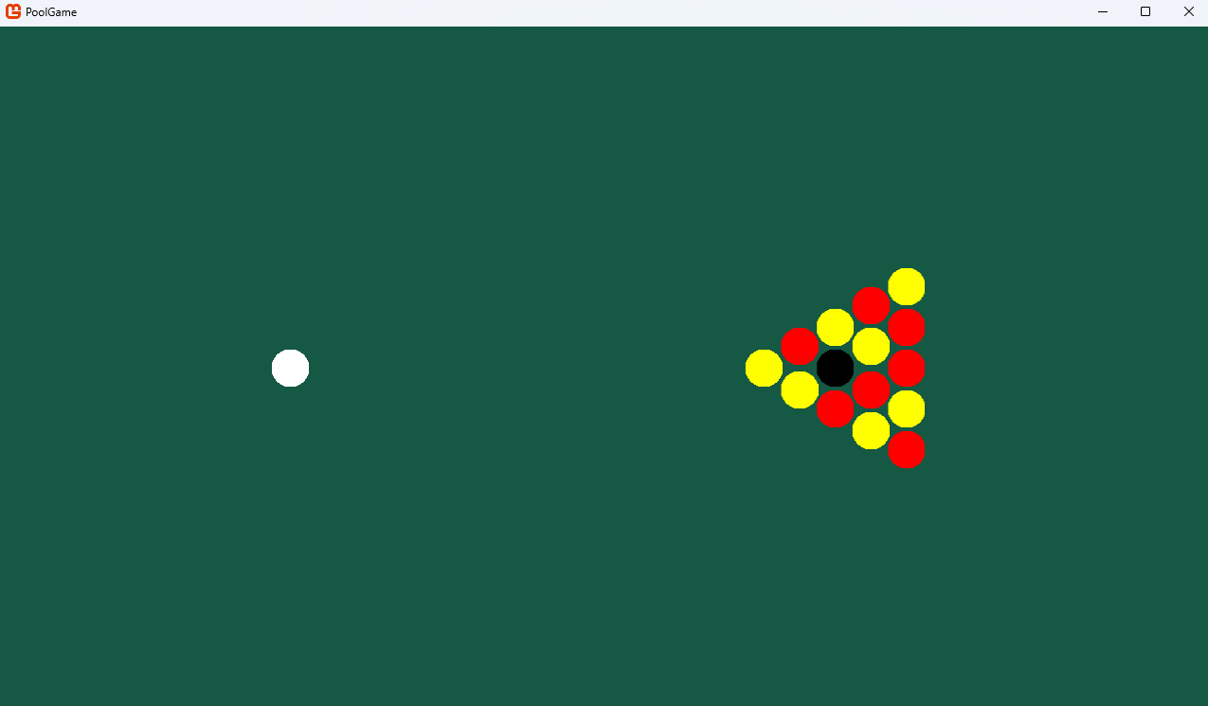
Note that I changed the background colour to new Color(21, 88, 67) to better represent the background of an analogue pool table.

Tests
There are no specific functions I can test here, so instead I will try a few breaks (i.e. shooting the cue ball at the triangle) with varying initial shot intensity and direction.
Test No. | Post-break screenshot | Stationary screenshot
1 | 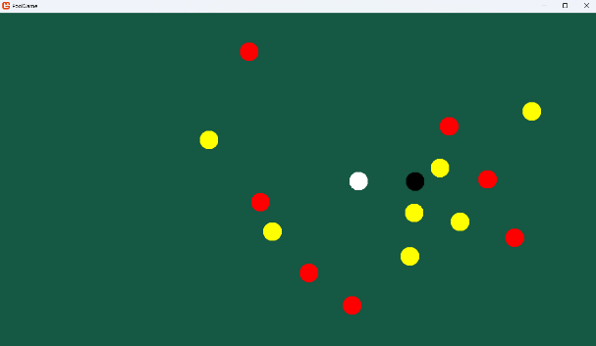 | 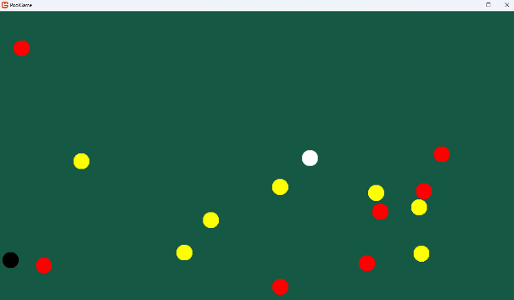
2 | 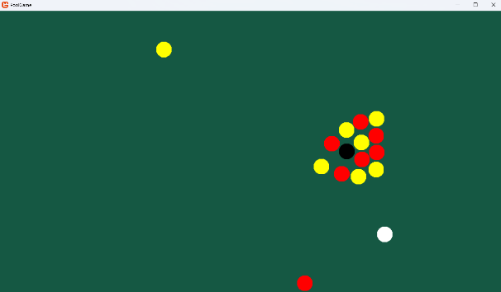 | 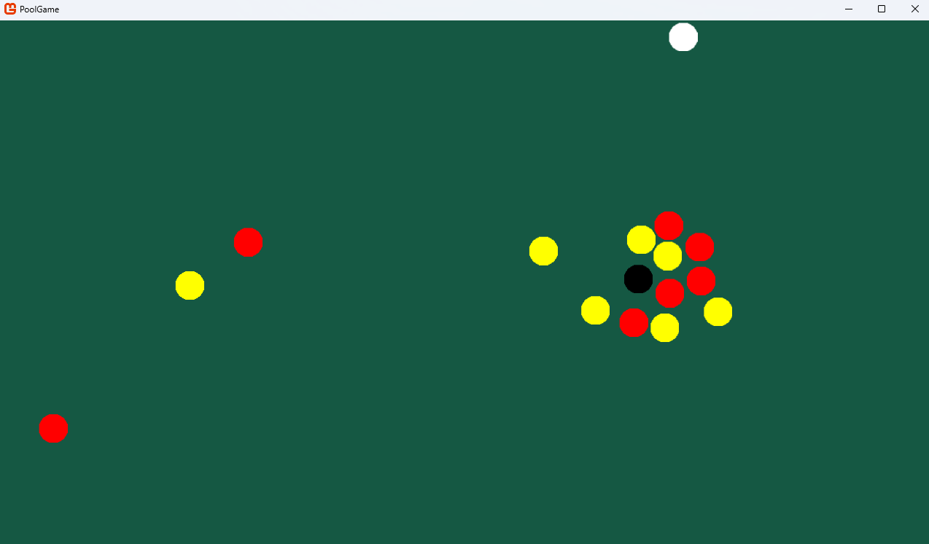
3 | 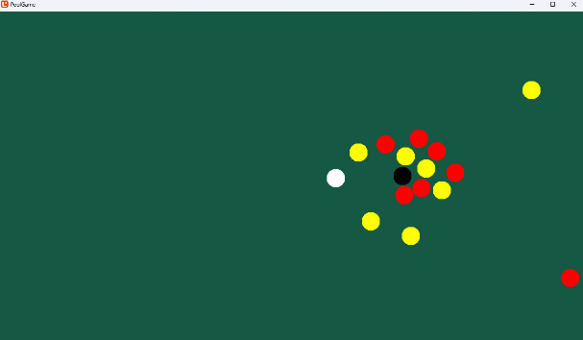 | 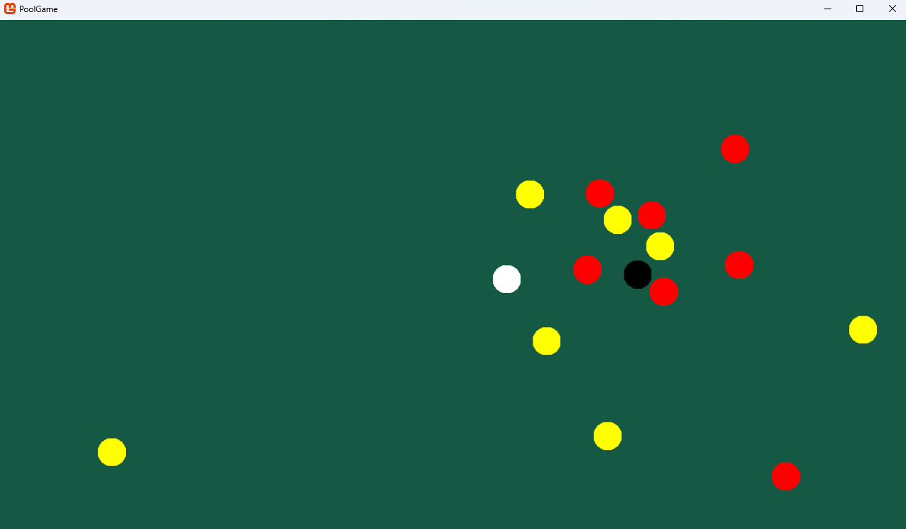
Overall, this shows that the positioning is working as expected, not causing issues with the larger number of PoolBalls. In response, no actions need to be taken.

Pockets
To continue filling out the table, I created the Pocket class (inheriting from CollideObject) which should remove any PoolBalls from the screen when they touch it.
public class Pocket: CircleSprite
{
public Pocket(Texture2D _texture, Vector2 _position, float _radius) : base(_texture, _position, _radius)
{
texture = _texture;
position = _position;
radius = _radius;
}

public override void Update(GameTime gameTime)
{
base.Update(gameTime);
}
}

Their sprites were created with the CreateBlockColouredCircleTexture function, with black as the colour and pocketRadius as the radius. I derived the position of each pocket when I created my Desmos graph, so I just needed to use those for Pocket centres. Here’s an example construction of a Pocket:
_pocketTopLeft = new(pocketTexture, new Vector2(pocketRadius + tablePocketSpacing, pocketRadius + tablePocketSpacing), pocketRadius);
Its only method, DoCollisions, iterated through poolBalls, checked if each PoolBall is touching it, and removes them from poolBalls. To do this, I had to change poolBalls’ type from PoolBall[] to List<PoolBall>. This changes it from a fix-sized array into a variable-sized list, allowing me to add and remove any PoolBalls when I need to. If I kept it as an array, I could’ve either set potted PoolBalls to null or added a Bool attribute to PoolBall to specify if the PoolBall is potted. However, using a list means that whenever I cycle through poolBalls I don’t even need to check if PoolBalls are potted because they no longer are a part of poolBalls. This reduces unnecessary loops when iterating through PoolBalls.
As for the collision detection, I used the same “if statement” I used for the PoolBall-PoolBall collisions (i.e. checking if the distance between both the circle’s centres is less than the sum of their radii).
public void DoCollisions()
{
for (int i = 0; i < Game1.poolBalls.Count; i++)
{
if (Vector2.Distance(position, Game1.poolBalls[i].position) < Game1.pocketRadius + Game1.poolBallRadius)
{
Game1.poolBalls.RemoveAt(i);
}
}
}
But when I looked at the collision range, they seem to disappear way earlier than when compared to analogue pool. Looking at actual pool physics, the ball should only begin to fall in when its centre of mass is over the pocket. To accommodate for this, I changed the distance between their centres to just the radius of the pocket, rather than both the pocket and the pool ball.
if (Vector2.Distance(position, Game1.poolBalls[i].position) < Game1.pocketRadius)
Now that balls successfully get potted, I need a way to respawn the CueBall (not the object balls because their disappearance is how the game progresses).
To do this, I had to add a Bool isPotted attribute to CueBall which becomes true when the CueBall is potted. Since the CueBall is always active (due to respawning), removing it from poolBalls when it’s potted doesn’t make sense. If it was removed, it would just have to be re-added which would change its index (causing issues for anything that might come to rely on the cue ball being inside of poolBalls[0]). Also, it wouldn’t be able to update since all PoolBalls are updated by iterating through poolBalls and updating each in Game1.Update, so it couldn’t run the code to add it back into poolBalls. The collision response inside of the collision detection’s “if statement” now looks like this:
if (Game1.poolBalls[i] is CueBall)
{
Game1._cueBall.velocity = Vector2.Zero; // stops it after it's pocketed so that IsAllStationary() doesn't think it's still moving
Game1._cueBall.isPotted = true; // removing _cueBall from poolBalls means it can't be updated so it can't reappear
}
else
{
Game1.poolBalls.RemoveAt(i);
}
Then, in CueBall, I added some code to its Update method to respawn the CueBall after the current turn ends. To do this, I needed to check if all PoolBalls were stationary and check for an input (I decided to use left click for this because it couldn’t be used to shoot when no CueBall exists). I started by defining an IsAllStationary (referenced in a comment in the code above) method in Game1 which iterates through poolBalls and checks if each PoolBall’s velocity is zero, returning false if any are and returning true if none are.
public static bool IsAllStationary()
{
foreach (PoolBall poolBall in poolBalls)
{
if (poolBall.velocity != Vector2.Zero)
{
return false;
}
}
return true;
}
Now the start of the block of code can look like this:
if (isPotted && Game1.IsAllStationary() && (Game1.GetState().LeftButton == ButtonState.Pressed)) // after all objects are stationary and LMB is pressed
Note that, at the same time, I added IsAllStationary as a requirement for shooing the CueBall as well to prevent some rule breaking. I used the same condition as above.
It then takes the current mouse position and checks if it’s to the left of the baulk line (aka if it’s within the left-most 5th of the table), respawning it there and setting isPotted to false if it is. This code will run until the CueBall is placed correctly because it is in CueBall’s Update method. The specifics of the boundaries were derived and checked by using my Desmos graph.
if (isPotted && Game1.IsAllStationary() && (Mouse.GetState().LeftButton == ButtonState.Pressed)) // after the table is stationary and LMB is pressed
{
int cueBallCentreX = (Game1.windowWidth + (6 * Game1.pocketRadius) + (3 * Game1.tablePocketSpacing)) / 5; // 1/5th across the playing surface (not 1/5th across entire table)
Vector2 inputPosition = new Vector2(Mouse.GetState().X, Mouse.GetState().Y);

// checking if it's in the left-most 5th of the board
if ((inputPosition.X > (2 * Game1.pocketRadius) + Game1.tablePocketSpacing)
&& (inputPosition.X < (Game1.windowWidth + (6 * Game1.pocketRadius) + (3 * Game1.tablePocketSpacing)) / 5)
&& (inputPosition.Y > (2 * Game1.pocketRadius) + Game1.tablePocketSpacing)
&& (inputPosition.Y < Game1.windowHeight - ((2 * Game1.pocketRadius) + Game1.tablePocketSpacing)))
{
position = inputPosition;
isPotted = false;
}
}
This worked, but if the CueBall is placed on top of another PoolBall it can cause issues when shooting. To prevent this, I needed to iterate through poolBalls and check if each is colliding with the proposed CueBall position. I defined a Bool isColliding variable as false which is changed to true if any PoolBalls are colliding with the CueBall. If the isColliding is still true after the loop, the code waits for another position again.
// checking if it would be inside of another PoolBall:
bool isColliding = false;
for (int i = 1; i < Game1.poolBalls.Count; i++) // starting at i = 1 skips the cue ball from checking itself
{
if (Vector2.Distance(inputPosition, Game1.poolBalls[i].position) < radius * 2)
{
isColliding = true;
break; // once one is colliding, there's no point checking any more
}
}
if (!isColliding)
{
position = inputPosition;
isPotted = false;
}
Finally, I added a pockets array to store all Pockets (an array because, unlike PoolBalls, there are a fixed number of them). This could then be iterated through in Game1.Update function much like how poolBalls is used. I positioned the loop before any other update loops because if any PoolBalls got potted then the other object update loops wouldn’t have to update then, increasing efficiency by a little.
// Pocket-PoolBall collisions before PoolBall-PoolBall collisions because deleting is less intensive than calculating all collision trajectories
// and if a PoolBall is deleted, less collision work needs to be done
foreach (Pocket _pocket in pockets)
{
_pocket.Update(gameTime);
}
Now the table looks like this:
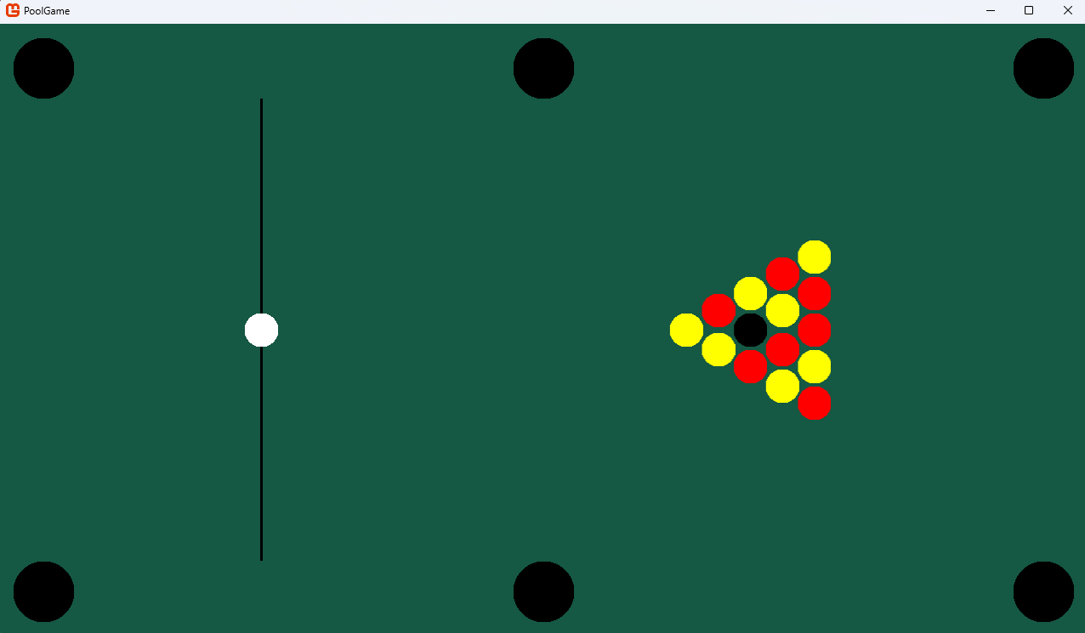
Note that the pockets are out in the open because the cushions which block parts of them haven’t been added yet. Also note that I added a baulk line texture as a line (or technically rectangle) using another texture generator method, CreateVerticalLineTexture(GraphicsDevice graphicsDevice, int length, int thickness, Color textureColour). But because this one was relatively simple (i.e. just make all pixels in the array one colour) I didn’t think it was necessary to show it.

Tests
DoCollisions()
To test DoCollisions, I shot the CueBall at each pocket a few times and at different angles to confirm that it does temporarily delete the CueBall when its centre overlaps with the pocket texture.
Pre-collision  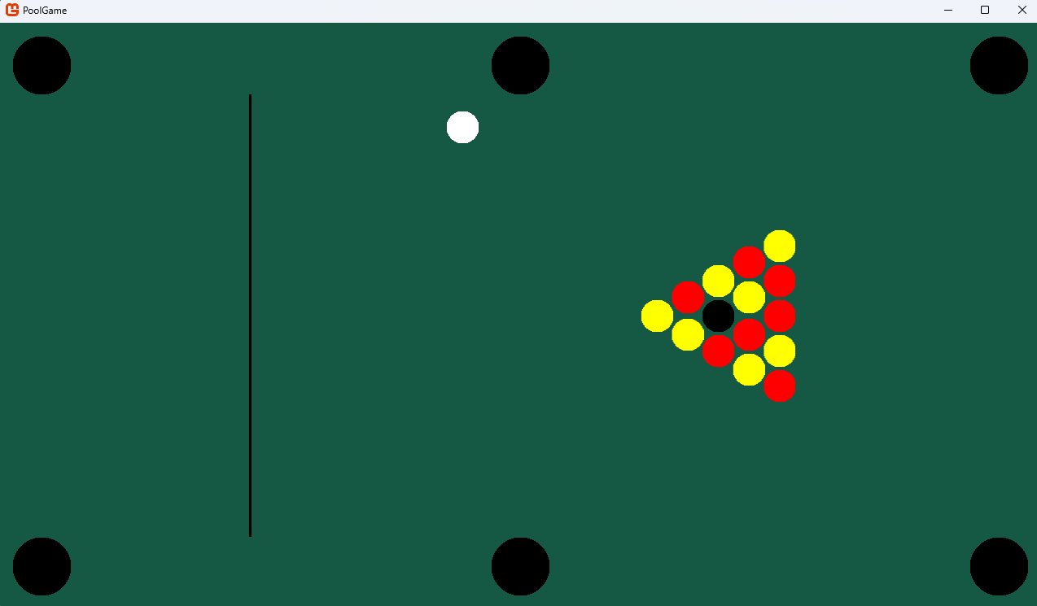 | Post-collision  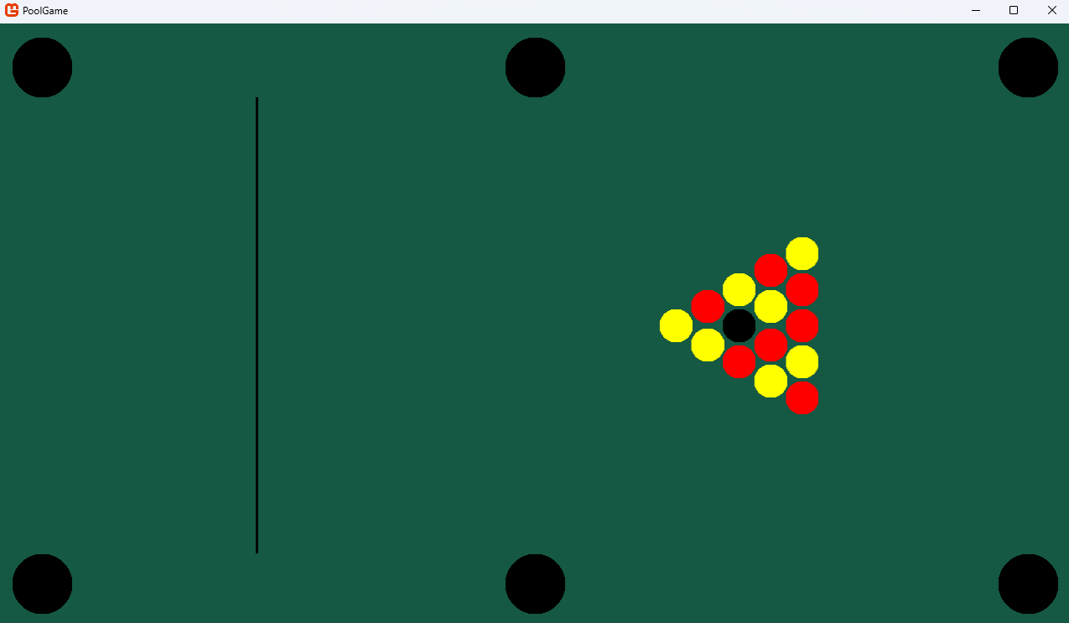
(There’s not much point showing this with images here for all pockets since it all basically looks the same.)
I also used DebugMove to move the CueBall right to the point where it would be potted a few times and then where it does get potted.
Pre-collision  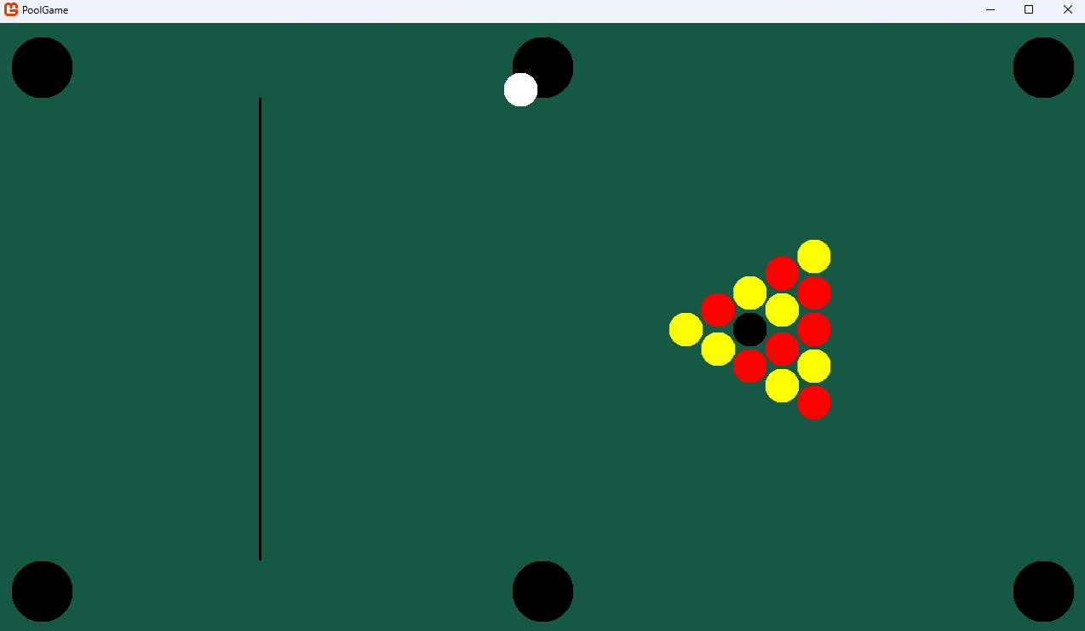 | Post-collision
Here we can also test the respawning of the cue ball (using screenshots of a recording to show the cursor position).
Pre-respawn attempt | Post-respawn attempt
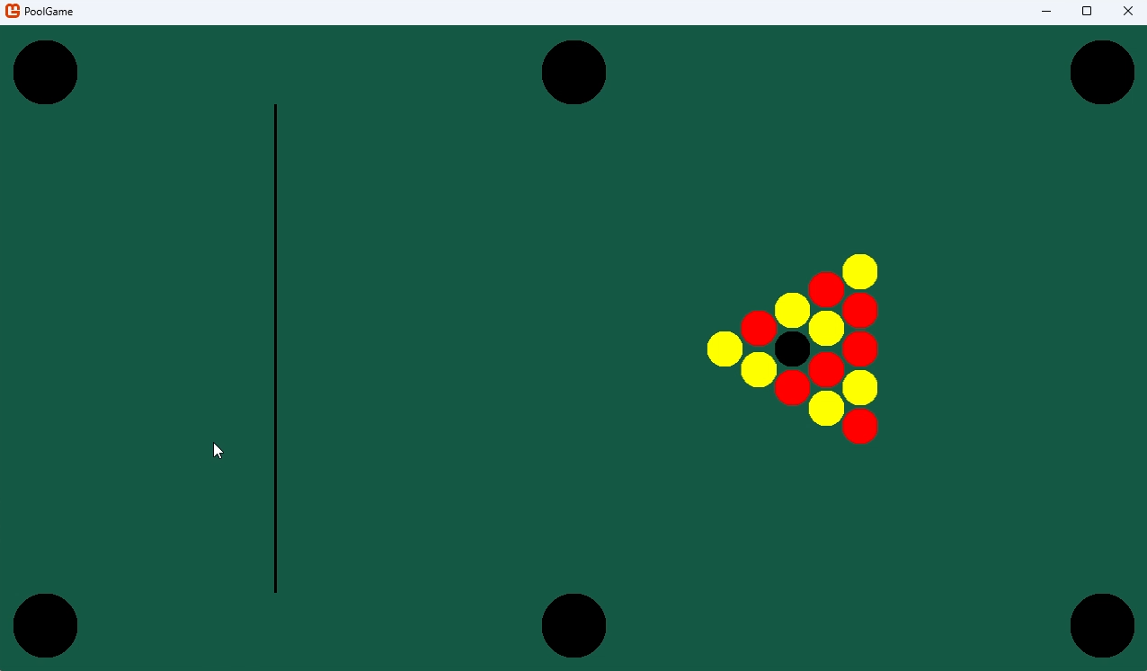 | 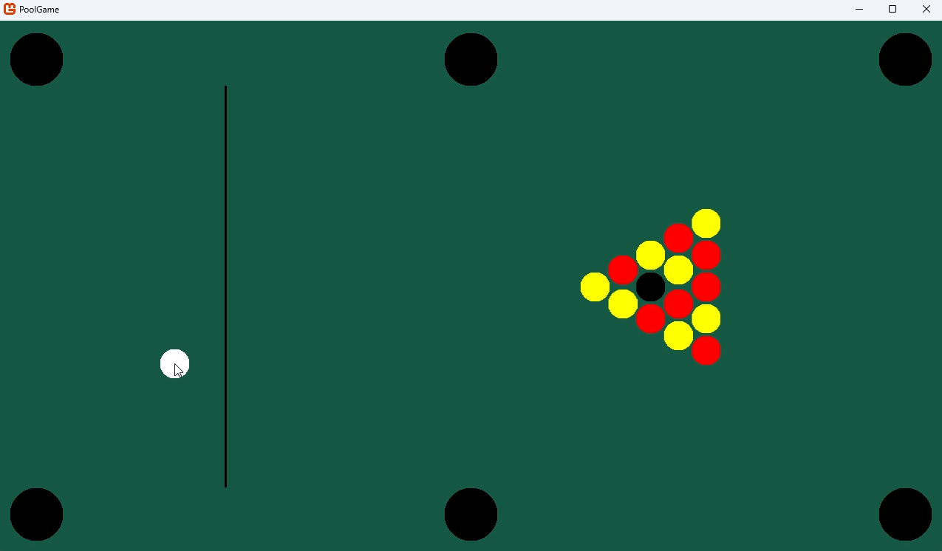
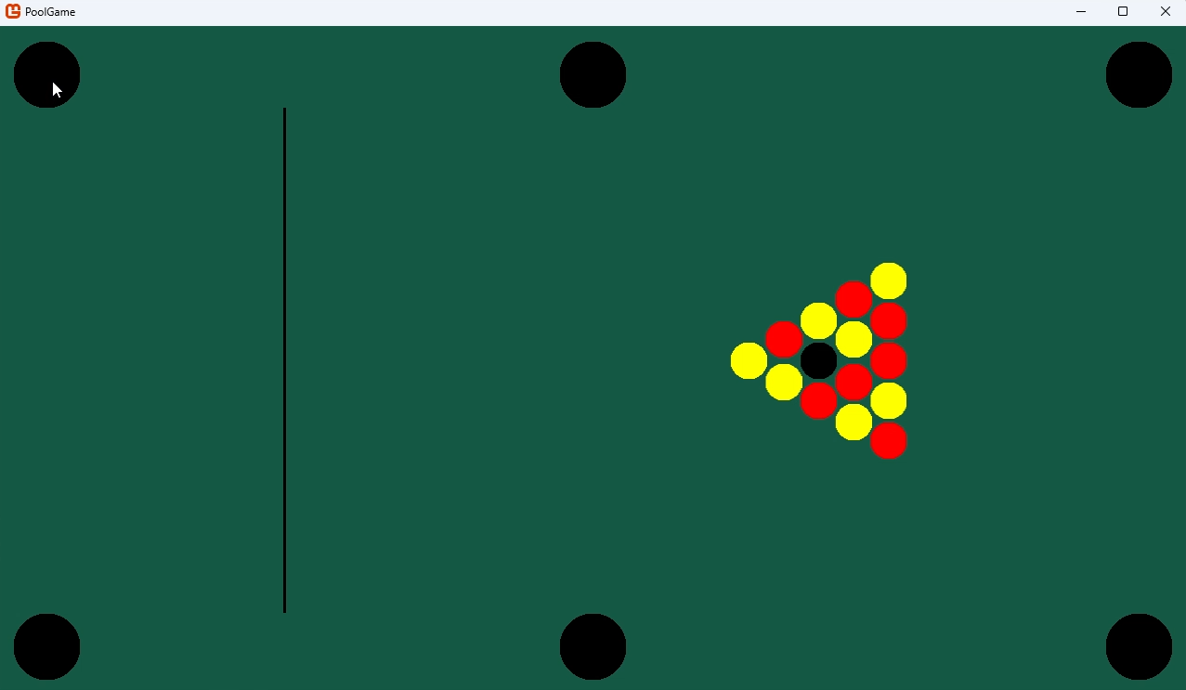
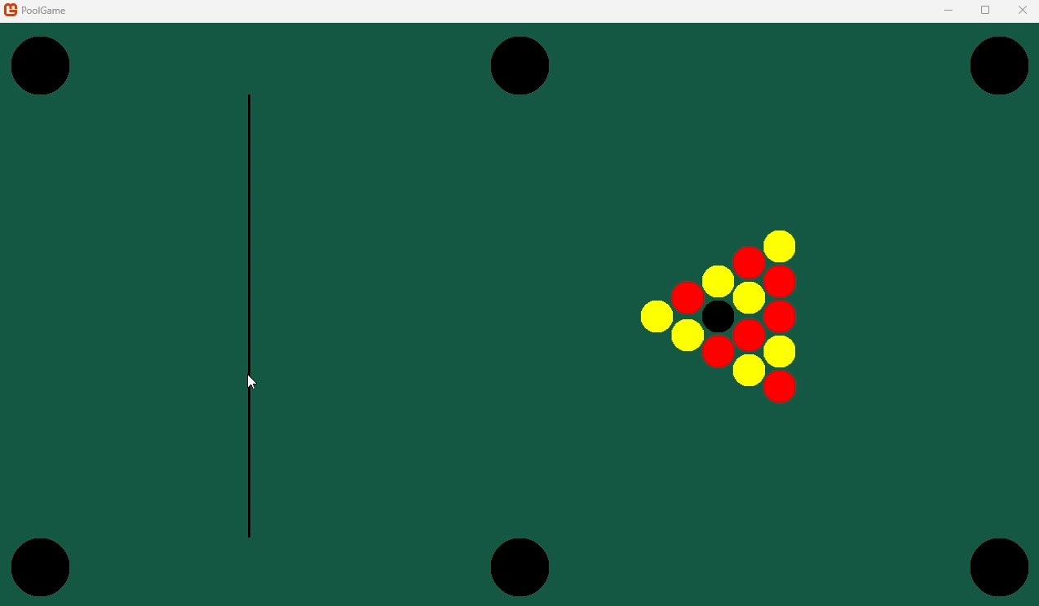 | 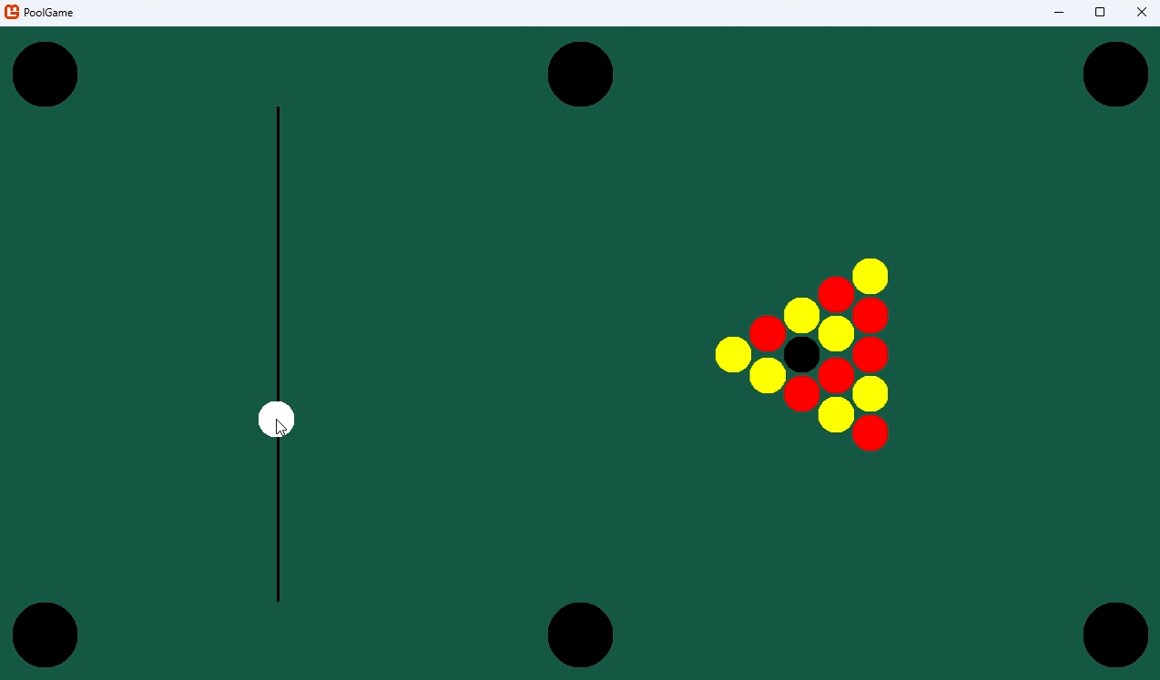
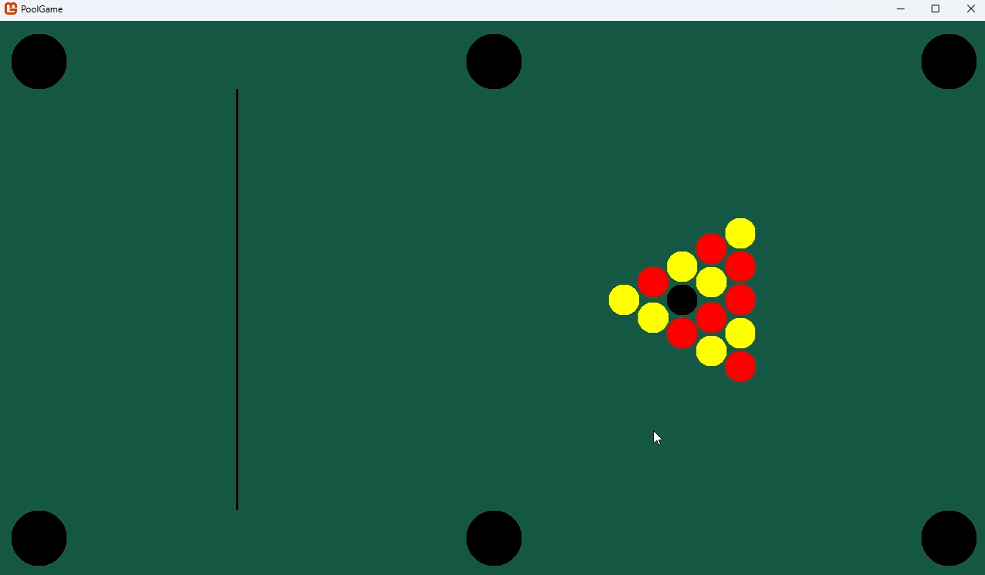
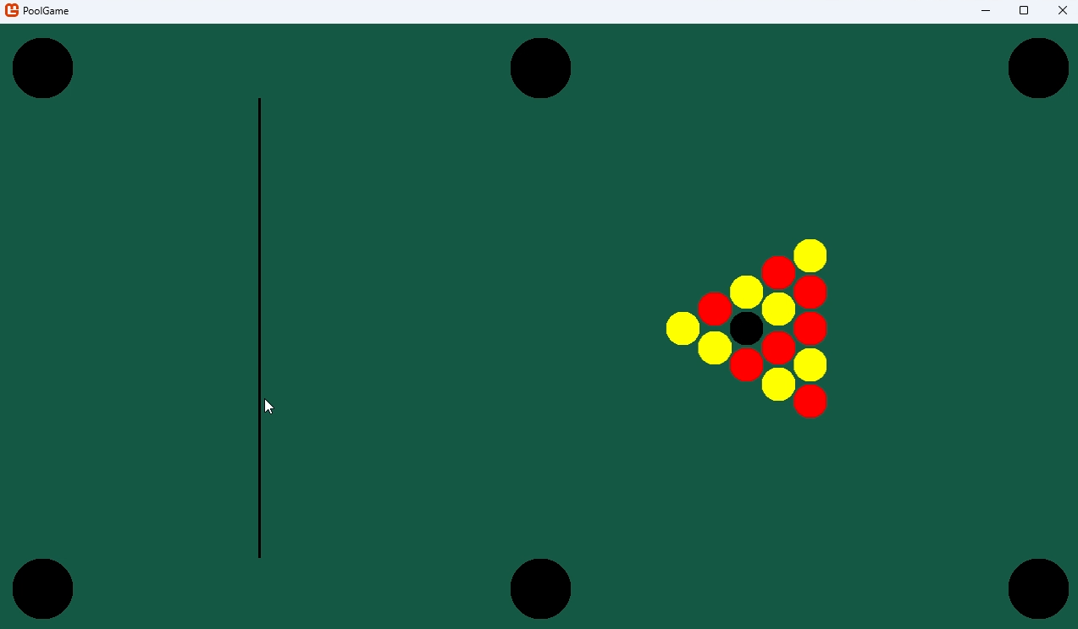
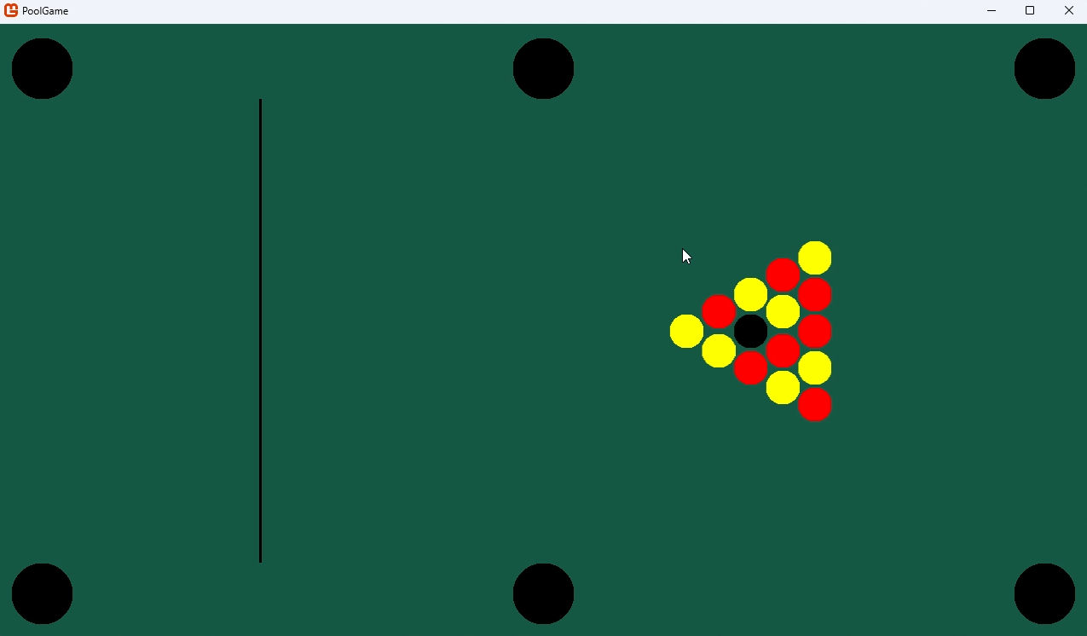
Note that, for the screenshots above, if there is no change from the left screenshot to the right screenshot it means that the CueBall didn’t respawn.
Here I realised that there aren’t any countermeasures to prevent players from respawning their CueBall directly into one of the two left-most Pockets. But, if players are taking the game seriously, there’s no reason for them to try to spawn it there in the first place so I see no reason to try and prevent it. Also, if it’s placed directly in a pocket it just gets pocketed and waits to respawn anyway.
I also tested a few times to make sure that object balls get pocketed and don’t respawn.
Post-break  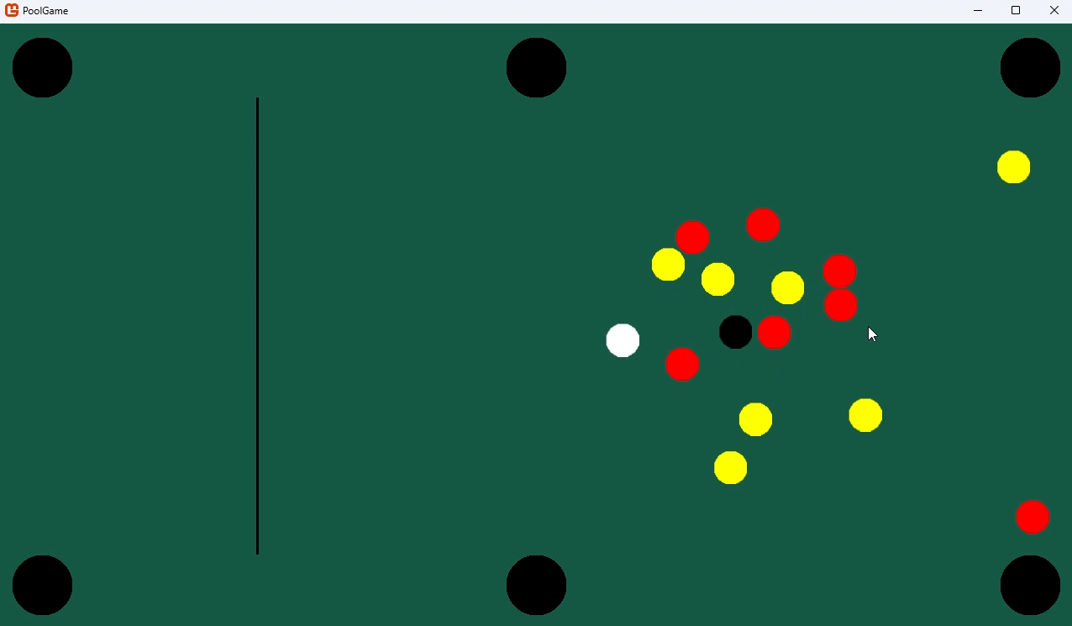 | Middle top red ball before getting potted  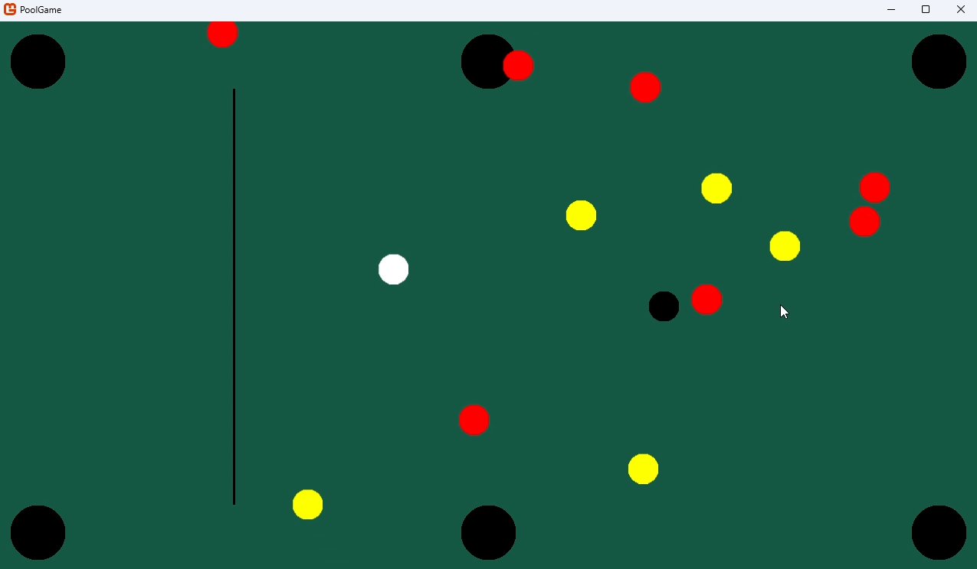
Middle top red ball after getting potted  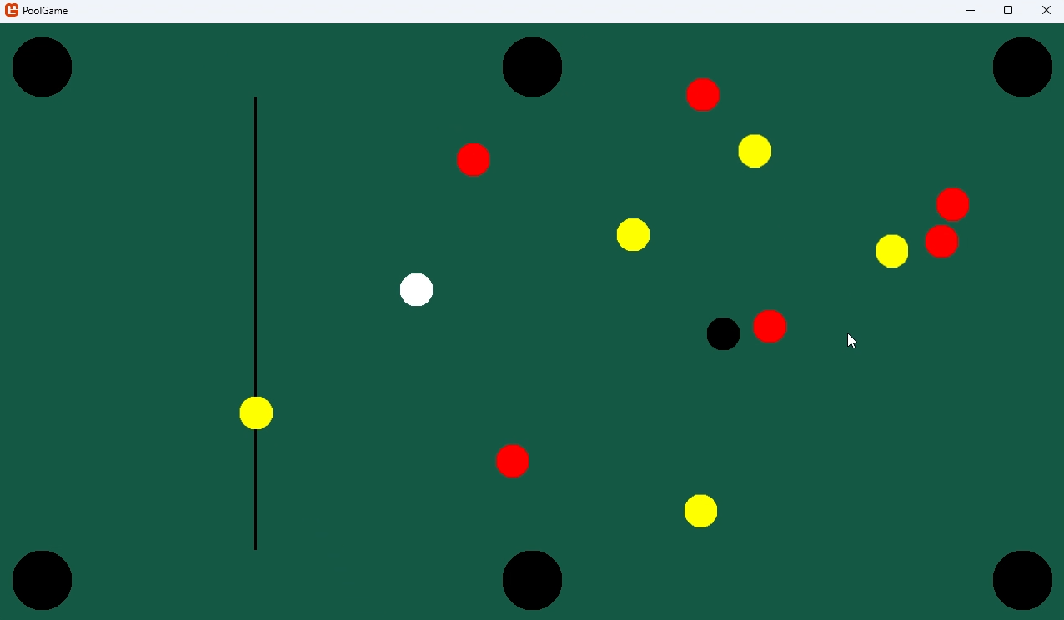 | Resting state  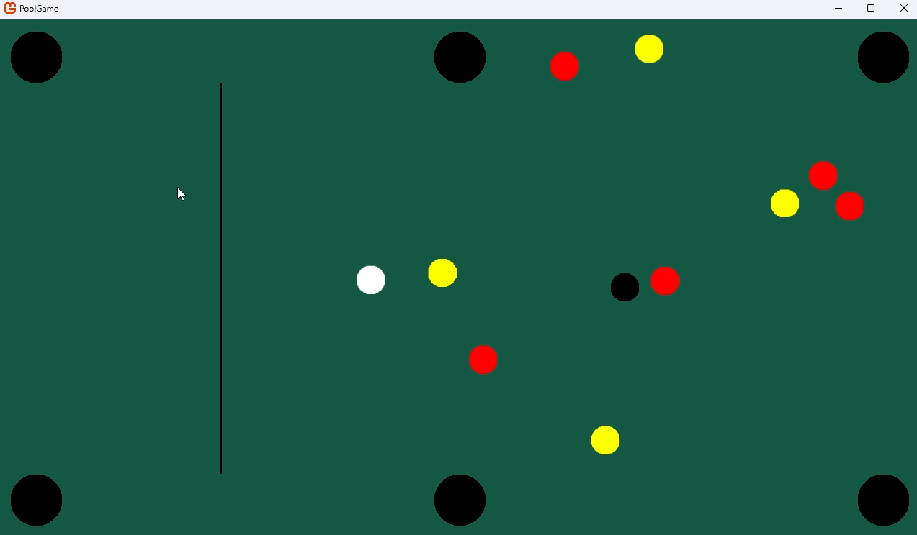
Note that the table starts with 15 object balls. This situation ended with 10, meaning that 5 have been successfully potted.
Overall, this shows that the function is working as expected. In response, no actions need to be taken.
IsAllStationary()
To test this function, it was as simple as left-clicking repeatedly after shooting until everything was stationary, at which point it would fire again. Each time I tested it, the CueBall didn’t move until every PoolBall was stationary.
Clicking after movement  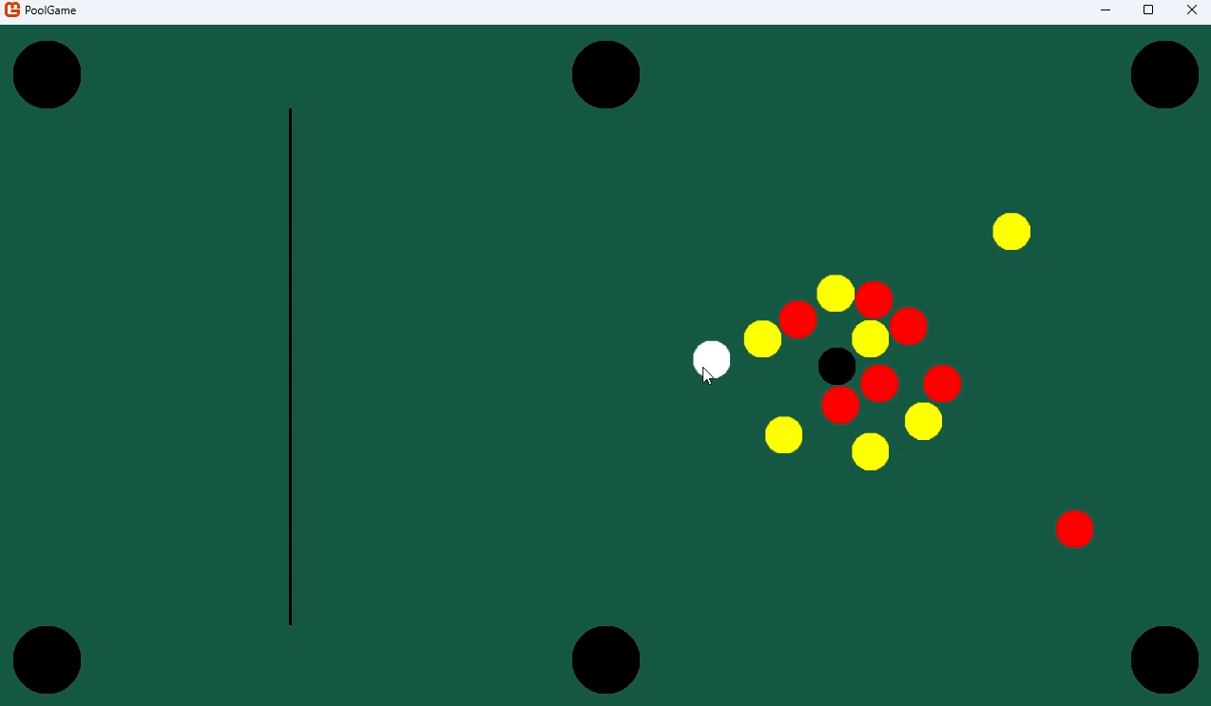 | Still clicking…  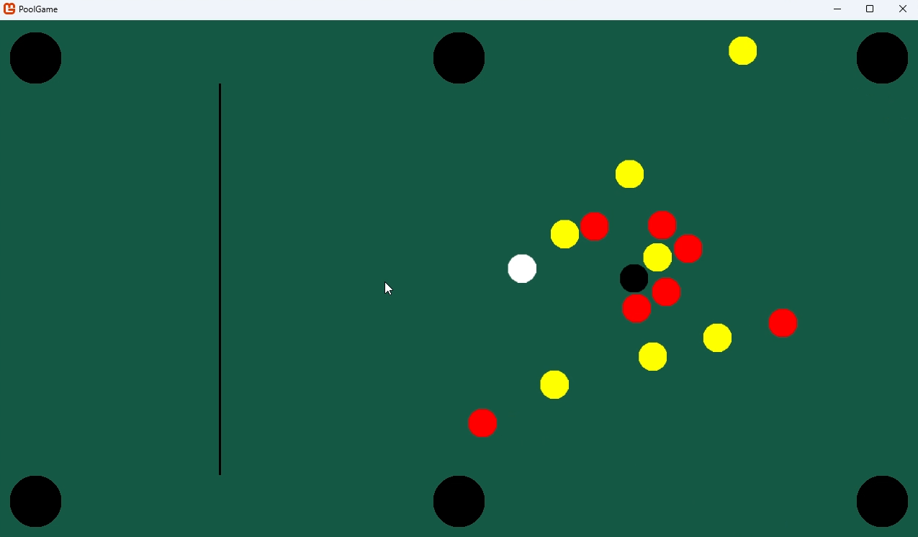
Stationary frame  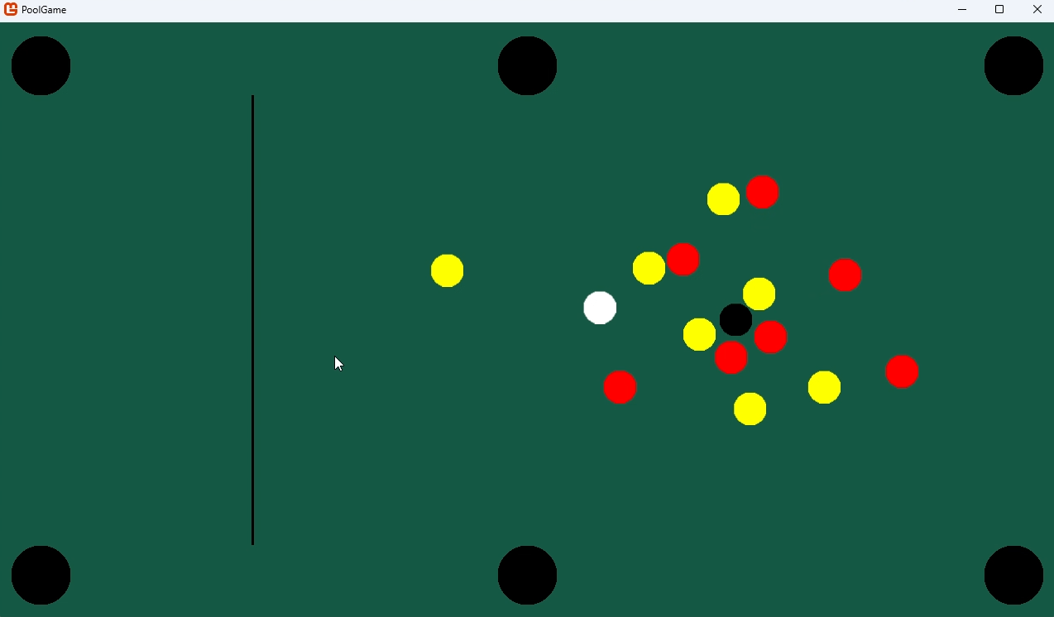 | After respawning  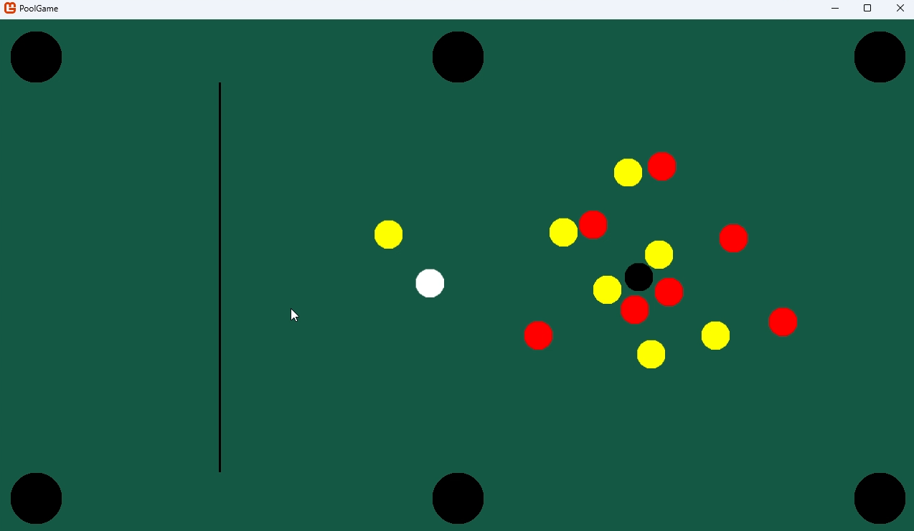
Overall, this shows that the function is working as expected. In response, no actions need to be taken.

Cushion textures
The Cushion class inherits from CollideObject. orientation must be between 1 and 4 inclusive because there are only 4 different orientaitons; this is enforced with error handling.
public class Cushion : Sprite
{
public int length;
public int width;
public int orientation;

public Cushion(Texture2D _texture, Vector2 _position, int _length, int _width, int _orientation) : base()
{
if (_orientation < 1 | _orientation > 4)
{
throw new ArgumentException("orientation must be between 1 and 4 inclusive");
}

texture = _texture;
position = _position;
length = _length;
width = _width;
orientation = _orientation;
}

public override void Update(GameTime gameTime)
{
base.Update(gameTime);
}
}
The centres, lengths, and widths of each Cushion were derived when I made the Desmos graph. Like the object balls, they get complicated too:
_cushionTopLeft = new(cushionTopTexture, new Vector2(topBottomLeftCushionCentreX, cushionWidth / 2), topBottomCushionLength, cushionWidth, 3);
For simplicity when rendering their sprites and calculating collisions, the cushions are shaped like trapeziums with its “legs” locked at 45 degrees to its longest side.
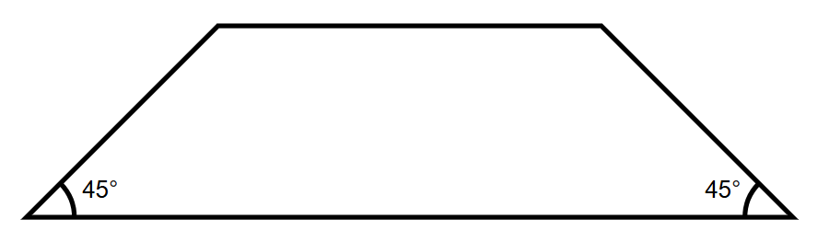
With 6 of these trapeziums, I could cover the areas of the table not already blocked by the pockets (the trapezium shape should also help guide PoolBalls into Pockets. The trapeziums are outlined in red below (from my Desmos graph, which also helped with positioning and sizing for the cushions).
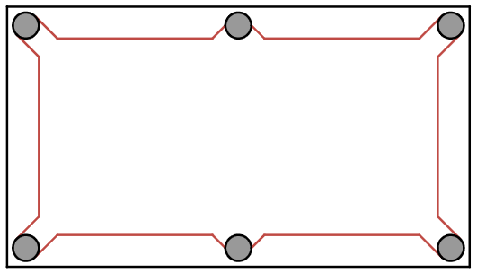
For their textures, I chose a similar approach to making the circle textures. I created a function called CreateTrapeziumTexture that maps all the points within a trapezium onto the Texture2D. However, since there are 4 differently oriented trapeziums, I needed 4 different rendering cases. To do this I added an integer variable called orientation to the function’s parameters that ranged from 1 to 4 inclusive depending on the trapezium’s orientation. Here’s a table to show this:
orientation’s value | Resulting trapezium
1 | 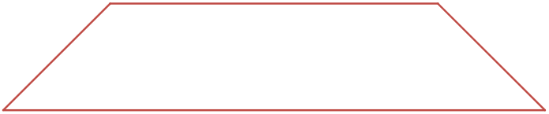
2 | 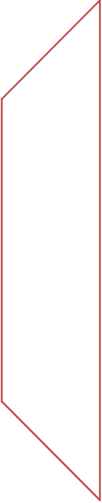
3 | 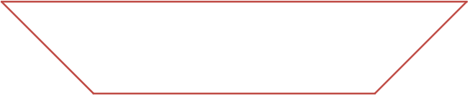
4 | 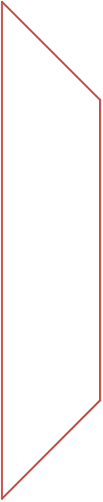
Essentially, as orientation increases by 1 the trapezium is rotated 90 degrees anticlockwise
Using a switch case, I created 4 slightly different trapezium texture generators inside of CreateTrapeziumTexture. For example, when orientation’s value is 1, the function just iterates through pixelColours (described when I made circle textures). It assigns a pixel a colour if the current column is greater than or equal to the width of the trapezium minus the current row and the current column is less than or equal to the length of the trapezium minus the width plus the row. This was based on all the points that would fit between two lines (imagine row was the $y$-coordinate and column was the $x$-coordinate).
At the start of the function, it also checks if orientation is between 1 and 4 inclusive and throws an argument exception error if not. Here’s the full function:
public static Texture2D CreateTrapeziumTexture(GraphicsDevice graphicsDevice, int length, int width, Color textureColour, int orientation)
{
if (orientation < 1 | orientation > 4)
{
throw new ArgumentException("orientation must be between 1 and 4 inclusive");
}

Color[] pixelColours = new Color[length * width];
Texture2D trapeziumTexture;

switch (orientation)
{
case 1:
trapeziumTexture = new(graphicsDevice, length, width); // empty texture the size of the trapezium
for (int column = 0; column < length; column++)
{
for (int row = 0; row < width; row++)
{
if ((column >= width - row) && (column <= length - (width - row)))
{
pixelColours[column + (row * length)] = textureColour;
}
else
{
pixelColours[column + (row * length)] = Color.Transparent;
}
}
}
break;
case 2:
trapeziumTexture = new(graphicsDevice, width, length); // empty texture the size of the trapezium
for (int row = 0; row < length; row++)
{
for (int column = 0; column < width; column++)
{
if (row <= width) // upper section
{
if (column >= width - row)
{
pixelColours[column + (row * width)] = textureColour;
}
else
{
pixelColours[column + (row * width)] = Color.Transparent;
}
}
else if (row >= length - width) // lower section
{
if (column >= row - (length - width))
{
pixelColours[column + (row * width)] = textureColour;
}
else
{
pixelColours[column + (row * width)] = Color.Transparent;
}
}
else // middle section
{
pixelColours[column + (row * width)] = textureColour;
}
}
}
break;
case 3:
trapeziumTexture = new(graphicsDevice, length, width); // empty texture the size of the trapezium
for (int column = 0; column < length; column++)
{
for (int row = 0; row < width; row++)
{
if ((column >= row) && (column <= length - row))
{
pixelColours[column + (row * length)] = textureColour;
}
else
{
pixelColours[column + (row * length)] = Color.Transparent;
}
}
}
break;
case 4:
trapeziumTexture = new(graphicsDevice, width, length); // empty texture the size of the trapezium
for (int row = 0; row < length; row++)
{
for (int column = 0; column < width; column++)
{
if (row <= width) // upper section
{
if (column <= row)
{
pixelColours[column + (row * width)] = textureColour;
}
else
{
pixelColours[column + (row * width)] = Color.Transparent;
}
}
else if (row >= length - width) // lower section
{
if (column <= length - row)
{
pixelColours[column + (row * width)] = textureColour;
}
else
{
pixelColours[column + (row * width)] = Color.Transparent;
}
}
else // middle section
{
pixelColours[column + (row * width)] = textureColour;
}
}
}
break;
default: // unreachable, but necessary so that C# thinks that trapeziumTexture is always defined
trapeziumTexture = null;
break;
}

trapeziumTexture.SetData(pixelColours); // maps the array of colours onto the texture
return trapeziumTexture;
}
Writing some lines to construct a Sprite and assign it the texture then creates a blue trapezium texture for a sprite:
testTexture = CreateTrapeziumTexture(graphicsDevice, 400, 40, Color.Blue, 1);
testSprite = new(testTexture, new Vector2(Game1.windowWidth / 2, Game1.windowHeight / 2));
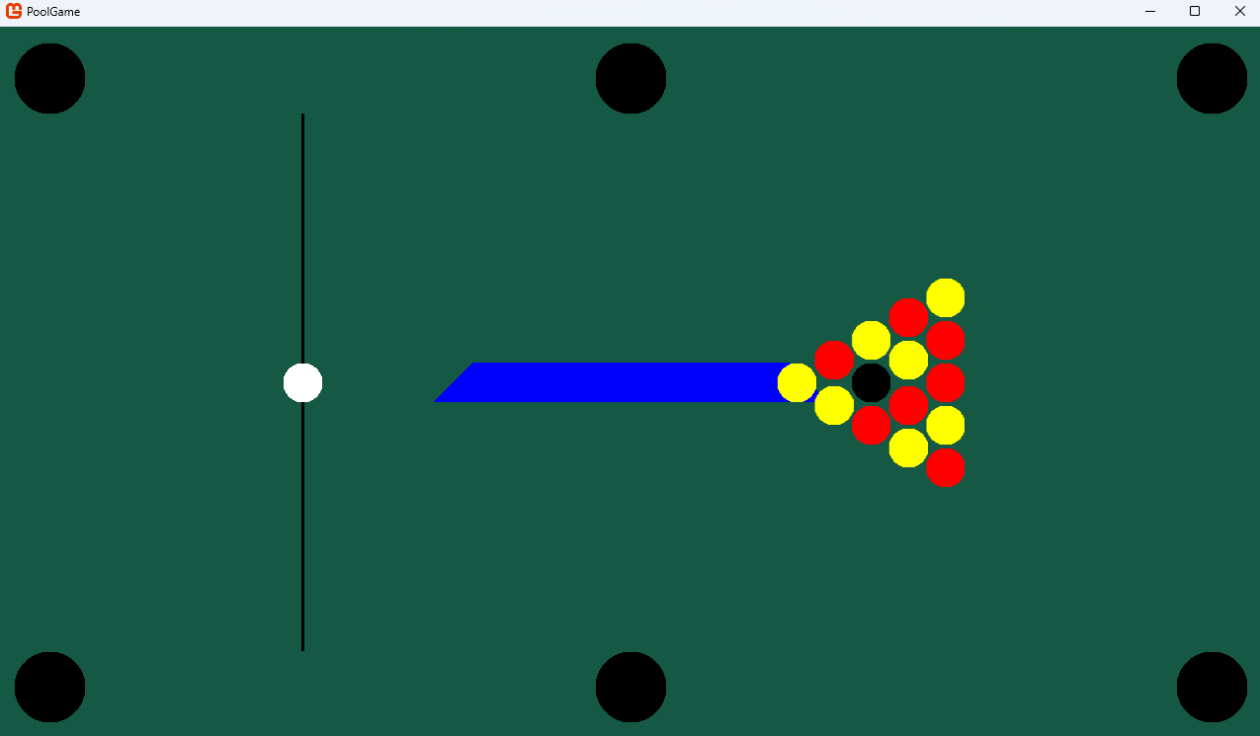
Note that the cushions should be before almost everything else so that any PoolBall that goes out of bounds can be seen on top of a cushion, rather than hidden underneath.
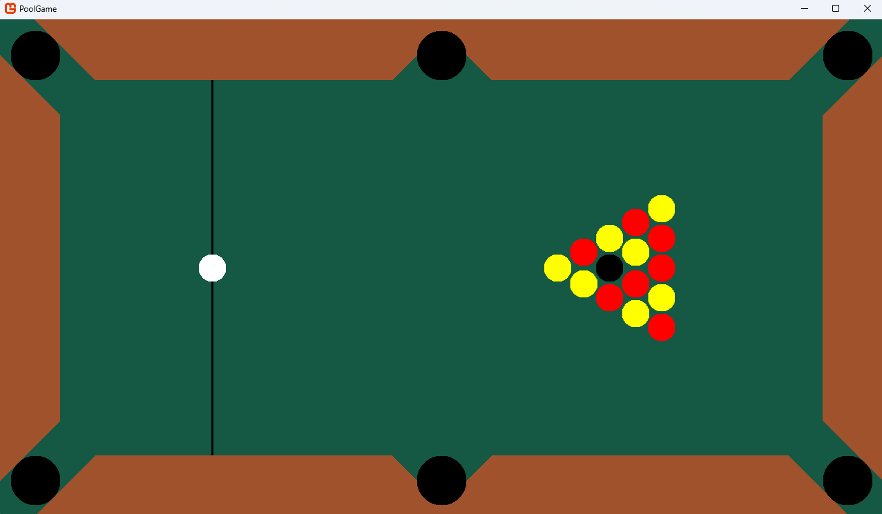
However, when all the cushions were rendered (using Color.Sienna as their colour because it looks vaguely wood-like), there was gaps behind some of the Pockets. This is because the Cushions were specifically placed to avoid the Pockets so that PoolBalls could still be pocketed.
To fill in these gaps I decided to make another texture, this time just triangles. I made the CreateRightAngledTriangleTexture function to generate the texture for a right angled triangle with two equal side lengths and internal angles of 45, 45, and 90 degrees. I followed a similar convention to the trapezium generator for orientation, rotating 90 degrees anticlockwise for incrementing orientation. Here’s a table to illustrate this:
orientation’s value | Resulting triangle
1 | 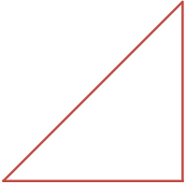
2 | 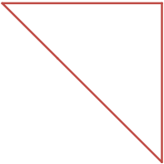
3 | 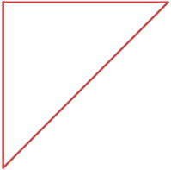
4 | 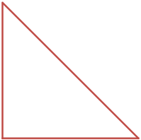
The implementation was similar to the trapezium as well, but with less steps:
public static Texture2D CreateRightAngledTriangleTexture(GraphicsDevice graphicsDevice, int sideLength, Color textureColour, int orientation)
{

Texture2D lineTexture = new(graphicsDevice, sideLength, sideLength); // empty texture the size of the line
Color[] pixelColours = new Color[sideLength * sideLength];

switch (orientation)
{
case 1:
for (int row = 0; row < sideLength; row++)
{
for (int column = 0; column < sideLength; column++)
{
if (column >= sideLength - row)
{
pixelColours[column + (row * sideLength)] = textureColour;
}
else
{
pixelColours[column + (row * sideLength)] = Color.Transparent;
}
}
}
break;
case 2:
for (int row = 0; row < sideLength; row++)
{
for (int column = 0; column < sideLength; column++)
{
if (column >= row)
{
pixelColours[column + (row * sideLength)] = textureColour;
}
else
{
pixelColours[column + (row * sideLength)] = Color.Transparent;
}
}
}
break;
case 3:
for (int row = 0; row < sideLength; row++)
{
for (int column = 0; column < sideLength; column++)
{
if (column <= sideLength - row)
{
pixelColours[column + (row * sideLength)] = textureColour;
}
else
{
pixelColours[column + (row * sideLength)] = Color.Transparent;
}
}
}
break;
case 4:
for (int row = 0; row < sideLength; row++)
{
for (int column = 0; column < sideLength; column++)
{
if (column <= row)
{
pixelColours[column + (row * sideLength)] = textureColour;
}
else
{
pixelColours[column + (row * sideLength)] = Color.Transparent;
}
}
}
break;
}

lineTexture.SetData(pixelColours); // maps the array of colours onto the texture
return lineTexture;
}
For example, this code produces this triangle:
testTexture = CreateRightAngledTriangleTexture(graphicsDevice, 200, Color.Blue, 1);
testSprite = new(testTexture, new Vector2(Game1.windowWidth / 2, Game1.windowHeight / 2));
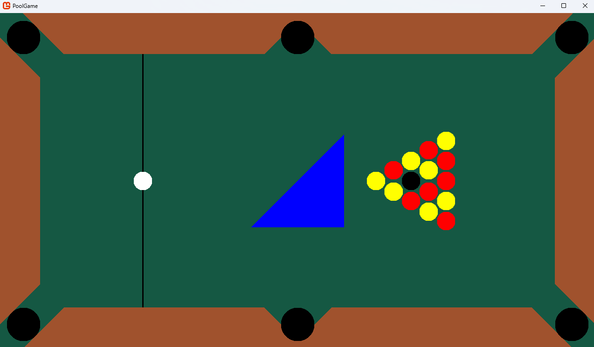
Now here’s the filled-out table:
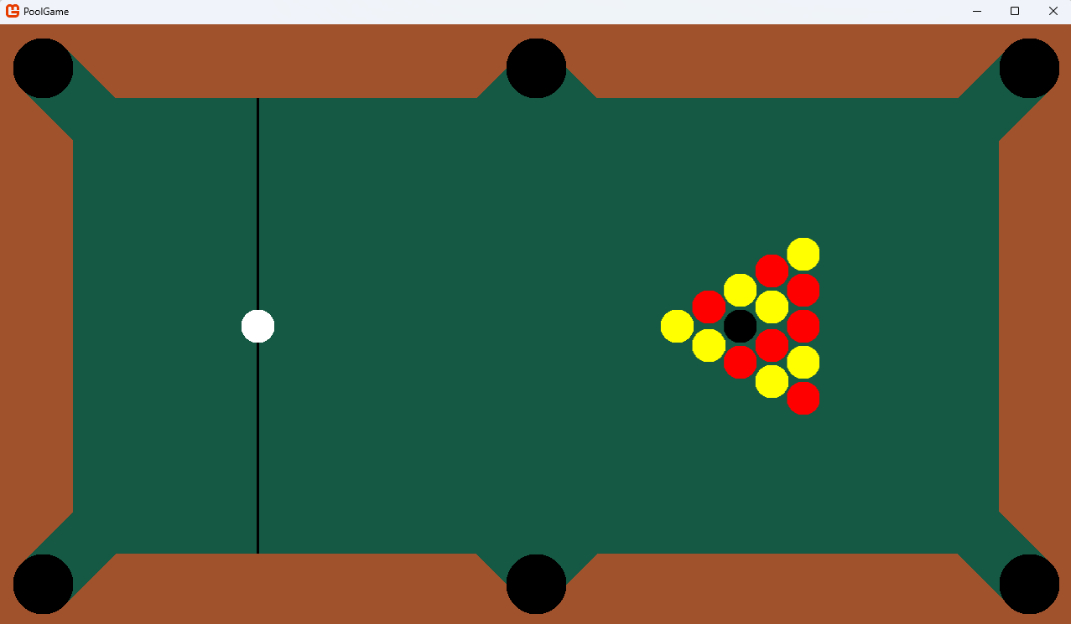
Note that the triangle textures are rendered as objects of the Sprite class because they don’t need their own collisions (since they are guaranteed to always be blocked by a Pocket).

Tests
CreateTrapeziumTexture(GraphicsDevice graphicsDevice, int length, int width, Color textureColour, int orientation)
To test CreateTrapeziumTexture, I used a similar approach to CreateBlockColouredCircleTexture (i.e. testing a bunch of parameter combinations. I stopped rendering all other textures and set the background to white for clarity.
Colour | Length | Width | Orientation | Image | Test passed?
Color.Orange | 200 | 20 | 1 | 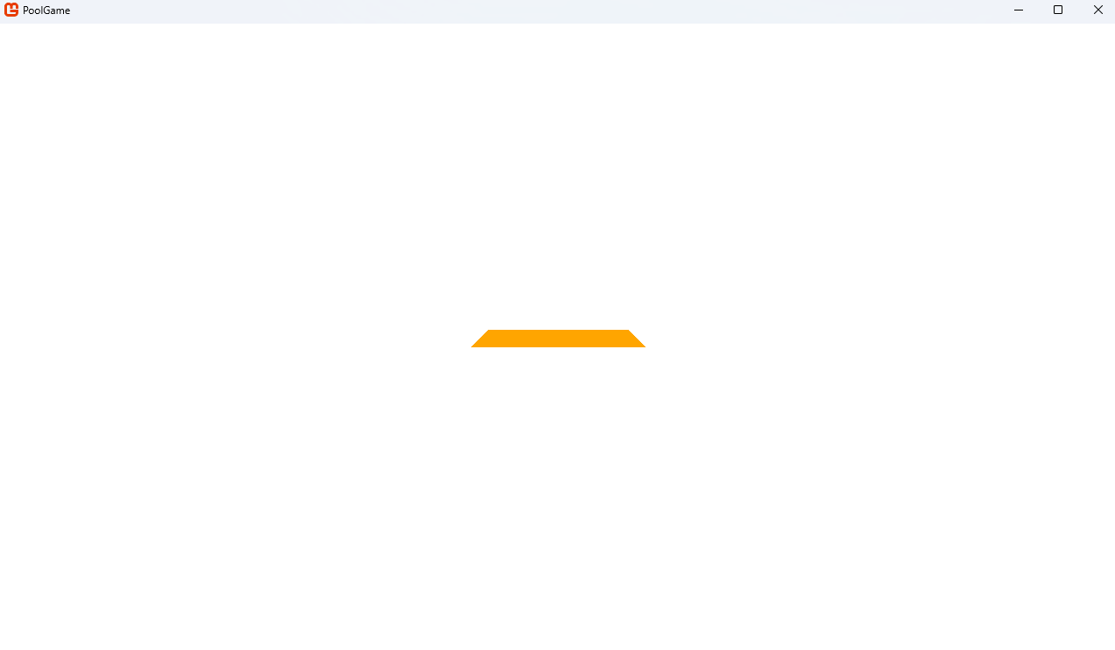 | Yes
Color.Tan | 200 | 20 | 1 | 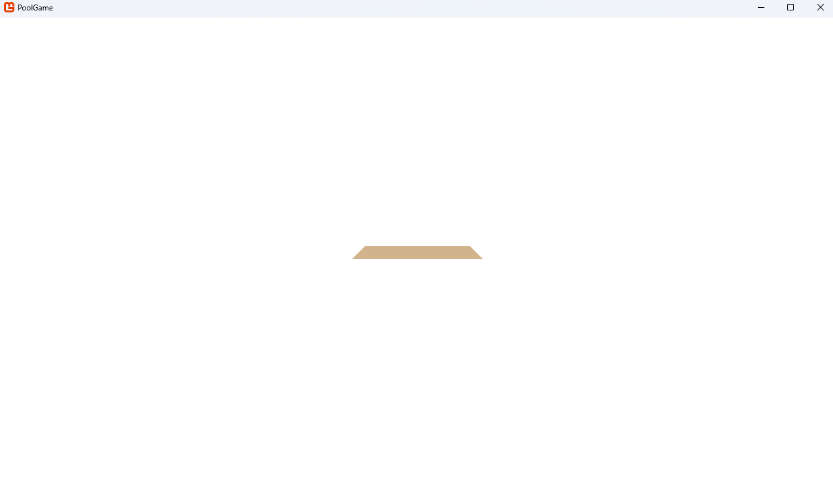 | Yes
Color.Blue | 200 | 20 | 1 | 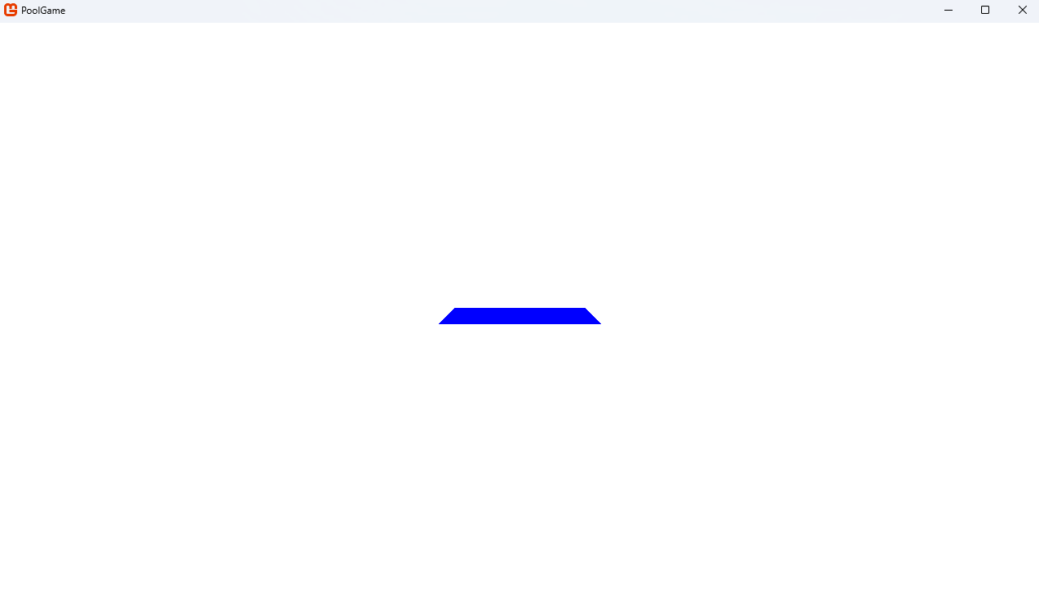 | Yes
Color.Blue | 200 | -20 | 1 | 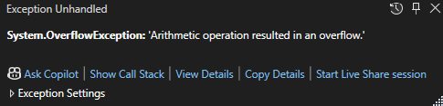 | Yes**
Color.Blue | -200 | 20 | 1 | 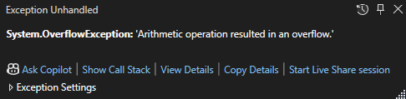 | Yes**
Color.Blue | 200 | 20 | -1 | 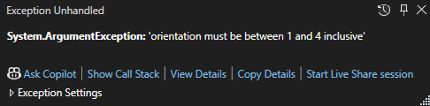 | Yes**
Color.Blue | 200 | 20 | 5 |  | Yes**
Color.Blue | 200 | 20 | 1.5 | Invalid input, C# mandates that all inputs must be integers | Yes**
Color.Blue | 200 | 20.5 | 1 | Invalid input, C# mandates that all inputs must be integers | Yes**
Color.Blue | 200.5 | 20 | 1 | Invalid input, C# mandates that all inputs must be integers | Yes**
Color.Blue | 200 | 200 | 1 | 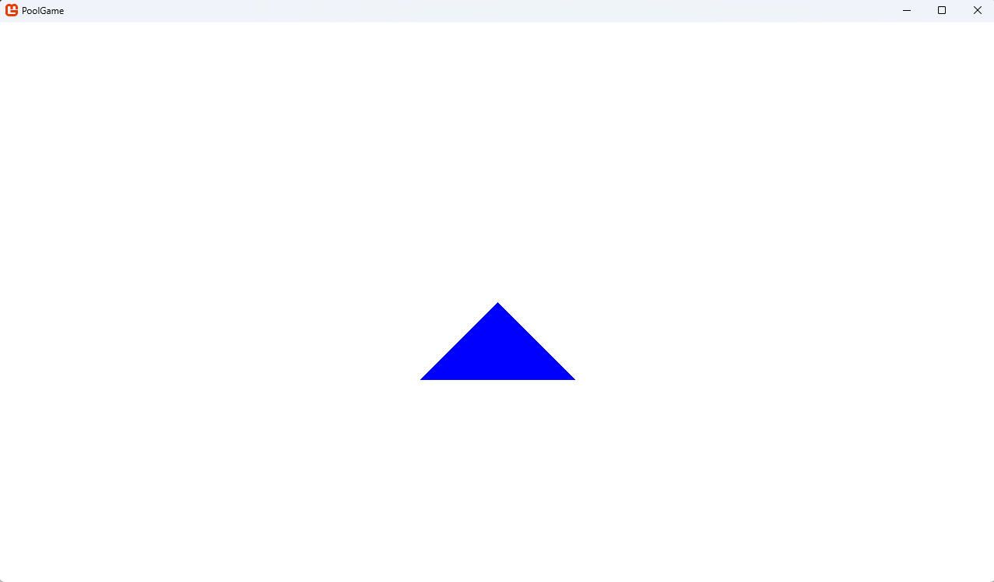 | No**
Color.Blue | 150 | 200 | 1 |  | No**/***
Color.Blue | 1280 | 360 | 1 | 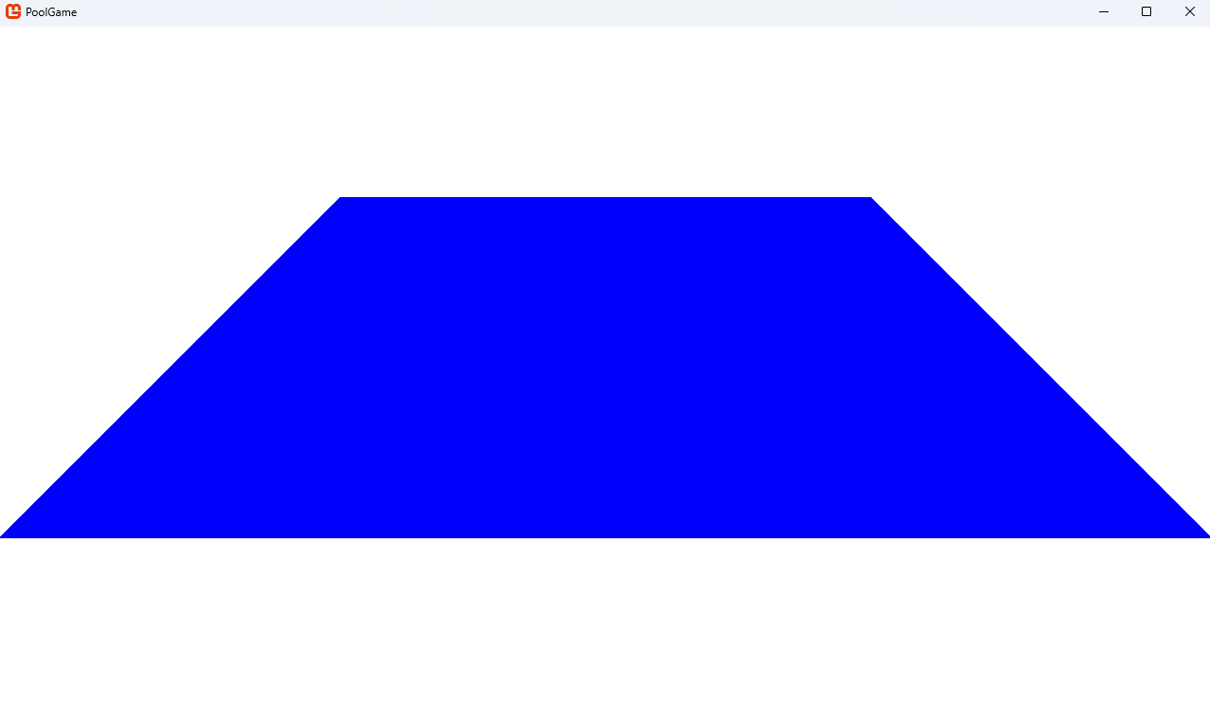 | Yes
Color.Blue | 20 | 5 | 1 | 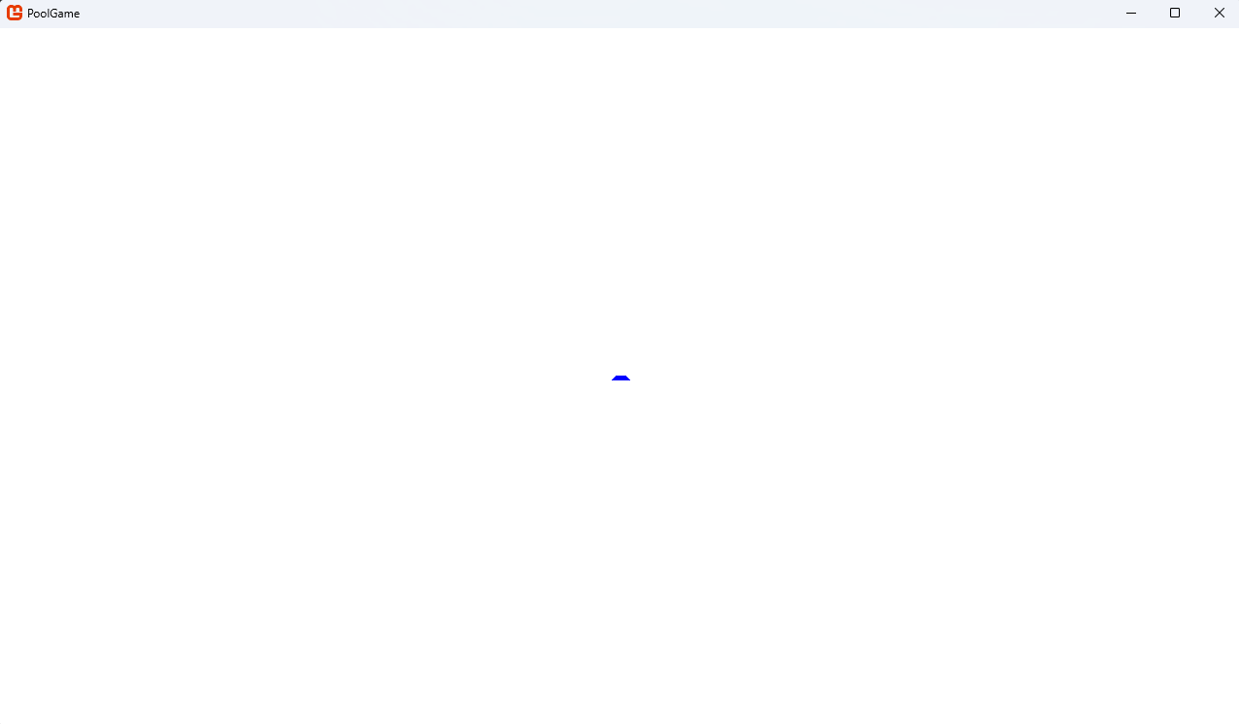 | Yes
Color.Blue | 300 | 50 | 1 | 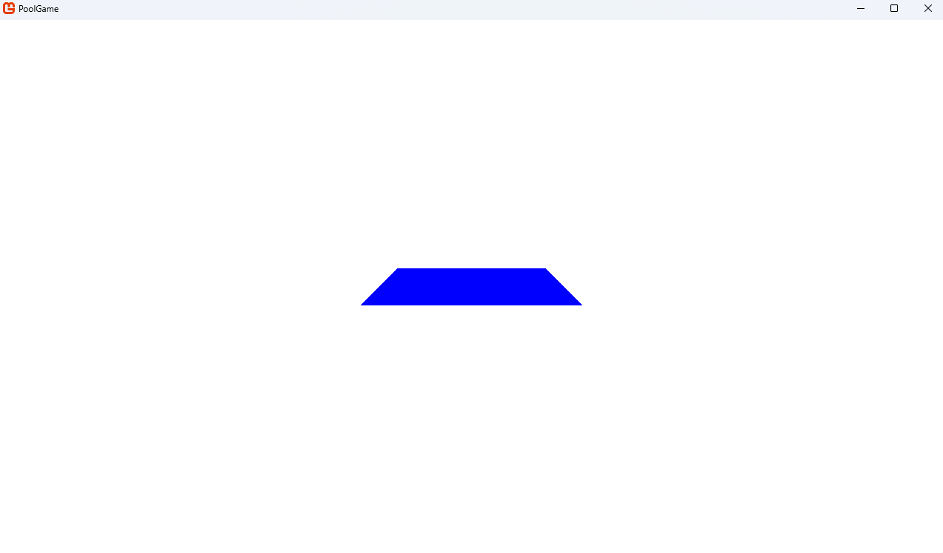 | Yes
Color.Blue | 300 | 50 | 2 | 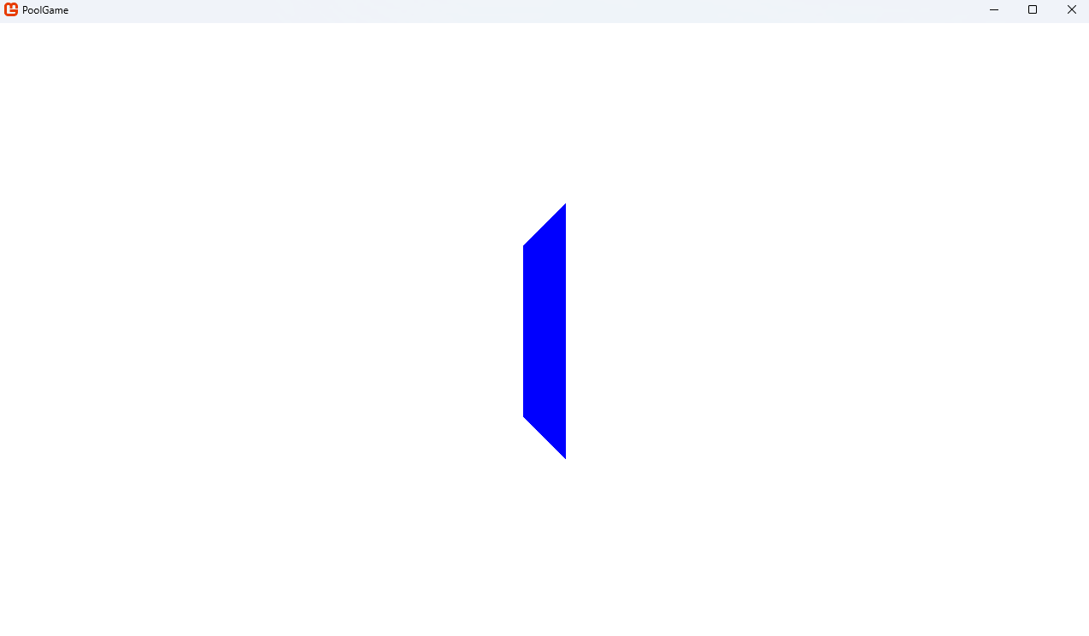 | Yes
Color.Blue | 300 | 50 | 3 | 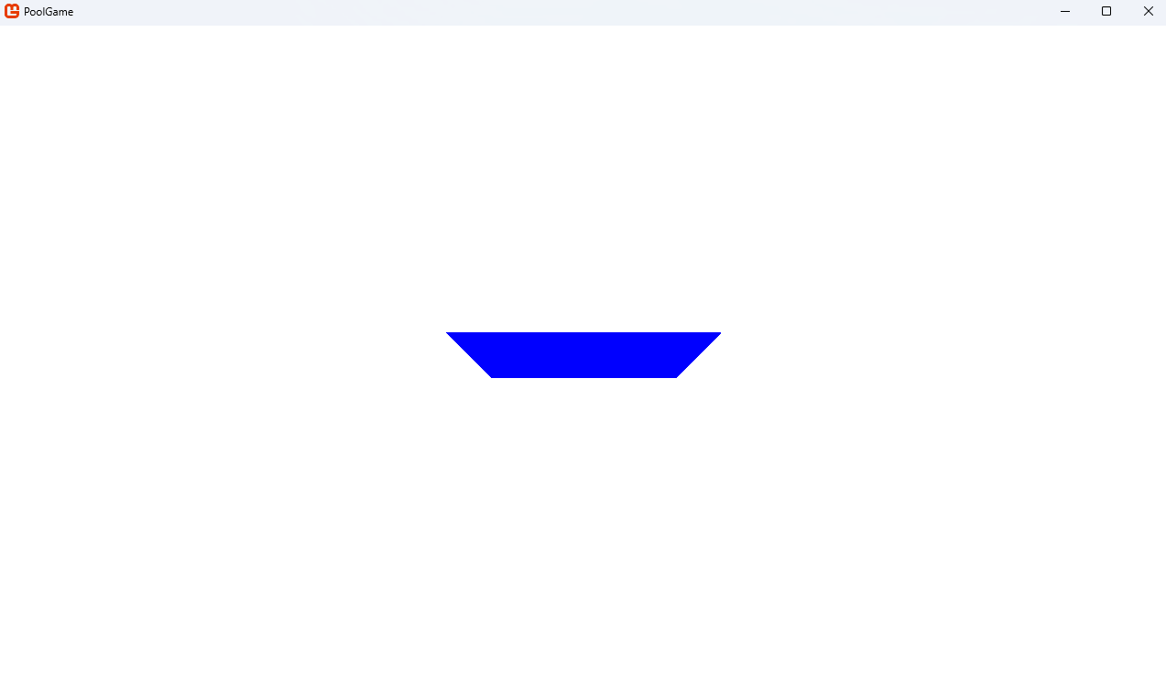 | Yes
Color.Blue | 300 | 50 | 4 | 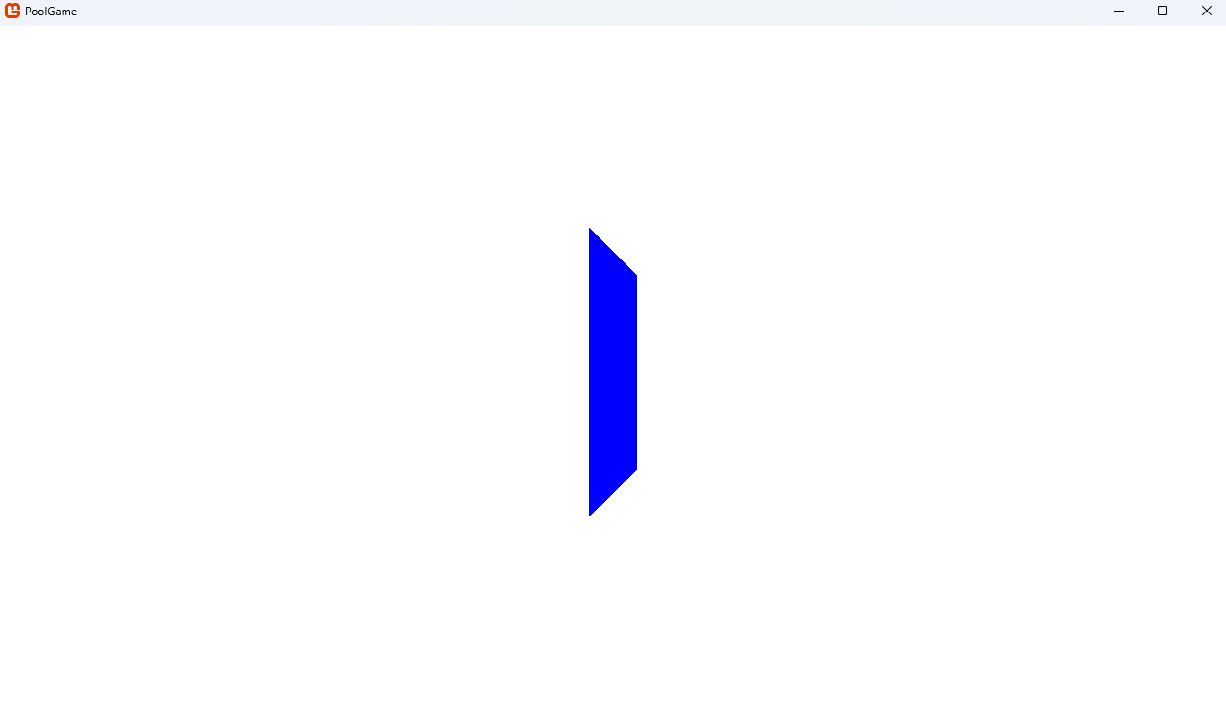 | Yes
*When length or width is negative, zero, or not an integer or when orientation isn’t an integer between 1 and 4 inclusive, the code correctly throws an error, eliminating the chance for undetected errors to go unnoticed down the road if, for example, the length was calculated by a function that could return non-positive numbers or floats.
**While this configuration doesn’t pass the test (creating a triangle instead of a trapezium), this extreme case will not be an option in my game, so it doesn’t need to be patched.
***It appears that, when length < width*2, it treats it as if length = width*2. Again, this doesn’t really matter because this case won’t be used in my game.
Overall, this shows that the function is working as expected. In response, no actions need to be taken.
CreateRightAngledTriangleTexture(GraphicsDevice graphicsDevice, int sideLength, Color textureColour, int orientation)
This will be tested almost identically to CreateTrapeziumTexture, just with one less variable.
Colour | Length | Orientation | Image | Test passed?
Color.Orange | 100 | 1 | 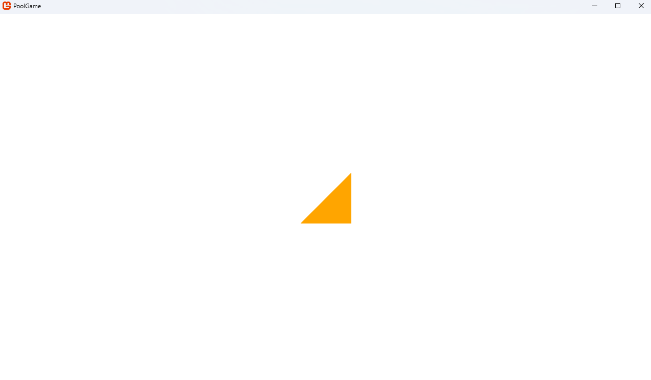 | Yes
Color.Tan | 100 | 1 | 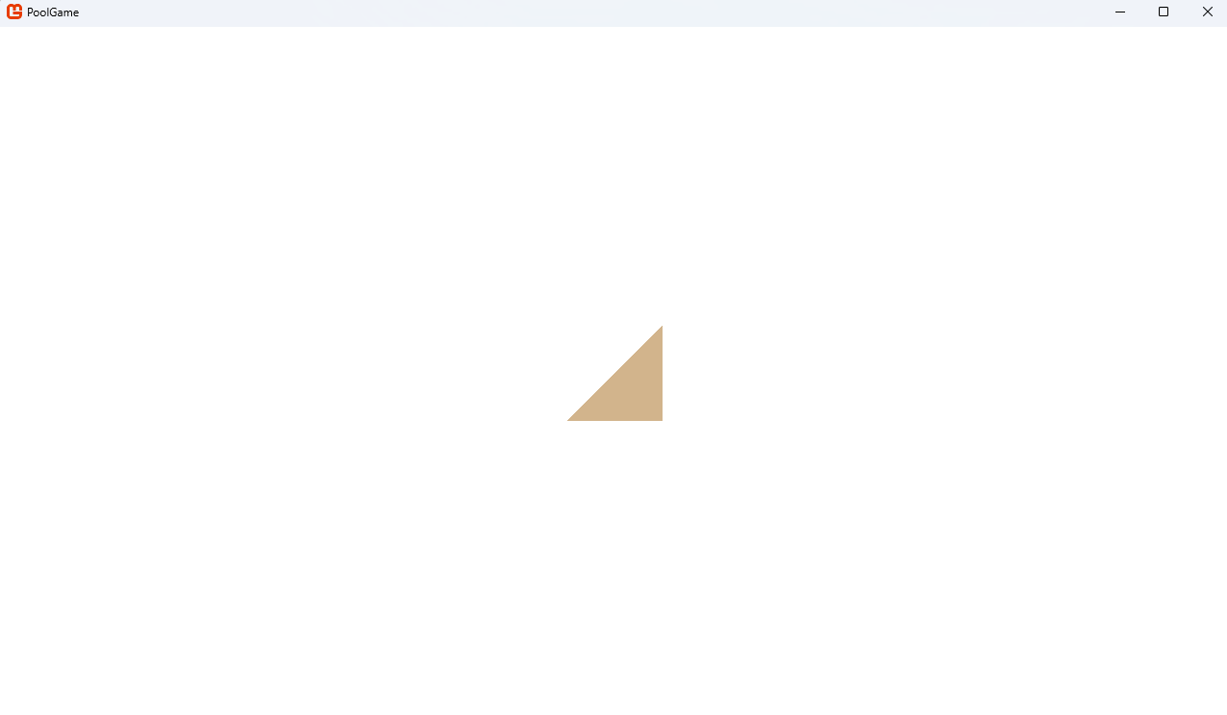 | Yes
Color.Blue | 100 | 1 | 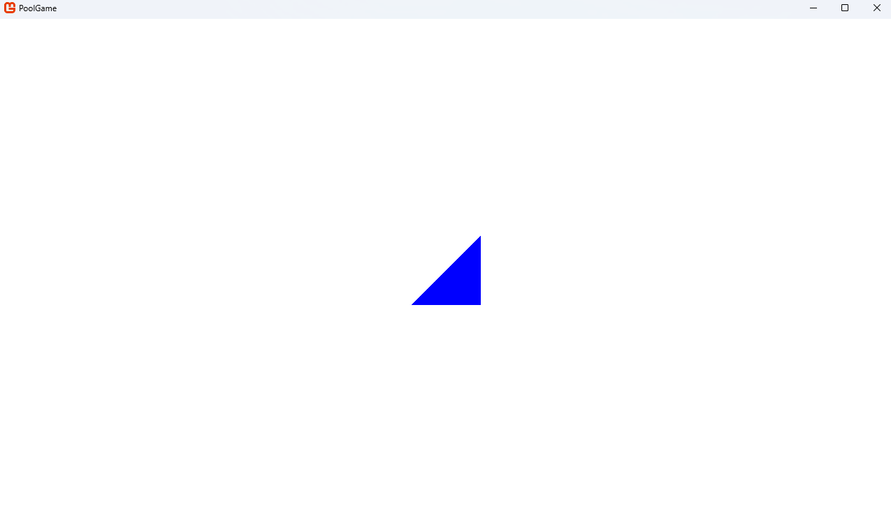 | Yes
Color.Blue | 5 | 1 | 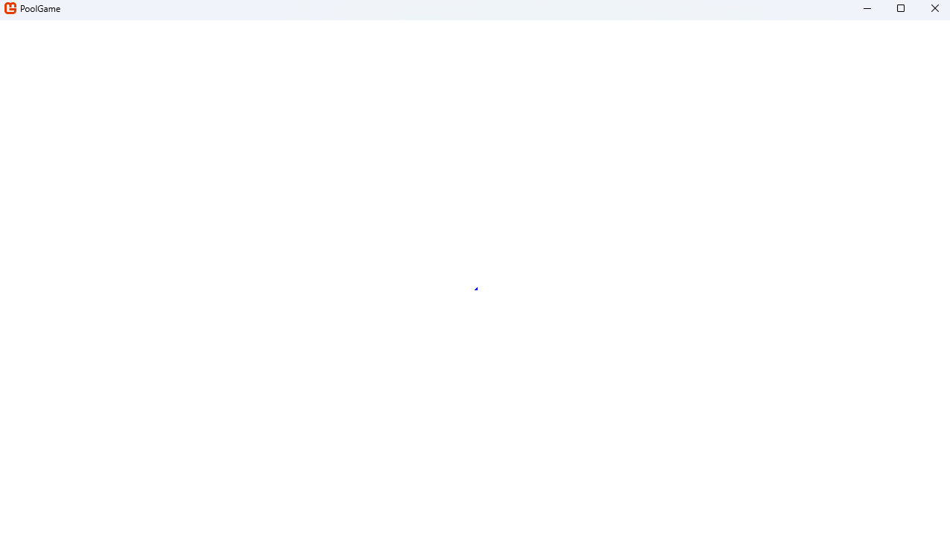 | Yes
Color.Blue | 500 | 1 | 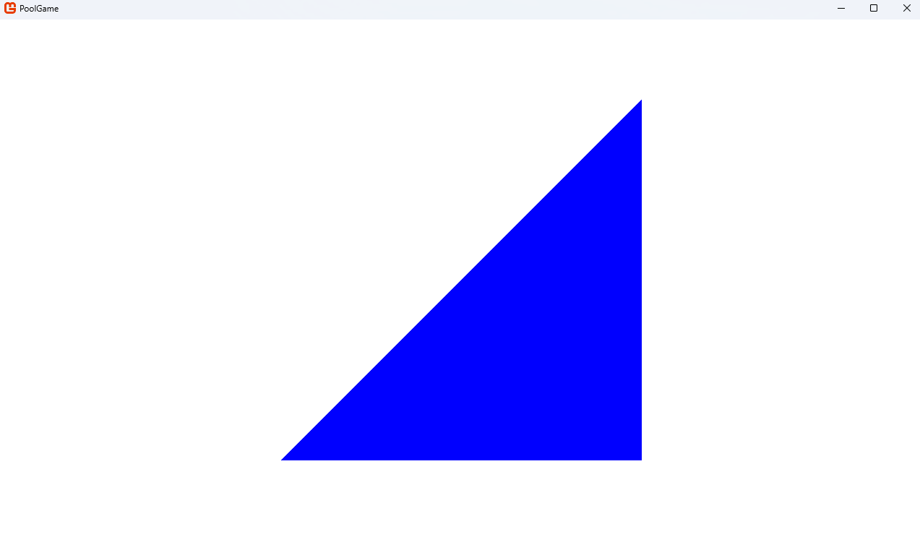 | Yes
Color.Blue | 500 | 2 | 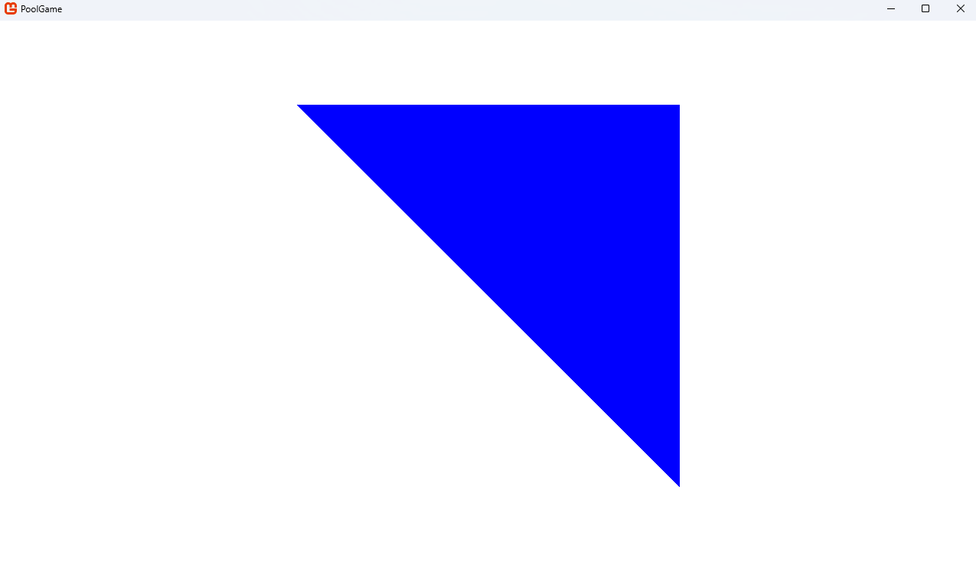 | Yes
Color.Blue | 500 | 3 | 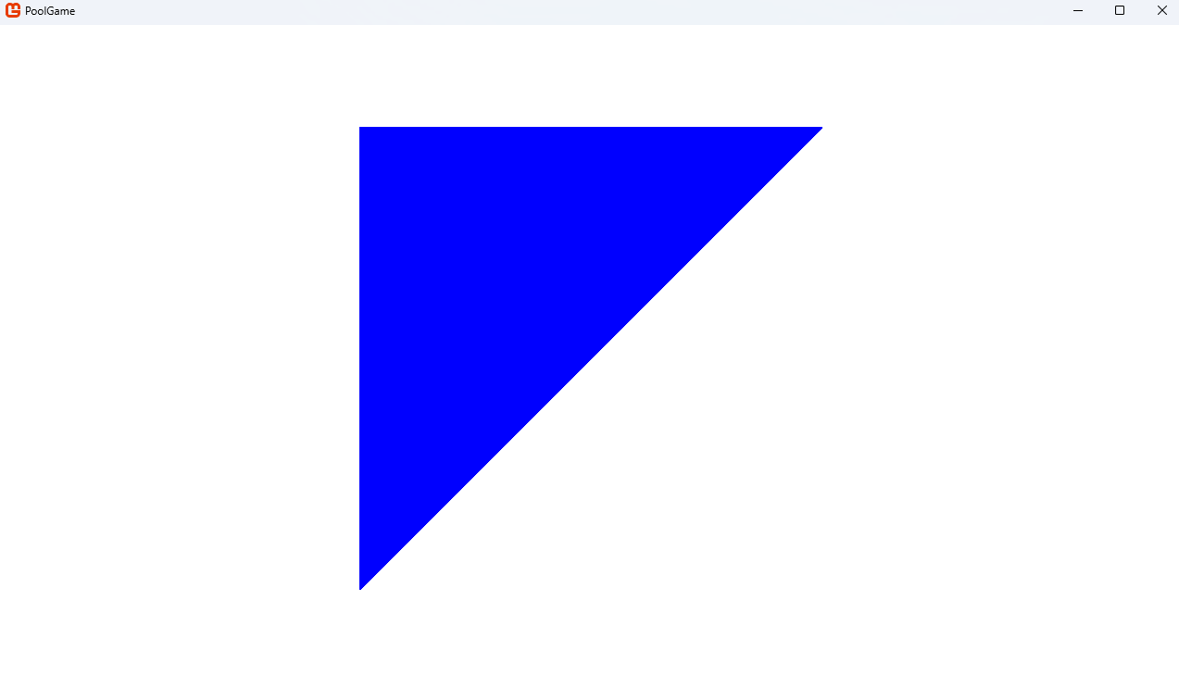 | Yes
Color.Blue | 500 | 4 | 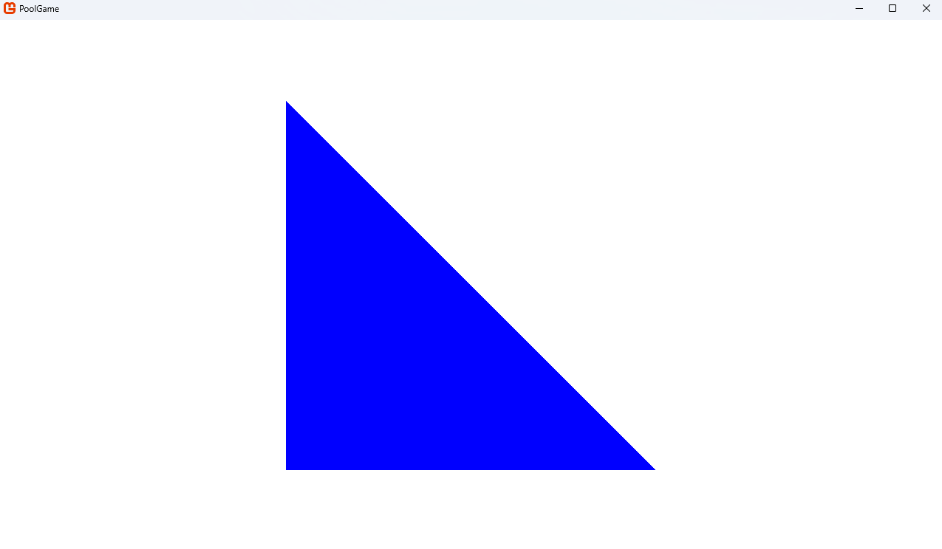 | Yes
Color.Blue | 500 | -1 |  | No*
Color.Blue | 500 | 5 |  | No*
Color.Blue | -500 | 1 | 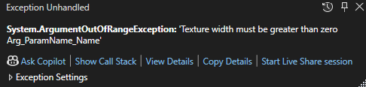 | Yes
Color.Blue | 200 | 1 | 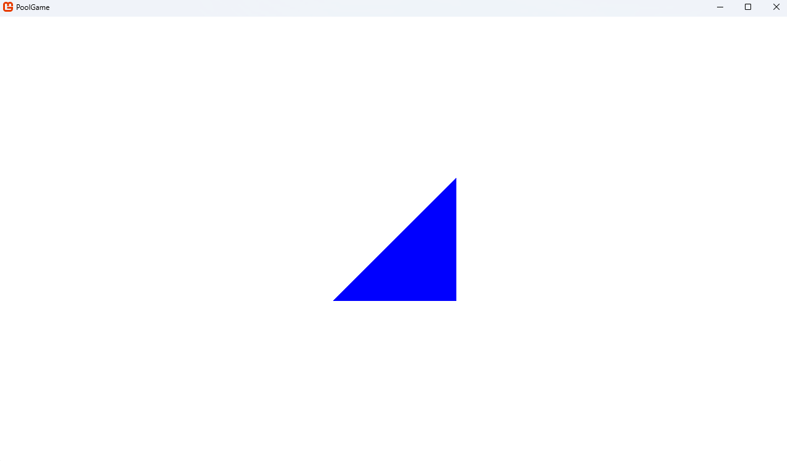 | Yes
Color.Blue | 400 | 1 | 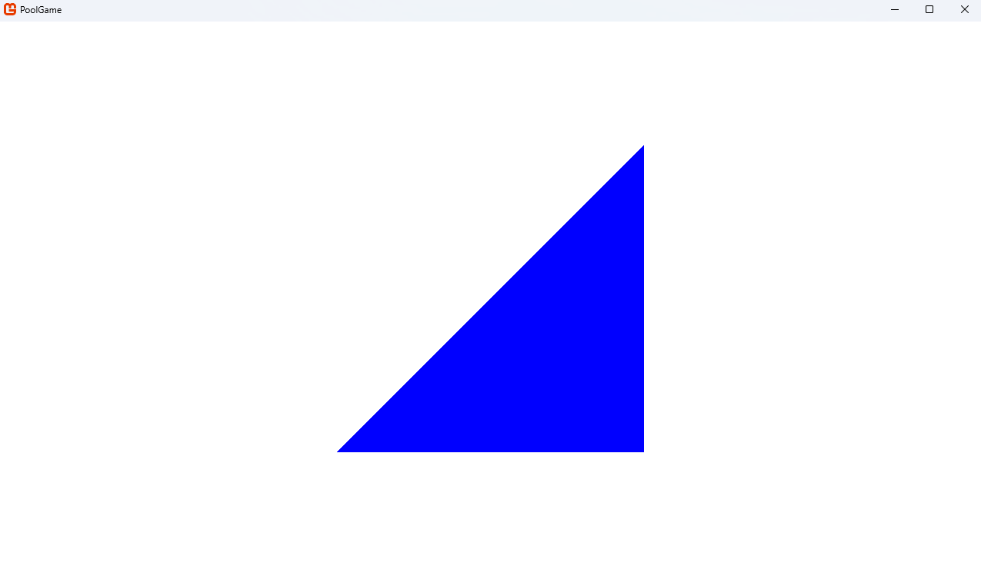 | Yes**
*When orientation isn’t within range, it just doesn’t render the triangle, rather than throwing an error. This can be fixed by doing something similar to what I did for the trapezium. I.e. placing this at the start of the function
if (orientation < 1 | orientation > 4)
{
throw new ArgumentException("orientation must be between 1 and 4 inclusive");
}
Testing it again with values out of range throws an error, as it should.
**Measured manually that its sides were twice as long as the triangle above.
Overall, this shows that the function is now working as expected. In response, no more actions need to be taken.

Cushion collisions
I ended up decomposing each of the 4 Cushion orientations into three parts: middle, left triangle, and right triangle. As these areas are different shapes, this allowed me to focus on each part’s collision individually. The three regions are each separated by if statements, checking which region of the Cushion a PoolBall could be colliding with. Here’s the three regions the first part of the if statements should check for:
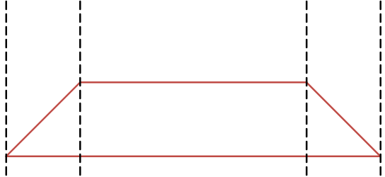
(Actually, it is slightly different because the edges would be able to be clipped through by PoolBalls as long as their centres don’t pass into it. This was dealt with by adding or subtracting the PoolBall’s radius from the considered left and right regions.)
For example, the middle of orientation 1’s if statement started like this:
if ((Game1.poolBalls[i].position.X > position.X - (length / 2) + width)
& (Game1.poolBalls[i].position.X < position.X + (length / 2) - width))
Note that left, middle, and right are used for all 4 orientations as if they were facing the same way as orientation 1 to make the code’s language used consistent (e.g. length is always a measure in the x direction).
Next, I needed to check if a PoolBall in each region was actually colliding with the trapezium. This was simple for the middle part, just accounting for the fact that the centres should actually be a distance apart equal to half the Cushion’s width plus the PoolBall’s radius.
(Game1.poolBalls[i].position.Y + Game1.poolBalls[i].radius > position.Y - (width / 2))
Note that this does technically extend infinitely beyond the Cushion (downwards in the case of orientation 1). However, since no PoolBall should be able to go there, it shouldn’t impact gameplay at all. In fact, it might actually prevent them from going too far out of bounds if they’re moving too fast to be detected by a smaller bounding area.
The sides are more complicated. To create collisions for them, I had to resort to deriving the region where the PoolBall and the hypotenuse of each triangle intersect using vectors. I tried to use Cartesian equations of lines and circles, but I found that vectors required less converting back and forth (since I wanted the end product to reference vectors anyway because the rest of my code uses vectors).
I began by representing one facet of the situation in Desmos, but it doesn’t have the capability to graph vector equations of lines, only regular vectors. However, I could still this new Desmos graph I made to visualize the situation a bit.
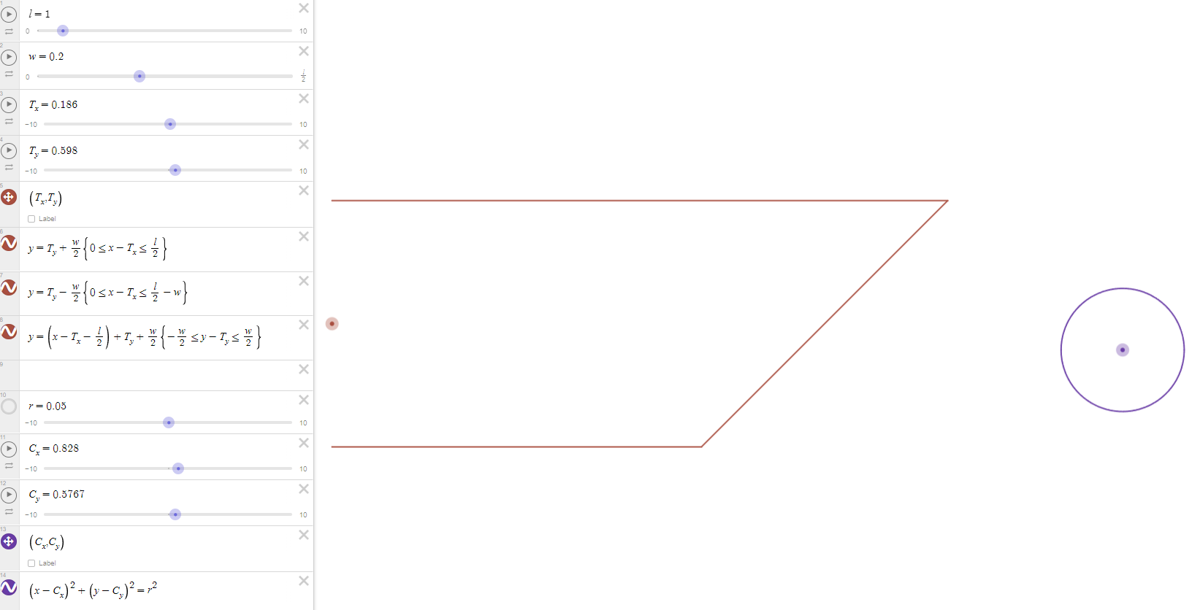
Note that this trapezium is in orientation 1 because Desmos and my game have flipped y directions.
Also, note that Desmos allows you to define points of variables and then drag those points to change variables. This was useful when I wanted the circle in a particular location relative to the trapezium.
Anyhow, I moved back into vectors. I defined my variables, $\left(T_{x},T_{y}\right)$ are the coordinates of the centre of the trapezium, $l$ and $w$ are its width and length respectively, $\left(C_{x},C_{y}\right)$ are the coordinates of the centre of the circle and $r$ is its radius. I then defined the points at which vertices of the trapezium were, $A$ and $B$, by inspection.
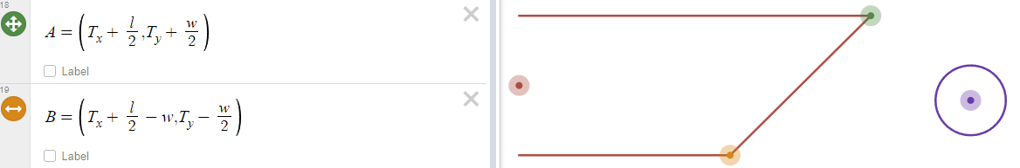
Then I found the vector equation of the right triangle’s hypotenuse (the diagonal line on the graph above), $l_{1}$.
$$l_{1}=\overline{OA}+λ\overline{AB}$$
Where $\overline{AB}$ is the vector from $A$ to $B$, $\overline{OA}$ is the vector from the origin $\left(0,0\right)$ to $A$, and $λ$ is a scalar number. This essentially defines the line that crosses through $\overline{OA}$ and travels some multiple of $\overline{AB}$ (in either direction). To find the two vectors, we take the coordinates of the first point and subtract them from those of the second point. This essentially treats the situation as if we have travelled to the second point while starting at the first point. $\backslash left( \backslash matrix\{a \backslash cr b \backslash cr\} \backslash right)$
$$\overline{OA}=\left(\begin{matrix}T_{x}+\frac{l}{2} \\ T_{y}+\frac{w}{2}\end{matrix}\right)-\left(\begin{matrix}0 \\ 0\end{matrix}\right)=\left(\begin{matrix}T_{x}+\frac{l}{2} \\ T_{y}+\frac{w}{2}\end{matrix}\right)$$
$$\overline{AB}=\left(\begin{matrix}T_{x}+\frac{l}{2}-w \\ T_{y}+\frac{w}{2}\end{matrix}\right)-\left(\begin{matrix}T_{x}+\frac{l}{2} \\ T_{y}-\frac{w}{2}\end{matrix}\right)=\left(\begin{matrix}-w \\ -w\end{matrix}\right)=-w\left(\begin{matrix}1 \\ 1\end{matrix}\right)$$
Since $\overline{AB}$ has a constant multiple in front of it, that can be “absorbed” into the $λ$. Then, this gives the equation of $l_{1}$ as:
$$l_{1}=\left(\begin{matrix}T_{x}+\frac{l}{2} \\ T_{y}+\frac{w}{2}\end{matrix}\right)+λ\left(\begin{matrix}1 \\ 1\end{matrix}\right)$$
As a reality check, we can see that the vector that $λ$ is multiplying has a gradient of $1$ (because $\frac{1}{1}=1$) which is the same as the gradient of the hypotenuse in Desmos (and makes sense since its 45 degrees of either axis). So, this derivation gains some more validity.
Continuing, we can derive an equation for the shortest distance between $l_{1}$ and the centre of the circle. We can define another line $l_{2}$ that goes from a point on $l_{1}$ to the circle’s centre. We can use the fact that it must pass through the centre of the circle $\left(C_{x},C_{y}\right)$ and have a gradient perpendicular to that of $l_{1}$ (because the perpendicular distance is always the shortest path between a line and a point).
To find a vector with a gradient perpendicular to $\left(\begin{matrix}1 \\ 1\end{matrix}\right)$, we can use the dot product again (or do it by inspection, but that’s less fun). For our perpendicular vector $p$:
$$p⋅\left(\begin{matrix}1 \\ 1\end{matrix}\right)=\left|p\right|\left|\left(\begin{matrix}1 \\ 1\end{matrix}\right)\right|\cos\left({90}^{∘}\right)=1×p_{1}+1×p_{2}$$
$$⟹p_{1}+p_{2}=0$$
$$⟹p_{1}=-p_{2}$$
The magnitude of $p$ doesn’t matter because it gets multiplied by another scalar number (in this case $μ$). So, we can define $p_{1}$ as anything we want. I defined it as $1$ to avoid unnecessary complexity. Then $p_{2}=-1$. Therefore, we now have an equation for $l_{2}$:
$$l_{2}=\left(\begin{matrix}C_{x} \\ C_{y}\end{matrix}\right)+μ\left(\begin{matrix}1 \\ -1\end{matrix}\right)$$
Then, we define a point $\left(x_{1},y_{1}\right)$ to be the point at which $l_{1}$ and $l_{2}$ intersect each other. At this point, since $\left(x_{1},y_{1}\right)$ lies on both lines (by definition), we find which value of $λ$ and which of $μ$ represent the point $\left(x_{1},y_{1}\right)$. To do this, we look at each vector’s components.
$$x_{1}=T_{x}+\frac{l}{2}+λ$$
$$x_{1}=C_{x}+μ$$
$$y_{1}=T_{y}+\frac{w}{2}+λ$$
$$y_{1}=C_{y}-μ$$
Since we have two equations for $x_{1}$ and two for $y_{1}$, we can equate them:
$$⟹T_{x}+\frac{l}{2}+λ=C_{x}+μ$$
$$⟹T_{y}+\frac{w}{2}+λ=C_{y}-μ$$
Solving simultaneously, if we subtract one equation from another, we can eliminate $λ$ and get an equation for $μ$ (we could also sum them to get $λ$., but that’s not as useful here):
$$⟹\left(T_{x}+\frac{l}{2}+λ\right)-\left(T_{y}+\frac{w}{2}+λ\right)=\left(C_{x}+μ\right)-\left(C_{y}-μ\right)$$
$$⟹T_{x}-T_{y}+\frac{l-w}{2}=C_{x}-C_{y}+2μ$$
$$⟹μ=\frac{1}{2}\left(\left(C_{y}-C_{x}\right)+\left(T_{x}-T_{y}\right)+\frac{l-w}{2}\right)$$
We know from before that:
$$\left(x_{1},y_{1}\right)=\left(C_{x}+μ,C_{y}-μ\right)$$
So, the vector from $\left(x_{1},y_{1}\right)$ and $\left(C_{x},C_{y}\right)$ is:
$$\left(\begin{matrix}C_{x} \\ C_{y}\end{matrix}\right)-\left(\begin{matrix}C_{x}+μ \\ C_{y}-μ\end{matrix}\right)=\left(\begin{matrix}-μ \\ μ\end{matrix}\right)=μ\left(\begin{matrix}-1 \\ 1\end{matrix}\right)$$
Therefore, the distance between $\left(x_{1},y_{1}\right)$ and $\left(C_{x},C_{y}\right)$ is:
$$\left|μ\left(\begin{matrix}-1 \\ 1\end{matrix}\right)\right|=|μ|\sqrt{{\left(-1\right)}^{2}+1^{2}}=|μ|\sqrt{2}$$
Now, for the circle and trapezium to be considered colliding, the distance between the circle’s centre and the edge of the trapezium must be less than the circle’s radius. With this, we get the inequality:
$$|μ|\sqrt{2}<r$$
$$⟹\frac{\sqrt{2}}{2}\left|\left(C_{y}-C_{x}\right)+\left(T_{x}-T_{y}\right)+\frac{l-w}{2}\right|<r$$
$$⟹\left|\left(C_{y}-C_{x}\right)+\left(T_{x}-T_{y}\right)+\frac{l-w}{2}\right|<r\sqrt{2}$$
Writing this as a condition in code within Cushion.cs and using another square root approximation overestimate, we get:
if (Math.Abs((Game1.poolBalls[i].position.Y - Game1.poolBalls[i].position.X) + (position.X – position.Y) + 0.5 * (length – width)) < Game1.poolBalls[i].radius * Math.Sqrt(2))
Using the same method, I derived similar conditions for the other 7 possibilities (number of orientations * number of triangles per orientation – 1 = 4 * 2 = 7).
Now, looking at the collision responses, we can view each triangle hypotenuse as lines in Cartesian coordinates. Each case is either $y=x$ or $y=-x$. In the case $y=x$, to reflect a vector in it we just swap the components. For example, the vector $\left(\begin{matrix}a_{1} \\ a_{2}\end{matrix}\right)$ becomes $\left(\begin{matrix}a_{2} \\ a_{1}\end{matrix}\right)$. Conversely, in the case $y=-x$, we swap the components and reverse the direction. For example, the vector $\left(\begin{matrix}a_{1} \\ a_{2}\end{matrix}\right)$ becomes $-\left(\begin{matrix}a_{2} \\ a_{1}\end{matrix}\right)$. Using this, I reflected the incident PoolBall’s velocity in either line where applicable. Putting all of this together, I created the Cushion.DoCollisions function.
public void DoCollisions() // [todo: add repositioning outside of the hitbox after collisions
// add correct corner collisions]
{

switch (orientation)
{
// NOTE: directions are from viewing the trapezium as if it's orientation = 1
case 1:
for (int i = 0; i < Game1.poolBalls.Count; i++)
{
// middle:
if ((Game1.poolBalls[i].position.X > position.X - (length / 2) + width) // if it's in the column of the screen that has this section of the trapezium
& (Game1.poolBalls[i].position.X < position.X + (length / 2) - width) // if it's in the column of the screen that has this section of the trapezium
& (Game1.poolBalls[i].position.Y + Game1.poolBalls[i].radius > position.Y - (width / 2))) // if it's below the top side of the trapezium
{
Game1.poolBalls[i].velocity = new Vector2(Game1.poolBalls[i].velocity.X, - Game1.poolBalls[i].velocity.Y); // reflected horizontally
}

// left triangle:
if ((Game1.poolBalls[i].position.X > position.X - (length / 2) - Game1.poolBalls[i].radius) // if in the column of the screen that has this section of the trapezium
& (Game1.poolBalls[i].position.X < position.X - (length / 2) + width) // if in the column of the screen that has this section of the trapezium
& (Math.Abs(((position.X + position.Y) - (Game1.poolBalls[i].position.X + Game1.poolBalls[i].position.Y) + (0.5 * (width - length)))) / Game1.sqrt_2 < Game1.poolBalls[i].radius))
{
Game1.poolBalls[i].velocity = new Vector2(-Game1.poolBalls[i].velocity.Y, - Game1.poolBalls[i].velocity.X); // reflected
}

// right triangle:
if ((Game1.poolBalls[i].position.X > position.X + (length / 2) - width) // if in the column of the screen that has this section of the trapezium
& (Game1.poolBalls[i].position.X < position.X + (length / 2) + Game1.poolBalls[i].radius) // if in the column of the screen that has this section of the trapezium
& (Math.Abs(((position.Y - position.X) + (Game1.poolBalls[i].position.X - Game1.poolBalls[i].position.Y) + (0.5 * (width - length)))) / Game1.sqrt_2 < Game1.poolBalls[i].radius))
{
Game1.poolBalls[i].velocity = new Vector2(Game1.poolBalls[i].velocity.Y, Game1.poolBalls[i].velocity.X); // reflected

}
}
break;
case 2:
for (int i = 0; i < Game1.poolBalls.Count; i++)
{
// left triangle:
if ((Game1.poolBalls[i].position.Y > position.Y + (length / 2) - width) // if in the row of the screen that has this section of the trapezium
& (Game1.poolBalls[i].position.Y < position.Y + (length / 2) + Game1.poolBalls[i].radius) // if in the row of the screen that has this section of the trapezium
& (Math.Abs(((position.X - position.Y) + (Game1.poolBalls[i].position.Y - Game1.poolBalls[i].position.X) + (0.5 * (width - length)))) / Game1.sqrt_2 < Game1.poolBalls[i].radius))
{
Game1.poolBalls[i].velocity = new Vector2(Game1.poolBalls[i].velocity.Y, Game1.poolBalls[i].velocity.X); // reflected
}

// right triangle:
if ((Game1.poolBalls[i].position.Y > position.Y - (length / 2) - Game1.poolBalls[i].radius) // if in the row of the screen that has this section of the trapezium
& (Game1.poolBalls[i].position.Y < position.Y - (length / 2) + width) // if in the row of the screen that has this section of the trapezium
& (Game1.Abs(((position.X + position.Y) - (Game1.poolBalls[i].position.Y + Game1.poolBalls[i].position.X) + (0.5 * (width - length)))) / Game1.sqrt_2 < Game1.poolBalls[i].radius))
{
Game1.poolBalls[i].velocity = new Vector2(-Game1.poolBalls[i].velocity.Y, - Game1.poolBalls[i].velocity.X); // reflected
}

// middle:
if ((Game1.poolBalls[i].position.Y > position.Y - (length / 2) + width)
& (Game1.poolBalls[i].position.Y < position.Y + (length / 2) - width)
& (Game1.poolBalls[i].position.X + Game1.poolBalls[i].radius > position.X - (width / 2)))
{
Game1.poolBalls[i].velocity = new Vector2(-Game1.poolBalls[i].velocity.X, Game1.poolBalls[i].velocity.Y); // reflected vertically
}
}
break;
case 3:
for (int i = 0; i < Game1.poolBalls.Count; i++)
{
// middle:
if ((Game1.poolBalls[i].position.X > position.X - (length / 2) + width)
& (Game1.poolBalls[i].position.X < position.X + (length / 2) - width)
& (Game1.poolBalls[i].position.Y - Game1.poolBalls[i].radius < position.Y + (width / 2)))
{
Game1.poolBalls[i].velocity = new Vector2(Game1.poolBalls[i].velocity.X, - Game1.poolBalls[i].velocity.Y); // reflected horizontally
}

// left triangle:
if ((Game1.poolBalls[i].position.X > position.X + (length / 2) - width) // if in the column of the screen that has this section of the trapezium
& (Game1.poolBalls[i].position.X < position.X + (length / 2) + Game1.poolBalls[i].radius) // if in the column of the screen that has this section of the trapezium
& (Game1.Abs(((position.X + position.Y) - (Game1.poolBalls[i].position.X + Game1.poolBalls[i].position.Y) + (0.5 * (length - width)))) / Game1.sqrt_2 < Game1.poolBalls[i].radius))
{
Game1.poolBalls[i].velocity = new Vector2(-Game1.poolBalls[i].velocity.Y, - Game1.poolBalls[i].velocity.X); // reflected
}

// right triangle:
if ((Game1.poolBalls[i].position.X > position.X - (length / 2) - Game1.poolBalls[i].radius) // if in the column of the screen that has this section of the trapezium
& (Game1.poolBalls[i].position.X < position.X - (length / 2) + width) // if in the column of the screen that has this section of the trapezium
& (Math.Abs(((position.X - position.Y) + (Game1.poolBalls[i].position.Y - Game1.poolBalls[i].position.X) + (0.5 * (width - length)))) / Game1.sqrt_2 < Game1.poolBalls[i].radius))
{
Game1.poolBalls[i].velocity = new Vector2(Game1.poolBalls[i].velocity.Y, Game1.poolBalls[i].velocity.X); // reflected
}
}
break;
case 4:
for (int i = 0; i < Game1.poolBalls.Count; i++)
{
// left triangle:
if ((Game1.poolBalls[i].position.Y > position.Y - (length / 2) - Game1.poolBalls[i].radius) // if in the row of the screen that has this section of the trapezium
& (Game1.poolBalls[i].position.Y < position.Y - (length / 2) + width) // if in the row of the screen that has this section of the trapezium
& (Math.Abs(((position.X - position.Y) + (Game1.poolBalls[i].position.Y - Game1.poolBalls[i].position.X) + (0.5 * (length - width)))) / Game1.sqrt_2 < Game1.poolBalls[i].radius))
{
Game1.poolBalls[i].velocity = new Vector2(Game1.poolBalls[i].velocity.Y, Game1.poolBalls[i].velocity.X); // reflected
}

// right triangle:
if ((Game1.poolBalls[i].position.Y > position.Y + (length / 2) - width) // if in the row of the screen that has this section of the trapezium
& (Game1.poolBalls[i].position.Y < position.Y + (length / 2) + Game1.poolBalls[i].radius) // if in the row of the screen that has this section of the trapezium
& (Math.Abs(((position.X + position.Y) - (Game1.poolBalls[i].position.Y + Game1.poolBalls[i].position.X) + (0.5 * (length - width)))) / Game1.sqrt_2 < Game1.poolBalls[i].radius))
{
Game1.poolBalls[i].velocity = new Vector2(-Game1.poolBalls[i].velocity.Y, - Game1.poolBalls[i].velocity.X); // reflected
}

// middle:
if ((Game1.poolBalls[i].position.Y > position.Y - (length / 2) + width)
& (Game1.poolBalls[i].position.Y < position.Y + (length / 2) - width)
& (Game1.poolBalls[i].position.X - Game1.poolBalls[i].radius < position.X + (width / 2)))
{
Game1.poolBalls[i].velocity = new Vector2(-Game1.poolBalls[i].velocity.X, Game1.poolBalls[i].velocity.Y); // reflected vertically
}
}
break;
}
}
Note that the triangle collisions aren’t as effective as the middle’s collisions because they only extend the length of 1 PoolBall radius inside. Here’s the hitbox (shaded in grey) to illustrate this, relative to the Cushion (outlined in red):
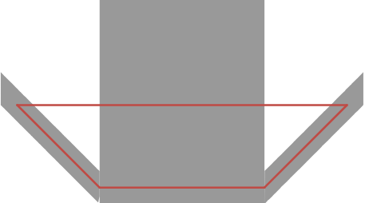
Note that the middle region extends upwards much further than shown.
Also, I’ve kept the simple bounds collisions I made near the start of development to make sure not a single PoolBall can leave the bounds of the screen. I did this because the less-than-optimal Cushion collisions could risk missing PoolBalls because their triangle collision regions don’t extend all the way back. If a PoolBall was going fast enough, it could jump past the region altogether and miss being teleported back, breaking the game. The simple bounds don’t prevent PoolBalls leaving the playing surface, but they will keep them on screen. This means that players can spot if something goes wrong, instead of missing the error and continuing the game with a player at an unknown disadvantage (this could happen if, for example, there’s too many fast-moving PoolBalls to keep track of).
Finally, I created an array of all Cushions called cushions. This is iterated through in Game1.Update to update and draw each Cushion every frame.
cushions = new Cushion[] { _cushionTopLeft, _cushionTopRight,
_cushionMiddleLeft, _cushionMiddleRight,
_cushionBottomLeft, _cushionBottomRight };

Tests
DoCollisions()
To test DoCollisions, I aimed the CueBall at it at various angles and speeds. I also tried potting PoolBalls to check how it felt and if it worked. I made sure to test every Cushion. Here are some screenshots.
Pre-collision  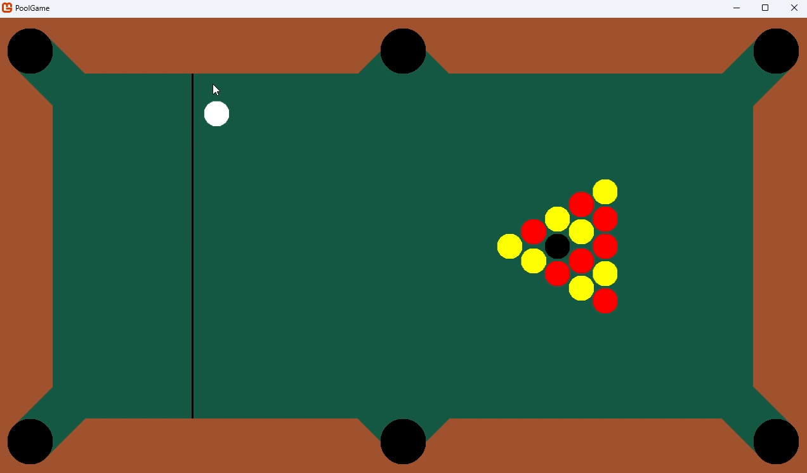 | Post collision  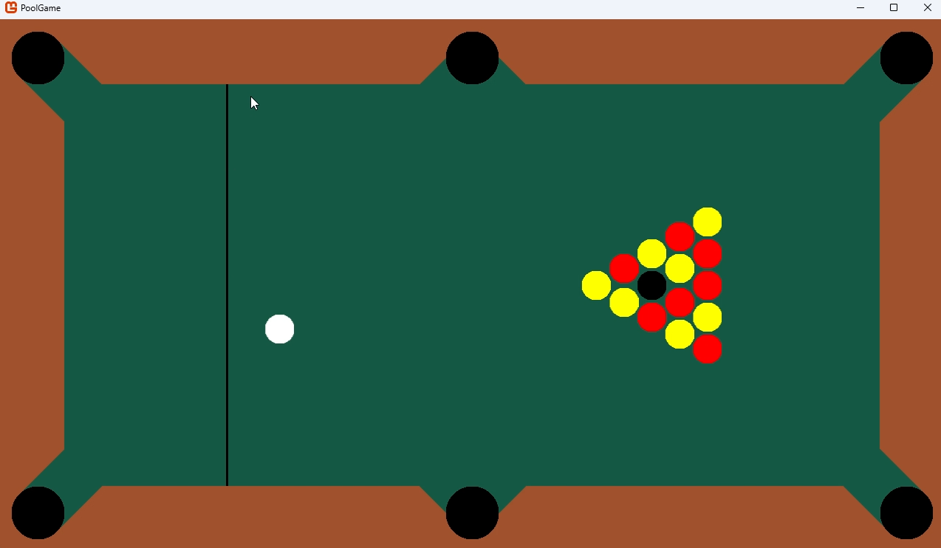
Pre-second-collision  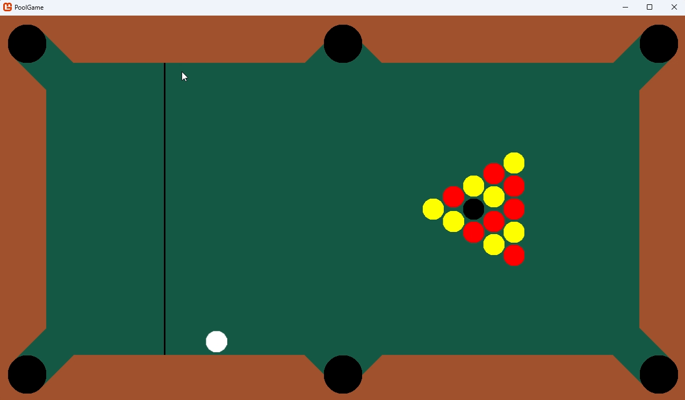 | Post-second-collision  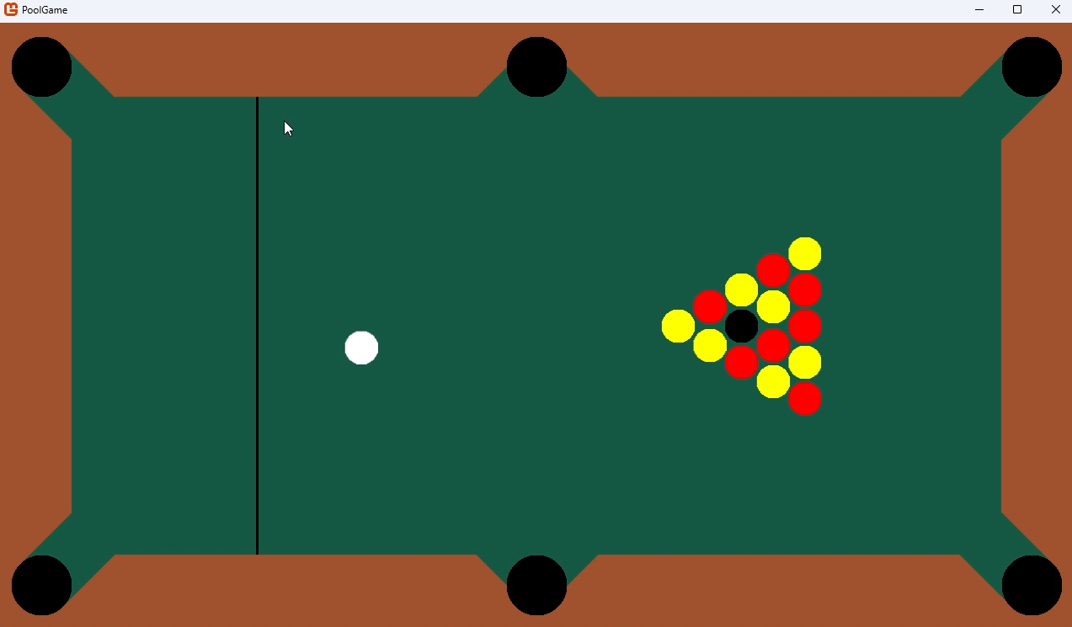

Pre-collision  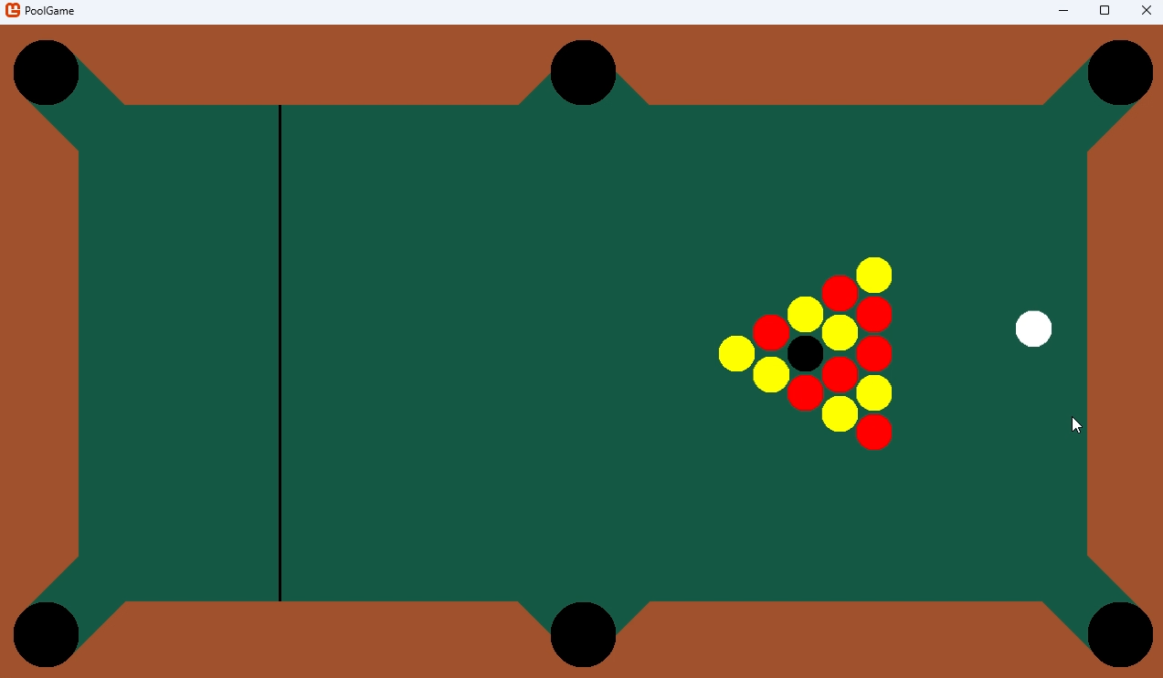 | Post-collision  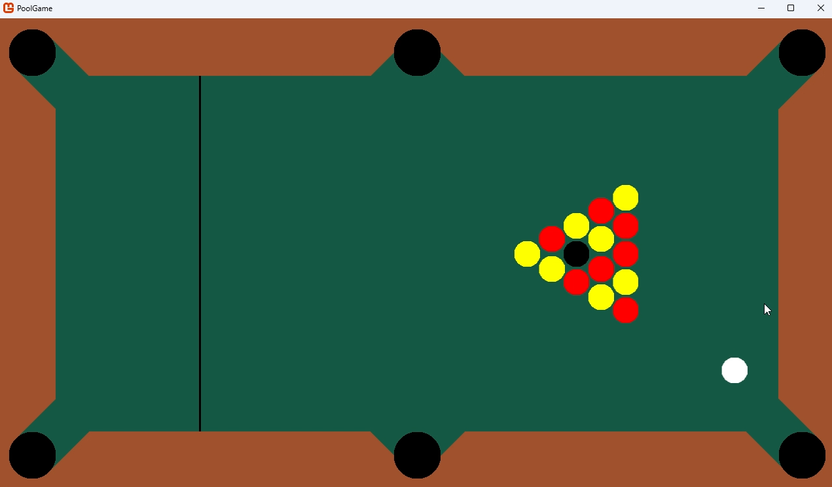
Pre-second-collision | Post-second-collision  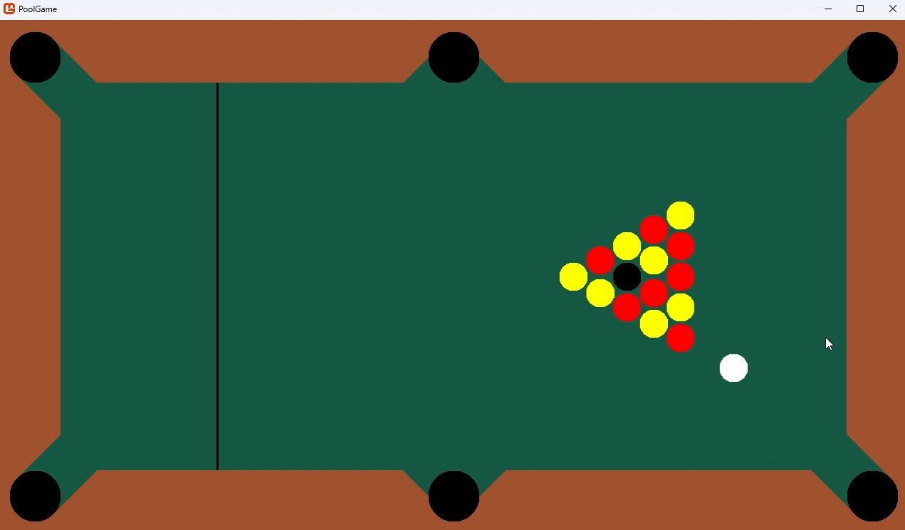
I also attempted to knock some object balls into a Cushion to check that they also get reflected.
Pre-break  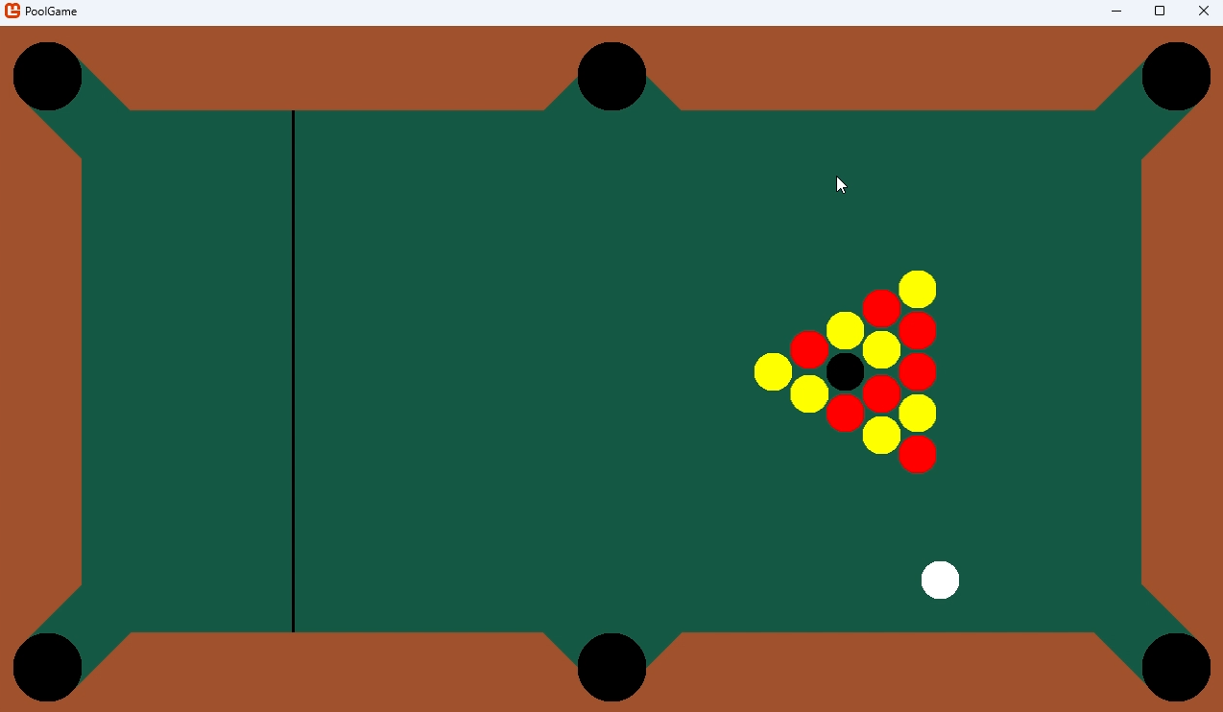 | Pre-top-yellow-collision  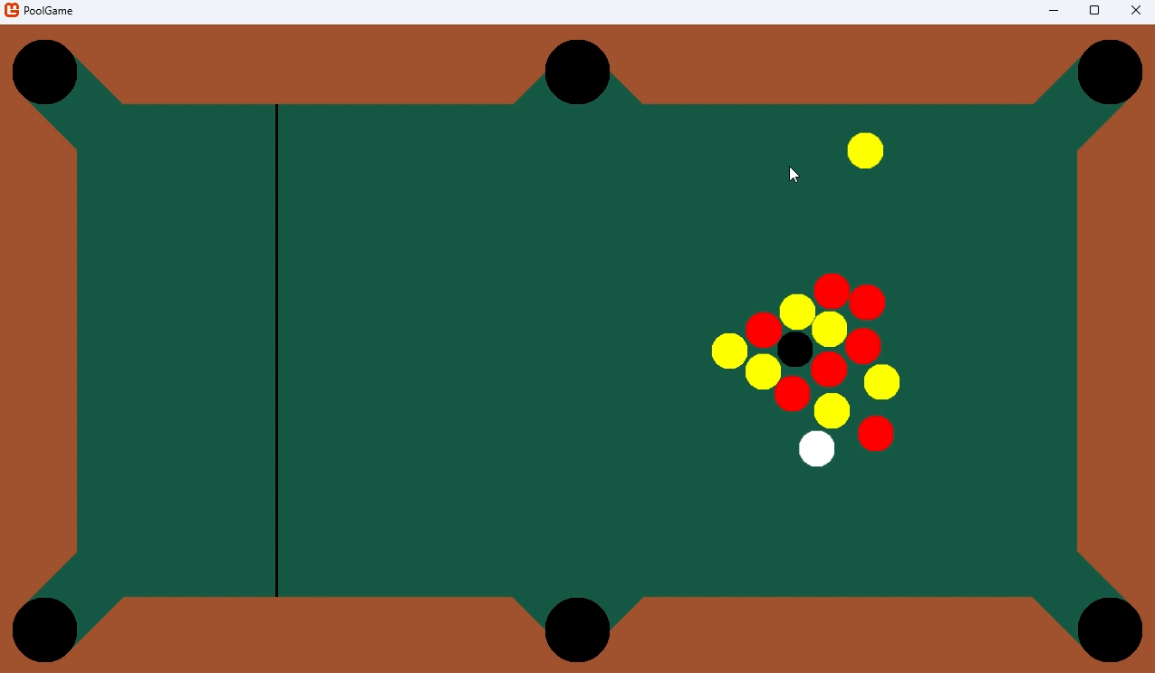
Post-top-yellow-collision  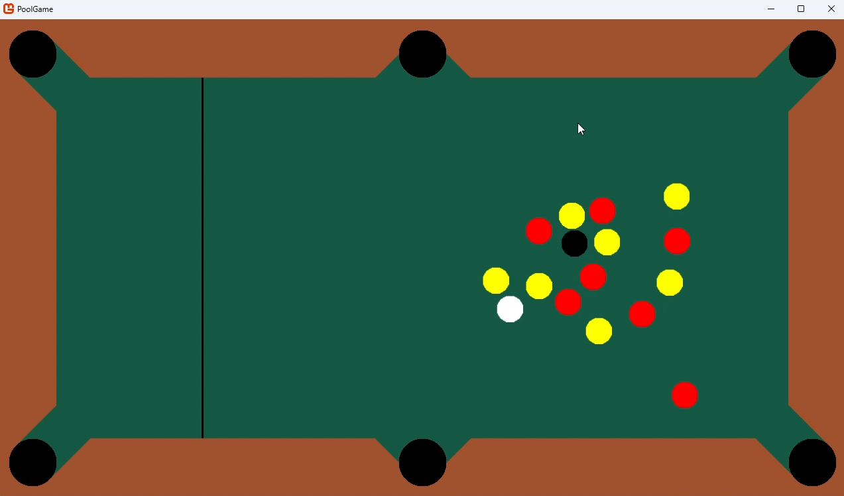 | Top left yellow just before getting potted  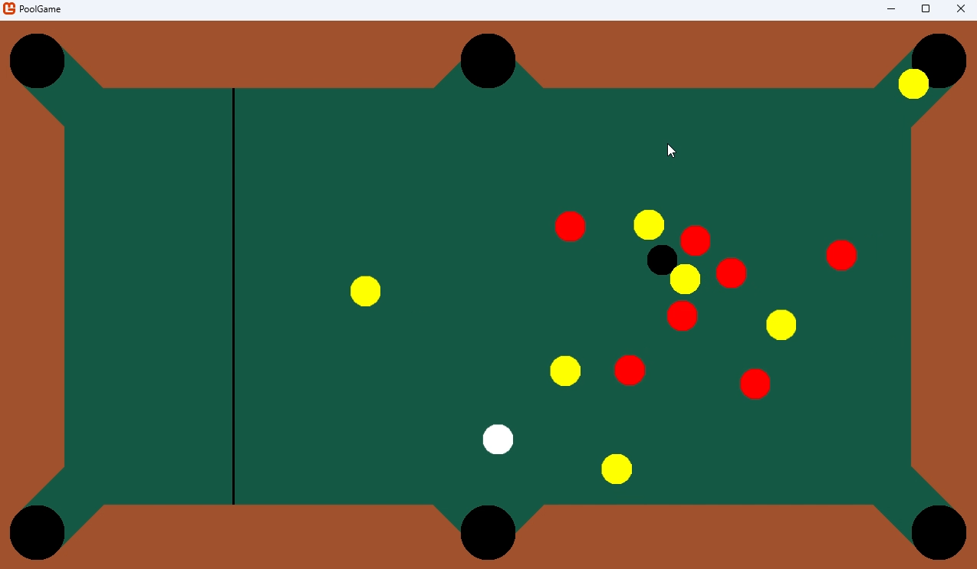
From my testing, all Cushions have accurate collisions and potting PoolBalls is achievable.
Overall, this shows that the function is working as expected. In response, no actions need to be taken.

Reworks
Now that all this iteration’s planned features were implemented, I went back to look at each part of it to assess it and rework parts of it if necessary. Here are the features I tweaked/added:

PoolBall-PoolBall collisions
While I was making other collisions, I noticed that, when PoolBalls collide, they sometimes get stuck inside of each other. This then leads to them slowly overlapping more and more until they are essentially one or slowly breaking away from each other and “pinging” off each other at high velocities. Both scenarios are unrealistic, so I added a position correction to each PoolBall when they collide. It moves each PoolBall half the distance they overlap so that both are slightly shunted away from each other to the point where they no longer overlap. Right under the velocity adjustments in DoAllPoolBallPoolBallCollisions, I added this:
// adjusting positions to prevent PoolBalls overlapping and getting stuck inside of each other:
poolBalls[j].position += ((0.5f * relativePositionVector.Length()) - poolBalls[i].radius) * unitNormalVector; // moving it half the distance they overlap
poolBalls[i].position -= ((0.5f * relativePositionVector.Length()) - poolBalls[i].radius) * unitNormalVector; // moving it half the distance they overlap

Scaling
Instead of poolBallRadius, pocketRadius, tablePocketSpacing being set as a number of pixels (like they were initially because they were that way in Desmos), I made them multiples of Game1.WindowWidth. This should now allow the window to be scaled up with no errors when the width of the window changed.
// sizing:
poolBallRadius = Game1.windowWidth / 64; // 20 for Game1.windowWidth = 1280
pocketRadius = (9 * Game1.windowWidth) / 320; // 36 for Game1.windowWidth = 1280
tablePocketSpacing = (Game1.windowWidth / 80); // 16 for Game1.windowWidth = 1280
I also set Game1.WindowHeight in terms of Game1.WindowHeight to ensure the aspect ratio is always 16x9 when scaling.
windowHeight = (9 * windowWidth) / 16; // 720 if windowWidth = 1280
Note that, in C#, if an int is on both sides of the / operator, the result will always be the truncated version of the answer in the form of an integer. For example, 3/2 evaluates to 1, whereas 3f/2, 3.0/2, 3/2f, and 3/2.0 all evaluate to 1.5. This ensures that these three sizes are always integers, preventing any potential errors from occurring if one accidentally became a float.

Resistive forces
From testing, I realised that just friction to slow PoolBalls doesn’t feel right. I decided to alter the perfectly elastic collisions I’d set up. After every collision with another PoolBall, I multiplied the PoolBall’s velocity by PoolBall.poolBallCoefficientOfRestitution. After every collision with a Cushion, I would multiply the PoolBall’s velocity by PoolBall.CushionCoefficientOfRestitution. Note that the coefficient of resolution is the magnitude of the sum of velocities after a collision in a system divided by those before the collision (i.e. $e=\frac{Σv}{Σu}$, where $e$ is the coefficient of resolution, $Σv$ is the sum of velocities after the collision, and $Σu$ is the sum of velocities before the collision). Rearranging, we get $Σv=eΣu$, meaning I can just multiply the calculated velocity after collision by $e$ to simulate a more inelastic collision than I had before.
The coefficients are dimensionless (because they are derived by dividing the square of a velocity by the square of another velocity), so I could use real-world data to inform the values I used. After searching the web for specific values of the coefficients, I found that Colorado State University had compiled some of the physical properties relevant to pool on their billiards website. I used their ball-ball coefficient of restitution range (0.92-0.98) and their ball-rail coefficient of restitution range (0.6-0.9). Note that rail and cushion are pretty much synonymous with each other in pool. After experimenting, I settled on 0.9 for the PoolBall-PoolBall coefficient of restitution and 0.8 for the PoolBall-Cushion one.
(https://billiards.colostate.edu/faq/physics/physical-properties/)
Here’s an example of the velocity change in Cushion.DoCollisions:
Before:
Match.poolBalls[i].velocity = new Vector2(Game1.poolBalls[i].velocity.Y, Game1.poolBalls[i].velocity.X); // reflected
After:
Match.poolBalls[i].velocity = PoolBall.poolBallCushionCoefficientOfRestitution * (new Vector2(Game1.poolBalls[i].velocity.Y, Game1.poolBalls[i].velocity.X)); // reflected, accounting for energy lost during collision
Also, with the friction I added on in the first iteration, I realised that it would be more accurate to refer to it as “rolling resistance” because pool balls don’t slide on a table, they roll. Referring back to Colorado State University’s observations, I adjusted the coefficient as well.
public Vector2 decelerationDueToRollingResistance { get; set; }
public const float coefficientOfRollingResistance = 0.03f; // between 0.005 - 0.015
Furthermore, I separated DoFriction into two methods: ApplyRollingResistance and StopWhenSlow. ApplyRollingResistance method only subtracts decelerationDueToRollingResistance from PoolBall.velocity and sets it to zero when stationary.
/// <summary>
/// Subtracts the PoolBall's decelerationDueToRollingResistance from its velocity, slowing it down by that amount.
/// </summary>
/// <remarks>This won't decelerate in a direction if the velocity in that direction is zero, otherwise the PoolBall with move backwards after stopping</remarks>
public void ApplyRollingResistance()
{
// horizontal:
if (velocity.X != 0) // if x velocity is 0, decelerating causes the velocity to change sign,
// meaning it moves backwards (relative to its original direction)
// which isn't how friction works
{
velocity = new Vector2(velocity.X - decelerationDueToRollingResistance.X, velocity.Y); // decelerating
}
else
{
decelerationDueToRollingResistance = new Vector2(0, decelerationDueToRollingResistance.Y); // prevents friction from changing x component of velocity when it's zero
}

// vertical:
if (velocity.Y != 0) // if x velocity is 0, decelerating causes the velocity to change sign,
// meaning it moves backwards (relative to its original direction)
// which isn't how friction works
{
velocity = new Vector2(velocity.X, velocity.Y - decelerationDueToRollingResistance.Y); // decelerating
}
else
{
decelerationDueToRollingResistance = new Vector2(decelerationDueToRollingResistance.X, 0); // prevents friction from changing y component of velocity when it's zero
}
}
StopWhenSlow just stops the PoolBall when its velocity in either the x or y direction is below the ThresholdVelocity and, if so, sets it to zero.
/// <summary>
/// If velocity in a certain direction is under a given threshold, the PoolBall will stop moving in that direction and decelerationDueToRollingResistance in that direction is set to 0.
/// </summary>
/// <remarks>This prevents a PoolBall from moving for too long when its really slow, enabling the next round to start faster.</remarks>
public void StopWhenSlow()
{
// horizontal velocity:
if (Math.Abs(velocity.X) < ThresholdVelicity)
{
velocity = new Vector2(0, velocity.Y);
decelerationDueToRollingResistance = new Vector2(0, decelerationDueToRollingResistance.Y); // setting decelerationDueToRollingResistance.Y to zero to prevent the PoolBall moving backwards when stopped
}

// vertical velocity:
if (Math.Abs(velocity.Y) < ThresholdVelicity)
{
velocity = new Vector2(velocity.X, 0);
decelerationDueToRollingResistance = new Vector2(decelerationDueToRollingResistance.X, 0); // setting decelerationDueToRollingResistance.X to zero to prevent the PoolBall moving backwards when stopped
}
}

Class structure
CollideObject never got used because each object that could collide had its own specific collision rules. I replaced it with CircleSprite since almost all sprites were circles. This meant I also needed to make Cushion inherit directly from Sprite.
I also created two more subclasses of PoolBall: ColouredBall and EightBall. These should make it easier to implement point scoring, winning, and other rules easier in iteration 4.
ColouredBall has a simple ballColor enum attribute, specifying if it’s red or yellow (assigned in the constructor). As it’s an enum, I can always go back and add extra colours/types of ColouredBalls for expansions. Also, note that the colours don’t always have to be red and yellow (they might be able to be changed in settings for customisability or accessibility). red and yellow are just their identifiers in the code.
namespace PoolGame.Classes
{
public class ColouredBall : PoolBall
{
public enum ballColour
{
red,
yellow,
}
public ballColour colour;

public ColouredBall(Texture2D texture, Vector2 initialPosition, float radius, bool isRed) : base(texture, initialPosition, radius)
{
if (isRed)
{
colour = ballColour.red;
}
else
{
colour = ballColour.yellow;
}
}
}
}
EightBall has no position parameter in its constructor because it always spawns in the same spot. This also allows ColouredBalls to reference EightBall.position in their positions, instead of needing a variable defined in Game1.LoadContent.
namespace PoolGame.Classes
{
public class EightBall : PoolBall
{
public EightBall(Texture2D texture, float radius) : base(texture, radius)
{
position = new Vector2((4f / 5) * ((Game1.windowWidth - (4 * Game1.pocketRadius) - (2 * Game1.tablePocketSpacing))), Game1.windowHeight / 2);
// positioned 1/5th the width of the playing surface, (derivation in writeup)
}

public override void Update(GameTime gameTime)
{
base.Update(gameTime);

//[todo: insert game-end logic here]
}
}
}
In light of these class changes, I took the opportunity to re-work the class structure a bit. Here it is:
PoolGame/
├── Classes/
├── Sprite Inheritors/
│ ├── CircleSprite Inheritors/
│ │ ├── PoolBall Inheritors/
│ │ │ ├── ColouredBall.cs
│ │ │ ├── CueBall.cs
│ │ │ └── EightBall.cs
│ │ ├── Pocket.cs
│ │ └── PoolBall.cs
│ ├── CircleSprite.cs
│ └── Cushion.cs
├── Sprite.cs
├── Game1.cs
└── Program.cs
I also gave some classes their own namespace to distinguish the files as classes. Here’s what I used for most of them:
namespace PoolGame.Classes
{
It’s simple, but it should keep them separate from any other objects I might need to add later on. (It also means I need to put using PoolGame.Classes; in the files in which I want to be able to use them.)

Docstrings
Despite their specific names, some of my methods and classes weren’t clearly described beyond the occasional comment above their declaration. Looking into conventions for this, I found out about C#’s docstrings. Essentially, right before the declaration of a class, method, or attribute, you can give a summary with html-style tags. I can also add references to other classes, methods, or attributes with <see> tags. I only added them to classes and methods because most of my attributes are self-explanatory. Here’s an example for the Cushion class:
/// <summary>
/// A subclass of <see cref="Sprite"></see> for cushions.
/// Cushions have the shape of trapeziums with only horizontal, vertical, and diagonal edges and one line of symmetry
/// <para>if orientation == 1, it will look like: ◢■◣</para>
/// <para>if orientation == 2, it will look like: ◢■◣ rotated 90 degrees anticlockwise</para>
/// <para>if orientation == 3, it will look like: ◥■◤</para>
/// <para>if orientation == 4, it will look like: ◥■◤ rotated 90 degrees anticlockwise</para>
/// </summary>
/// <remarks>The long side of the trapezium doesn't have collisions because PoolBalls shouldn't be able to reach there.</remarks>
public class Cushion : Sprite
Now, whenever I hover over a Cushion object, I can get some quick information on it. 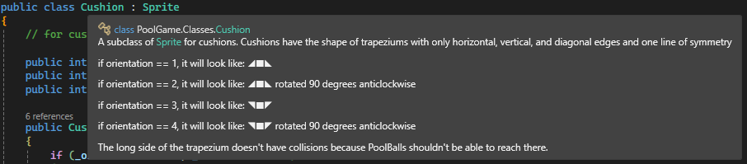
You can also state return values (if applicable) and give remarks on the function, like I did with Game1.IsAllStationary.
/// <summary>
/// Checks if all PoolBalls are stationary (i.e. not moving).
/// </summary>
/// <returns>true if all PoolBalls are stationary, false if not.</returns>
/// <remarks>Since PoolBalls are the only things that move, it only needs to check all PoolBalls to make sure everything is stationary.</remarks>
public static bool IsAllStationary()
Which is rendered as: 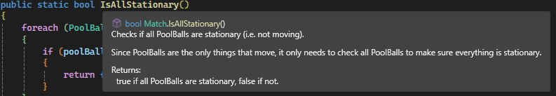
I added these to most classes and methods. Although you could argue that some are more necessary than others…
/// <summary>
/// A subclass of <see cref="Sprite"></see>, used for circular sprites.
/// </summary>
/// <remarks>This exists because multiple different objects need circular sprites, but some don't.</remarks>
public class CircleSprite : Sprite
I also referenced MonoGame’s documentation (https://docs.monogame.net) for the docstrings of pre-existing methods. For example, Game1.Update has a short description to outline exactly what it does and when.
/// <summary>
/// Updates the game by (when specified) recieving input, altering attributes, and calling methods.
/// </summary>
/// <remarks>Called 1 time every frame.</remarks>
protected override void Update(GameTime gameTime)
Which is rendered as:
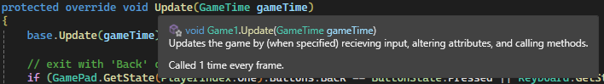

GitHub repository
I also decided to update PoolGame’s GitHub repository by using a README file in markdown to give a rough summary of it.
# PoolGame
## Overview
PoolGame is a work-in-progress game of pool I'm developing and coding for my A-Level Computer Science Programming Project. My writeup for it is attached to this repository.

The premise of PoolGame is pool but for 2+ players so that larger groups can play.
I'm also planning on implementing other features (e.g. obstacles, multiple cue balls). For more details, see my attached writeup.

## Tools, Frameworks, and Libraries used
- [**C#**](https://learn.microsoft.com/en-us/dotnet/csharp/) - A programming language built for the .NET Framework, used for coding PoolGame.
- [**Visual Studio 2022**](https://visualstudio.microsoft.com/vs/) - An integrated development environment, used for writing, debugging, and compiling the code.
- [**MonoGame**](https://monogame.net) - An open-source framework based on the Microsoft XNA Framework, providing the structure and tools for developing the game.
Rendered as:
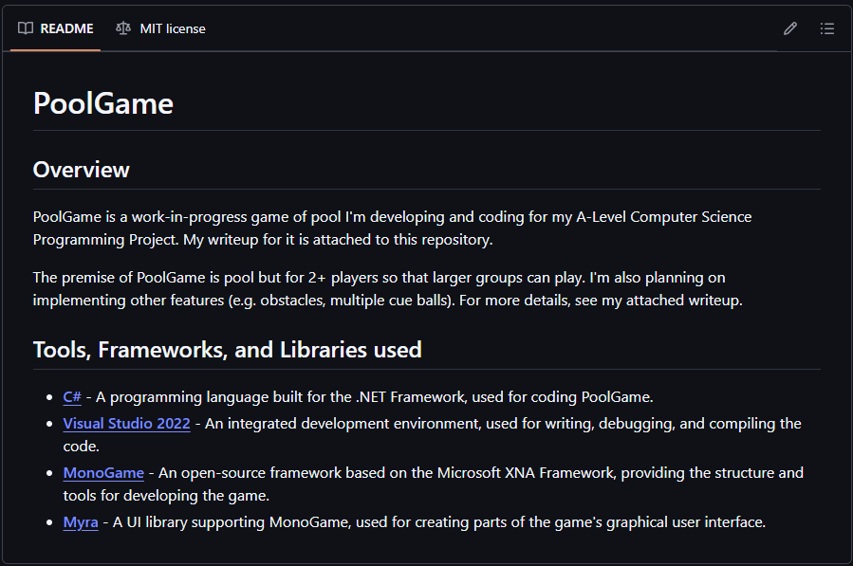

Review
Throughout this iteration, I filled out the table with more pool balls, pockets, and cushions (all of whom have functioning rendering and collisions). I also made some texture-generating methods for object sprites and made everything coloured. These allow for an unexpected amount of customisation and resizing, which could help me out in later iterations. These methods might be able to generate the textures for objects down the line too. Also, now that I know how to make these sorts of methods, I could make some more complicated ones down the line if necessary (sort of using this iteration’s methods as a warmup).
Each class and feature were developed independently of each other. In addition, each feature was tested after addition to make sure that the game was fully functioning. This meant that, overall, there were no conflicts I observed between features.
At the end, I reworked a few functions. However, most of my reworks weren’t patching game-breaking issues, just tweaking existing features or improving clarity and readability. GitHub’s Issues feature was useful for keeping track of these as I was going along. But, overall, I think this iteration met its targets while also improving the code as a whole (even if the game isn’t fully functioning yet).

3rd iteration – adding menus and a graphical user interface
My plan for this iteration is to first comment out all of the Update and Draw logic I have implemented far. This should give me a blank slate to design a basic main menu screen. From there, I can implement some sort of screen-switching system and re-add in the match logic into another screen.

UI framework
I first needed to decide on a UI framework to use to add UI elements. I originaly wanted to make a UI system myself, but I realised during the last two iterations that I may not have enough time for something like that. It is also a reatively minor part of my game, so I felt like sinking too much effort into it would distact me from the point of my game.
After looking around for monogame-compatible UI frameworks, I discovered GeonBit.UI (https://github.com/RonenNess/GeonBit.UI). However, after trying it out, it seemed to rely more on pre-generated assets which quickly filled up my project files. This could add unnecessary bloat, increasing storage space and therefore increasing the hardware requirements for the game to run. So I decided to keep looking for another UI framework.
Then I found Myra (https://github.com/rds1983/Myra). Myra should have pretty much everything I need for my game. It has buttons, check boxes, list boxes, sliders, and more. It doesn’t have any in-built images, so it should only add a minor increase to the disc space the game takes up. But that’s more than worth it considering the amount of development hours it should save.

Barebones main menu
Using Myra’s documentation and quick start tutorial (https://github.com/rds1983/Myra/wiki) as a reference, I built a simple main menu graphical user interface. Myra categorises most input objects as widgets (e.g. radio buttons). In Game1’s LoadContent method, I defined panelStack, a VerticalStackPanel to display the screen’s buttons.
// group of Widgets, on top of each other, positioned in the centre of the screen:
panelStack = new VerticalStackPanel
{
Spacing = 10,
HorizontalAlignment = HorizontalAlignment.Center,
VerticalAlignment = VerticalAlignment.Center,
};
Then I defined screenTitle, a Label with attributes I could designate in a similar way to CSS. I customised some attributes until it looked like I wanted it to. The code then adds it to panelStack to be displayed.
var screenTitle = new Label
{
Text = "Main Menu",
TextColor = textColor,
Width = Game1.windowWidth / 10,
Height = Game1.windowHeight / 20,
TextAlign = (FontStashSharp.RichText.TextHorizontalAlignment)HorizontalAlignment.Center,
Background = widgetBackground,
Padding = new Thickness(10),
BorderThickness = new Thickness(2),

};
panelStack.Widgets.Add(screenTitle);
It’s a bit more complicated for buttons, so it took me a while to understand the documentation (it seems to assume a lot of prior knowledge and doesn’t include all of Myra’s features). Having a basic grasp on it, I defined exitButton as another Label object with broadly similar attributes to screenTitle.
var exitButton = new Button
{
Content = new Label
{
Text = "Exit to Desktop",
TextColor = textColor,
Width = Game1.windowWidth / 10,
Height = Game1.windowHeight / 20,
TextAlign = (FontStashSharp.RichText.TextHorizontalAlignment)HorizontalAlignment.Center,
Background = widgetBackground,
Padding = new Thickness(10),
BorderThickness = new Thickness(2),
}
};
However, since this was meant to be a button, I added an event handler function to close the game when pressed. Myra’s documentation uses C# lambda functions (i.e. those defined in-line with =>), but I found those less intuitive than regular subroutines. So, I modified some of the quick start tutorial’s code to make it more understandable for me. (I also lengthened its one letter variable names s and a to sender and args). I used MonoGame’s built in Exit method to exit when the button was pressed.
Then I had to add it to exitButton’s Click attribute before adding it all to panelStack.
void OnExitButtonClick(object sender, EventArgs args) // event handler
{
Exit();
}
exitButton.Click += OnExitButtonClick; // attaching the event handler to the Click event
panelStack.Widgets.Add(exitButton);
I then added a startMatchButton button whose attributes are almost the exact same as the Labels above (only with Text changed). For now, since I hadn’t worked out screen-switching logic yet, I used the same event handler as exitButton to exit the game when it was pressed.
Finally, I created a new Desktop, define its Root as panelStack, and rendered it in Draw.
// Adding it to desktop so it can be rendered by Draw()
desktop = new Desktop();
desktop.Root = panelStack;
desktop.Render(); // renders Myra UI elements

When I ran the game I, this was being displayed:
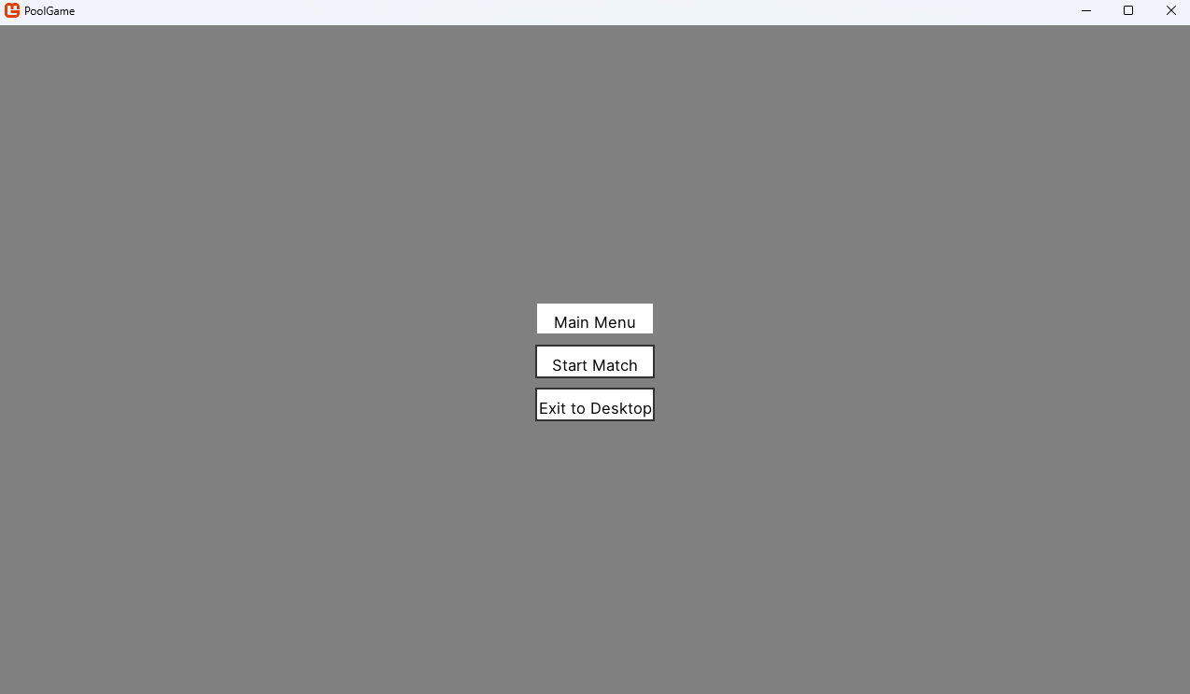
Sure enough, clicking either of the buttons (the top rectangle is just a label) closed the game.
Overall, this shows that the code is working as expected. In response, no actions need to be taken for now.

Screen switching
I tried two different approaches to switch screens in my game. First, I initialised another subclass of Game (like a sibling to Game1). Then I tried using a screen manager and a Screen class.

Method 1 – Game1 subclasses
I first started by creating Match1 as a subclass of Game. I then moved all of the match-related content from Game1 to Match1. I then changed startMatchButton‘s event handler to construct an instance of Match1 and use Match1.Run to run it (like MonoGame does in Program.cs, but not for Game1).
void OnStartMatchButtonClick(object sender, EventArgs args) // event handler
{
Match1 match = new Match1();
match.Run();
}
When I ran the code and clicked the button, it successfully created a match window. The physics all worked the same way they did before. However, the match window didn’t replace the main menu one, it just appeared on top of it. Furthermore, when I closed the match window, instead of going back to a functioning main menu window, it showed the window, but it was frozen and wouldn’t accept any inputs (even the corner exit button wouldn’t work; I had to manually terminate the program in Visual Studio). After some research, it turned out that MonoGame is really only designed for one subclass of Game (i.e. Game1) to run. This meant it was only able to close all of them.
I tried to use workarounds like Using Match1.Exit instead of Game.Exit, hoping it would only close Match1, but that didn’t work. I would have to find a different method to use instead.

Method 2 – Screen manager
Aiming to create a screen manager, I added a ScreenState enum attribute to Game1, having MainMenu and Match as possible values.
public enum ScreenState
MainMenu,
Match,
Settings
}
public static ScreenState _screenState;
Then I created an abstract class called Screen from which the subclasses MainMenu and Match could inherit from.
public abstract class Screen
{
public Color backgroundColor;

/// <summary>
/// Loads the initial content for the current screen (determined by <see cref="Game1.ScreenState"/>).
/// </summary>
/// <remarks>All overrides are called by <see cref="Game1.LoadContent"/> (1 time on startup) and whenever the screen state.</remarks>
public abstract void LoadInitialContent(GraphicsDevice graphicsDevice);

/// <summary>
/// Updates the game by (when specified) recieving input, altering attributes, and calling methods.
/// </summary>
/// <remarks>Called by <see cref="Game1.Update"/> (1 time every frame) when this is the active screen.</remarks>
public abstract void Update(GraphicsDevice graphicsDevice, GameTime gameTime);

/// <summary>
/// Draws all active sprites.
/// </summary>
/// <remarks>Called by <see cref="Game1.Draw"/> (1 time every frame) when this is the active screen.</remarks>
public abstract void Draw(GameTime gameTime);
}
I moved all of Game1’s main menu code to Screen’s MainMenu subclass. I had to define a static instance of Game1 as a property of Game1 (instantiated within its constructor) in order to use Exit (I had to write Game1.instance.Exit();). I then moved the match-related code to Match.
Back in Game1.LoadContent, I initialised MainMenu so that it would run on startup.
// MainMenu screen setup:
var mainMenu = new MainMenu(); // since LoadInitialContent() isn't static, an instance is needed
mainMenu.LoadInitialContent(GraphicsDevice);
I also changed startMatchButton‘s event handler to create an instance of Match when pressed. I switched _screenState to Match to keep things consistent.
Game1._screenState = Game1.ScreenState.Match;

var match = new Match(); // since Match.LoadInitialContent() isn't static, an instance is needed
match.LoadInitialContent(graphicsDevice);
Finally, in Game1.Update and Game1.Draw, I used switch cases to perform different actions based on which Screen was active. I needed to create local instances of each Screen to be able to run its non-static methods.
switch (_screenState) // varies depending on which screen is active
{
case ScreenState.MainMenu:
MainMenu _mainMenu = new();
_mainMenu.Update(GraphicsDevice, gameTime);
break;

case ScreenState.Match:
Match _match = new();
_match.Update(GraphicsDevice, gameTime);
break;
}
switch (_screenState) // varies depending on which screen is active
{
case ScreenState.MainMenu:
MainMenu _mainMenu = new();
_mainMenu.Draw(gameTime);
break;

case ScreenState.Match:
Match _match = new();
_match.Draw(gameTime);
break;
}
It ran well, with all the physics and buttons working.
Overall, this shows that the classes are working as expected. In response, no actions need to be taken.

Settings
I began to implement the groundwork for Settings (another subclass of Screen), but I ran out of time to develop much of it because of the non-exam assessment deadline. And I still need time to do the Evaluation section. I can continue to develop PoolGame, but I won’t be able to include my progress in this writeup anymore.

Evaluation
Back in the design stage, I outlined a few methods I would use to test my solution after development and how feedback would be used in the future. I will carry those out here. After I collect the necessary data, I will also be back referring to the features I outlined in the analysis section to check which ones I’ve met and which I haven’t. I will mainly focus on the essential features because they act as success criteria, but I will still go through the rest. I will then outline how or if I plan to implement/improve each feature in the future.

Testing to inform evaluation
Since I didn’t make it to the end of my iterative development process, I won’t be able to test some of the things I had planned on testing (e.g. settings). But I will still test all of the other parts that I can.

Gameplay loop tests
I ran my game and started a match, playing it to completion by potting all of one colour’s balls (as if I were a players). Using Window’s Game Bar, I overlaid the FPS in the corner of my screen. I also recorded task manager to keep track of memory usage. I made sure to do a fast break so that pool balls would move around and collide as fast as possible in an attempt to stress test it.
Start of match  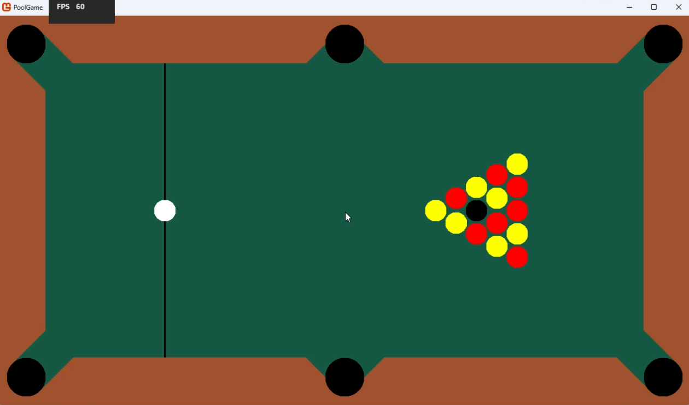 | During movement and collisions  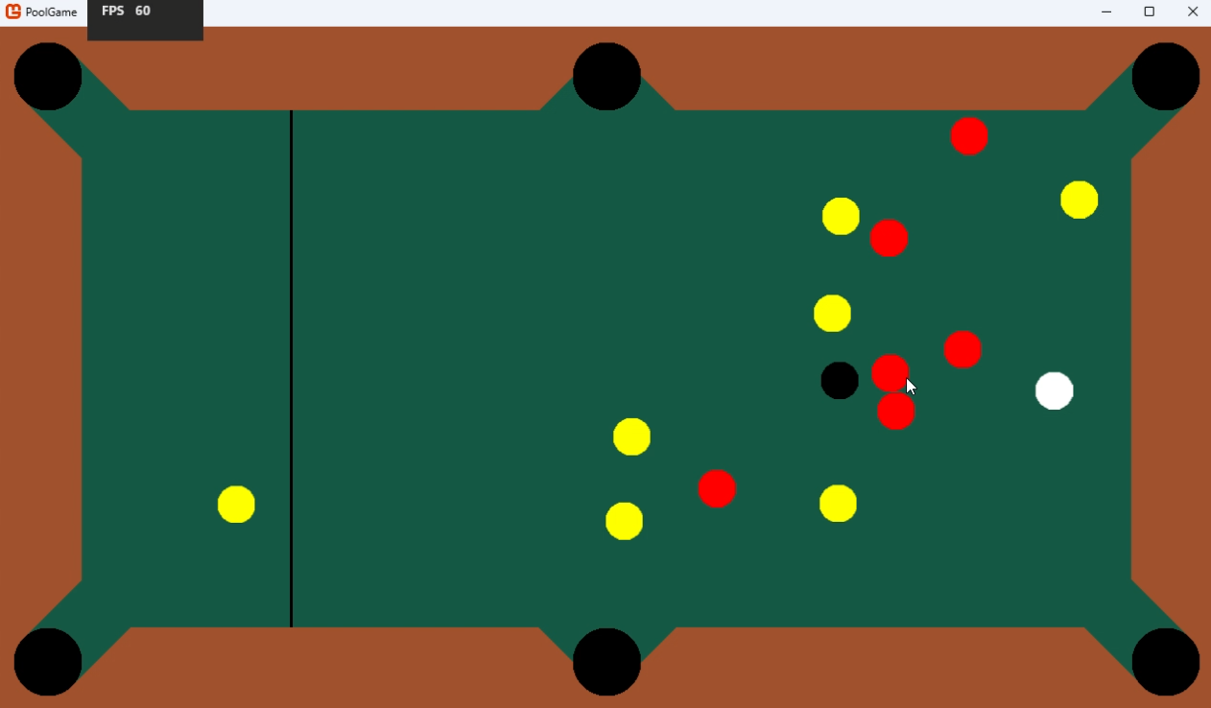
During more movement and collisions  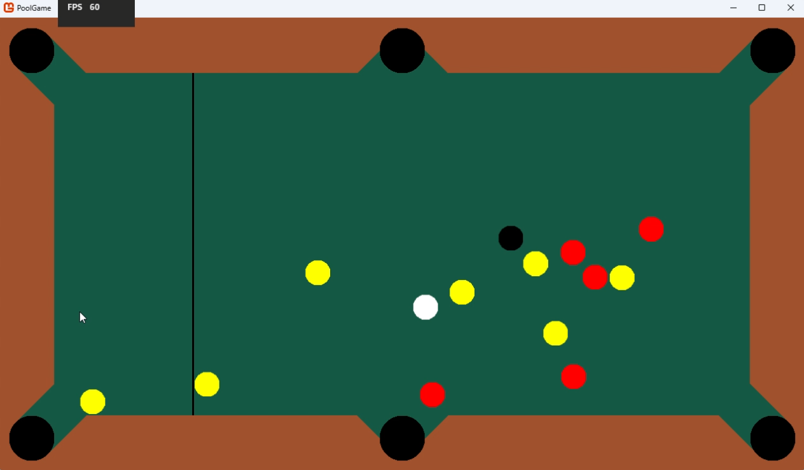 | Towards the end of the match  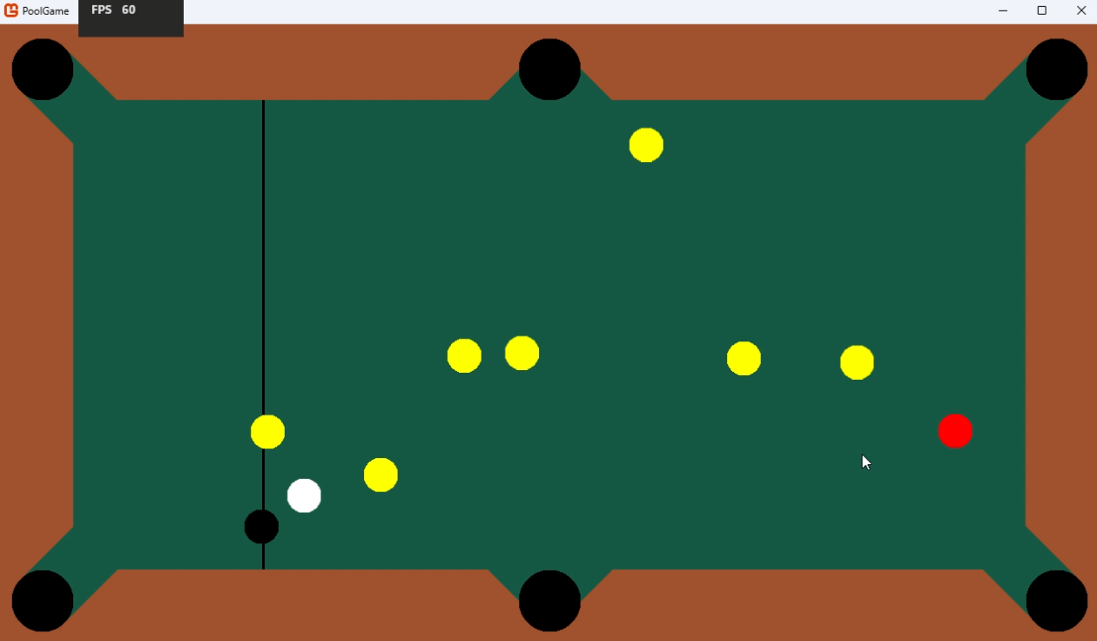
After the eight ball was potted
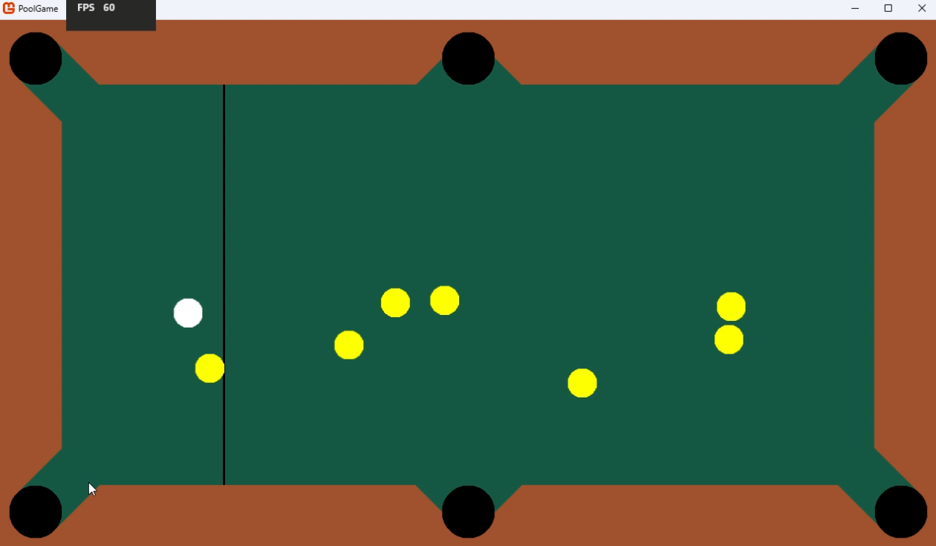
It stayed at a constant 60 FPS the entire time (The maximum FPS of my laptop’s monitor). I also did several more runs and the FPS was also 60 the entire time.

The maximum memory usage was 58.6 MB across all games. However, this maximum occurred at the very end. In fact, the memory usage was rising slowly constantly when I was playing. To test if this would keep happening, I ran my game for 10 minutes without performing any inputs.
Runtime (minutes) | Memory usage (MB) | Image
0 | 56.4
1 | 57.7
2 | 58.1
3 | 58.5
4 | 59.0
5 | 59.5
6 | 59.9
7 | 60.4
8 | 60.8
9 | 61.2
10 | 61.7
Plotting these points on Desmos, I saw that they form a pretty straight line (for the most part)
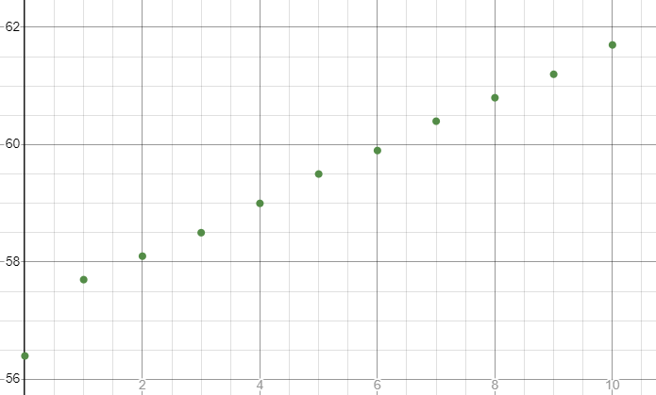
Using Desmos’ built in regression calculator, I set it to linear regression and it graphed this line:
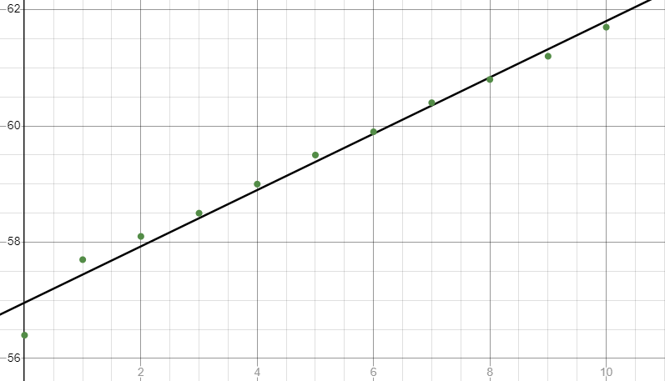
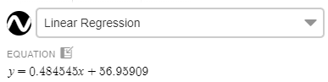
I removed the first point because it was far enough off the line to look anomalous.
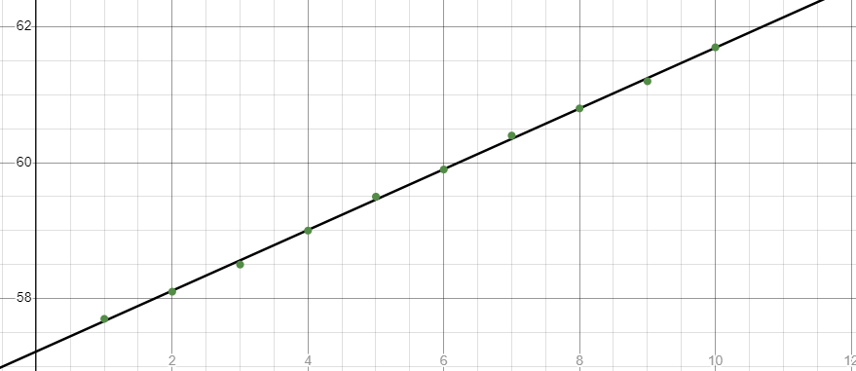
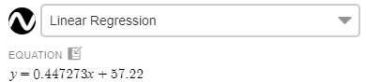
This looks like it will predict future data much more accurately. Since I know the gradient of the line (0.447273), I can relatively safely say that, for every minute that I run my game for, it uses an extra 0.45 MB (rounded to 2 significant figures) of memory. Repeating this whole process a two more times gave similar results. This suggests that my game has a memory leak, which could cause some performance issues for longer play sessions. Calculating, I found that, in just over 2 hours, the memory it takes up will double. This definitely needs to be taken care of; I will outline the steps I will take to fix it later in this section.
Apart from the memory leak however, this gameplay loop testing ran smoothly.

Survey
The other major test I was able to do was the survey I had outlined in the design section. I removed some of the questions because they covered some of the features I hadn’t implemented yet. Here are the responses from 4 participants, testing in pairs (i.e. a, b and c, d)

Responses
On a scale of 1-5, 1 being “strongly disagree” and 5 being "strongly agree”, how much do you agree with the following statements:
- I have experience playing real life pool often.
  - 3
  - 5
  - 3
  - 2
- The physics of the game was like you expect it to be in real life pool. (If you haven’t played real life pool, just rate the physics according to how you think they should be.)
  - 5
  - 4
  - 5
  - 4
- Playing with a keyboard and mouse was intuitive and simple.
  - 4
  - 3
  - 5
  - 4
- The graphics of the game were clear, simplistic, and easy to interpret.
  - 5
  - 5
  - 3
  - 4
- The game is suitable for all ages in terms of how much inappropriate imagery or wording there was.
  - 5
  - 5
  - 5
  - 5
- I enjoyed the gameplay.
  - 5
  - 4
  - 5
  - 4
Did you experience any bugs/issues while playing? If so, describe them.
- “No.”
- “Sometimes the pool balls would slip into the corners of the cushions, causing them to get stuck. This made it harder to pot sometimes.”
- “None, it seemed to run alright.”
- “N/A”
What was the worst feature of the game? Why?
- “There wasn’t many features and none of them were that bad.”
- “I can’t quite describe it, but something felt a bit off about the physics.”
- “I’m colour blind, so one of the ball types looked like a similar shade to the background, making it slightly hard to tell them apart when everything was moving around. Adding a colour change option or stripes or something on some of the balls could be a good idea.”
- “N/A”
What was the best feature of the game? Why?
- “It was nice when a ball almost landed in a pocket but just avoided going in. It meant I could block my opponent from scoring in that pocket sometimes.”
- “The initial break was quite satisfying; seeing the pool balls all dart around from above was nice.”
- “I liked how the aiming was done, it felt more like regular pool a some other pool video games.”
- “I liked the aiming, it was nice to just be able to click to shoot.”
What feature/s would you recommend adding or changing in the game?
- “A way to restart the game after someone wins. Also maybe a more structured tun system would be nice.”
- “You might want to consider adding diamonds around the edge of the table. They are used by a lot of pool players to guide their shots. Another input mode could be a good idea as well.”
- “Again, a colour change option or some other way to tell balls apart from the background could be a good idea. You could even give the balls an outline or something. Also, a guide for controls could be good, I had to ask you to tell me that it was left click to fire otherwise I couldn’t have played.”
- “N/A”

Review
I’ll give the mean score for each question.
Number | Question | Mean score
1 | I have experience playing real life pool often. | 3.25
2 | The physics of the game was like you expect it to be in real life pool. (If you haven’t played real life pool, just rate the physics according to how you think they should be.) | 4.5
3 | Playing with a keyboard and mouse was intuitive and simple. | 4
4 | The graphics of the game were clear, simplistic, and easy to interpret. | 4.25
5 | The game is suitable for all ages in terms of how much inappropriate imagery or wording there was. | 5
6 | I enjoyed the gameplay. | 4.5
Note that I personally knew most of the survey participants. This means that the mean scores for the questions (except for the first one) might be slightly higher than they otherwise should be.
The first question was just to gauge how their experience with pool effected their other responses. In relation to the second question, the person that was the most experienced found that the physics wasn’t exactly how they expected (clarified in one of their wordy responses). This was likely due to some of the abstracting I did and also the trial-and-error method I used to come up with things like the coefficients of restitution. The person with the least experience also rated the physics a 4/5. While I could brush this off as their fault for not knowing what to exactly expect, it shows that the physics isn’t 100% clear for players newer to pool. So the physics still need a small rework to make them both better for experienced players and better for less experienced players.
The third question was similarly seemingly influenced by participant b’s experience with analogue pool. Their relatively low score suggests that my shooting system does differ enough from analogue pool’s to be jarring for experienced players. As suggested (and as planned), I should think about adding different shooting methods so that players can find one that suits them. However, overall the scores for this question were reasonably high.
The fourth question was high scoring from all but one participant. The impact of their vision difficulties negatively affected their experience. This goes against one of my game’s goals of being accessible to everyone, so I will definitely take their feedback into consideration in future development.
The fifth question was in here just to make sure my game is suitable for all ages. While I didn’t think there was anything inherently inappropriate about my game, I wanted to make sure by asking other people’s opinion on it.
The sixth question was good overall, the average score (4.5/5) shows that I have at least achieved my goal of making an enjoyable game for most people in my target demographics.
The first wordy question only had one bug report, which is good because it shows that both there likely aren’t many bugs and that the discovered bug doesn’t show up often. However, the fact that they said “sometimes” implies that it happened more than once, so it could be their specific playstyle that got effected by the bug. I will need to both rework the corner collisions of my cushions and research different playstyles to accommodate them in future updates. I also need to be more vigorous with my development testing in the future in order to catch these sorts of bugs before release (I didn’t think to test the specific corner collisions of the cushions).
The second wordy question showed that there wasn’t many glaringly-bad features in my game. It also provided a bit more insight into the experienced player’s opinion on the physics (as explained above). It also raised the point that colour blind people might have a hard time distinguishing some objects apart (especially during movement of a lot of pool balls). Participant c suggested some features I was already planning on adding (i.e. colour changing and pool ball patterns). They also suggested outlining pool balls to make sure they don’t blend into the background (in their response to the final question), which is a good idea I didn’t think of.
The third wordy question was some nice positive feedback, showing that some of the features I added stood out as great. I would’ve had some thinking to do if some players couldn’t think of a response or left it blank, but, as it stands, there’s not much to feedback on here.
The fourth wordy question covers some things I already talked about (e.g. pool ball outlines) and some things I already planned on adding (e.g. restarts, more input modes). But it also provided some insight from participant b again. They suggested adding diamonds along the edges of the table to help with aiming. Looking into it, these are often on analogue pool tables because some more experienced players use them to guide their shots (I’m not sure exactly how but they are useful). Since these would be trivial to add they will definitely be a new feature in the near future.
Overall, the survey provided me with some invaluable data on players’ experience with gameplay and usability features (even if most of those weren’t implemented yet). I can expand more on how/when I plan to implement them later in this section.

Unused tests
Some of the features I had planned on testing didn’t get implemented because I ran out of time and didn’t reach them during my iterative development process. But, I can still use these after I implement the relevant features.

New player settings test
I had planned to test how effectively players who had never seen my game before could navigate through settings. Timing them, I would’ve gotten two or three (hopefully more) people to navigate to a random setting and change it. I would then evaluate if the times were consistent (to see if some settings were harder to find than others) and if they were long or short (to see how easy they were to find). I would’ve also kept track of how many times they would’ve had to exit out of a sub-menu because their setting wasn’t there (to see if the menu names were clear enough). However, since there was no settings menu, I couldn’t.

Keyboard and mouse verses controller
I had planned to test if there was a significant difference in experience between playing with keyboard and mouse and controller. I would’ve given about half of the players a keyboard and mouse to start, and the other half a controller (to make sure results wouldn’t be skewed if everyone started with the same one of the two as a result of players to get a hang of the game before trying controller). After they played for a while, I would then ask them to rate their experience on a scale of 1 to 10 in terms of how easy the game was to navigate and control. They I would’ve swapped what each player was using to the alternative. After a while again, I would get them to rate their experience. If the data showed that one input method consistently scored significantly higher than the other, I would need to make some adjustments. (I could also solicit more specific feedback from the players as to how exactly it might be improved.)

Success of the solution and description of the final product

Evaluating against success criteria
Here I will go over which of the essential features (outlined in the analysis section) and usability features my solution includes to see how successful it is so far. I will also review the desirable features because one of the essential features relies on them.
Essential Feature | Description | Does my solution include it? Why?
Simulated physics (EF.1) | The game’s physics must make sense for players, being as realistic as possible while abstracting where necessary to avoid performance issues. Where it becomes more complex, the physics used must be derived mathematically with proof shown. | Yes. Each object’s physics is as accurate as I could reasonably make it, making use of mathematical derivations where necessary to ensure this. The survey also rated it at 4.5 out of 5, almost perfect.
Local multiplayer (EF.2) | There must be capability for more than two players to play in one match. | No. I didn’t reach the stage in my development plan that includes it, so it wasn’t developed.
A Score system (EF.3) | There must be a clear way for players to keep track of their scores mid-match. | No. While players can technically check how many of their coloured balls, they have left through counting them, this was not what I had in mind when outlining this feature.
Performance on lower-end devices (EF.4) | The game must be able to run on my low-end laptop with at least 30 frames per second. | Partially. As shown by my gameplay loop tests, it maintained a constant 60 frames per second, which was the maximum frame rate of my laptop’s monitor. It also used minimal (i.e. less than 100 MB) of ram. But the memory leak is a major flaw and needs to be patched as soon as possible to prevent it from snowballing.
Controller support (on top of keyboard and mouse support) (EF.5) | Controller inputs to be able to do everything that a keyboard and mouse can as easily as they can. This includes menu navigation, settings alteration, and cue aiming/firing. | No. I didn’t reach the stage in my development plan that includes it, so this usability feature wasn’t developed.
Desirable features (EF.6) | At least two desirable features (listed below) should be implemented. | No. See below.

Desirable Feature | Description | Does my solution include it?
An assist mode (DF.1) | An option should exist (enabled within settings or if chosen on startup) to help players aim the cue for shooting. This could be an algorithm to adjust aim to increase the chance to pot a ball, or it could be guidelines to show the cue ball’s (and potentially others’) paths after a number of bounces. | No. Since I didn’t finish all of my planned iterations for development, I had no time to add this usability feature.
Control remapping (DF.2) | An option in the settings menu that allows all possible in-game player actions to be remapped to any button on keyboard and mouse or standard gamepad controllers. | No. Since I didn’t finish all of my planned iterations for development, I had no time to add it.
Minimalistic/simplistic graphics (DF.3) | Any visuals in all parts of the program (including menus) need to be clear, concise, and easy for players (especially younger or (STK.3)) to interpret. The colour scheme will be simple and won’t include excessive detail like reflections or shading.  (Note that, due to the vague nature of this requirement, a survey will have to be used to make sure that a high proportion of (STK.3) agree or disagree if this requirement has been met.) | Yes. There are only three colours on the start screen and two buttons, each labelled. This usability is successfully in my game. However, this is partially because I didn’t manage to develop most of the user interface yet. The player survey also ranked it 4.25 out of 5, which shows that the majority of players viewed it well (since a score of 4 equates to agreeing with the statement).
Variable resolution (not aspect ratio) (DF.4) | The aspect ratio of the screen should be able to switched between at least the following resolutions: 1280x720, 1920x1080, and 2048x1080 (i.e. 720p, 1080p, and 2K). | No. While technically I set up a small bit of code to allow me to alter the window’s aspect ratio, that was not available within the game (only by changing a variable within the code). I had planned to add it to the settings menu when it was built, but I didn’t reach the stage in my development plan that includes it.
Clear ways for players to receive information and differentiate objects in the game (DF.5) | Every element on the screen should aim to have multiple ways for players to observe it (e.g. both colours and patterns on object balls to distinguish them from each other). Where this is not feasible, things like high contrast and large text should be used instead.  (As above, a survey will also be used to evaluate this requirement’s success.) | No. After changing the stripes/colours to red/yellow for pool balls, I had planned to re-add some way to better tell them apart. However, I didn’t reach the stage in my development plan that would’ve included this usability feature, so it wasn’t developed. I also got feedback from one of the survey participants that it was not that easy to tell certain objects apart.
Overall, I only met two out of six of my success criteria and most of the usability features I planned on adding relied on further stages of the iterative development process being reached to be developed. This suggests that my solution is far from finished and is currently unsuccessful at fixing the problem it aims to solve. I will explain how I plan to implement these gameplay and usability features for future iterations of development later in this section.

Conclusions
As it stands, my game successfully simulates a game of analogue pool well. It does so with very minor memory usage (i.e. less than 100 MB), but the memory leak will slowly increase that until users will have to restart (even if such an event would happen a long time into a play session). It has a functioning start screen to let players start matches or exit the game clearly if they accidentally opened it. However, it doesn’t have a functioning settings menu, so many of the usability features I planned to add can’t even be toggled on or off. It also doesn’t have a proper gameplay loop since there is no way of restarting a game yet. Furthermore, there isn’t the capability for more than two players to play at once because there are only two different coloured object ball types.
In conclusion, my game does not currently fully solve the problem I set out to solve in my analysis section. More work is needed to be done for it to meet that requirement.

Maintenance and development

Maintenance
During the second iteration of development, I added docstrings to most methods and classes. This should help not only me but also other developers who might view this project have a clear understanding of the code. This should help with locating and fixing bugs faster and more effectively because the layout and description of everything is clear and organised. I will continue to add these to new parts of the code being introduced in the future to maintain this level of readability for developers.
I will also code unit tests to many sections of the code, ensuring that features continue to work without me needing to manually evaluate them continuously. This should make development faster and the code more reusable if I choose to port features to another project I do in the future. Doing some research, it seems that Visual Studio 2022 can help streamline this process a bit. However, a limitation of these is that they won’t fully compensate for human testing. I will still need to frequently check that everything is fully functional, also looking at edge cases and stress testing like I did in the development section of this document earlier.

Further development
Most of the unmet criteria are due to me running out of development time. To prevent that happening again, I put together a development timeline. This should make sure I hit the required milestones in a reasonable timeframe and avoid not meeting deadlines.
Feature | Time to implement | Implementation/Justification
Bug fixing | ~1-2 week/s | The memory leak is the important bug to fix at this stage, because if I don’t know what caused it, I could accidentally implement another. I will need to check through all of my code to make sure I’m disposing of objects and clearing data structures when they are no longer being used. Also, with some research I found a tool called .NET Memory Profiler (https://memprofiler.com) which other .NET developers seem to use to find problems like memory leaks. With this, I should hopefully be able to find it quickly.  Also, since I already know the location of the trapezium collision issue (i.e. the corner collisions) from my survey’s feedback, it shouldn’t take me long to figure out both why the collisions aren’t working and how to implement an appropriate patch for them.
Finishing iteration 3 (includes working settings screens, key remapping, and controller support) | ~2-3 weeks | Before I had to pause development, I was in the middle of developing the third iteration of my game. This was the iteration that included implementing menus and a graphical user interface.  Now that I’ve gotten the hang of Myra and have created a screen manager, it should be relatively straightforward to create another subclass of Screen with the capability of a settings menu. From there I could easily create other subclasses for settings’ sub-screens.  I may also need to figure out a method to store the settings data persistently as well (i.e. after game closures). Looking into it, I found that using JSON could be a good idea. Since I had planned on storing my settings in a Dictionary anyway, JSON’s key value pair system should be easy to work with.  Note that, while the original goal of this iteration doesn’t encompass controller support, I might as well add it when implementing the controls menu. This way I can test if it works with controllers (on top of keyboard and mouse) immediately, reducing the potential need to rework it later.
Iteration 4 (includes local multiplayer and a score system) | ~2-3 weeks | This iteration’s complexity is relatively low. I don’t need to develop an entire environment or learn a new framework or language.  However, I will still need to code in all of the rules and consequences, win conditions, and the overall gameplay loop. But, those should mainly be logic (with added methods and attributes here and there), so shouldn’t take too long. The player turn system will be integral to the gameplay loop, so I will need to make sure it’s solid and scalable with more players. I will also need to consider adding more object balls for more players and think about where they should spawn.  I could need to scale down the size of all pool balls to fit that many object balls on screen. This could also require more stress testing because there would be even more objects on screen simultaneously. To help with this, if needed I might split the screen into segment. I could then add to the collision detection to make each object only detect other objects in the same segment of the screen as itself. This could improve performance with tens of pool balls flying around the place and colliding.
Iteration 5 (includes features from desirable features and any others I think of) | ~2-5 weeks | I will still have a few features I need to add that, up until this point, I wouldn’t’ve implemented. This iteration will cover all of them. Since each is different, I can’t really give a concrete amount of time for each of them.  Since this iteration’s size entirely depends on the number of features I choose to add, I’ve limited its duration to 5 weeks to curb scope creep. That way I can keep developing more of the desirable features (and maybe optional ones if I run out of desirable ones) without worrying about never finishing.
Final evaluation | N/A | With all of the previous steps complete, at this point I should have a fully functional game that aligns with all of my specifications and can tackle the problem I laid out in my analysis section. I will perform the tests I outlined in the design section in full, as well as any extra ones I think of while developing. If I still fail to meet all of my success criteria, I will go back to the drawing board, designing and developing another iteration.
Overall, I should be finished in anywhere from 7 to 13 weeks. This gives me a reasonable amount of time to finish all of my iterative development cycles and end with a finished product. It should meet all of my success criteria and implements all of my described usability features, while not creeping in scope too much.

Credits
- Steam – Gang Beasts (https://store.steampowered.com/app/285900/Gang_Beasts/)
- Jackbox Games “How many players can join each game?” (https://support.jackboxgames.com/hc/en-us/articles/15794756085015-How-many-players-can-join-each-game)
- Steam – The Jackbox Party Pack (https://store.steampowered.com/app/331670/The_Jackbox_Party_Pack/)
- Steam – The Jackbox Party Pack 2 (https://store.steampowered.com/app/397460/The_Jackbox_Party_Pack_2/)
- Steam – Golf With Your Friends (https://store.steampowered.com/app/431240/Golf_With_Your_Friends/)
- Nintendo – Mario Kart 8 Deluxe (https://www.nintendo.com/en-gb/Games/Nintendo-Switch-games/Mario-Kart-8-Deluxe-1173281.html?red_source=mariokart8.nintendo.co.uk#Overview)
- World 8 Ball Pool – Rules (https://www.wepf.org/docs/rules_2014.pdf)
- C# documentation (https://learn.microsoft.com/en-us/dotnet/csharp/)
- MonoGame documentation (https://docs.monogame.net)
- PhET Collision Lab (https://phet.colorado.edu/en/simulations/collision-lab)
- Desmos (https://www.desmos.com)
- Colorado State University Billiards – Pool Physics Property Constants (https://billiards.colostate.edu/faq/physics/physical-properties/)
- Myra documentation (https://github.com/rds1983/Myra/wiki)

Source code
When created, C# projects generate a lot of behind-the-scenes boilerplate code. I also didn’t change much of it, so it wouldn’t make sense to show it here. Instead, I’ll only show the code that I’ve written (or changed, in the case of program.cs).

Program.cs
using PoolGame;

Game1 game = new Game1(); // (changed the default statement so that it's easier to understand)
game.Run();

Game1.cs
using Microsoft.Xna.Framework;
using Microsoft.Xna.Framework.Graphics;
using Microsoft.Xna.Framework.Input;
using System;
using PoolGame.Classes;
using Myra;
using Myra.Graphics2D.UI;

namespace PoolGame
{
public class Game1 : Game
{
public static Game1 instance; // instance of Game1 so that Game1's static methods can be used in other classes

public enum ScreenState // screen states
{
MainMenu,
Match,
Settings
}
public static ScreenState _screenState;

public static GraphicsDeviceManager _graphics;
public static SpriteBatch _spriteBatch;

public static int windowWidth;
public static int windowHeight;

private KeyboardState previousKeyboardState;

public Game1()
{
instance = this;
_graphics = new GraphicsDeviceManager(this);
Content.RootDirectory = "Content";
IsMouseVisible = true;

// [placeholder resolution]
windowWidth = 1280; // Convert.ToInt32(Console.ReadLine()); ; // default 1280
windowHeight = (9 * windowWidth) / 16; // 720 if windowWidth = 1280
_graphics.PreferredBackBufferWidth = windowWidth; // default window width
_graphics.PreferredBackBufferHeight = windowHeight; // default window height
_graphics.ApplyChanges();

Window.AllowUserResizing = true;
}

/// <summary>
/// Handles initialisation logic, loads any non-graphical resources, and calls <see cref="LoadContent"/>
/// </summary>
/// <remarks>Called when <see cref="Game.Run"/> is called (1 time on startup).</remarks>
protected override void Initialize()
{
previousKeyboardState = Keyboard.GetState(); // getting the starting state of the keyboard, so that fullscreen can be used
_screenState = ScreenState.MainMenu; // always dispays the main menu on startup

base.Initialize();
}

/// <summary>
/// Loads anything not loaded by <see cref="Initialize"/>
/// </summary>
/// <remarks>Called by <see cref="Initialize"/> (1 time on startup).</remarks>
protected override void LoadContent()
{
_spriteBatch = new SpriteBatch(GraphicsDevice);

previousKeyboardState = Keyboard.GetState(); // getting the starting state of the keyboard so that hotkeys can be used

MyraEnvironment.Game = this; // initialising Myra for the UI

// MainMenu screen setup:
var mainMenu = new MainMenu(); // since LoadInitialContent() isn't static, an instance is needed
mainMenu.LoadInitialContent(GraphicsDevice);

base.LoadContent();
}

/// <summary>
/// Updates the game by (when specified) recieving input, altering attributes, and calling methods.
/// </summary>
/// <remarks>Called 1 time every frame.</remarks>
protected override void Update(GameTime gameTime)
{
base.Update(gameTime);

// exit with 'Back' or 'Escape':
if (GamePad.GetState(PlayerIndex.One).Buttons.Back == ButtonState.Pressed || Keyboard.GetState().IsKeyDown(Keys.Escape))
{
Exit();
}

// toggle fullscreen with 'F':
if (Keyboard.GetState().IsKeyDown(Keys.F))
{
if (!previousKeyboardState.IsKeyDown(Keys.F))
{
_graphics.IsFullScreen = !_graphics.IsFullScreen;
_graphics.ApplyChanges();
}
}

previousKeyboardState = Keyboard.GetState(); // re-assign for the next Update()

switch (_screenState) // varies depending on which screen is active
{
case ScreenState.MainMenu:
MainMenu _mainMenu = new();
_mainMenu.Update(GraphicsDevice, gameTime);
break;

case ScreenState.Match:
Match _match = new();
_match.Update(GraphicsDevice, gameTime);
break;
case ScreenState.Settings:
Match _setings = new();
_setings.Update(GraphicsDevice, gameTime);
break;
}
}

/// <summary>
/// Draws all active sprites.
/// </summary>
/// <remarks>Called 1 time every frame.</remarks>
protected override void Draw(GameTime gameTime)
{
base.Draw(gameTime);

switch (_screenState) // varies depending on which screen is active
{
case ScreenState.MainMenu:
MainMenu _mainMenu = new();
_mainMenu.Draw(gameTime);
break;

case ScreenState.Match:
Match _match = new();
_match.Draw(gameTime);
break;
case ScreenState.Settings:
Match _setings = new();
_setings.Draw(gameTime);
break;
}
}
}
}

Classes/

Screen.cs
using Microsoft.Xna.Framework;
using Microsoft.Xna.Framework.Graphics;

namespace PoolGame.Classes
{
/// <summary>
/// The superclass for all in-game screens, managed by an instance of <see cref="Game1.ScreenState"./>
/// </summary>
public abstract class Screen
{
public Color backgroundColor;

/// <summary>
/// Loads the initial content for the current screen (determined by <see cref="Game1.ScreenState"/>).
/// </summary>
/// <remarks>All overrides are called by <see cref="Game1.LoadContent"/> (1 time on startup) and whenever the screen state.</remarks>
public abstract void LoadInitialContent(GraphicsDevice graphicsDevice);

/// <summary>
/// Updates the game by (when specified) recieving input, altering attributes, and calling methods.
/// </summary>
/// <remarks>Called by <see cref="Game1.Update"/> (1 time every frame) when this is the active screen.</remarks>
public abstract void Update(GraphicsDevice graphicsDevice, GameTime gameTime);

/// <summary>
/// Draws all active sprites.
/// </summary>
/// <remarks>Called by <see cref="Game1.Draw"/> (1 time every frame) when this is the active screen.</remarks>
public abstract void Draw(GameTime gameTime);
}
}

Screen Inheritors/

MainMenu.cs
using System;
using System.Collections.Generic;
using System.ComponentModel.DataAnnotations;
using System.Linq;
using System.Text;
using System.Threading.Tasks;
using Microsoft.Xna.Framework;
using Microsoft.Xna.Framework.Graphics;
using Myra;
using Myra.Graphics2D;
using Myra.Graphics2D.UI;
using Myra.Graphics2D.UI.Styles;
using Myra.Graphics2D.Brushes;

namespace PoolGame.Classes
{
/// <summary>
/// The screen that sets up everything for the main menu and renders the user interface.
/// </summary>
public class MainMenu : Screen
{
public static Desktop desktop;
public VerticalStackPanel panelStack;

public Color textColor;

public MainMenu()
{
backgroundColor = Color.Gray;
}

public override void LoadInitialContent(GraphicsDevice graphicsDevice)
{
// setting up the UI: [work in progress]

textColor = Color.Black;
IBrush widgetBackground = new SolidBrush(Color.White);

// group of Widgets, on top of each other, positioned in the centre of the screen:
panelStack = new VerticalStackPanel
{
Spacing = 10,
HorizontalAlignment = HorizontalAlignment.Center,
VerticalAlignment = VerticalAlignment.Center,
};

// Widgets:

var screenTitle = new Label
{
Text = "Main Menu",
TextColor = textColor,
Width = Game1.windowWidth / 10,
Height = Game1.windowHeight / 20,
TextAlign = (FontStashSharp.RichText.TextHorizontalAlignment)HorizontalAlignment.Center,
Background = widgetBackground,
Padding = new Thickness(10),
BorderThickness = new Thickness(2),

};
panelStack.Widgets.Add(screenTitle);

var mainMenubutton = new Button
{
Content = new Label
{
Text = "Start Match",
TextColor = textColor,
Width = Game1.windowWidth / 10,
Height = Game1.windowHeight / 20,
TextAlign = (FontStashSharp.RichText.TextHorizontalAlignment)HorizontalAlignment.Center,
Background = widgetBackground,
Padding = new Thickness(10),
BorderThickness = new Thickness(2),
}
};
void OnMainMenuButtonClick(object sender, EventArgs args) // event handler; note: the documentation uses a lambda expression, but I think this is clearer
{
Game1._screenState = Game1.ScreenState.Match;

var match = new Match(); // since Match.LoadInitialContent() isn't static, an instance is needed
match.LoadInitialContent(graphicsDevice);
}
mainMenubutton.Click += OnMainMenuButtonClick; // attaching the event handler to the Click event
panelStack.Widgets.Add(mainMenubutton);

var exitButton = new Button
{
Content = new Label
{
Text = "Exit to Desktop",
TextColor = textColor,
Width = Game1.windowWidth / 10,
Height = Game1.windowHeight / 20,
TextAlign = (FontStashSharp.RichText.TextHorizontalAlignment)HorizontalAlignment.Center,
Background = widgetBackground,
Padding = new Thickness(10),
BorderThickness = new Thickness(2),
}
};
void OnExitButtonClick(object sender, EventArgs args) // event handler; note: the documentation uses a lambda expression, but I think this is clearer
{
Game1.instance.Exit();
}
exitButton.Click += OnExitButtonClick; // attaching the event handler to the Click event
panelStack.Widgets.Add(exitButton);

// Adding it to desktop so it can be rendered by Draw()
desktop = new Desktop();
desktop.Root = panelStack;

}

public override void Update(GraphicsDevice graphicsDevice, GameTime gameTime)
{

}

public override void Draw(GameTime gameTime)
{
Game1.instance.GraphicsDevice.Clear(backgroundColor); // background colour

desktop.Render(); // renders Myra UI elements
}
}
}

Match.cs
using System;
using System.Collections.Generic;
using System.Linq;
using System.Net.Sockets;
using System.Text;
using System.Text.RegularExpressions;
using System.Threading.Tasks;
using Microsoft.Xna.Framework;
using Microsoft.Xna.Framework.Graphics;
using Microsoft.Xna.Framework.Input;

namespace PoolGame.Classes
{
/// <summary>
/// The screen that sets up everything for a match, renders everything during a match, and calculates collisions between PoolBalls
/// </summary>
public class Match : Screen
{
// sizing:
// using the approx. scale 1cm : 8px for 1280x720
public static int poolBallRadius;
public static int pocketRadius;
public static int tablePocketSpacing;

// pool balls:

public static CueBall _cueBall;
public static Texture2D cueBallTexture;

public static EightBall _eightBall;
public static Texture2D eightBallTexture;

public static ColouredBall _yellowObjectBall1;
public static ColouredBall _yellowObjectBall2;
public static ColouredBall _yellowObjectBall3;
public static ColouredBall _yellowObjectBall4;
public static ColouredBall _yellowObjectBall5;
public static ColouredBall _yellowObjectBall6;
public static ColouredBall _yellowObjectBall7;
public static Texture2D yellowObjectBallTexture;

public static ColouredBall _redObjectBall1;
public static ColouredBall _redObjectBall2;
public static ColouredBall _redObjectBall3;
public static ColouredBall _redObjectBall4;
public static ColouredBall _redObjectBall5;
public static ColouredBall _redObjectBall6;
public static ColouredBall _redObjectBall7;
public static Texture2D redObjectBallTexture;

public static List<PoolBall> poolBalls; // List (not array) so that PoolBalls can be removed when potted

// pockets:
public static Pocket _pocketTopLeft;
public static Pocket _pocketTopMiddle;
public static Pocket _pocketTopRight;
public static Pocket _pocketBottomLeft;
public static Pocket _pocketBottomMiddle;
public static Pocket _pocketBottomRight;
public static Texture2D pocketTexture;
public static Pocket[] pockets;

// cushions:

public static Cushion _cushionTopLeft;
public static Cushion _cushionTopRight;
public static Texture2D cushionTopTexture;

public static Cushion _cushionMiddleLeft;
public static Texture2D cushionMddleLeftTexture;

public static Cushion _cushionMiddleRight;
public static Texture2D cushionMddleRightTexture;

public static Cushion _cushionBottomLeft;
public static Cushion _cushionBottomRight;
public static Texture2D cushionBottomTexture;

public static Cushion[] cushions;

// misc sprites:

public static Sprite baulkLine;
public static Texture2D baulkLineTexture;

public static Sprite bottomRightTriangle;
public static Texture2D bottomRightTriangleTexture;
public static Sprite topRightTriangle;
public static Texture2D topRightTriangleTexture;
public static Sprite topLeftTriangle;
public static Texture2D topLeftTriangleTexture;
public static Sprite bottomLeftTriangle;
public static Texture2D bottomLeftTriangleTexture;

// constants:
// rounded up so that things don't overlap (since they are mainly used for positioning)
public const float sqrt_2 = 1.4142135624f; // √2, to not need to repeatedly use Math.Sqrt(2), plus C# doesn't like the results of Math.Sqrt() being assigned as a constant
public const float sqrt_3 = 1.7320508076f; // √3, to not need to repeatedly use Math.Sqrt(3), plus C# doesn't like the results of Math.Sqrt() being assigned as a constant

public Match()
{
backgroundColor = new Color(21, 88, 67); // pale dark green
}

public override void LoadInitialContent(GraphicsDevice graphicsDevice)
{
// sizing:
poolBallRadius = Game1.windowWidth / 64; // 20 for Game1.windowWidth = 1280
pocketRadius = (9 * Game1.windowWidth) / 320; // 36 for Game1.windowWidth = 1280
tablePocketSpacing = (Game1.windowWidth / 80); // 16 for Game1.windowWidth = 1280

// PoolBalls:

cueBallTexture = CreateBlockColouredCircleTexture(graphicsDevice, poolBallRadius, Color.White);
_cueBall = new(cueBallTexture, poolBallRadius);

eightBallTexture = CreateBlockColouredCircleTexture(graphicsDevice, poolBallRadius, Color.Black);
_eightBall = new(eightBallTexture, poolBallRadius);

yellowObjectBallTexture = CreateBlockColouredCircleTexture(graphicsDevice, poolBallRadius, Color.Yellow);
redObjectBallTexture = CreateBlockColouredCircleTexture(graphicsDevice, poolBallRadius, Color.Red);

const int spacing = 3; // to reduce messy collisions

// (derivation for exact positions in writeup):

// first column:
_yellowObjectBall1 = new(yellowObjectBallTexture, new Vector2(_eightBall.position.X - (2 * poolBallRadius * sqrt_3) - (2 * spacing), _eightBall.position.Y), poolBallRadius, false);

// second column:
_yellowObjectBall2 = new(yellowObjectBallTexture, new Vector2(_eightBall.position.X - (poolBallRadius * sqrt_3) - spacing, _eightBall.position.Y + poolBallRadius + spacing), poolBallRadius, false);
_redObjectBall1 = new(redObjectBallTexture, new Vector2(_eightBall.position.X - (poolBallRadius * sqrt_3) - spacing, _eightBall.position.Y - poolBallRadius - spacing), poolBallRadius, false);

// third column:
_redObjectBall2 = new(redObjectBallTexture, new Vector2(_eightBall.position.X, _eightBall.position.Y + (2 * poolBallRadius) + spacing), poolBallRadius, false);
// (eight ball goes here)
_yellowObjectBall3 = new(yellowObjectBallTexture, new Vector2(_eightBall.position.X, _eightBall.position.Y - (2 * poolBallRadius) - spacing), poolBallRadius, false);

// fourth column:
_yellowObjectBall4 = new(yellowObjectBallTexture, new Vector2(_eightBall.position.X + (poolBallRadius * sqrt_3) + spacing, _eightBall.position.Y + (3 * poolBallRadius) + (2 * spacing)), poolBallRadius, false);
_redObjectBall3 = new(redObjectBallTexture, new Vector2(_eightBall.position.X + (poolBallRadius * sqrt_3) + spacing, _eightBall.position.Y + poolBallRadius + spacing), poolBallRadius, false);
_yellowObjectBall5 = new(yellowObjectBallTexture, new Vector2(_eightBall.position.X + (poolBallRadius * sqrt_3) + spacing, _eightBall.position.Y - poolBallRadius - spacing), poolBallRadius, false);
_redObjectBall4 = new(redObjectBallTexture, new Vector2(_eightBall.position.X + (poolBallRadius * sqrt_3) + spacing, _eightBall.position.Y - (3 * poolBallRadius) - (2 * spacing)), poolBallRadius, false);

// fith column:
_redObjectBall5 = new(redObjectBallTexture, new Vector2(_eightBall.position.X + (2 * poolBallRadius * sqrt_3) + (2 * spacing), _eightBall.position.Y + (4 * poolBallRadius) + (2 * spacing)), poolBallRadius, false);
_yellowObjectBall6 = new(yellowObjectBallTexture, new Vector2(_eightBall.position.X + (2 * poolBallRadius * sqrt_3) + (2 * spacing), _eightBall.position.Y + (2 * poolBallRadius) + spacing), poolBallRadius, false);
_redObjectBall6 = new(redObjectBallTexture, new Vector2(_eightBall.position.X + (2 * poolBallRadius * sqrt_3) + (2 * spacing), _eightBall.position.Y), poolBallRadius, false);
_redObjectBall7 = new(redObjectBallTexture, new Vector2(_eightBall.position.X + (2 * poolBallRadius * sqrt_3) + (2 * spacing), _eightBall.position.Y - (2 * poolBallRadius) - spacing), poolBallRadius, false);
_yellowObjectBall7 = new(yellowObjectBallTexture, new Vector2(_eightBall.position.X + (2 * poolBallRadius * sqrt_3) + (2 * spacing), _eightBall.position.Y - (4 * poolBallRadius) - (2 * spacing)), poolBallRadius, false);

poolBalls = new List<PoolBall> { _cueBall, _eightBall,
_yellowObjectBall1, _yellowObjectBall2, _yellowObjectBall3, _yellowObjectBall4, _yellowObjectBall5, _yellowObjectBall6, _yellowObjectBall7,
_redObjectBall1, _redObjectBall2, _redObjectBall3, _redObjectBall4, _redObjectBall5, _redObjectBall6, _redObjectBall7};
// Pockets:

pocketTexture = CreateBlockColouredCircleTexture(graphicsDevice, pocketRadius, Color.Black);
_pocketTopLeft = new(pocketTexture, new Vector2(pocketRadius + tablePocketSpacing, pocketRadius + tablePocketSpacing), pocketRadius);
_pocketTopMiddle = new(pocketTexture, new Vector2(Game1.windowWidth / 2, pocketRadius + tablePocketSpacing), pocketRadius);
_pocketTopRight = new(pocketTexture, new Vector2(Game1.windowWidth - pocketRadius - tablePocketSpacing, pocketRadius + tablePocketSpacing), pocketRadius);
_pocketBottomLeft = new(pocketTexture, new Vector2(pocketRadius + tablePocketSpacing, Game1.windowHeight - pocketRadius - tablePocketSpacing), pocketRadius);
_pocketBottomMiddle = new(pocketTexture, new Vector2(Game1.windowWidth / 2, Game1.windowHeight - pocketRadius - tablePocketSpacing), pocketRadius);
_pocketBottomRight = new(pocketTexture, new Vector2(Game1.windowWidth - pocketRadius - tablePocketSpacing, Game1.windowHeight - pocketRadius - tablePocketSpacing), pocketRadius);

pockets = new Pocket[6] { _pocketTopLeft, _pocketTopMiddle, _pocketTopRight,
_pocketBottomLeft, _pocketBottomMiddle, _pocketBottomRight };

// cushions:

Color cushionColor = Color.Sienna;

int topBottomCushionLength = (int)((Game1.windowWidth / 2) + tablePocketSpacing - (sqrt_2 * pocketRadius));
int middleCushionLength = (int)(Game1.windowHeight - (2 * sqrt_2 * pocketRadius));
int cushionWidth = (2 * pocketRadius) + tablePocketSpacing;
int topBottomLeftCushionCentreX = (int)(((Game1.windowWidth / 2) + tablePocketSpacing + (sqrt_2 * pocketRadius)) / 2);
int topBottomRightCushionCentreX = Game1.windowWidth - topBottomLeftCushionCentreX;

cushionTopTexture = CreateTrapeziumTexture(graphicsDevice, topBottomCushionLength, cushionWidth, cushionColor, 3);
_cushionTopLeft = new(cushionTopTexture, new Vector2(topBottomLeftCushionCentreX, cushionWidth / 2), topBottomCushionLength, cushionWidth, 3);
_cushionTopRight = new(cushionTopTexture, new Vector2(topBottomRightCushionCentreX, cushionWidth / 2), topBottomCushionLength, cushionWidth, 3);

cushionMddleLeftTexture = CreateTrapeziumTexture(graphicsDevice, middleCushionLength, cushionWidth, cushionColor, 4);
_cushionMiddleLeft = new(cushionMddleLeftTexture, new Vector2(cushionWidth / 2, Game1.windowHeight / 2), middleCushionLength, cushionWidth, 4);

cushionMddleRightTexture = CreateTrapeziumTexture(graphicsDevice, middleCushionLength, cushionWidth, cushionColor, 2);
_cushionMiddleRight = new(cushionMddleRightTexture, new Vector2(Game1.windowWidth - (cushionWidth / 2), Game1.windowHeight / 2), middleCushionLength, cushionWidth, 2);

cushionBottomTexture = CreateTrapeziumTexture(graphicsDevice, topBottomCushionLength, cushionWidth, cushionColor, 1);
_cushionBottomLeft = new(cushionBottomTexture, new Vector2(topBottomLeftCushionCentreX, Game1.windowHeight - (cushionWidth / 2)), topBottomCushionLength, cushionWidth, 1);
_cushionBottomRight = new(cushionBottomTexture, new Vector2(topBottomRightCushionCentreX, Game1.windowHeight - (cushionWidth / 2)), topBottomCushionLength, cushionWidth, 1);

cushions = new Cushion[] { _cushionTopLeft, _cushionTopRight,
_cushionMiddleLeft, _cushionMiddleRight,
_cushionBottomLeft, _cushionBottomRight };

// triangles fill in the rest of the sides, they don't need collisions because they are always behind pockets:

bottomRightTriangleTexture = CreateRightAngledTriangleTexture(graphicsDevice, 2 * (pocketRadius + tablePocketSpacing), cushionColor, 1);
bottomRightTriangle = new(bottomRightTriangleTexture, new Vector2(Game1.windowWidth - (pocketRadius + tablePocketSpacing), Game1.windowHeight - (pocketRadius + tablePocketSpacing)));

topLeftTriangleTexture = CreateRightAngledTriangleTexture(graphicsDevice, 2 * (pocketRadius + tablePocketSpacing), cushionColor, 2);
topLeftTriangle = new(topLeftTriangleTexture, new Vector2(Game1.windowWidth - (pocketRadius + tablePocketSpacing), pocketRadius + tablePocketSpacing));

topRightTriangleTexture = CreateRightAngledTriangleTexture(graphicsDevice, 2 * (pocketRadius + tablePocketSpacing), cushionColor, 3);
topRightTriangle = new(topRightTriangleTexture, new Vector2(pocketRadius + tablePocketSpacing, pocketRadius + tablePocketSpacing));

bottomLeftTriangleTexture = CreateRightAngledTriangleTexture(graphicsDevice, 2 * (pocketRadius + tablePocketSpacing), cushionColor, 4);
bottomLeftTriangle = new(bottomLeftTriangleTexture, new Vector2(pocketRadius + tablePocketSpacing, Game1.windowHeight - (pocketRadius + tablePocketSpacing)));

// misc. sprites:

baulkLineTexture = CreateVerticalLineTexture(graphicsDevice, Game1.windowHeight - (4 * pocketRadius) - (2 * tablePocketSpacing), 3, Color.Black);
int baulkLineCentreX = (Game1.windowWidth + (6 * pocketRadius) + (3 * tablePocketSpacing)) / 5; // 1/5th across the playing surface (not 1/5th across entire table)
baulkLine = new(baulkLineTexture, new Vector2(baulkLineCentreX, Game1.windowHeight / 2));
}

// Game-loop methods for use in Game1:

public override void Update(GraphicsDevice graphicsDevice, GameTime gameTime)
{
// restart match with 'R':
if (Keyboard.GetState().IsKeyDown(Keys.R))
{
LoadInitialContent(graphicsDevice);
}

// Pocket-PoolBall collisions before PoolBall-PoolBall collisions because deleting is less intensive than calculating all collision trajectories
// and if a PoolBall is deleted, less collision work needs to be done
foreach (Pocket _pocket in pockets)
{
_pocket.Update(gameTime);
}

DoAllPoolBallPoolBallCollisions();

// foreach means that PoolBalls removed from the array aren't updated:
foreach (PoolBall _poolBall in poolBalls)
{
_poolBall.Update(gameTime);
}

foreach (Cushion _cushion in cushions)
{
_cushion.Update(gameTime);
}
}

public override void Draw(GameTime gameTime)
{
Game1.instance.GraphicsDevice.Clear(backgroundColor); // background colour

Game1._spriteBatch.Begin();

baulkLine.Draw(Game1._spriteBatch);

bottomRightTriangle.Draw(Game1._spriteBatch);
topRightTriangle.Draw(Game1._spriteBatch);
topLeftTriangle.Draw(Game1._spriteBatch);
bottomLeftTriangle.Draw(Game1._spriteBatch);

foreach (Cushion _cushion in cushions)
{
_cushion.Draw(Game1._spriteBatch);
}

foreach (Pocket _pocket in pockets)
{
_pocket.Draw(Game1._spriteBatch);
}

// foreach means that PoolBalls removed from the array aren't drawn
foreach (PoolBall _poolBall in poolBalls)
{
_poolBall.Draw(Game1._spriteBatch);
}

Game1._spriteBatch.End();
}

// Misc. methods:

/// <summary>
/// Checks if all PoolBalls are stationary (i.e. not moving).
/// </summary>
/// <returns>true if all PoolBalls are stationary, false if not.</returns>
/// <remarks>Since PoolBalls are the only things that move, it only needs to check all PoolBalls to make sure everything is stationary.</remarks>
public static bool IsAllStationary()
{
foreach (PoolBall poolBall in poolBalls)
{
if (poolBall.velocity != Vector2.Zero)
{
return false;
}
}
return true;
}

/// <summary>
/// Checks if any PoolBalls are colliding.
/// If they are, their velocities are altered accordingly
/// and their positions are moved to make sure they aren't stuck overlapping
/// </summary>
/// <remarks>
/// This can't be in the PoolBall class because both velocities need to be changed at the same time for it to work.
/// If one PoolBall's velocity is changed and then another calls its collision detection function,
/// the second PoolBall with alter its velocity with the wrong pre-collision velocity for the first PoolBall.
/// </remarks>
public static void DoAllPoolBallPoolBallCollisions() // in Matc.cs rather than PoolBall.cs so that all velocities can be changed on the same frame
{
for (int i = 0; i < poolBalls.Count - 1; i++)
{
for (int j = i + 1; j < poolBalls.Count; j++) // j = i + 1 prevents repeatedly checking the same pairs
{
if (poolBalls[i] == poolBalls[j]) // no need to check if it collides with itself
{ continue; }
else
{
if (Vector2.Distance(poolBalls[i].position, poolBalls[j].position) < poolBalls[i].radius * 2)
{
Vector2 relativePositionVector = poolBalls[i].position - poolBalls[j].position; // the vector that is normal to the collision surface (aka other ball), pointing towards poolBalls[i]
Vector2 unitNormalVector = relativePositionVector / relativePositionVector.Length(); // normalised to have a magnitude of 1

// adjusting velocities:
Vector2 newVelocity = poolBalls[i].velocity + (Vector2.Dot(poolBalls[j].velocity - poolBalls[i].velocity, unitNormalVector) * unitNormalVector);
Vector2 newOtherVelocity = poolBalls[j].velocity + (Vector2.Dot(poolBalls[i].velocity - poolBalls[j].velocity, unitNormalVector) * unitNormalVector);
poolBalls[j].velocity = newOtherVelocity; //* PoolBall.poolBallpoolBallCoefficientOfRestitution;
poolBalls[i].velocity = newVelocity; //* PoolBall.poolBallpoolBallCoefficientOfRestitution;

// adjusting positions to prevent PoolBalls overlapping and getting stuck inside of each other:
poolBalls[j].position += ((0.5f * relativePositionVector.Length()) - poolBalls[i].radius) * unitNormalVector; // moving it half the distance they overlap
poolBalls[i].position -= ((0.5f * relativePositionVector.Length()) - poolBalls[i].radius) * unitNormalVector; // moving it half the distance they overlap
}
}
}
}
}

// Texture creating methods:

/// <summary>
/// Creates a texture for a circle with a specified radius and colour.
/// </summary>
/// <returns>The circle texture.</returns>
/// <remarks>This is relatively intensive since it iterates through an array whose size is the number of pixels in the texture (e.g. size 1600 for a radius of 20px), but it's only called a few times and only during <see cref="Initialize"/> so it shouldn't notably impact performance.</remarks>
public static Texture2D CreateBlockColouredCircleTexture(GraphicsDevice graphicsDevice, int radius, Color textureColour)
{
int diameter = radius * 2;
Texture2D circleTexture = new(graphicsDevice, diameter, diameter); // empty texture the size of the circle
Color[] pixelColours = new Color[diameter * diameter];

// iterating through array as if it were a coordinate grid to find points easier:
for (int xCoordinate = 0; xCoordinate < diameter; xCoordinate++)
{
for (int yCoordinate = 0; yCoordinate < diameter; yCoordinate++)
{
// centre is at the point: (radius, radius)
int distanceSquared = ((radius - xCoordinate) * (radius - xCoordinate)) + ((radius - yCoordinate) * (radius - yCoordinate)); // square root isn't necessary because it can be compared to radius^2

if (distanceSquared < radius * radius) // note: <= produces some spikey edges whereas < doesn't
{
pixelColours[xCoordinate + (yCoordinate * diameter)] = textureColour;
}
else
{
pixelColours[xCoordinate + (yCoordinate * diameter)] = Color.Transparent;
}
}
}
circleTexture.SetData(pixelColours); // maps the array of colours onto the texture
return circleTexture;
}

/// <summary>
/// <para>[unfinished, not implemented]</para>
/// Creates a texture for the eight ball with a specified radius.
/// </summary>
/// <returns>The eight ball texture.</returns>
/// <remarks>This is relatively intensive since it iterates through an array whose size is the number of pixels in the texture (e.g. size 1600 for a radius of 20px), but it's only called a few times and only during <see cref="Initialize"/> so it shouldn't notably impact performance.</remarks>
public static Texture2D CreateEightBallTexture(GraphicsDevice graphicsDevice, int radius)
{
int diameter = radius * 2;
Texture2D circleTexture = new(graphicsDevice, diameter, diameter); // empty texture the size of the circle
Color[] pixelColours = new Color[diameter * diameter];

circleTexture.SetData(pixelColours); // maps the array of colours onto the texture
return circleTexture;
}

/// <summary>
/// Creates a vertical line texture with a specified radius and colour.
/// </summary>
/// <returns>The vertical line texture.</returns>
public static Texture2D CreateVerticalLineTexture(GraphicsDevice graphicsDevice, int length, int thickness, Color textureColour)
{
Texture2D lineTexture = new(graphicsDevice, thickness, length); // empty texture the size of the line
Color[] pixelColours = new Color[length * thickness];

for (int i = 0; i < length * thickness; i++)
{
pixelColours[i] = textureColour;
}

lineTexture.SetData(pixelColours); // maps the array of colours onto the texture
return lineTexture;
}

/// <summary>
/// Creates a trapezium texture with a specified radius and colour.
/// Its sides with be parallel to the vertical and horizonal, and 45 degrees from the vertical and horizontal
/// (e.g. if orientation == 1, it will look like: ◢■◣)
/// </summary>
/// <param name="length">The length of the bottom side when orientation == 1</param>
/// <param name="width">The height when orientation == 1</param>
/// <param name="orientation">
/// <para>if orientation == 1, it will look like: ◢■◣</para>
/// <para>if orientation == 2, it will look like: ◢■◣ rotated 90 degrees anticlockwise</para>
/// <para>if orientation == 3, it will look like: ◥■◤</para>
/// <para>if orientation == 4, it will look like: ◥■◤ rotated 90 degrees anticlockwise</para>
/// </param>
/// <returns>The trapezium texture.</returns>
/// <remarks>This is relatively intensive since it iterates through an array whose size is the number of pixels in the texture (e.g. size 50000 for a length of 500px and a width of 100px), but it's only called a few times and only during <see cref="Initialize"/> so it shouldn't notably impact performance.</remarks>
public static Texture2D CreateTrapeziumTexture(GraphicsDevice graphicsDevice, int length, int width, Color textureColour, int orientation)
{
if (orientation < 1 | orientation > 4)
{
throw new ArgumentException("orientation must be between 1 and 4 inclusive");
}

Color[] pixelColours = new Color[length * width];
Texture2D trapeziumTexture;

switch (orientation)
{
case 1:
trapeziumTexture = new(graphicsDevice, length, width); // empty texture the size of the trapezium
for (int column = 0; column < length; column++)
{
for (int row = 0; row < width; row++)
{
if ((column >= width - row) && (column <= length - (width - row)))
{
pixelColours[column + (row * length)] = textureColour;
}
else
{
pixelColours[column + (row * length)] = Color.Transparent;
}
}
}
break;
case 2:
trapeziumTexture = new(graphicsDevice, width, length); // empty texture the size of the trapezium
for (int row = 0; row < length; row++)
{
for (int column = 0; column < width; column++)
{
if (row <= width) // upper section
{
if (column >= width - row)
{
pixelColours[column + (row * width)] = textureColour;
}
else
{
pixelColours[column + (row * width)] = Color.Transparent;
}
}
else if (row >= length - width) // lower section
{
if (column >= row - (length - width))
{
pixelColours[column + (row * width)] = textureColour;
}
else
{
pixelColours[column + (row * width)] = Color.Transparent;
}
}
else // middle section
{
pixelColours[column + (row * width)] = textureColour;
}
}
}
break;
case 3:
trapeziumTexture = new(graphicsDevice, length, width); // empty texture the size of the trapezium
for (int column = 0; column < length; column++)
{
for (int row = 0; row < width; row++)
{
if ((column >= row) && (column <= length - row))
{
pixelColours[column + (row * length)] = textureColour;
}
else
{
pixelColours[column + (row * length)] = Color.Transparent;
}
}
}
break;
case 4:
trapeziumTexture = new(graphicsDevice, width, length); // empty texture the size of the trapezium
for (int row = 0; row < length; row++)
{
for (int column = 0; column < width; column++)
{
if (row <= width) // upper section
{
if (column <= row)
{
pixelColours[column + (row * width)] = textureColour;
}
else
{
pixelColours[column + (row * width)] = Color.Transparent;
}
}
else if (row >= length - width) // lower section
{
if (column <= length - row)
{
pixelColours[column + (row * width)] = textureColour;
}
else
{
pixelColours[column + (row * width)] = Color.Transparent;
}
}
else // middle section
{
pixelColours[column + (row * width)] = textureColour;
}
}
}
break;
default: // unreachable, but necessary so that C# thinks that trapeziumTexture is always defined
trapeziumTexture = null;
break;
}

trapeziumTexture.SetData(pixelColours); // maps the array of colours onto the texture
return trapeziumTexture;
}

/// <summary>
/// Creates a right-angles triangle texture with two equal-length sides and a specified side length and colour.
/// Its sides with be parallel to the vertical and horizonal, and 45 degrees from either the vertical or horizontal.
/// (e.g. if orientation == 1, it will look like: ◢)
/// </summary>
/// <param name="orientation">
/// <para>if orientation == 1, it will look like: ◢</para>
/// <para>if orientation == 2, it will look like: ◥</para>
/// <para>if orientation == 3, it will look like: ◤</para>
/// <para>if orientation == 4, it will look like: ◣</para>
/// </param>
/// <param name="sideLength">The length of the triangle's two perpendicular</param>
/// <returns>The triangle texture.</returns>
/// <remarks>This is relatively intensive since it iterates through an array whose size is the number of pixels in the texture (e.g. size 2500 for a sideLength of 50px), but it's only called a few times and only during <see cref="Initialize"/> so it shouldn't notably impact performance.</remarks>
public static Texture2D CreateRightAngledTriangleTexture(GraphicsDevice graphicsDevice, int sideLength, Color textureColour, int orientation)
{

Texture2D lineTexture = new(graphicsDevice, sideLength, sideLength); // empty texture the size of the line
Color[] pixelColours = new Color[sideLength * sideLength];

switch (orientation)
{
case 1:
for (int row = 0; row < sideLength; row++)
{
for (int column = 0; column < sideLength; column++)
{
if (column >= sideLength - row)
{
pixelColours[column + (row * sideLength)] = textureColour;
}
else
{
pixelColours[column + (row * sideLength)] = Color.Transparent;
}
}
}
break;
case 2:
for (int row = 0; row < sideLength; row++)
{
for (int column = 0; column < sideLength; column++)
{
if (column >= row)
{
pixelColours[column + (row * sideLength)] = textureColour;
}
else
{
pixelColours[column + (row * sideLength)] = Color.Transparent;
}
}
}
break;
case 3:
for (int row = 0; row < sideLength; row++)
{
for (int column = 0; column < sideLength; column++)
{
if (column <= sideLength - row)
{
pixelColours[column + (row * sideLength)] = textureColour;
}
else
{
pixelColours[column + (row * sideLength)] = Color.Transparent;
}
}
}
break;
case 4:
for (int row = 0; row < sideLength; row++)
{
for (int column = 0; column < sideLength; column++)
{
if (column <= row)
{
pixelColours[column + (row * sideLength)] = textureColour;
}
else
{
pixelColours[column + (row * sideLength)] = Color.Transparent;
}
}
}
break;
}

lineTexture.SetData(pixelColours); // maps the array of colours onto the texture
return lineTexture;
}
}
}

Sprite Inheritors/

CircleSprite.cs
using System;
using System.Collections.Generic;
using System.Linq;
using System.Text;
using System.Threading.Tasks;
using Microsoft.Xna.Framework;
using Microsoft.Xna.Framework.Graphics;

namespace PoolGame.Classes
{
/// <summary>
/// A subclass of <see cref="Sprite"></see>, used for circular sprites.
/// </summary>
/// <remarks>This exists because multiple different objects need circular sprites, but some don't.</remarks>
public class CircleSprite : Sprite
{
public float radius { get; set; }

public CircleSprite(Texture2D _texture, Vector2 _position, float _radius)
{
texture = _texture;
position = _position;
radius = _radius;
}

public CircleSprite(Texture2D _texture, float _radius) // allowing CueBall to have a constructor that doesn't need initialPosition
{
texture = _texture;
position = Vector2.Zero;
radius = _radius;
}

public override void Update(GameTime gameTime)
{
base.Update(gameTime);
}
}
}

CircleSprite Inheritors/

Pocket.cs
using System;
using System.Collections.Generic;
using System.Linq;
using System.Text;
using System.Threading.Tasks;
using Microsoft.Xna.Framework;
using Microsoft.Xna.Framework.Graphics;
using Microsoft.Xna.Framework.Input;

namespace PoolGame.Classes
{
public class Pocket : CircleSprite
{
public Pocket(Texture2D _texture, Vector2 _position, float _radius) : base(_texture, _position, _radius)
{
texture = _texture;
position = _position;
radius = _radius;
}

public void DoCollisions()
{
for (int i = 0; i < Match.poolBalls.Count; i++)
{
if (Vector2.Distance(position, Match.poolBalls[i].position) < Match.pocketRadius) // not Match.pocketRadius + Match.poolBallRadius,
// otherwise it would delete PoolBalls before they would realistically fall in a Pocket
{
if (Match.poolBalls[i] is CueBall)
{
Match._cueBall.velocity = Vector2.Zero; // stops it after it's pocketed so that IsAllStationary() doesn't think it's still moving
Match._cueBall.isPotted = true; // removing _cueBall from poolBalls means it can't be updated so it can't reappear
}
else
{
Match.poolBalls.RemoveAt(i);
}
}
}
}

public override void Update(GameTime gameTime)
{
base.Update(gameTime);

DoCollisions();
}
}
}

PoolBall.cs
using System;
using System.Collections.Generic;
using System.Linq;
using System.Text;
using System.Threading.Tasks;
using Microsoft.Xna.Framework.Graphics;
using Microsoft.Xna.Framework;
using Microsoft.Xna.Framework.Input;
using PoolGame;

namespace PoolGame.Classes
{
public class PoolBall : CircleSprite
{
// all PoolBall objects have a mass of 1,
// meaning that a PoolBall's velocity is always equal to its momentum
// and its acceleration is always equal to the resultant force acting upon it,
// so I will only use velocity and acceleration in calculations for simplicity.

public Vector2 velocity { get; set; }
public const float VelocityMultiplier = 1 / 25f;
public const float ThresholdVelicity = 0.05f;

public Vector2 acceleration { get; set; }

public Vector2 decelerationDueToRollingResistance { get; set; }
public const float coefficientOfRollingResistance = 3 * 0.01f; // between 0.005 - 0.015

public const float poolBallpoolBallCoefficientOfRestitution = 0.9f; // between 0.92 - 0.98
public const float poolBallCushionCoefficientOfRestitution = 0.8f; // between 0.75 - 0.85

public PoolBall(Texture2D texture, Vector2 initialPosition, float radius) : base(texture, initialPosition, radius)
{
velocity = Vector2.Zero;
acceleration = Vector2.Zero;
position = initialPosition;
radius = Match.poolBallRadius;
}

public PoolBall(Texture2D texture, float radius) : base(texture, radius) // allowing CueBall to have a constructor that doesn't need initialPosition
{
velocity = Vector2.Zero;
acceleration = Vector2.Zero;
position = Vector2.Zero;
radius = Match.poolBallRadius;
}

/// <summary>
/// Subtracts the PoolBall's decelerationDueToRollingResistance from its velocity, slowing it down by that amount.
/// </summary>
/// <remarks>This won't decelerate in a direction if the velocity in that direction is zero, otherwise the PoolBall with move backwards after stopping</remarks>
public void ApplyRollingResistance()
{
// horizontal:
if (velocity.X != 0) // if x velocity is 0, decelerating causes the velocity to change sign,
// meaning it moves backwards (relative to its original direction)
// which isn't how friction works
{
velocity = new Vector2(velocity.X - decelerationDueToRollingResistance.X, velocity.Y); // decelerating
}
else
{
decelerationDueToRollingResistance = new Vector2(0, decelerationDueToRollingResistance.Y); // prevents friction from changing x component of velocity when it's zero
}

// vertical:
if (velocity.Y != 0) // if x velocity is 0, decelerating causes the velocity to change sign,
// meaning it moves backwards (relative to its original direction)
// which isn't how friction works
{
velocity = new Vector2(velocity.X, velocity.Y - decelerationDueToRollingResistance.Y); // decelerating
}
else
{
decelerationDueToRollingResistance = new Vector2(decelerationDueToRollingResistance.X, 0); // prevents friction from changing y component of velocity when it's zero
}
}

/// <summary>
/// If velocity in a certain direction is under a given threshold, the PoolBall will stop moving in that direction and decelerationDueToRollingResistance in that direction is set to 0.
/// </summary>
/// <remarks>This prevents a PoolBall from moving for too long when its really slow, enabling the next round to start faster.</remarks>
public void StopWhenSlow()
{
// horizontal velocity:
if (Math.Abs(velocity.X) < ThresholdVelicity)
{
velocity = new Vector2(0, velocity.Y);
decelerationDueToRollingResistance = new Vector2(0, decelerationDueToRollingResistance.Y); // setting decelerationDueToRollingResistance.Y to zero to prevent the PoolBall moving backwards when stopped
}

// vertical velocity:
if (Math.Abs(velocity.Y) < ThresholdVelicity)
{
velocity = new Vector2(velocity.X, 0);
decelerationDueToRollingResistance = new Vector2(decelerationDueToRollingResistance.X, 0); // setting decelerationDueToRollingResistance.X to zero to prevent the PoolBall moving backwards when stopped
}
}

/// <summary>
/// Adds the PoolBall's velocity to its position, moving it by that amount.
/// </summary>
/// <remarks>
/// limiting friction = coefficientOfFriction * reaction force.
/// Letting mass and gravitational field strength equal 1 and assuming the PoolBall is always either moving or about to move
/// implies that friction = coefficientOfFriction (acting in the opposite direction to motion) for an arbitrary coefficientOfFriction.
/// </remarks>
public void ChangePosition()
{
if (velocity.Length() > 0) // to prevent division by 0 when normalising (since normalising divides by the vector's magnitude)
{
decelerationDueToRollingResistance = Vector2.Normalize(velocity) * coefficientOfRollingResistance; // normalising velocity allows only its direction to be used, with coefficientOfFriction as the magnitude
}

position += velocity;
}

/// <summary>
/// Keeps the PoolBall within the bounds of the screen, teleporting it back in if necessary.
/// </summary>
/// <remarks>Although cushion and pocket collisions should prevent PoolBalls from escaping, this method makes sure of that.</remarks>
public void DoBoundsCollision()
{
// with top:
// -------------
// | O |
// | |
// | |
// -------------
if (position.Y - radius < 0)
{
position = new Vector2(position.X, radius); // keeping in bounds if it clips out
velocity = new Vector2(velocity.X, -velocity.Y); // reversing part of it to give the effect of an elastic collision
decelerationDueToRollingResistance = new Vector2(decelerationDueToRollingResistance.X, -decelerationDueToRollingResistance.Y);
}

// with bottom:
// -------------
// | |
// | |
// | O |
// -------------
if (position.Y + radius > Game1.windowHeight)
{
position = position = new Vector2(position.X, Game1.windowHeight - radius); // keeping in bounds if it clips out
velocity = new Vector2(velocity.X, -velocity.Y); // reversing part of it to give the effect of an elastic collision
decelerationDueToRollingResistance = new Vector2(decelerationDueToRollingResistance.X, -decelerationDueToRollingResistance.Y); // reversing part of it to prevent it from speeding up PoolBall
}

// with left:
// -------------
// | |
// | O |
// | |
// -------------
if (position.X - radius < 0)
{
position = new Vector2(radius, position.Y); // keeping in bounds if it clips out
velocity = new Vector2(-velocity.X, velocity.Y); // reversing part of it to give the effect of an elastic collision
decelerationDueToRollingResistance = new Vector2(-decelerationDueToRollingResistance.X, decelerationDueToRollingResistance.Y); // reversing part of it to prevent it from speeding up PoolBall
}

// with right:
// -------------
// | |
// | O |
// | |
// -------------
if (position.X + radius > Game1.windowWidth)
{
position = new Vector2(Game1.windowWidth - radius, position.Y); // keeping in bounds if it clips out
velocity = new Vector2(-velocity.X, velocity.Y); // reversing part of it to give the effect of an elastic collision
decelerationDueToRollingResistance = new Vector2(-decelerationDueToRollingResistance.X, decelerationDueToRollingResistance.Y); // reversing part of it to prevent it from speeding up PoolBall
}
}

public override void Update(GameTime gameTime)
{
base.Update(gameTime);

DoBoundsCollision();

if (velocity.Length() > 0) // these methods don't do anything if the PoolBall is stationary
{
StopWhenSlow();

ApplyRollingResistance();
}

ChangePosition();
}
}
}

PoolBall Inheritors/

ColouredBall.cs
using Microsoft.Xna.Framework.Graphics;
using Microsoft.Xna.Framework.Input;
using Microsoft.Xna.Framework;
using System;
using System.Collections.Generic;
using System.Linq;
using System.Text;
using System.Threading.Tasks;

namespace PoolGame.Classes
{
public class ColouredBall : PoolBall
{
public enum ballColour
{
red,
yellow,
}
public ballColour colour;

public ColouredBall(Texture2D texture, Vector2 initialPosition, float radius, bool isRed) : base(texture, initialPosition, radius)
{
if (isRed)
{
colour = ballColour.red;
}
else
{
colour = ballColour.yellow;
}
}
}
}

CueBall.cs
using System;
using System.Collections.Generic;
using System.Linq;
using System.Text;
using System.Threading.Tasks;

using Microsoft.Xna.Framework;
using Microsoft.Xna.Framework.Graphics;
using Microsoft.Xna.Framework.Input;
using PoolGame;

namespace PoolGame.Classes
{
public class CueBall : PoolBall
{
public bool isPotted;

public CueBall(Texture2D texture, float radius) : base(texture, radius)
{
acceleration = Vector2.Zero;
int cueBallCentreX = (Game1.windowWidth + (6 * Match.pocketRadius) + (3 * Match.tablePocketSpacing)) / 5; // 1/5th across the playing surface (not 1/5th across entire table)
position = new Vector2(cueBallCentreX, Game1.windowHeight / 2);
isPotted = false;
}

public void Shoot(Vector2 mousePosition)
{
Vector2 movementVector = mousePosition - position; // calculating the distance between the cue ball and the mouse to form a direction vector
velocity = movementVector * VelocityMultiplier;
}

/// <summary>
/// Moves the cue ball to the specified position
/// </summary>
public void DebugMove(Vector2 _position)
{
velocity = Vector2.Zero;
position = _position;
}

public override void Update(GameTime gameTime)
{
base.Update(gameTime);

Vector2 currentMousePosition = new Vector2(Mouse.GetState().X, Mouse.GetState().Y);

if (!isPotted) // can only move when not potted
{
if ((Mouse.GetState().LeftButton == ButtonState.Pressed)
&& (Match.IsAllStationary() == true)) // only allowed to shoot again when everything is stationary
// [todo: keep in window]: && )currentMousePosition.X > 0 && currentMousePosition.X < Game1.windowWidth && currentMousePosition.Y > 0 && currentMousePosition.Y < Game1.windowHeight)
{
Shoot(currentMousePosition);
};

if (Mouse.GetState().RightButton == ButtonState.Pressed)
{
DebugMove(currentMousePosition);
}
}

// replace CueBall after it's potted:
if (isPotted && Match.IsAllStationary() && (Mouse.GetState().LeftButton == ButtonState.Pressed)) // after the table is stationary and LMB is pressed
{
int cueBallCentreX = (Game1.windowWidth + (6 * Match.pocketRadius) + (3 * Match.tablePocketSpacing)) / 5; // 1/5th across the playing surface (not 1/5th across entire table)
Vector2 inputPosition = new Vector2(Mouse.GetState().X, Mouse.GetState().Y);

// checking if it's in the left-most 5th of the board
if ((inputPosition.X > (2 * Match.pocketRadius) + Match.tablePocketSpacing)
&& (inputPosition.X < (Game1.windowWidth + (6 * Match.pocketRadius) + (3 * Match.tablePocketSpacing)) / 5)
&& (inputPosition.Y > (2 * Match.pocketRadius) + Match.tablePocketSpacing)
&& (inputPosition.Y < Game1.windowHeight - ((2 * Match.pocketRadius) + Match.tablePocketSpacing)))
{
// checking if it would be inside of another PoolBall:
bool isColliding = false;
for (int i = 1; i < Match.poolBalls.Count; i++) // starting at i = 1 skips the cue ball from checking itself
{
if (Vector2.Distance(inputPosition, Match.poolBalls[i].position) < radius * 2)
{
isColliding = true;
break; // once one is colliding, there's no point checking any more
}
}
if (!isColliding)
{
position = inputPosition;
isPotted = false;
}
}
}

}

public override void Draw(SpriteBatch spriteBatch)
{
if (!isPotted) // can only be drawn when not potted
{
base.Draw(spriteBatch);
}
}
}
}

EightBall.cs
using Microsoft.Xna.Framework;
using Microsoft.Xna.Framework.Graphics;
using Microsoft.Xna.Framework.Input;
using System;
using System.Collections.Generic;
using System.Linq;
using System.Text;
using System.Threading.Tasks;

namespace PoolGame.Classes
{
public class EightBall : PoolBall
{
public EightBall(Texture2D texture, float radius) : base(texture, radius)
{
position = new Vector2((4f / 5) * ((Game1.windowWidth - (4 * Match.pocketRadius) - (2 * Match.tablePocketSpacing))), Game1.windowHeight / 2);
// positioned 1/5th the width of the playing surface, (derivation in writeup)
}

public override void Update(GameTime gameTime)
{
base.Update(gameTime);

//[todo: insert game-end logic here]
}
}
}

Cushion.cs
using Microsoft.Xna.Framework.Graphics;
using Microsoft.Xna.Framework;
using System;
using System.Collections.Generic;
using System.Linq;
using System.Text;
using System.Threading.Tasks;

namespace PoolGame.Classes
{
/// <summary>
/// A subclass of <see cref="Sprite"></see> for cushions.
/// Cushions have the shape of trapeziums with only horizontal, vertical, and diagonal edges and one line of symmetry
/// <para>if orientation == 1, it will look like: ◢■◣</para>
/// <para>if orientation == 2, it will look like: ◢■◣ rotated 90 degrees anticlockwise</para>
/// <para>if orientation == 3, it will look like: ◥■◤</para>
/// <para>if orientation == 4, it will look like: ◥■◤ rotated 90 degrees anticlockwise</para>
/// </summary>
/// <remarks>The long side of the trapezium doesn't have collisions because PoolBalls shouldn't be able to reach there.</remarks>

public class Cushion : Sprite
{
// for cushions in

public int length;
public int width;
public int orientation;

public Cushion(Texture2D _texture, Vector2 _position, int _length, int _width, int _orientation) : base()
{
if (_orientation < 1 | _orientation > 4)
{
throw new ArgumentException("orientation must be between 1 and 4 inclusive");
}

texture = _texture;
position = _position;
length = _length;
width = _width;
orientation = _orientation;
}

/// <summary>
///
/// </summary>
public void DoCollisions() // [todo: add repositioning outside of the hitbox after collisions
// add correct corner collisions]
{

switch (orientation)
{
// NOTE: directions are from viewing the trapezium as if it's orientation = 1
case 1:
for (int i = 0; i < Match.poolBalls.Count; i++)
{
// middle:
if ((Match.poolBalls[i].position.X > position.X - (length / 2) + width) // if it's in the column of the screen that has this section of the trapezium
& (Match.poolBalls[i].position.X < position.X + (length / 2) - width) // if it's in the column of the screen that has this section of the trapezium
& (Match.poolBalls[i].position.Y + Match.poolBalls[i].radius > position.Y - (width / 2))) // if it's below the top side of the trapezium
{
Match.poolBalls[i].position = new Vector2(Match.poolBalls[i].position.X, position.Y - Match.poolBalls[i].radius - (width / 2)); // places it outside of hitbox
Match.poolBalls[i].velocity = PoolBall.poolBallCushionCoefficientOfRestitution * (new Vector2(Match.poolBalls[i].velocity.X, -Match.poolBalls[i].velocity.Y)); // reflected horizontally, accounting for energy lost during collision
}

// left triangle:
if ((Match.poolBalls[i].position.X > position.X - (length / 2) - Match.poolBalls[i].radius) // if in the column of the screen that has this section of the trapezium
& (Match.poolBalls[i].position.X < position.X - (length / 2) + width) // if in the column of the screen that has this section of the trapezium
& (Math.Abs(((position.X + position.Y) - (Match.poolBalls[i].position.X + Match.poolBalls[i].position.Y) + (0.5 * (width - length)))) / Match.sqrt_2 < Match.poolBalls[i].radius))
{
// [todo: add repositioning]: Match.poolBalls[i].position = new Vector2(); // places it outside of hitbox
Match.poolBalls[i].velocity = PoolBall.poolBallCushionCoefficientOfRestitution * (new Vector2(-Match.poolBalls[i].velocity.Y, -Match.poolBalls[i].velocity.X)); // reflected, accounting for energy lost during collision
}

// right triangle:
if ((Match.poolBalls[i].position.X > position.X + (length / 2) - width) // if in the column of the screen that has this section of the trapezium
& (Match.poolBalls[i].position.X < position.X + (length / 2) + Match.poolBalls[i].radius) // if in the column of the screen that has this section of the trapezium
& (Math.Abs(((position.Y - position.X) + (Match.poolBalls[i].position.X - Match.poolBalls[i].position.Y) + (0.5 * (width - length)))) / Match.sqrt_2 < Match.poolBalls[i].radius))
{
// [todo: add repositioning]: Match.poolBalls[i].position = new Vector2(); // places it outside of hitbox
Match.poolBalls[i].velocity = PoolBall.poolBallCushionCoefficientOfRestitution * (new Vector2(Match.poolBalls[i].velocity.Y, Match.poolBalls[i].velocity.X)); // reflected, accounting for energy lost during collision
}

// left corner:

// right corner:

}
break;
case 2:
for (int i = 0; i < Match.poolBalls.Count; i++)
{
// left triangle:
if ((Match.poolBalls[i].position.Y > position.Y + (length / 2) - width) // if in the row of the screen that has this section of the trapezium
& (Match.poolBalls[i].position.Y < position.Y + (length / 2) + Match.poolBalls[i].radius) // if in the row of the screen that has this section of the trapezium
& (Math.Abs(((position.X - position.Y) + (Match.poolBalls[i].position.Y - Match.poolBalls[i].position.X) + (0.5 * (width - length)))) / Match.sqrt_2 < Match.poolBalls[i].radius))
{
// [todo: add repositioning]: Match.poolBalls[i].position = new Vector2(); // places it outside of hitbox
Match.poolBalls[i].velocity = PoolBall.poolBallCushionCoefficientOfRestitution * (new Vector2(Match.poolBalls[i].velocity.Y, Match.poolBalls[i].velocity.X)); // reflected, accounting for energy lost during collision
}

// right triangle:
if ((Match.poolBalls[i].position.Y > position.Y - (length / 2) - Match.poolBalls[i].radius) // if in the row of the screen that has this section of the trapezium
& (Match.poolBalls[i].position.Y < position.Y - (length / 2) + width) // if in the row of the screen that has this section of the trapezium
& (Math.Abs(((position.X + position.Y) - (Match.poolBalls[i].position.Y + Match.poolBalls[i].position.X) + (0.5 * (width - length)))) / Match.sqrt_2 < Match.poolBalls[i].radius))
{
// [todo: add repositioning]: Match.poolBalls[i].position = new Vector2(); // places it outside of hitbox
Match.poolBalls[i].velocity = PoolBall.poolBallCushionCoefficientOfRestitution * (new Vector2(-Match.poolBalls[i].velocity.Y, -Match.poolBalls[i].velocity.X)); // reflected, accounting for energy lost during collision
}

// middle:
if ((Match.poolBalls[i].position.Y > position.Y - (length / 2) + width)
& (Match.poolBalls[i].position.Y < position.Y + (length / 2) - width)
& (Match.poolBalls[i].position.X + Match.poolBalls[i].radius > position.X - (width / 2)))
{
Match.poolBalls[i].position = new Vector2(position.X - Match.poolBalls[i].radius - (width / 2), Match.poolBalls[i].position.Y); // places it outside of hitbox
Match.poolBalls[i].velocity = PoolBall.poolBallCushionCoefficientOfRestitution * (new Vector2(-Match.poolBalls[i].velocity.X, Match.poolBalls[i].velocity.Y)); // reflected vertically, accounting for energy lost during collision
}

// left corner:

// right corner:
}
break;
case 3:
for (int i = 0; i < Match.poolBalls.Count; i++)
{
// middle:
if ((Match.poolBalls[i].position.X > position.X - (length / 2) + width)
& (Match.poolBalls[i].position.X < position.X + (length / 2) - width)
& (Match.poolBalls[i].position.Y - Match.poolBalls[i].radius < position.Y + (width / 2)))
{
Match.poolBalls[i].position = new Vector2(Match.poolBalls[i].position.X, position.Y + Match.poolBalls[i].radius + (width / 2)); // places it outside of hitbox
Match.poolBalls[i].velocity = PoolBall.poolBallCushionCoefficientOfRestitution * (new Vector2(Match.poolBalls[i].velocity.X, -Match.poolBalls[i].velocity.Y)); // reflected horizontally, accounting for energy lost during collision
}

// left triangle:
if ((Match.poolBalls[i].position.X > position.X + (length / 2) - width) // if in the column of the screen that has this section of the trapezium
& (Match.poolBalls[i].position.X < position.X + (length / 2) + Match.poolBalls[i].radius) // if in the column of the screen that has this section of the trapezium
& (Math.Abs(((position.X + position.Y) - (Match.poolBalls[i].position.X + Match.poolBalls[i].position.Y) + (0.5 * (length - width)))) / Match.sqrt_2 < Match.poolBalls[i].radius))
{
// [todo: add repositioning]: Match.poolBalls[i].position = new Vector2(); // places it outside of hitbox
Match.poolBalls[i].velocity = PoolBall.poolBallCushionCoefficientOfRestitution * (new Vector2(-Match.poolBalls[i].velocity.Y, -Match.poolBalls[i].velocity.X)); // reflected, accounting for energy lost during collision
}

// right triangle:
if ((Match.poolBalls[i].position.X > position.X - (length / 2) - Match.poolBalls[i].radius) // if in the column of the screen that has this section of the trapezium
& (Match.poolBalls[i].position.X < position.X - (length / 2) + width) // if in the column of the screen that has this section of the trapezium
& (Math.Abs(((position.X - position.Y) + (Match.poolBalls[i].position.Y - Match.poolBalls[i].position.X) + (0.5 * (width - length)))) / Match.sqrt_2 < Match.poolBalls[i].radius))
{
// [todo: add repositioning]: Match.poolBalls[i].position = new Vector2(); // places it outside of hitbox
Match.poolBalls[i].velocity = PoolBall.poolBallCushionCoefficientOfRestitution * (new Vector2(Match.poolBalls[i].velocity.Y, Match.poolBalls[i].velocity.X)); // reflected, accounting for energy lost during collision
}

// left corner:

// right corner:
}
break;
case 4:
for (int i = 0; i < Match.poolBalls.Count; i++)
{
// left triangle:
if ((Match.poolBalls[i].position.Y > position.Y - (length / 2) - Match.poolBalls[i].radius) // if in the row of the screen that has this section of the trapezium
& (Match.poolBalls[i].position.Y < position.Y - (length / 2) + width) // if in the row of the screen that has this section of the trapezium
& (Math.Abs(((position.X - position.Y) + (Match.poolBalls[i].position.Y - Match.poolBalls[i].position.X) + (0.5 * (length - width)))) / Match.sqrt_2 < Match.poolBalls[i].radius))
{
// [todo: add repositioning]: Match.poolBalls[i].position = new Vector2(); // places it outside of hitbox
Match.poolBalls[i].velocity = PoolBall.poolBallCushionCoefficientOfRestitution * (new Vector2(Match.poolBalls[i].velocity.Y, Match.poolBalls[i].velocity.X)); // reflected, accounting for energy lost during collision
}

// right triangle:
if ((Match.poolBalls[i].position.Y > position.Y + (length / 2) - width) // if in the row of the screen that has this section of the trapezium
& (Match.poolBalls[i].position.Y < position.Y + (length / 2) + Match.poolBalls[i].radius) // if in the row of the screen that has this section of the trapezium
& (Math.Abs(((position.X + position.Y) - (Match.poolBalls[i].position.Y + Match.poolBalls[i].position.X) + (0.5 * (length - width)))) / Match.sqrt_2 < Match.poolBalls[i].radius))
{
// [todo: add repositioning]: Match.poolBalls[i].position = new Vector2(); // places it outside of hitbox
Match.poolBalls[i].velocity = PoolBall.poolBallCushionCoefficientOfRestitution * (new Vector2(-Match.poolBalls[i].velocity.Y, -Match.poolBalls[i].velocity.X)); // reflected, accounting for energy lost during collision
}

// middle:
if ((Match.poolBalls[i].position.Y > position.Y - (length / 2) + width)
& (Match.poolBalls[i].position.Y < position.Y + (length / 2) - width)
& (Match.poolBalls[i].position.X - Match.poolBalls[i].radius < position.X + (width / 2)))
{
Match.poolBalls[i].position = new Vector2(position.X + Match.poolBalls[i].radius + (width / 2), Match.poolBalls[i].position.Y); // places it outside of hitbox
Match.poolBalls[i].velocity = PoolBall.poolBallCushionCoefficientOfRestitution * (new Vector2(-Match.poolBalls[i].velocity.X, Match.poolBalls[i].velocity.Y)); // reflected vertically, accounting for energy lost during collision
}

// left corner:

// right corner:

}
break;
}
}

public override void Update(GameTime gameTime)
{
base.Update(gameTime);

DoCollisions();
}
}
}

